ACCOUNTING THEORY AND PRACTICE

Professional 1 examination
4 December 2001

From 2.00 to 5.00 pm,
plus ten minutes reading time from 1.50 pm to 2.00 pm.

Instructions to candidates

Answer four questions in total. Question 1 in Section A and three questions from Section B. The marks available for each question are shown in italics in the right hand margin.

All workings should be shown. Where calculations are required using formulae, calculators may be used but steps in the workings must be shown. Calculations with no evidence of this (for example, using the scientific functions of calculators) will receive no credit. Programmable calculators are not permitted in the examination room.

Formula sheets, statistical tables, graph paper and cash analysis paper are available from the invigilator, where applicable.

A proforma Profit & Loss Account, Balance Sheet, Cash Flow Statement and Statement of Total Recognised Gains & Losses are appended to this paper and can be submitted as part of an answer.

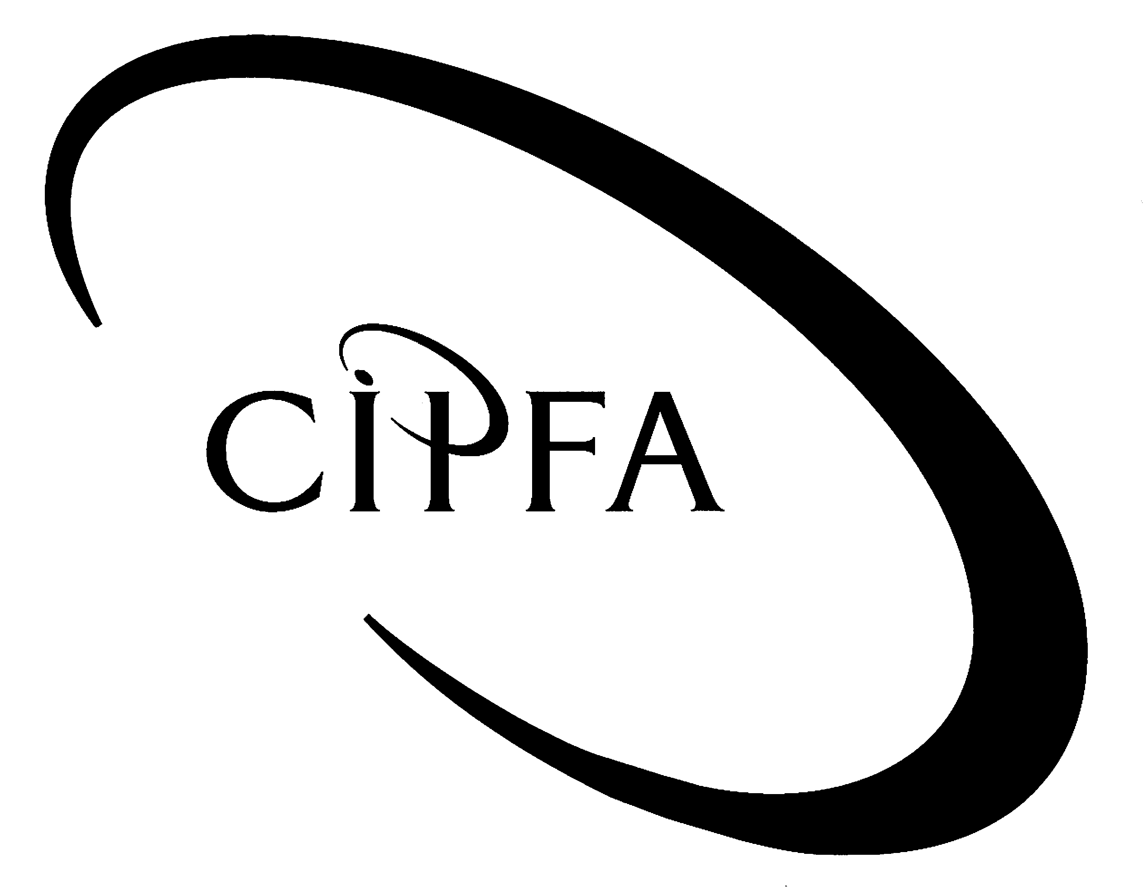

SECTION A (Compulsory)

Use may be made of the proformas attached to this question paper.
1
The following are summarised financial statements of Beta plc for the period 1 April 1998 to 31 March 2001.

Balance Sheet extracts as at 31 March:

 | 2001 |  | 2000 |  | 1999
 | £m | £m | £m | £m | £m | £m
Fixed assets
Intangible assets |  | 1,105 |  | 937 |  | 987
Tangible assets |  | 6,514 |  | 3,261 |  | 2,156
Investments |  | 820 |  | 520 |  | 520
 |  | 8,439 |  | 4,718 |  | 3,663
Current assets
Stock | 1,335 |  | 728 |  | 629
Debtors | 2,316 |  | 1,904 |  | 1,998
Investments | 0 |  | 200 |  | 0
Bank | 1,320 |  | 751 |  | 334
 | 4,971 |  | 3,583 |  | 2,961
Less creditors due in less than one year:
Trade creditors | 1,334 |  | 1,872 |  | 1,341
Taxation | 221 |  | 136 |  | 122
Proposed dividend | 264 |  | 142 |  | 156
Bank loans and overdrafts | 1,889 |  | 1,018 |  | 991
 | 3,708 |  | 3,168 |  | 2,610
Current assets less current liabilities: |  | 1,263 |  | 415 |  | 351
Total assets less current liabilities |  | 9,702 |  | 5,133 |  | 4,014
Creditors due in more than one year:
10% Debentures |  | 3,800 |  | 3,000 |  | 3,000
Provisions for liabilities and charges:
Deferred tax |  | 22 |  | 17 |  | 11
 |  | 5,880 |  | 2,116 |  | 1,003
Financed by:
Ordinary shares of 20p each |  | 320 |  | 150 |  | 150
Share premium |  | 2,290 |  | 900 |  | 900
Revaluation reserve |  | 2,600 |  | 700 |  | 0
Profit and Loss account |  | 670 |  | 366 |  | (47)
 |  | 5,880 |  | 2,116 |  | 1,003

Profit and Loss Account extracts for the year to 31 March:

 | 2001 |  |  | 2000
 | £m |  | £m | £m |  | £m
Turnover |  |  | 7,847 |  |  | 7,087
Cost of sales |  |  | 5,689 |  |  | 5,221
Gross profit |  |  | 2,158 |  |  | 1,866
Expenses:
Distribution and marketing | 354 |  |  | 316
Administration | 611 |  | 965 | 581 |  | 897
Operating profit |  |  | 1,193 |  |  | 969
Interest received | 31 |  |  | 84
Interest paid | (380) |  | (349) | (300) |  | (216)
Profit before tax |  |  | 844 |  |  | 753
Taxation |  |  | (220) |  |  | (140)
Profit after tax |  |  | 624 |  |  | 613
Ordinary dividend |  |  | (320) |  |  | (200)
Retained profit |  |  | 304 |  |  | 413

Cash Flow Statement for year ended 31 March 2000:

 | £m |  | £m
Net cash inflow from operating activities |  |  | 2,028
Returns on investment and servicing of finance
Interest received | 84
Interest paid | (300)
 |  |  | (216)
Taxation |  |  | (120)
Capital expenditure
Payments to acquire fixed assets |  |  | (888)
 |  |  | 804
Equity dividend paid |  |  | (214)
 |  |  | 590
Management of liquid resources:
Purchase of short term investment |  |  | (200)
Financing |  |  | 0
Increase in cash |  |  | 390

Notes:

- During the year ended 31 March 2001 debentures were issued at a premium of £80m. The premium was credited to the profit and loss account. There were no issues during the year ended 31 March 2000.

(ii) During the year ended 31 March 2001 plant and machinery, costing £4,200m and written down to £840m at 31 March 2000, was sold for £950m.

- Tangible fixed assets purchased during the year ended 31 March 2001 were £2,735m.

- Intangible fixed assets purchased during the year ended 31 March 2001 were £228m.

- All sales are credit sales.

- Revaluation reserve relates entirely to tangible fixed assets.

- The profit on sale of the current asset investment of £50m is included in operating profit for the year ended 31 March 2001.

(viii) At 31 March 2001 there were outstanding share options that had been granted to the directors during the year. No options were exercised during the year ended 31 March 2001.

- Options at 31 March 2001, 200,000 ordinary 20p shares @ £1.75.
- Average share price for the period was £2.00.

(ix) A new share issue took place on 1 October 2000.

- Requirement for question 1

(a) Prepare the Cash Flow Statement as required by FRS 1 (Revised) for the year ended 31 March 2001. (Notes to the Cash Flow Statement except note 1, are not required). 21

(b) Calculate ordinary and fully diluted Earnings per Share, for the years ended 31 March 2000 and 31 March 2001, as required by FRS 14. 5

- Your organisation is considering the purchase of shares in Beta plc. As the assistant accountant you have been asked to prepare a draft report to assess the performance of Beta plc over the period 1 April 1998 to 31 March 2001. Your report should include:

- A discussion of profitability, earnings per share, liquidity and control of working capital; and 14

- An appendix of relevant ratios. 9

(49)

SECTION B (Answer three questions)
2

ZZ Ltd prepares accounts to 30 September each year. The following relate to the year ended 30 September 2001:

(i) Industrial buildings, housing the company’s production facilities, were valued on 1 October 2000 at £500,000. The valuation, assessed by a professional valuer at 30 September 2001, is £400,000. The original cost 20 years ago of these industrial buildings was £250,000, and their total expected useful economic life was 50 years.

(ii) Production machinery when purchased 3 years ago on 1 October 1997, for £80,000, was expected to have a useful life of 8 years. A new model has been launched on the market, and although not yet easily available is expected to be available from October 2002. The current machine will become obsolete at that time.

(iii) Software was purchased during the year for the production system, but this turned out to be less suitable than originally expected. In-house programmers spent time configuring the production system so that it completely met ZZ Ltd’s requirements. The systems are constantly changing and will probably require further changes in a year’s time. The salary and associated costs for the extra work amounted to £15,000. The production manager wants this work capitalised as an asset so that he does not get charged with it all in this year.

(iv) A new computer controlled machine has been purchased from an American company. The purchase price was:

 | £
Basic cost of system | 110,000
Shipping and transport charges in USA | 3,200
Delivery and handling charges UK | 900
 | 114,100 | @50% = £57,050
Import duties and taxes | 4,300
Installation and set up costs | 1,110
 | 119,510

The contract provided for 50% to be paid in advance and the balance one month after installation. ZZ Ltd has paid £57,050 and has agreed to pay the balance on 10 October 2001 now that installation is complete.

The accountant of ZZ Ltd has heard that FRS 15 allows finance costs to be charged to the fixed asset account. She is proposing to charge the new machine’s asset account with the cost of financing the £57,050 for the six months it took to deliver the machine. The company’s average cost of finance is 8%.

- Requirement for question 2

For each of the assets above state how they should be dealt with in the profit and loss account and balance sheet of ZZ Ltd at 30 September 2001. Your treatment should be justified by reference to appropriate accounting standards. 17
On 1 May 2001 Z plc issued a 10% debenture for £500,000. The terms of the issue were:
3

(i) Issued at par.

(ii) Redeem at any time between 5 and 7 years after date of issue. The terms of redemption are:

- Redeem in 5 years at 15% premium.
- Redeem in 6 years at 10% premium.
- Redeem in 7 years at 5% premium.

(iii) Issue costs amounted to:

- Apportioned internal administration costs, £100,000.
- Underwriting fees £75,000.

(iv) The effective rate of interest implicit in the instrument is 16.8%.

- Requirement for question 3

(a) Calculate the Profit and Loss Account and Balance Sheet entries for the first two years after the issue. 7

(b) Explain the main objectives of FRS13 – Derivatives and Other Financial Instruments: Disclosures. 3

(c) Explain the main requirements of FRS13. 7

(17)
The trial balance of DY plc as at 31 October 2001 is as follows:
4
 | £000 |  | £000
Investment properties at valuation 1 November 2000 | 5,898
Freehold land and buildings (land £500,000) | 2,500
Plant and machinery | 920
Stock 31 October 2001 | 110
Debtors | 225
Cash | 29
Suspense account |  |  | 10
Depreciation provision land and buildings 1 November 2000 |  |  | 800
Depreciation provision plant and machinery 1 November 2000 |  |  | 368
Sale proceeds disposal of plant |  |  | 5
Creditors |  |  | 195
Provision for doubtful debts |  |  | 9
Provision for deferred tax 1 November 2000 |  |  | 260
Revaluation reserve |  |  | 990
Ordinary shares 50p each |  |  | 3,500
Share premium account |  |  | 700
7% debentures |  |  | 1,200
Bank overdraft |  |  | 150
Retained profits b/f 1 November 2000 |  |  | 810
Retained profits for current year before tax |  |  | 685
 | 9,682 |  | 9,682

The following information is available and the above balances will require adjustment where appropriate:

(i) The market value of the investment properties as at 31 October 2001 is £6,400,000.

(ii) The directors engaged a professional valuer to calculate the current value of the freehold land and buildings. The valuer advised the directors that the land should be valued at £570,000 and the buildings should be valued, net of depreciation, at £1,330,000 as at 31 October 2001. This has not been incorporated in the above balances. The buildings are fifteen years old as at 31 October 2001. Depreciation is provided on a straight line basis on cost or revalued amount, assuming a life of 50 years.

(iii) The sale proceeds of plant, £5,000, relates to the sale of an item during the year with a net book value of £1,000. The item was four years old as at 1 November 2000. Depreciation is provided on plant and machinery at a rate of 20% on a straight line basis. A full year’s depreciation is charged in the year of acquisition but no depreciation is charged in the year of disposal.

(iv) The provision for doubtful debts is to be set at 5% of debtors figure as at 31 October 2001.

(v) As at 31 October 2001 the company was engaged in a legal action, the outcome of which was estimated (with a probability of 95%) to be a charge against the company of £110,000.

(vi) The suspense account consists of the receipt of a government grant towards the cost of the plant bought during the year.

(vii) A final proposed dividend of 5p per share is to be provided for.

(viii) Corporation tax for the year is estimated at £180,000 and deferred tax provision is to be set at £310,000.

(ix) Debenture interest has not yet been provided for.

- Requirement for question 4

(a) Prepare a statement showing the calculation of the correct retained profits for the year ended 31 October 2001. 6

(b) Prepare a Balance Sheet as at 31 October 2001 for DY plc. Detailed notes to the accounts are not required, but all workings must be shown. 11

(17)

VAS plc produced the following Profit and Loss account for the year ended 30 June 2001 for internal use.
5

VAS plc
Profit and Loss Account for the year to 30 June 2001

 | £000 |  | £000
Sales |  |  | 25,580
Cost of raw materials used |  |  | 14,520
Gross proft |  |  | 11,060
Expenses:
Wages and salaries | 6,150
Rent | 770
Business rates | 310
Heat and light | 985
Telephone | 222
Depreciation | 1,443 |  | 9,880
 |  |  | 1,180
Investment income |  |  | 870
 |  |  | 2,050
Interest paid on debentures |  |  | 630
Profit before tax |  |  | 1,420
Corporation tax |  |  | 365
Profit after-tax |  |  | 1,055
Dividends |  |  | 615
Retained profit |  |  | 440

- Requirement for question 5

(a) Published accounts produced using the traditional historical cost basis are often said to have several limitations. Explain, with examples, the limitations of historical cost based published accounts. 9

(b) Prepare a Value Added Statement for VAS plc for the year ended 30 June 2001. 8

(17)
PROFORMA PROFIT AND LOSS ACCOUNT

Continuing acquisitions discontinued total
operations
£ £ £ £

Turnover

Cost of sales

Gross profit or loss

Distribution costs

Administration costs

Other operating income

Operating profit or loss

Exceptional items

Profit or loss on ordinary activities
before interest

Interest receivable

Interest payable

Profit or loss on ordinary activities before tax

Taxation

Profit or loss for the financial year

Dividends

Retained profit for the financial year

PROFORMA BALANCE SHEET

Fixed assets
intangible assets

tangible assets

investments

Current assets
stock
debtors
investments
cash at bank and in hand

Prepayments and accrued income

Creditors: amounts falling due within one year
trade creditors
tax
loans
dividends
other creditors
accruals and deferred income

NET CURRENT ASSETS

TOTAL ASSETS LESS CURRENT LIABILITIES

Creditors: amounts falling due after more than one year

Provisions for liabilities and charges

CAPITAL AND RESERVES
Called up share capital

Share premium account

Revaluation reserve

Other reserves

Retained profits
PROFORMA CASH FLOW STATEMENT

Net cash inflow from operating activities

Returns on investments and servicing of finance

Taxation

Capital expenditure

Equity dividends paid

Management of liquid resources

Financing

Increase in cash

PROFORMA STATEMENT OF TOTAL RECOGNISED GAINS AND LOSSES

Profit for the financial year

Revaluation reserve arising during the year

Exchange adjustments

TOTAL RECOGNISED GAINS AND LOSSES FOR THE FINANCIAL YEAR

Prior year adjustments

TOTAL GAINS AND LOSSES RECOGNISED SINCE LAST ANNUAL REPORT

