AUDIT

Professional 1 examination
6 December 2002

From 2.00 pm to 5.00 pm,
plus ten minutes reading time from 1.50 pm to 2.00 pm.

Instructions to candidates

Answer four questions. Question 1 from Section A and three questions from Section B. The marks available for each question are shown in italics in the right-hand margin.

Where a question asks for a specific format or style, such as a letter, report or layout of accounts, marks will be awarded for presentation and written communication.

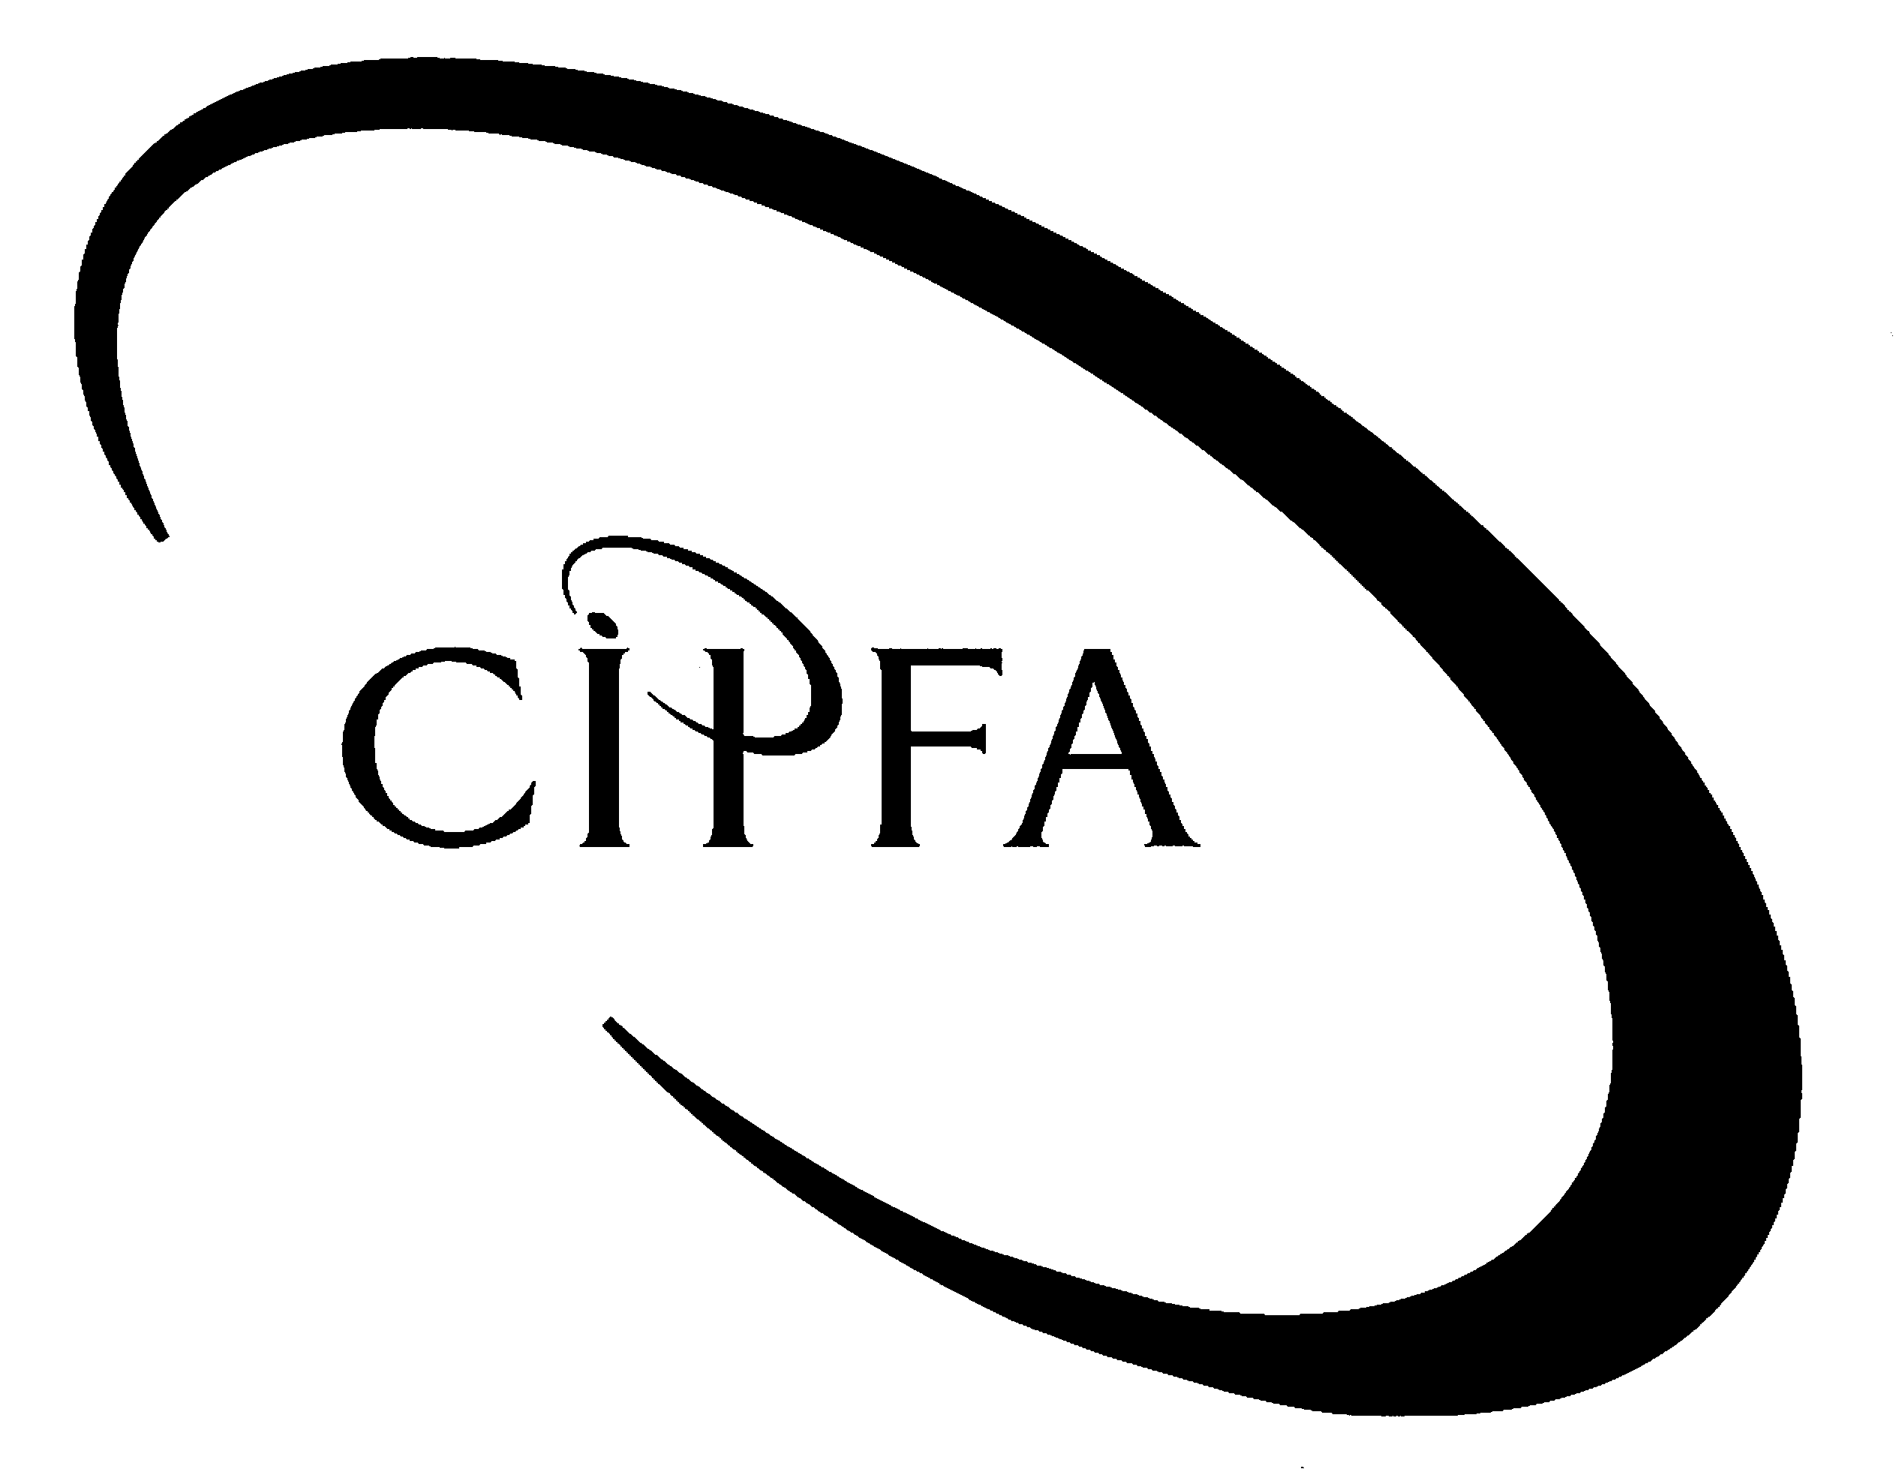

SECTION A (Compulsory)
1
Watermill City Council has just submitted its draft accounts, for financial year end 31 March 2002, to your organisation for the purposes of final accounts audit. You work as a recently qualified auditor for the external auditors of Watermill and, due to the recent departure of various audit staff, you have been put in charge of the audit process.

One of the CIPFA trainees from your organisation has been sent to help you with the final accounts audit. Given their relative inexperience in the field of auditing, your boss has indicated that he would like you to explain to the trainee the importance of the audit planning process.

After a perusal through previous years’ audit plans and reports, you discover that it has been difficult in the past to verify the existence of certain of the organisation’s fixed assets. The audit of stock has also been particularly problematic and, in several instances, the accounts have been ‘qualified’ because of the inaccuracy of the stock figures presented. It appears that there are no stock records so the stock-counts at the year-end are used to value the stock figure in the financial statements. It has been decided that the stock-count should take place on Sunday 31 March when there is no movement of stock and which is also the financial year-end. The CIPFA trainee has agreed to help you out in attending the stock-count.

The Information Systems and Technology Department of Watermill City Council is currently located in several towns and the Director of the department now wishes to centralise the computer systems at one location, as yet undecided. He is, however, concerned about selecting a new site and has asked for your help in this. There are two specific areas of concern to the Director:

- Preventing and recovering from unforeseen disasters;
- Ensuring the continuity of the supply and maintenance of essential service to the site.

The Chief Internal Auditor has also paid you a visit at the start of your audit process and is keen for your thoughts on an emerging audit technique that he heard about at a recent audit conference. The Chief Internal Auditor informs you that the technique, known as ‘Control Self Assessment’, was hailed by the speakers of the conference as “the next big thing in auditing”. Unfortunately, the Chief Internal Auditor did not attend the morning conference session on this new technique but is keen to know more, particularly when some of the elected members of the council have also raised the topic in conversation.

- Requirement for question 1

(a) Prepare a note of the points you would like to include in explaining the purposes of audit planning to the CIPFA trainee. 5

(b) (i) Describe the audit procedures you would perform to verify the accuracy of the stock-count:

- before the stock-count; and
- on the day of the stock-count. 8

(ii) Outline the audit procedures to check purchases cut-off at 31 March 2002. 4

(c) In relation to fixed assets, outline the following:

- a suggested control objective;
- a control which would help meet this objective;
- a possible compliance test; and
- a possible substantive test. 4

(d) Describe what measures might be taken to address the problems identified by the Director of Information Systems and Technology. 9

(e) Prepare a briefing note for the Chief Internal Auditor which:

(i) Defines what is meant by the ‘Control Self Assessment’ (CSA) technique. 2

(ii) Outlines the six broad approaches to CSA. 6

(iii) Gives one example of the application of the concept of CSA in the public or private sector environment. 2

(40)

SECTION B (Answer three questions only)
2

WATCHDOG PROBES ACCOUNTANTS’ ETHICS

“The regulatory body for accountants has launched a research programme to examine whether the profession operates in the public interest.
The Accountancy Foundation decided to launch its investigation after surveys showed that public trust in accountants had fallen. This trend has been exacerbated by high-profile corporate failures, most recently that of US energy giant Enron”.

(Joseph McHugh, Public Finance, March 1-7 2002)

The above statement reinforces the perception of the public that auditors are responsible for discovering and disclosing fraud. This concerned the government and the profession, and has resulted in a series of reports on aspects of corporate governance in the private and public sectors.

- Requirement for question 2

(a) Write short notes which describe the principles and key recommendations contained in the reports produced by any two of the following committees:

- The Greenbury Committee

(ii) The Hampel Committee

(iii) The Turnbull Committee 12

(b) The Cadbury Report was published as a response to concerns about the perceived low level of confidence both in financial reporting and the ability of auditors to provide safeguards. One of the major recommendations on good practice advised by Cadbury was the formation of ‘audit committees’.

(i) Outline the role and composition of an audit committee as set out by the Cadbury Report. 4

(ii) Describe the advantages of an audit committee. 4

(20)

You work as an auditor with a large accountancy firm and your firm has several housing associations as part of its external audit client portfolio. The national regulatory body for housing associations has decided to issue guidance to all housing associations requiring them to have a minimum level of internal audit provision.
3
Your firm is planning to approach several housing associations with a view to providing them with internal audit services. One of the senior auditors in your firm has asked you to take the lead role and design marketing material to promote your firm as a leading internal audit provider. Your senior auditor is also keen that you examine the use of performance indicators to evaluate internal audit performance and ensure value for money will be achieved in providing such a service.

- Requirement for question 3

- Outline the various points which you would wish to include in drafting a brochure to market the internal audit services of your firm. 6

(b) Identify the performance measures and indicators which can be used to assess internal audit. 14

(20)

As the Chief Internal Auditor of Hobly NHS Trust, you have been informed by the Finance Manager that a petty cash fraud has recently been discovered. The fraud appears to have been carried out by the Chief Cashier and extends to several thousand pounds. Subsequent investigation of this fraud has revealed that the fraud has been carried out over the period of a year.
4

In discussion with Trust Management you have decided to involve the Police with a view to prosecuting the cashier. The Finance Manager is keen to ensure that all evidence obtained should be more likely to result in conviction of the culprit rather than acquittal, and would like you to provide guidance as to the differing forms of evidence.
In order to prevent subsequent frauds, the Finance Manager would like you to investigate the services that could be provided by a forensic accountant.

- Requirement for question 4

(a) Describe the various forms of evidence which may come to light during a fraud investigation. 14

(b) Outline the services which can be provided by a forensic accountant before an organisation suffers loss from fraud. 6

(20)

5
(a) Below are some of the key control questions for the purchases cycle control objectives.

- Requirement for question 5 part (a)

Describe the controls you would expect to see in place for the following objectives:

(i) Completeness: Can purchases be omitted from the accounting records? 3

(ii) Disclosure: Can purchases and creditors be incorrectly described? 3

(iii) Occurrence: Can creditors’ balances be overstated? 3

(iv) Accuracy: Can purchases be stated at the wrong value? 3

(b) Substantive testing of sales is geared towards the following financial statement assertions which relate to sales – these are:

Rights and obligations: The sale relates to the organisation

Occurrence: The sale is a genuine transaction of the year

Completeness: There are no unrecorded sales

Measurement: The sale is recorded at the correct amount

Presentation/disclosure: The sale is properly disclosed in the accounts

- Requirement for question 5 part (b)

Describe one substantive test you would do for each of these assertions in respect of sales. 5

(c)

- Requirement for question 5 part (c)

Define what is meant by ‘financial statement assertions’ according to SAS 400 and outline the two further financial statement assertions not included in part (b) above. 3

(20)

