AUDIT

Professional 1 examination
11 June 2004

From 2.00 pm to 5.00 pm,
plus ten minutes reading time from 1.50 pm to 2.00 pm.

Instructions to candidates

Answer four questions. Question 1 in Section A and three questions from Section B. The marks available for each question are shown in italics in the right-hand margin.

Where a question asks for a specific format or style, such as a letter, report or layout of accounts, marks will be awarded for presentation and written communication.

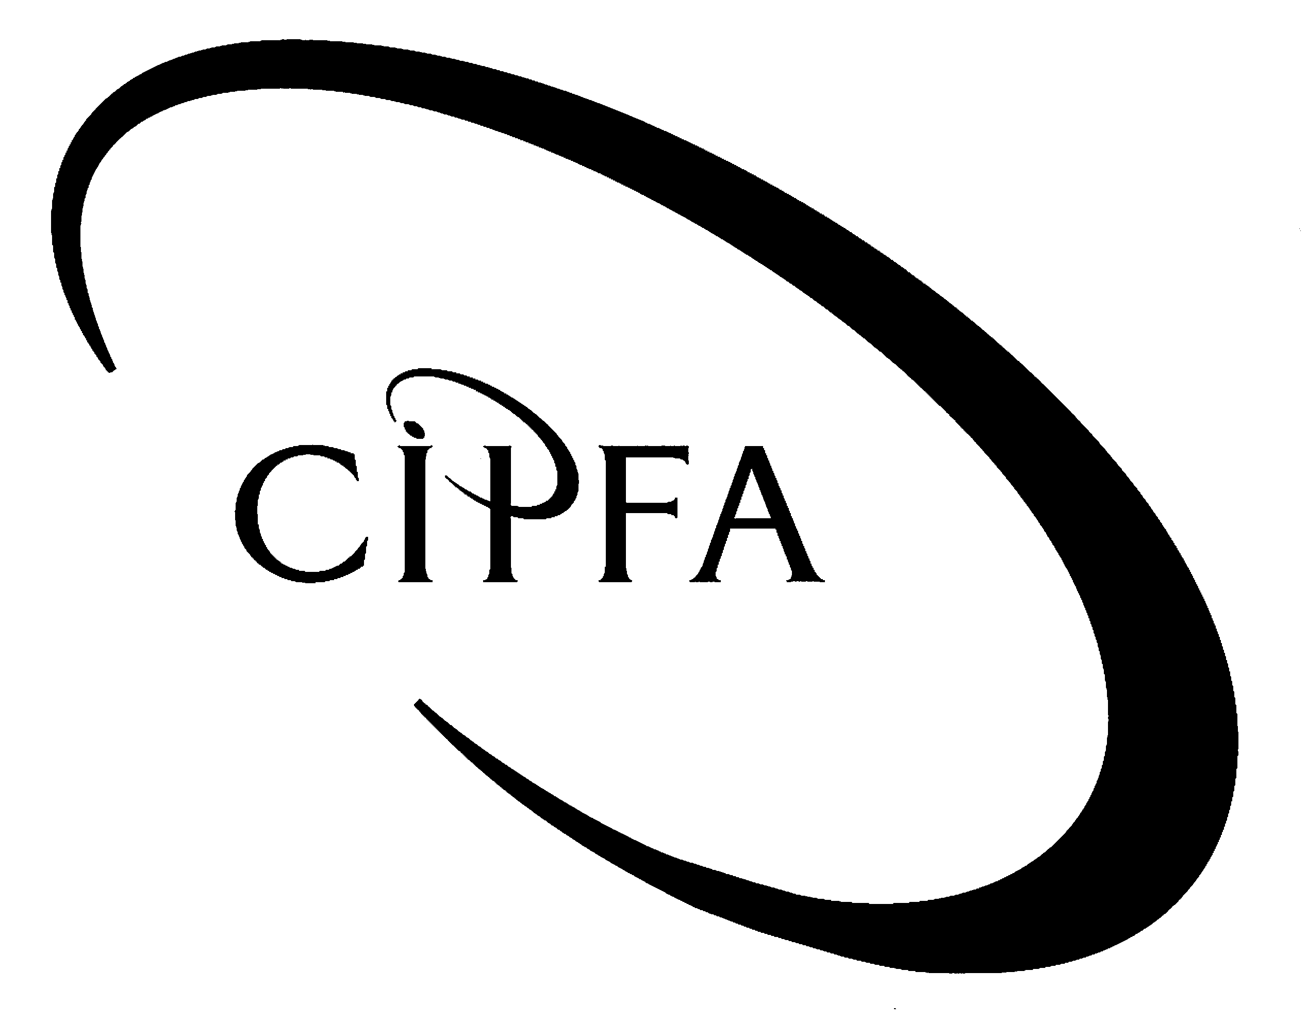

SECTION A (Compulsory)

1
As the audit senior on the external audit of South Cannerton NHS Trust, you have recently received your schedule of work for the forthcoming weeks from your audit manager and note that you have been assigned, amongst other things, the audit section ‘bank and cash’.

As part of your investigation of bank and cash, your audit manager has asked you to conduct a review of the petty cash imprest system of the Finance Department. Petty cash is used by the department mainly to reimburse staff for travel expenses and allowances, and to buy other stationery items and minor office equipment. Petty cash should not be used for purchasing items where value for money could be achieved by ordering goods in bulk or where the value of an individual claim exceeds £50. The Senior Finance Officer is responsible for the operation of the petty cash, which has an imprest level of £700.

Your audit manager has also asked you to consider income from one part of the Trust which runs hostels to provide short stay accommodation for the families of patients who have periods of long stay in hospital. The six hostels are attached to the six hospitals in the Trust area and under their control. The hostels receive some grants from the NHS centrally; however, these do not cover all of the Trust’s financial obligations, and therefore the hostels organise various fund-raising events and appeals, and also receive occasional legacies from individuals. One such large bequest to the hostels received during the year has been invested in the stock market on the advice of a local stockbroker.

The six hostels are each run by unpaid voluntary staff and act as a base for the volunteers and as a collection point for donations of clothes and furniture, which are then sold in the hostel shop. Each hostel has a cafe and a charity shop. Separate tills are held in the shops and in the cafes. All accounting entries are based on a manual cashbook with no purchase or sales ledgers. You have concluded that the major risk area here for audit purposes is completeness of income.

In planning your audit you have initial discussions with the Chief Internal Auditor who tells you about an on-going case of fraud with one of the Trust’s employees, an Accounting Assistant who is responsible for compiling the monthly bank account reconciliations. Whilst this Accounting Assistant was on sick leave, his line manager completed the monthly reconciliation for January 2003. He discovered that a cheque, drawn on South Cannerton NHS Trust and shown in their bank statement as having been presented, did not match the supporting accounting records. A copy of the original cheque was requested from the Trust’s bankers to clarify this discrepancy and, on receipt of this copy cheque, it was apparent that the name of the payee did not match the details contained in the Trust’s accounting records. The payee’s name on the cheque was the same as the Accounting Assistant who issued the cheque. It was also evident that the cheque had been lodged in the bank account used by the Accounting Assistant for his salary transfer. One of your junior members of staff has also been advised of this finding and wants to visit the Accounting Assistant at home to interview him about the irregularities in cheque payments. He is however, concerned about how to proceed with the audit interview process, which at this stage, is only a fact finding exercise.

The junior member of staff is also concerned about the adequacy and effectiveness of the internal audit section of the Trust. Whilst the internal audit section appears to operate as suggested by best practice, ie they appear to be independent, adequately staffed, complying with Standards etc, several hearsay comments have been made about the work of internal audit. Your staff member has asked for the things that you would look for in evaluating the effectiveness of the section.

- Requirement for question 1

(a) Produce a schedule that clearly identifies for the audit of bank and cash of South Cannerton NHS Trust, the following;

- Audit risk.
- Audit procedures/tests. 8

(b) (i) Outline the objectives of the audit of the petty cash imprest of the Finance Department. 4

(ii) Outline the procedures you would follow in the audit of the petty cash imprest of the Finance Department. 4

(c) Prepare a list of audit tests to check for completeness of the hostels’ various streams of income. 7

(d) In light of the above discussion with the Chief Internal Auditor regarding the fraud case, outline the important controls in relation to cheque payments. 4

- You advise your junior member of staff that the process for an audit fact finding interview has four main stages – describe each of the stages for him. 8

(f) Outline the features you would look for to indicate the effectiveness or otherwise of the internal audit section. 5

(40)

SECTION B (Answer three questions)

2
The relationship between the auditor and the management and staff of the organisations subject to audit must be based on mutual confidence and understanding. The auditor must make searching enquiries, carry out thorough tests and checks and occasionally may submit critical or controversial reports.

Management at all levels must have complete confidence in the integrity and independence of the auditors which should be reflected and maintained in good working relationships between audit and general management.

In order to develop an effective working relationship with a member of staff, the auditor must realise that there are inherent perceptions of auditing and the auditor by others. The underlying perception of auditors is that they act as a police force. Auditing style is a factor that can stifle or promote the development of an interactive and effective working environment, and there are three main audit styles – traditionalist, current moderate and participative.

- Requirement for question 2

(a) Outline how the auditor can best achieve a good working relationship with general management. 8

(b) Explain how the reporting lines of the external auditor and the internal auditor differ. 6

(c) Describe each of the three main audit styles identified in the above text. 6

(20)

The sales/income cycle is one of the fundamental areas of most audits. Sales of goods or services generate either cash (cash sales), debtor balances (credit sales) or return of those goods (credit notes). From the dispatch of the goods to the year-end review of bad debts, the potential audit problems are numerous and potentially material. As the figures in the cycle are often some of the most material in the accounts, much audit work is concentrated on these areas to acquire sufficient, appropriate evidence.
3
An overview of the sales cycle of any organisation shows that it consists of the following stages: order, dispatch, invoice, payment. In understanding the sales system it is necessary to consider the risks and therefore the control objectives for each of the key stages in the sales system, and also to identify the controls that management should put in place to ensure that these objectives are met.

- Requirement for question 3

(a) Outline three risks and three controls which address the risks, which should be in place for the order stage of the sales cycle. 6

- Outline three risks and three controls which address the risks, which should be in place for the dispatch stage of the sales cycle. 6

(c) Outline two risks and two controls which address the risks, which should be in place for the invoice stage of the sales cycle. 4

(d) Outline two risks and two controls which address the risks, which should be in place for the payments stage of the sales cycle. 4

(20)

Westworld Housing Association Ltd has been recently formed following the amalgamation of three former housing associations. As a major provider of social housing, it is important that Westworld has a planned repairs programme to ensure its properties remain fit for occupation and to prolong the useful life of the buildings. The organisation is aware that the key to an effective major repairs programme is having detailed knowledge of the attributes of the housing stock. Without a detailed survey, the major repairs programme runs the risk of committing resources in a manner that does not optimise overall stock improvement. It can also lead to significant problems being addressed via future response repairs, at a much higher cost than would have been the case had replacement occurred.
4

Any ideal repairs programme should cover at least a five year period with annual revisions, although, in practice, a shorter period, say three years, may be more realistic and manageable. These reviews should be based on periodic stock surveys and inspections. The repairs programme is usually carried out by employing various contractors, recruited by following normal contract procedures. Once the decision to go ahead with a contract has been made, several key audit issues need also to be addressed, covering the early stages of the contract process right through to post-completion.

As the external auditor for Westworld, you have been asked by the organisation to review the procedures over the planning of the major repairs programme and to determine the extent and effectiveness of any controls that should be in place for such a programme.

- Requirement for question 4

(a) Identify any six key control objectives associated with the major housing repairs programme planned by Westworld. 6

(b) Identify the value for money issues that would arise in respect of a major housing repairs programme. 6

(c) Once the decision to go ahead with a contract has been made by Westworld, outline the key audit issues which need to be addressed. 8

(20)

Birnham City Council is one of the largest local authorities in the country and its Cultural & Leisure Services Department is the second largest operationally within the council.
5
The organisation’s operations are highly computerised and, in addition to making use of computer systems operated by outside agencies, it has its own computer system “Systco”, which records details of each transaction and which also keeps track of each stage of the booking, confirmation, invoicing and ticketing arrangements for every cultural or leisure activity. The organisation is highly dependent on Systco and relies on it totally for its operations and for the accounting entries it generates, which are automatically posted into the organisation’s ledger.

You are one of the external auditors for Birnham City Council and would like to be satisfied that the operation of Systco produces accurate accounting entries. Accordingly you wish to assess the general controls over the Cultural & Leisure Services Department’s computer systems, with particular emphasis on the Systco system. These general controls include the organisation and management of the IT function; system development and program change controls; access controls over programs and data; physical security over computer equipment; and back-up and contingency planning arrangements.

- Requirement for question 5

- Explain what audit work you would perform in assessing the general controls over the computer systems of the Cultural & Leisure Services Department. 10

(b) Detail the implications of any adverse assessment of each of these general controls in relation to the external auditor’s report and management letter for Birnham City Council. Explain the reasons for your answers. 10

(20)

