AUDIT

Professional 1 examination
5 December 2003

From 2.00 pm to 5.00 pm,
plus ten minutes reading time from 1.50 pm to 2.00 pm.

Instructions to candidates

Answer four questions. Question 1 from Section A and three questions from Section B. The marks available for each question are shown in italics in the right-hand margin.

Where a question asks for a specific format or style, such as a letter, report or layout of accounts, marks will be awarded for presentation and written communication.

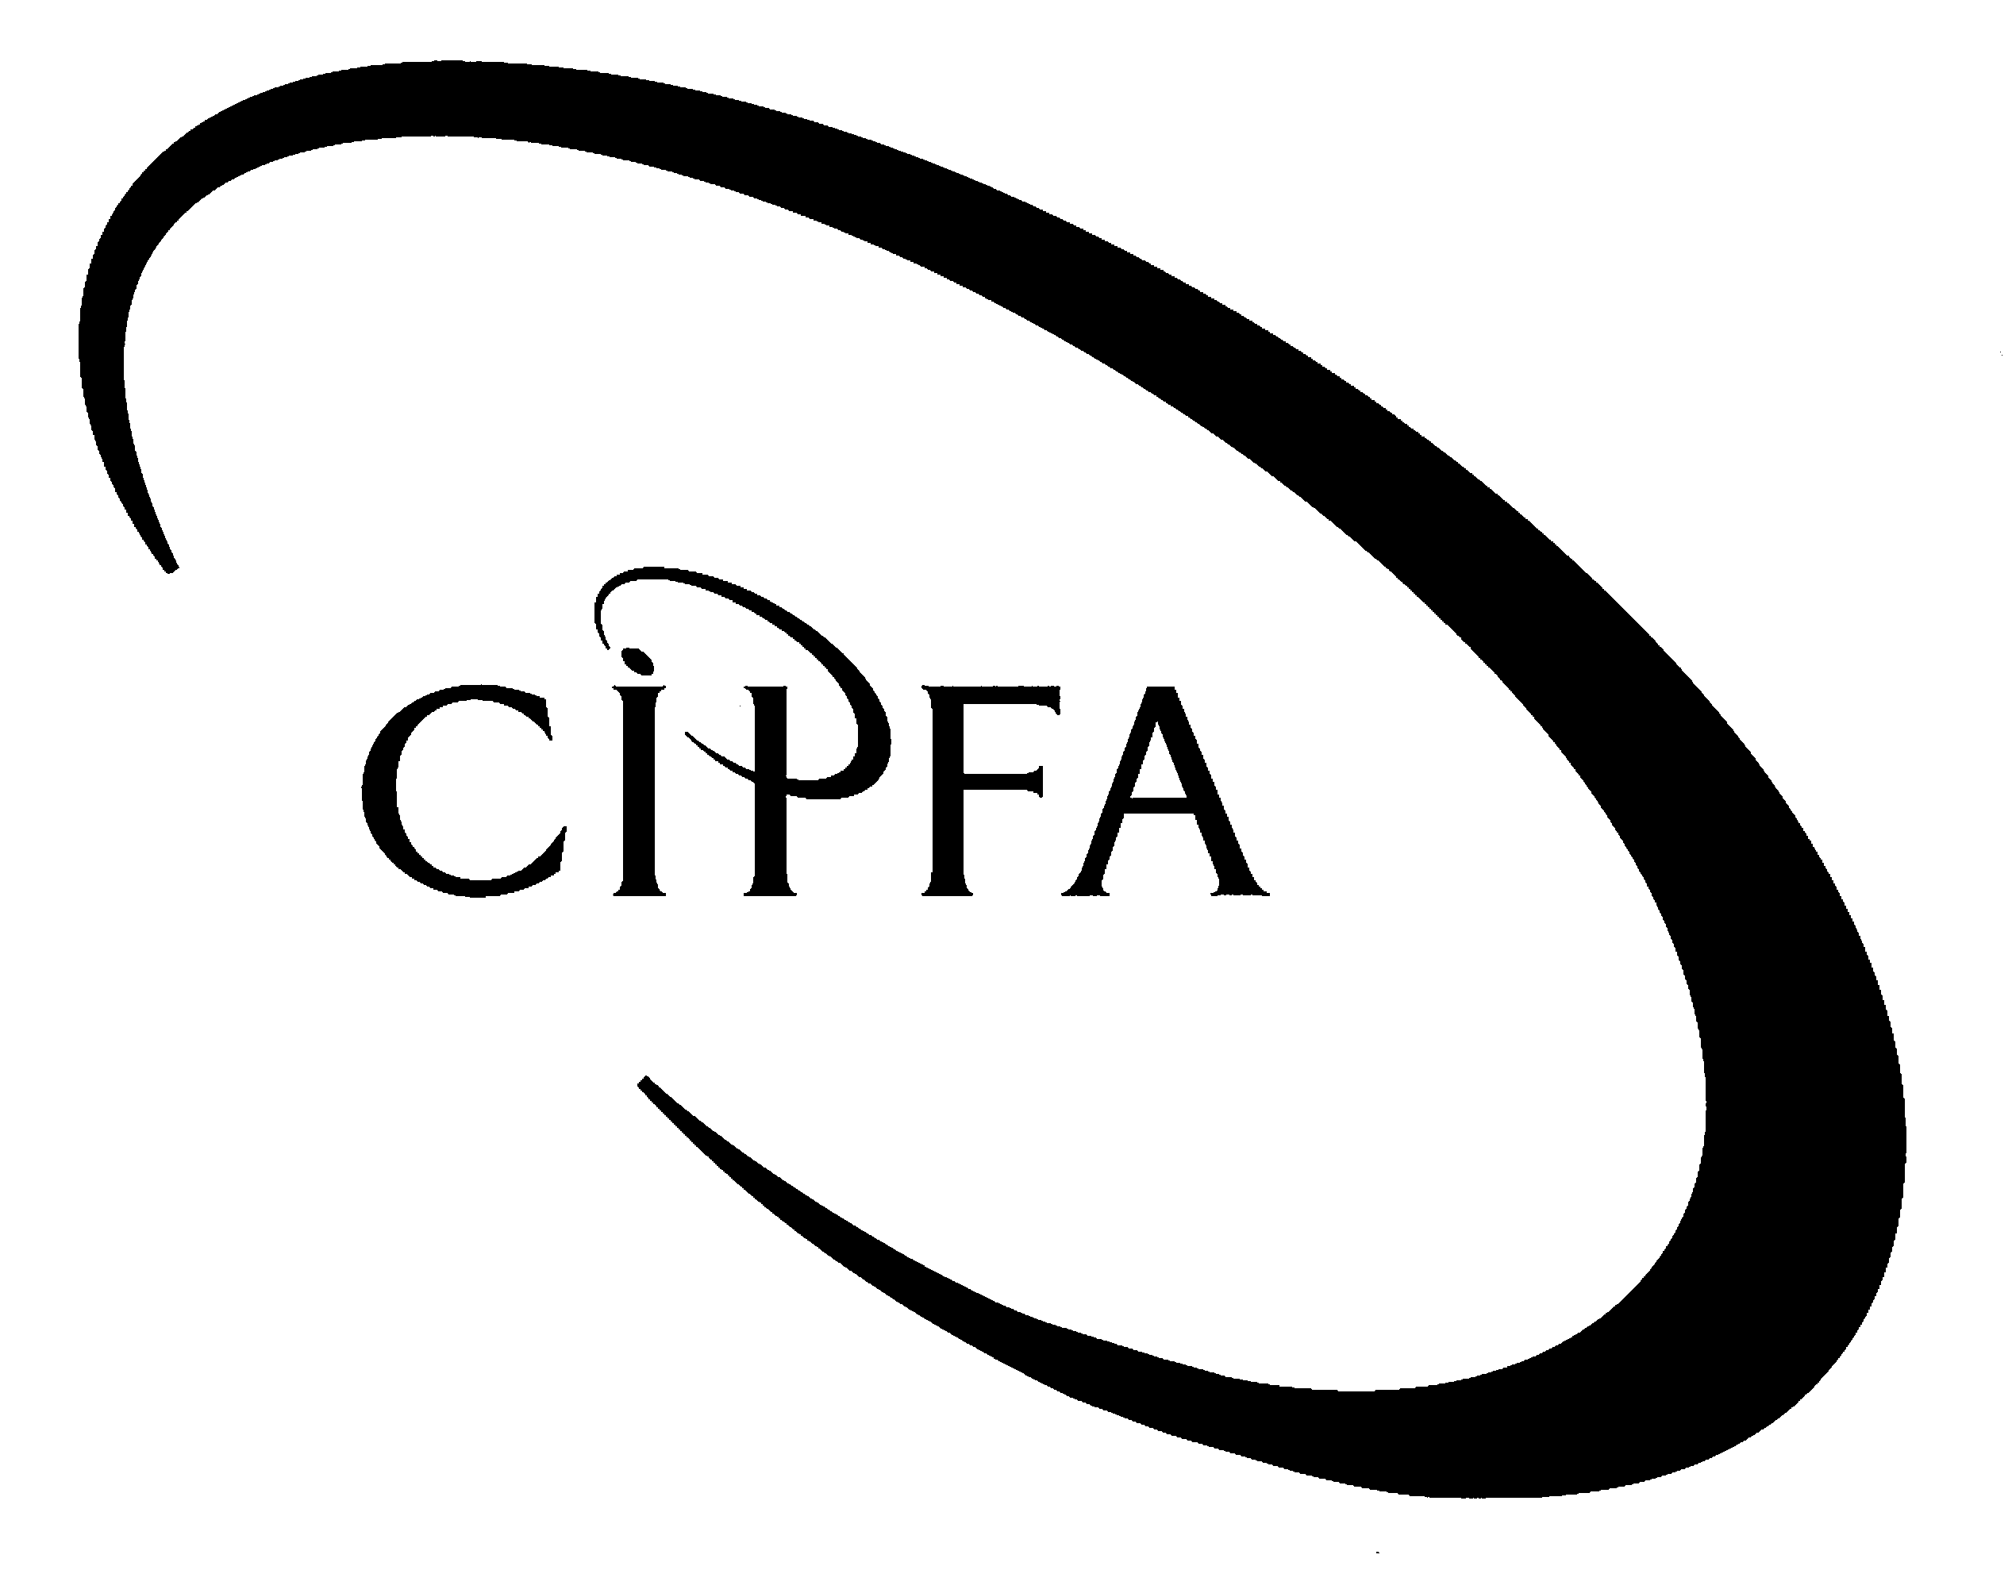

SECTION A (Compulsory)

Your organisation is responsible for the external audit of Clambridge City Council, a typical local authority. Due to the large number of council houses under its control, Clambridge City Council operates a trading organisation called “City Building” to service repairs to the council houses and manufacture products such as doors and windows for use in renovation and refurbishment programmes of the houses. Your organisation, as Clambridge’s external auditor, is also responsible for the audit of City Building. City Building had a turnover of £9 million during financial year 2002/3 and made a year-end surplus of £325,000.
1

The audit manager from your organisation in charge of the audit of City Building has recently stopped work to go on maternity leave and you have been given the responsibility of taking over her role. As this is your first audit as manager, you are keen to ensure that the correct procedures are followed in the conduct of the audit. You are aware that these procedures should be set out and communicated to all personnel in your organisation and should be formally recorded in writing. Accordingly you have sent an email, to your head office requesting a copy of these procedures.

The audit manager has already completed the planning stage of the audit and the next stage of the audit is the on-site audit work to be carried out by the audit team. One of the areas that she has flagged as being particularly important, for investigation purposes, is stock. This concern has arisen out of the planning process and several problems with verifying the stock figure in the past.

City Building is large enough to have its own production, purchasing and accounts departments. It has recently appointed a new Head of Finance who has asked for your advice on controls in the organisation’s purchases system. The Production Department was reviewed by your audit colleagues as part of last year’s interim audit and controls there were found to be operating satisfactorily, therefore no further work is required in this area. The Purchasing Department is responsible for obtaining goods and services for the organisation at the lowest price, but at prices which are also consistent with quality and a prompt delivery date. The purchase of goods involves materials which are used in the manufacture of doors and windows, while the purchase of services includes gas, electricity, telephone and minor repairs. Most purchases are required by the Production Department for use in the manufacture of doors and windows, although the Purchasing Department itself and the Accounts Department also often purchase small items. The Accounts Department is responsible for obtaining authorisation of purchase invoices before they are input to the computer, which then posts them to the ledger.

- Requirement for question 1

(a) As the manager in charge of the external audit of City Building, outline what should be included as standard in the auditors’ procedures which are formally recorded and communicated to all personnel in your audit organisation. 5

(b) Having completed the planning stage of the audit, the next stage in completing the audit is the on-site work carried out by auditors. What responsibilities would you as audit manager have at this stage of the audit of City Building? 10

(c) To complete the evidence-gathering verification process in relation to items stated on the balance sheet, an auditor completes tests which cover Completeness, Ownership, Valuation, Existence and Disclosure (COVED). Describe how you would verify the figure for stock using the mnemonic COVED. 5

(d) In relation to the current arrangements for purchasing outlined at City Building:

(i) Describe the procedures which should be in operation to control the order and receipt of goods. 8

(ii) Outline the controls which should be in place in the Accounts Department to ensure the authorisation of purchase invoices before posting them to the ledger. 6

(e) In considering that City Building purchase both services and goods, explain how controls over the purchase of services might differ from controls over the purchase of goods. 6

(40)

SECTION B (Answer three questions)

As an audit manager working in the public sector, one of your CIPFA trainees has asked for your help with a piece of coursework required by CIPFA as part of the student’s professional studies.
2

The exercise asks for some research to be conducted by the student into the external audit arrangements for various parts of the UK public and private sectors. Given your audit experience in all sectors and in many parts of the UK, the CIPFA trainee has asked for a meeting with you to discuss the issues in question and has already forwarded a copy of the coursework to you, which has to be answered in a UK context.

- Requirement for question 2

(a) Write short notes on the external audit arrangements in the different parts of the UK for any three of the following, to help in your meeting with the CIPFA trainee:

- Central Government;
- Educational establishments;
- Registered social landlords;
- Water organisations.
5 marks for each catergory chosen
(15)

(b) Write short notes on the external audit arrangement for companies in the UK. 5

(20)

(a) It is vital that all auditors, especially external, remain suitably independent from their clients. Anything less could bring discredit on the auditors themselves, their professional body, the profession generally and the auditor’s employer, as well as leading to various conflicts of interest.
3

- Requirement for question 3 (a)

(i) For external auditors, define the needs and conditions for independence at both the firm and personal levels. 7

(ii) Describe the most common instances of conflict of interest which can arise between external auditors and their client. 3

(b) The main strength of internal audit is its independence. Thus management must recognise this and respond by ensuring that the position of internal audit within the organisational structure emphasises this. Internal audit needs to be demonstrably free from all undue influences, which either restrict or modify the scope or conduct of its work, or significantly affect its judgement as to the content of audit reports issued to management.

- Requirement for question 3 (b)

Audit independence can take a variety of forms in the internal audit environment. Identify and explain the various forms of internal auditor independence. 10

(20)

The following case studies describe instances where fraud may occur.
4

Wages and salaries systems

It is common in some housing associations to employ casual workers when a temporary need arises such as a need for grass cutting, communal area cleaning or gardening. The maximum term of employment is often as little as three months, although the term can be renewed for another three months or so when necessary.

In Nowark Housing Association, local area housing managers are allowed to recruit and dismiss casual workers when the need arises. An attendance register is maintained and each casual worker has to sign it when reporting for work each morning, indicating their arrival time. However, the managers know the casual workers by faces and names and therefore do not bother to be physically present when the attendance register is being signed.

Payments to casual workers are made in cash according to the register, which is reviewed and approved by the housing association’s cashier before actual payments are made to respective workers. 7

- Stocks and stores systems

Allswell NHS Trust makes all purchases of stores by using a Local Purchase Order (LPO). Before writing an LPO, the purchasing officer obtains price quotations from several potential suppliers. The supplier who quotes the lowest price for goods of the required quality is given an LPO after it has been signed by the head of department or Director of Finance. However, in most cases it happens that the same people who have been supplying goods are the same who are allowed to supply year in year out.

In almost all cases deliveries by suppliers are made on the scheduled dates. These deliveries are accompanied by Delivery Notes prepared by the supplier and signed by the receiving supplies officer. The supplies officer prepares and issues a Goods Received Note (GRN) to the supplier. The GRN is prepared after checking that the amount (quantity) on the LPO is in agreement with that on the Delivery Note but without checking the actual deliveries. The reason behind this is that the supplies officer has a working experience of nine years in the same job and therefore most suppliers are known to him.

Allswell NHS Trust has a big storage room for a variety of stores of which some are easily portable and expensive. There is no indication that there is limited access to the stores room and staff in need of minor items such as stationery can simply contact the store keeper and get some for official use. 7

Contract audit

Sunnyoaks Council’s Financial Regulations require that all tenders must be advertised to the public specifying the last date and time by which tenders should be in possession of the Council in sealed envelopes that contain no identification marks. Tenderers are given a span of thirty days to submit their tenders but no controls exist to monitor this.

Five days after the closing date the tender box is opened in the presence of tender board members and tenderers or their representatives. It is at this point that all tenderers are numbered or listed from the first tender to the last. The last tender is supposed to be endorsed “last tender” and signed by Chairman and Secretary to the meeting but this is not always done. At this point no discussion is held on any tender and therefore tenders are treated as confidential documents.

Fourteen days after the day specified to submit tenders, a tender board meeting is called to discuss all the listed tenders and at the end of the day tenderers are selected according to a general discussion or based on the recommendations of experts in the case of technical assignments. Selection often takes several days to complete and tenderers are informed of the decision on an ‘ad hoc’ basis.

Where it turns out that a tenderer is a council member, he is still allowed to form part of the discussion session and selection process. 6

- Requirement for question 4

For each of the above case studies, you are required to discuss the following issues:

1. The weaknesses that might give rise to fraud.

2. How can these frauds be detected?

3. How can the system be improved?

(20)

Computer Assisted Audit Techniques (CAATs) involve the use of a computer to perform audit testing. While these techniques may help the work of the auditor, the introduction of the Internet, which by its very nature is inherently insecure, has caused additional problems for the auditor.
5

- Requirement for question 5

(a) Explain the three main categories of CAATs. 6

(b) Discuss the advantages that CAATs offer over manual audit testing. 10

(c) Describe the key issues which will be of interest to auditors in reviewing the use of the Internet by public sector organisations. 4

(20)

