AUDIT

Professional 1

June 2004

MARKING SCHEME

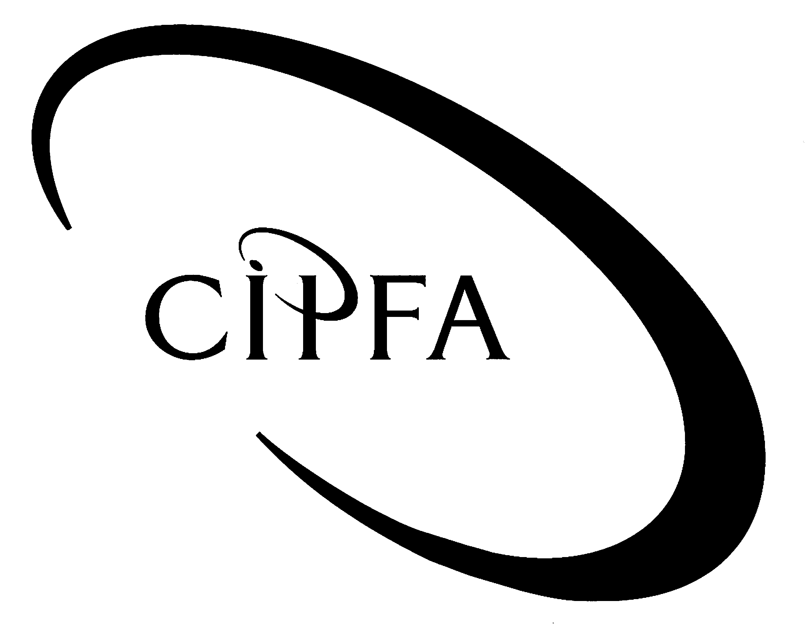

Question 1

(a) (i) Audit Risks:

- The risk that the list of bank accounts given to the auditors may be incomplete.
- The organisation may not have title to all the bank accounts.
- The organisation may have ‘window dressed’ their bank balances.
- Disclosure may not be in accordance with proper accounting practice.
- Cash in hand may be miss-stated.
- Cash in hand may be mis-appropriated or lost.
- The bank reconciliations may not be correct.

1 mark available for any of the above points subject to a maximum of 4

(ii) Audit procedures/tests:

- Obtain listings of all bank accounts open at any time during the year, list closing balance and agree to the ledger.
- Obtain a certificate from the organisation’s bankers for all bank accounts as at the year-end and agree with the bank reconciliations.
- Establish if there have been any material receipts/payments near the year-end that could have distorted the organisation’s position.
- Ensure that all details required for disclosure purposes have been obtained by reference to the bank certificate.
- Obtain a schedule of all cash balances at the balance sheet date and agree with the ledger.
- Carry out selected cash counts on a surprise basis and record the balance of the cash floats and all cash counted. (Count the cash and obtain the cashier’s signature). Make sure that all cash balances are controlled to prevent substitution of one float from another.
- Obtain the bank reconciliations for the year-end and agree balance per bank statement to the bank letter and bank statement. Agree balance for the cashbook to the ledger.
- Obtain a breakdown of the unpresented cheques and for a sample, agree to pre year-end cashbook and past year-end bank statement.
- Obtain an analysis of the outstanding lodgments and vouch to pre year-end cashbook and post year-end bank statement.
- Review documentation from the bank in relation to their error to ensure it is a valid reconciling item.

1 mark available for any of the above or any other relevant
points subject to a maximum of 4

(b) (i) The objectives of the audit will be:

- To examine relevant financial documentation and procedural notes.
- To determine whether guidelines exist for the management of the petty cash float and whether procedures are in line with these guidelines.
- To assess whether reimbursement procedures are satisfactory.
- To ensure that the nature of expenditure is appropriate and supported by receipts where possible.
- To ensure that claims are completed correctly and are appropriately authorised.
- To assess controls over temporary advances if applicable.
- To ensure that physical security of petty cash is adequate.
- To draw conclusions and make recommendations as appropriate and to report to management.

(Page 275-276 of textbook)

1 mark available for any of the above points subject to a maximum of 4

(ii)
- Review the relevant financial documentation to gain a general understanding of the area to be audited.
- Interview the relevant members of staff who operate the petty cash floats to establish the procedures in operation.
- The physical security of the petty cash will be examined, and reimbursements checked.
- A reconciliation of the petty cash account will be undertaken.
- A sample around 20 petty cash transactions will be examined and tests made to verify the adequacy of procedures. Areas tested will include:

- proper use and completion of forms,
- separation of duties,
- maintenance of supporting documentation,
- accounting for VAT,
- temporary advances.

- Report to management, making recommendations where appropriate.

(Page 275-276 of textbook)

1 mark available for any of the above points subject to a maximum of 4

(c) Audit tests to check completeness of hostels’ income:

NHS Funding
- Analytical review of current years’ income compared to prior years, given that levels are likely to be consistent and comparable year on year.
- Review of correspondence to check all grants awarded have been included.

Legacies
- Review of correspondence from lawyers noting awards of legacies, checking all have been included.
- Discuss large bequest with local stockbroker and ensure all money awarded was included in the cashbook.
- Ensure all money sent to stockbroker is accounted for as invested or used for charges.

Events and Appeals.
- For all events, discuss procedures and controls in place over cash at events with management, and consider the need to attend one or more events to compliance test procedures and controls.
- Analytical review of events during the year to identify recurring and one-off events as compared to previous years. Discuss income received with management, comparing to previous years where relevant.
- Review meetings’ minutes for discussion of events and ensure income from events appears in cashbooks.

Cafes/Shops
- Review procedures and controls in place for collecting cash and remitting to bank/finance office as relevant, and procedures and controls regarding receipts of donations.
- Walk through the system and ensure operating correctly.
- For a number of days throughout the year, ensure cash is remitted completely and accurately to the bank, and recorded correctly in the cashbook.
- Tills are in use where appropriate.
- Agree a sample of till receipts to the bank statement and cashbook.
- Carry out an analytical review of shop and café takings compared to prior year.

General
- Discuss levels of income generally with management, taking account of knowledge of the organisation’s activities.
- Review bank reconciliation’s during the year, investigating all recurring reconciling items and any delays in banking takings.
- Review events occurring around the year-end, in particular the weeks following the year end, and ensure that all relevant events are accounted for in the correct period.

1 mark available for any of the above points subject to a maximum of 7

(d)
- For on-line updating of creditors payments, all payments must be authorised by a separate (and senior) officer to the officer checking and processing the payment.
- Check that the separate duties above are protected by separate passwords and these passwords generate an accountable officer code or initials in a tamper-proof field on the terminal screen and any hard copy printout.
- Cheques should be crossed and a separate record kept of any specific written requests for open cheques.
- Pre-printed cheques over a certain amount should be manually countersigned by an authorised officer.
- Spoilt and cancelled cheques should be returned to the issuing officer and recorded in the stock book.

- Serial numbers of used, spoilt and cancelled cheques should be reconciled by a person independent of the payments system before cheques are dispatched.
- An independent check should be carried out on the disposal of spoilt and cancelled cheques.

(Pages 173, Page 247, Page 375 of textbook)

1 mark available for any of the above points
or any other relevant points subject to a maximum of 4

(e) The interviewing process has four main stages:

1. Planning the interview.
2. Commencing the interview.
3. Conducting the interview.
4. Concluding the interview.

1. Planning the interview

It is essential to build a rapport between the auditor and the client. In order to do this, the client must feel relaxed and be placed in a co-operative frame of mind. There are a number of steps which the auditor can take to achieve this including setting clear objectives for the interview, ensure that the client you arrange to interview is the most appropriate person to interview to obtain the information you are seeking, arranging the interview for a time which is mutually convenient for both parties, clarifying for the client the documentation you require access to during the interview, deciding where it would be most appropriate to conduct the interview.

- If the interview is to be held in audit offices you have more control and can arrange the furniture in the room to encourage a relaxed atmosphere;
- Prepare an outline of the areas to be discussed and make this available to the client prior to the interview; and
- Consider who is to be present at the interviews and consider any knowledge of their attitudes, opinions, responsibilities and the results of previous meetings with auditors where these are known.

2. Commencing the interview

First impressions are always important and it is therefore important that the auditor attempts to set the right tone. Where the interview is being held at the auditor's own office, then this is easier to control. However, when the interview is held at the client's office, there are a number of issues to be aware of in setting the tone. The auditor should:

- Arrive at the interview on time, introduce himself and provide means of identification, respond to a shaken or offered hand, sit down on invitation only, not rush into the questioning, have a short introductory statement ready which should ideally contain a reference to the assistance or assurances which the audit will provide to management and explain to the client why the information is required.

3. Conducting the interview

The auditor must retain control over the pace and content of the interview. This will help to avoid irrelevancies and ensure that all of the information required is obtained. The auditor must maintain a rapport with the client and should be aware of questioning, listening, note-taking, non-verbal communication and summarising.

4. Concluding the interview

When the auditor has obtained all necessary information and has confirmed his or her discussion with the client through summarising, it is a good opportunity to ask whether the client has anything else to add which he or she thinks may be relevant. After the interview the auditor can follow up any matters which require further clarification or information. This will normally be done by contacting other sources.

(Page 178 – 182 of textbook)

Up to 2 marks available for discussing each stage of the interviewing process
(8)

(f) In considering the effectiveness of internal audit, the following points would give concern with regard to its effectiveness:

- Absence of a formal role for internal audit in management’s policies/structure.
- Low awareness of internal audit’s work and importance in the organisation.
- Reluctance by management to ask internal audit to participate.
- Poor record of compliance with internal audit’s recommendations.
- No mechanisms for following up reports
- Abnormally high staff turnover in internal audit or poorly qualified or inexperienced staff.
- Evidence of management seeking help form others when problems occur.
- Inability of internal audit to meet plans/budgets.

1 mark for each of the above or any other relevant points subject to a maximum of 5

(40)

Question 2

(a) The auditor can best achieve good working relationships with general management by;

- Understanding the reactions of different levels of management to the work the auditors are doing.
- Being sympathetic to different management styles when planning the audit approach.
- Explaining thoroughly the methods of and reasons for the audit tasks they are carrying out.
- Carrying out their tasks in an open, friendly and courteous manner.
- Respecting local protocol on matters such as punctuality and dress.
- Liaising with management throughout the audit process.
- Not deviating from the plan for the audit without good reason and prior notification.

(Page 10 of textbook)

1 mark for each of the above or any other relevant points, subject to a maximum of 8

(b) The primary reporting line for the external auditor is to the ‘owners’ of the organisation. For a limited company these are the shareholders of a company. For the public sector these ‘owners’ may be taxpayers, board members, committee members or the general public. There are occasions when the external auditors must/can report to others. eg when reporting fraud or when reporting matters of material significance to the regulators empowered by statute to regulate business in the financial sector.

The primary reporting line for internal auditors is to management. The role and objectives of an internal audit function are often described in a mission statement or charter. The reporting line is set out formally in writing and made clear to all levels of management. It is essential that the reporting line for the internal auditor does not detract from his independence or inhibit the freedom to report in any way. Not every report made by internal audit need be sent to the Chief Executive or the Director of Finance. Reports on routine investigations carried out for specific departments will normally be sent to the head of the relevant department. Internal auditors must use their professional judgment to determine whether a copy of the report should go to ‘the top’. As with external auditing, special consideration must also be given to reporting frauds and irregularities.

(Pages 9-10 of textbook)
Up to 6 marks available for discussion of the above points
(6)

(c) There are three main audit styles:

- Traditionalist

In a traditionalist approach, the auditor works with a planned audit programme. There is little interaction between the auditor and the operational staff. In the majority of cases, the staff are not informed in advance of the audit, particularly when spot cash counts and stock counts are the focus of the audit. The approach is formal and audit findings are presented in an audit report at the conclusion of the audit.

- Current Moderate

In the current moderate style, an auditor will make contact with the relevant operational staff to outline the audit process. The assignment is completed in accordance with a plan and an audit programme is followed. A closing meeting is held with the management of the organisation and an audit report is presented at the conclusion of the audit.

- Participative

In the participative style, an auditor holds an initial meeting with the operational staff or management to discuss the objectives of the audit and to ascertain if there are any areas or aspects of special concern. The management and staff are consulted at all stages of the audit and the audit report is discussed at the conclusion of the audit before it is formally presented.

The participative style involves working together to achieve the objectives of the audit assignment. Behavioral aspects are important whatever the style of the audit, but interpersonal skills are fundamental to the participative model.

(Page 10.4 of Study Folder)

Up to 2 marks available for discussion of each audit style
(6)

(20)

Question 3

- The Order Stage

Risks;

- Orders accepted from bad credit risk.
- Orders taken down incorrectly.
- Orders not fulfilled.
- Orders not accepted as best prices.
- Goods dispatched without order or dispatched twice.

Up to three marks available for any three risks identified

(3)

Controls;

- Credit check or check to approved customer list showing credit limits.
- Use of pre-printed standardised order forms to obtain all details with use of trained personnel.
- Sequential numbering of order forms. Follow up of orders not fulfilled ie matched to Goods Delivery Note (GDN).
- Use of authorised price list with any discounts authorised by managers.
- Dispatch notes matched to order prior to dispatch.

Up to three marks available for any three controls identified
(3)

- The Dispatch Stage

Risks;

- Goods dispatched without order.
- No record kept of goods dispatched.
- Goods dispatched wrong in quantity and quality.
- Goods not dispatched.
- Goods dispatched not received by customer.
- Returns of goods incorrectly accounted for.

Up to three marks available for any three risks identified (3)

Controls;
1. Sequentially numbered Goods Delivery Notes generated from order details.
2. Supervision controls to prevent goods leaving premises without valid GDN and matching of order to GDN.
3. Independent check of goods packed to order forms prior to dispatch.
4. Periodic review and follow up by sales department of unfulfilled orders.
5. Consumer acknowledgement of goods delivered (signed delivery note).
- Matching of delivery note to order.
- Returns notes correctly completed and associated invoices credit noted.

Up to three marks available for any three controls identified (3)

- The Invoice Stage

Risks;

- Goods dispatched not invoiced.
- Errors in invoicing.
- Invoices not recorded in accounting system.
- Errors in VAT.
- Credit notes raised in error.

Up to two marks available for any two risks identified

(2)

Controls;

- Periodic review for unmatched GDNs.
- Checking of invoice to GDN/order and approval prior to sending invoice.
- Sequence check of all invoices raised to invoices posted in ledger.
- VAT training for invoicing staff.
- Credit note issue restricted to senior staff.

Up to two marks available for any two controls identified
(2)

(d) The Payment Stage

Risks;

- Remittances from customers not recorded.
- Cash/cheques subsequently misappropriated.
- Remittances not recorded in accounting system.
- Remittances not received.
- Cheque returned due to “insufficient funds”.

Up to two marks available for any two risks identified

(2)

Controls;

- Two responsible officers open and record all receipts.
- All assets banked promptly/stored securely. Reconciliation of pay-in slip to add list.
- Bank reconciliations.
- Credit control procedure followed.
Up to two marks available for any two controls identified
(2)

(20)

Question 4

(a) Key control objectives associated with a major housing repairs programme;

- The association has a formal major repairs programme that includes all necessary forms of replacement.
- The programme is based on an accurate stock condition database.
- Procedures should be in place for ordering and monitoring the programme.
- Contractors who are awarded the major repairs programmes should be of appropriate standing.
- Selected contractors are reviewed on a regular basis to ensure that the Association is obtaining value for money and quality of service.
- The progress of all major repairs contracts in terms of timing and quality is closely monitored.
- Payments are made to the correct people and on time.

1 mark for each of the above or any other relevant points subject to a maximum of 6

(b) Value for money issues which could arise in respect of a major housing repairs programme;

- There is a deterioration of stock, storing up future problems and costs.
- There is tenant dissatisfaction leading to increased voids and possible arrears.
- The required work is not reflected within the costing budget for the Association.
- Provisions are inadequate to cover future costs.
- Unapproved contractors are used for the major repairs programme.
- Contractors are not providing a quality service leading to unsatisfactory work, increased costs and dissatisfied tenants.
- Contractors are selected in a haphazard fashion leading to allegations of corruption and poor quality work.
- The programme is not monitored therefore poor quality and timetable over runs are not identified at an early stage leading to increased costs.
- Not all properties are included within the programme leading to deterioration of the stock and greater voids.
- Contractors are not paid when due leading to a tarnished reputation within the sector.

Candidates could also have chosen to answer this question by addressing the 3 E’s, ie Economy, Efficiency and Effectiveness, and giving several illustrations of each in relation to a major housing repairs programme.

1 mark for each of the above or any other relevant points subject to a maximum of 6

(c) Several key audit issues need to be addressed once the decision to go ahead with a contract has been made;

- The relationship between client and contractor.
- Selection of contractors.
- Financial vetting of contractors.
- Tendering and awarding of procedures.
- Contract monitoring arrangements.
- Arrangements to settle disputes.
- Payment of accounts (interim and final).
- Post-completion appraisal.

(Page 200 of textbook)

1 mark for explanation of each of the above points
(8)

(20)

Question 5

(a) Organisation and management

- Obtain an organisation chart and observe to see if this is adhered to.
- Observe the IT function workload and ensure that there is adequate manpower to ensure smooth operation.
- Observe and enquire as to whether staff are competent – do they run checks to ensure integrity of the system and its correct operation?

System development and program change controls

- Review the system development and program change documentation.
- Test controls which exist for program changes by completing a walkthrough test.
- Interview users and enquire as to their knowledge of program change procedures, asking questions such as ‘do they follow these procedures?’ and ‘have they made any changes and not followed the documentation?’
- Review any override procedures and test by walkthrough.
- If possible, use a computer audit specialist to interrogate the system to see if any changes have been made to programs. Cross refer these to documented changes to ensure those documented have been done properly and followed procedures, and check if any have not been documented at all.

Access controls over programs and data

- Interview IT staff to obtain a working knowledge of controls and test by walkthrough if possible.
- Use CAAT’s or other techniques to review the system for unauthorised access/multiple access attempts.
- Review documentation relating to access controls and consider adequacy.

Physical security

- Observe and enquire with staff about physical security.
- Review any security breaches and interview any security personnel.
- Review any insurance claims.
- Observe security measures eg alarms, cameras.

Back-up and contingency planning

- Review documentation of procedures and consider their adequacy.
- Observe back-ups taking place and physically verify these.
- Interview IT staff and ascertain if procedures are followed.
- Enquire about any computer crashes etc and their impact/results.
- Confirm any emergency back-up procedures with third parties/see if they have been tested.

Up to 2 marks available for audit work identified in each category

(10)

(b) Organisation and management

An adverse assessment is serious because if the structure/organisation and the management of the IT are poor, actual operation of the IT is unlikely to be satisfactory. Implications could be that the accounting system may not be relied upon without significant additional testing. If this testing did not indicate that the system was operating satisfactorily this may lead to an unfavorable opinion on the accounts.

System development and program change controls

The system is the organisation’s own, not a bought-in package, and it is relied upon totally by the organisation. An adverse assessment of system development and program change controls is serious, as this implies that the integrity of the system is unsatisfactory and therefore information could be suspect. Significant further testing would be required to ensure the ledger entries are correct. Poor documentation of system development would also hinder any problem resolution.

Access controls over programs and data

An adverse assessment here implies that data and programs may have been altered, which has a potentially serious impact on the financial statements. The possibility of fraud should also be considered in light of the details of the adverse assessment.

Physical security

An adverse assessment is not as serious here unless data is stored on hard drives. The main risk would be business interruption due to theft or damage. This is more of an insurance risk than an audit risk. Any implication would normally be a point for inclusion in the management letter.

Back-up and contingency planning

A potential serious risk to business. Any adverse assessment would reflect a major IT weakness, although the implication for the audit is not as serious, unless data has been lost at some point during the year due to back-ups not working. Most weaknesses identified here would be referred to management through the management letter.

Note: Candidates could also have chosen to answer this question by categorising general controls under the headings Organisational, Operational, Network, File and Environmental although it must be stressed that the general controls asked about have actually been stated in the question.

Up to 2 marks available for explanations given in each category

(10)

(20)

