AUDIT

Professional 1
December 2003

MARKING SCHEME

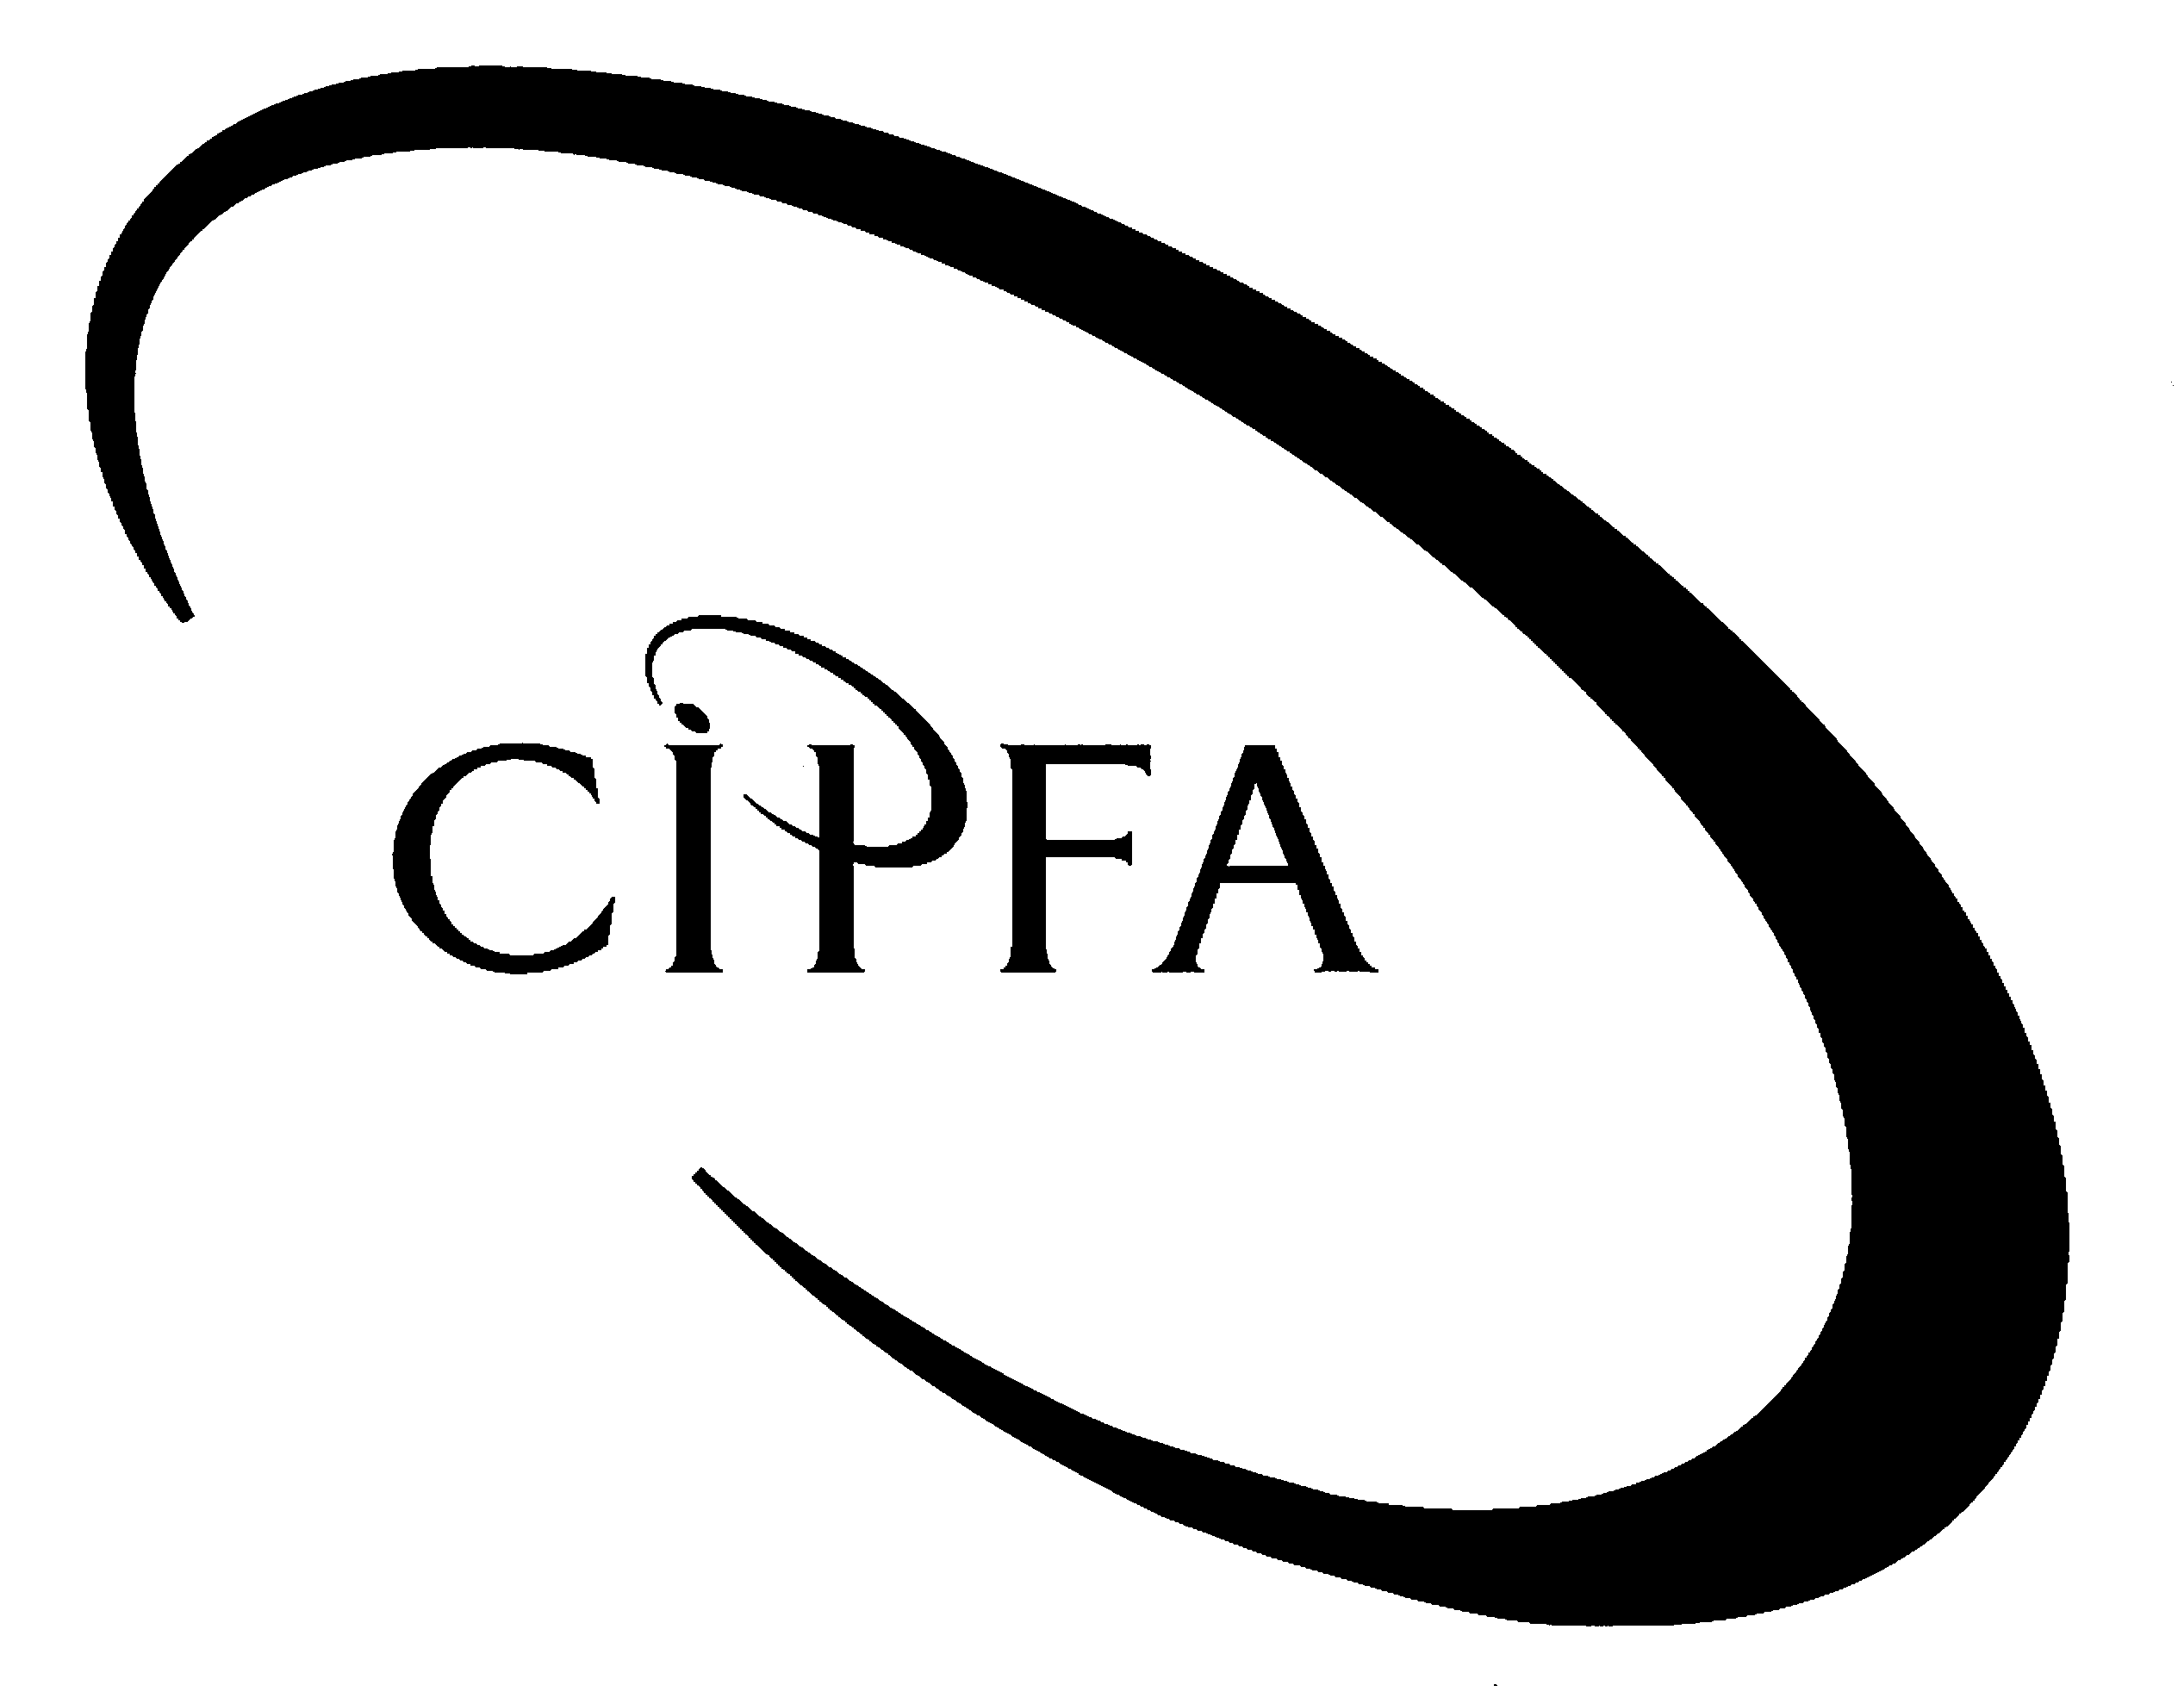

Question 1

(a) The auditors' procedures should be set out and communicated to all personnel in the audit firm. They should be formally recorded in writing and should include:

- Acceptance and re-appointment as auditors. The procedure should cover:
- the evaluation of prospective clients,
- the consideration of the ability to meet clients' needs,
- the consideration for making the decision on acceptance,
- integrity of clients' management;

- Professional ethics. This should set out the firm's commitment to the principles of:
- independence,
- objectivity,
- integrity,
- confidentiality;

- Audit procedures, practices and techniques. The firms' techniques and practices used to carry out their audits should be clearly explained, so that all levels of audit personnel understand the techniques;

- Continual professional development. This should cover the firm’s policy on recruitment, work experience, appraisal, training and updating;

- Consultation on problem areas. Problem areas can include ethical, technical or personal matters or problems of risk. These are dealt with through consultation with technical specialists within the firm and professional advisory services. The procedures should set out the steps to be taken.

1 mark for each of the above points (5)

(Page 14 of textbook)

(b) The audit manager will have the following responsibilities at the audit fieldwork stage of an audit:

- Providing suitable instructions to subordinates at the outset of an audit;

- Ensuring that fieldwork conforms with office standards;

- Ensuring that assignment plans are carried out when deviations are both justified and authorised;

- Ensuring that appropriate audit techniques are used;

- Ensuring that working papers adequately support audit findings, conclusions and reports;

- Ensuring that draft audit reports are accurate, objective, clear, concise, constructive and timely;

- Ensuring that audit objectives are met within allocated time budgets unless there are valid reasons for change;

- Resolving issues as they are identified by subordinates;

- Keeping senior audit management (Head of Internal Audit or Partner) informed about progress on the audit;

- Devising a strategy for the use of information technology. Eg what equipment will be required for the audit team – personal computers or terminals with access into the organisation's mainframe or network?

- Liaising with auditees on site and speaking to a range of client staff, with a view to improving his or her 'feel' for the client organisation (the manager should not personally become involved in testing transactions or documenting systems). In deciding when and how to be involved in the work on site the audit manager will also have to take account of practical considerations.

Other practical points that the manager would have to keep in mind are the movements of the audit team. For example, if one member of staff on a four-week audit is to go off on study leave at the end of the second week, the manager should make sure that he or she has reviewed that assistant's work in time for that assistant to clear the review notes before moving on to the next job. The manager will find it helpful to go on site if only to enhance client relations and to gain the best opportunity of finding out at first hand what is going on at the client's premises.

1 mark for any of the above points subject to a maximum of 10

(Pages 118 - 119 of textbook)

(c) Completeness:

- Obtain stocklists from management.
- Review stocktaking procedures.
- Attend stocktake and review adequacy of procedures.
- Review the internal control accounting systems in relation to stock.
- Reconcile changes in stocks with records of movements, purchases and sales.
- Complete analytical review procedures e.g. gross profit ratios.
- Review cut-off procedures.
- Ensure all stock has been accounted for in the financial year.

Ownership:
The auditor must be aware of circumstances such as:
- Goods on the premises of the organisation which belong to third parties.
- Goods held on consignment which belong to the supplier until such time as they are sold by the client.

Valuation:
- Ensure that stock is valued in accordance with the correct Accounting Practice.
- Review the stocktaking records and recompute a sample to ensure a consistent valuation basis is applied.
- Age the stock held and consider whether any should be written off as obsolete.
- Review apportionment of overheads to stock manufactured by the organisation.
- Complete analytical review procedures eg trends in relation to stock levels.

Existence:
- Physically verify a sample of stocks held.
- If stock is held at a remote location, instruct a third party to independently verify existence.

Disclosure:
- Ensure stock and work-in-progress is shown separately in the balance sheet.

1 mark for a discussion of each of the catergories in the mnemonic
COVED subject to a maximum of 5

(Pages 13.1 - 13.2 of Open Learning Study Guide)

(d)
(i) Procedures which should be in place to control the purchase and receipt of goods;

- For all goods ordered, there should be a purchase requisition from the relevant department. For goods required by the purchasing department, they should request another department (eg the accounts department) to raise a purchase requisition.
- The purchasing department should check the purchase requisition is for goods which the relevant department is authorised to buy or consume.
- The purchase requisition should use a standard form and be signed by an authorised signatory.
- The purchasing department should order the goods from an authorised supplier. Where there is a choice of supplier, or a new supplier is required, the purchasing department should obtain the product from the supplier who provides the product or service at the best price, quality and delivery.
- The purchasing department should raise the purchase order, which should be signed by the purchasing manager. The purchase order should be sent to the supplier, the relevant department and the accounts department.
- The purchasing department should ensure the goods are received on time.
- When the goods are received, the purchasing department should receive a copy of the goods received note and record the goods received against the order. This will allow action to be taken where there are short deliveries or the goods are received late.
- The purchasing department should check the goods on the invoice are consistent with the purchase order and the price per unit is correct.
- The purchasing department should record short deliveries and when there are quality problems.

1 mark for each of the above or any other relevant point subject to a maximum of 8

(ii) The controls which should be in place in the accounts department before the purchase invoice is input into the computer and posted to the ledger include:

- The accounts department will receive the purchase invoice which they should record in a register.
- The accounts department will either match the purchase invoice to the goods received note and delivery note, or ask the purchasing department to check and authorise the purchase invoice.
- The purchasing department will be asked to confirm the goods as described on the purchase order and that the price per unit is correct.
- The relevant department may be asked to authorise the purchase invoice.
- An appropriate responsible officer will be asked to authorise the purchase invoice.
- Provided the above checks are satisfactory, the accounts department should input the invoice details into the computer which will post it to the relevant ledgers.

1 mark for each of the above or any other relevant point subject to a maximum of 6

(e) Differences between the purchase of services and the purchase of goods;

- Often no system for raising purchase orders ie receipt of electricity/gas.
- Review costs of services by comparing them with previous year, period, budget, alternative suppliers etc.
- For the purchase of services, try and find cost reductions and consider the reasonableness of charges.
- Before the service is obtained a purchase requisition should be raised by the user department and the purchasing department should raise a purchase order.
- Emergency situations may allow a purchase requisition and order after the service has been received.
- Should be a system whereby action is taken when no purchase order has been raised for a service which has been received.
- When a service has been received, it is probably appropriate that the department receiving the service should issue a goods received note and send it to the accounts and purchasing departments.
- Quality is often more difficult to judge in the case of services. Providers may be asked to reduce their fee for poor service.

1 mark for each of the above or any other relevant point subject to a maximum of 6

(40)

Question 2

(a) The external audit of central governments;
- England & Wales – central government departments audited by the National Audit Office although changes are underway with regard to Wales.
- Scotland – Audit Scotland has the responsibility for the audit of central government in Scotland.
- Northern Ireland – Northern Ireland Audit Office has equivalent responsibilities.
- NAO reports directly to the Public Accounts Committee and are funded/monitored by the Public Accounts Commission.
- In Scotland, Audit Scotland reports to the Auditor General for Scotland who in turn reports to the Scottish Parliament.

1 mark for each of the above or any other relevant points subject to a maximum of 5

The external audit of educational establishments;
- The external audit of Local Education Authorities in England & Wales is the responsibility of the Audit Commission.
- In Scotland, the external audit of education departments of local authorities is the responsibility of the Accounts Commission, however they are audited on a day to day basis by Audit Scotland or nominated private firms.
- Sixth Form Colleges and Technical colleges subject to the Further and Higher Education Act 1992 can select and appoint their own external auditors. They are, however, also subject to audit visits from the Learning and Skills Council.
- The audit of Further Education Colleges in Scotland falls within the remit of the Auditor General for Scotland, who utilises Audit Scotland or nominated private firms to complete this task.
- Higher education institutions throughout the UK, ie universities, appoint their own external auditors and they must satisfy the provisions for appointment of external auditors under the various Companies Acts.
- Audit visits to universities by staff of the Higher Education Funding Councils and the National Audit Office are also common throughout the UK.

1 mark for each of the above or any other relevant point subject to a maximum of 5

The external audit of registered social landlords;
- Various national housing organisations and departments in the UK are responsible for the regulation and funding of housing.
- Scottish Homes, now Communities Scotland (Scotland), the Housing Corporation (England), Northern Ireland Housing Executive (Northern Ireland), National Assembly for Wales (Wales).
- The national housing organisations report annually to their relevant Parliaments. Therefore they are subject to audit scrutiny by the National Audit Office.
- Housing Associations are audited by a private firm, whom they have complete freedom in choosing.

1 mark for each of the above or any other relevant point subject to a maximum of 5

The external audit of water organisations;
- England & Wales – privately owned water companies who have their financial statements and procedures audited by a private accountancy firm.
- Their financial and commercial performance is also subject to periodic review by their regulator, OFWAT.
- Scotland – water authorities are public sector bodies accountable to the Scottish Parliament and fall under the remit of the Auditor General for Scotland, who utilises Audit Scotland or nominated private firms to complete this task.
- Northern Ireland – the government’s Northern Ireland Water Service as part of the Northern Ireland Department of the Environment is audited by the Northern Ireland Audit Office.

1 mark for each of the above or any other relevant point subject to a maximum of 5

(b) The external audit of companies;
- Every company formed under the Companies Act is required to have an audit with the exception of dormant companies.
- Audit exemption for small companies changed in 2000 – all companies with a turnover of under £1 million are exempt from the requirement to have an audit.
- Ineligible companies, however small, eg banking or insurance companies, are still required to have an audit.
- Auditors of companies are appointed at each general meeting at which accounts are laid before the members.
- Auditors must be registered with a Recognised Supervisory Body under the Companies Act.

1 mark for each of the above or any other relevant point subject to a maximum of 5

(Pages 36 – 40 of textbook)
(20)

Question 3

(a) (i) It is vital that all auditors remain suitably independent from their clients. Independence is defined at both the firm and personal levels and will include:

- Fees. An audit firm should not get more than 15% of its gross recurring fee income from any one client or group of connected clients. (10% for plc’s).

- Personal relationships. If a personal relationship exists, a professional relationship should be avoided. Spouses or other relations should not audit the other's accounts.

- Beneficial shareholding in client companies. No personnel of an audit firm should own shares in a client company.

- Loans or guarantees to and from clients. An audit firm should not make or receive loans or guarantees to or from clients.

- Goods or services from a client. These should be accepted only on the same terms as supplied to the client's staff.

- Commission. Some firms receive commission from insurance companies and building societies when clients act on their advice. This advice must be seen to be in the best interests of the client, who should be informed, in writing, of the terms of all such transactions.

- Hospitality from a client. The auditors must have a reasonable relationship with their clients. Some hospitality from a client is acceptable. The audit organisation should have its own procedures in place to ensure that hospitality given and received is reasonable and properly disclosed.

- Rotation of engagement partner every 5 years.

1 mark for any of the above points, up to a maximum of 7

(Pages 12 – 13 of textbook)

(ii) The most common conflicts of interest may arise when:

- Being asked to advise two clients competing for the same business. The auditor should not accept a job which involves advising both sides;

- Preparing the accounting records. In limited companies where all the shares are owned by husband and wife (owner-controlled companies), it is common for the auditor to act also as the accountant and prepare the accounting records. In this situation it is vital that the preparation of the records is seen to be the responsibility of the client and that the audit then carried out is seen to be an independent report on these accounting records;

- Providing other services to clients. It is usual for auditors to provide other services as well as carrying out the audit. These include:
- giving taxation, management and corporate finance advice;
- giving advice on computer hardware and software purchase;
- human resource consultancy as well as the preparation of accounting records referred to above.

1 mark for each of the above points, up to a maximum of 3

(Page 13 of textbook)

(b) Audit independence can take a variety of forms:

- Independence of access: the head of internal audit should have direct access to, and freedom to report to, all senior management including the chief executive, board of directors and the non-executive review function;

- Independence of reporting: the head of internal audit should have the right of reporting, without editing, under his or her own name;

- Independence from line operations: internal audit should be completely independent of all financial and operational systems within the organisation. Involvement in systems and project development should be limited to:
- the provision of advice concerning the inclusion of controls in revised or new systems and/or projects,
- the evaluation of proposed controls for specific projects, and
- the appraisal of controls generally within systems and the decision-making process;

- Independence of position: organisational status should be such that internal audit operates independently of personnel directly responsible for the operations under review. If part of the finance department, the head of internal audit should be accountable and report directly to the chief financial officer or equivalent, have rights of access to that officer at all reasonable times, and be a member of the departmental management team. It is also essential that internal audit's ability to report to a higher authority within the organisation is not impaired in any way and thus certain rights of access should be permitted, where necessary, to the chief executive, to all executive directors and to the non-executive review function, where appropriate;

- Independence of mind: the internal auditor should have an objective attitude of mind and be in a sufficiently independent position to be able to exercise judgment, express opinions and present recommendations with impartiality.

2 marks for each of the above forms of independence, up to a maximum of 10

(Page 88 of textbook)

(20)

Question 4

(a) Issues re fraud:
- Breach of employment laws.
- Head of department can recruit anyone of their choice.
- Head of department could add a ghost employee.
- Potential for another worker to sign in for a colleague.
- Cashier accepts listing without any further checks.
- Erratic renewal of workers making it difficult to know who is in employment.

Issues re detection:
- Inability to match amount paid with extent of work done.
- Budgets for casuals being overspent.

Issues re improvements:
- Formalise procedures for hiring casual staff and periods of employment.
- Involve Personnel Department in the process.
- Supervisor presence when register is signed.
- Consider alternatives for ‘clocking in.

1 mark for each of the above or any other relevant point subject to a maximum of 7

(b) Issues re fraud:
- Purchasing Officer in direct search for price quotations therefore collusion between officer and suppliers.
- No segregation of duties.
- No checks by Head of Department or Director of Finance.
- Common suppliers used with no rotation.
- Actual deliveries not checked.
- Reliant on working experience of supplies officer.
- Insufficient controls over stores access.

Issues re detection:
- Poor value for money.
- Prices rising even in low inflation times.
- Declining quantity of supplies.
- Purchasing officer has a lifestyle beyond his means.

Issues re improvements:
- Introduce controls re proper tendering procedures
- Introduce controls re the physical check of deliveries
- Introduce controls re access to the stores area.

1 mark for each of the above or any other relevant point subject to a maximum of 7

(c) Issues re fraud:
- No controls over tender receipt.
- Tenderers are present at the tender opening.
- Last tender meant to be endorsed but no indication this is done meaning that ‘extra’ applications could be submitted.
- Applicants who are Council Members still allowed to be part of discussion, which could lead to corruption.
- No established criteria used to select successful contractor; again, corruption a possibility.

Issues re detection:
- Contract costs ahead of budgets.
- Selection of same group of tenderers on a regular basis.

Issues re improvements
- Deadline for tenders should be a firm one.
- Tenders should be date stamped on receipt.
- Selection of contractor should be decided within a set number of days.
- All tenderers should be informed of the final decision at the same time.
- Exclude Council Members who have a financial/business interest.
- Introduce controls to monitor submission timescale of tenders.
- The Financial Memorandum should be redrafted and made more explicit.

1 mark for each of the above or any other relevant point subject to a maximum of 6

(20)

Question 5

(a) Computer Assisted Audit Techniques, or CAATs, is the use of a computer to perform audit testing. There are three main categories of CAATs:

- Data testing CAATs. The auditor uses special audit interrogation software to review and test the contents of data files which form part of the application system under audit review. This can identify faulty data and also provide management information.

- System testing CAATs. The auditor processes specially prepared audit test data through an application system to test its operation (for example its calculations) and its controls.

- Analytical and support CAATs. Special software is used to analyse information from the audit not necessarily computer produced information. Examples include regression analysis and analytical review of historical financial data for trend analysis.

2 marks for each of the above categories, up to a maximum of 6

(Pages 330 – 331 of textbook)

(b) CAATs offer several advantages over manual audit testing in appropriate cases:

- Increased extent of audit testing. The speed and accuracy with which the computer can process large volumes of information can enable the auditor to greatly increase the extent of audit verification, frequently allowing 100 per cent coverage. This can reduce or even eliminate sampling risk for a minimal increase in audit cost. For example, it would take little longer for the computer to recalculate all the price extensions on an inventory file than to draw and check a sample of calculations.

- Performing manually impossible tasks. In some computer systems, particularly in very sophisticated ones. There may be no visible audit trail. The only option available to the auditor in such cases may be to use the computer to trace through the system to verify the correct operation of key controls and processes.

- Cost-effectiveness. CAATs may be a cost-effective method of achieving an audit objective when compared with the cost of alternative manual procedures. Cost- effectiveness will increase where there is scope for re-use, for example in successive years. This is because most of the cost is usually in one-off development costs.

- Elimination of repetitive work. Using the computer to perform repetitive and tedious tasks frees the auditor to concentrate on the important judgmental aspects of the audit.

- Increased knowledge of client systems. A significant by-product of using a computer as an audit tool is that the auditor can achieve a greatly enhanced knowledge of the auditee's systems.

2 marks for each of the above advantages, up to a maximum of 10

(Pages 331 – 332 of textbook)

(c) For auditors four key issues will be of interest.

- There needs to be some restrictions over access to the Internet to ensure that resources are not being wasted (for example by staff 'surfing the net' indiscriminately during office hours).
- There must be restrictions over access to the Internet to ensure that staff do not access inappropriate sites.
- There must be sufficiently strong user authentication protocols, supported by an infrastructure of firewalls and gateways that prevent unauthorised access to the organisation's systems by unauthorised hackers or reduce the increased likelihood of virus attacks.
- Even though it is known that the computer being communicated with is secure, there is no real way of knowing whether the communications lines through which messages are routed are similarly secure.

1 mark for each of the above issues, up to a maximum of 4

(Page 330 of textbook)

(20)

