AUDIT AND ASSURANCE

Diploma stage examination

10 June 2005

From 2.00pm to 5.00pm
plus ten minutes reading time from 1.50pm to 2.00pm

Instructions to candidates

Answer four questions in total: One question from Section A and three questions from Section B. The marks available for each question are shown in italics in the right-hand margin.

Where a question asks for a specific format or style, such as a letter, report or layout of accounts, marks will be awarded for presentation and written communication.

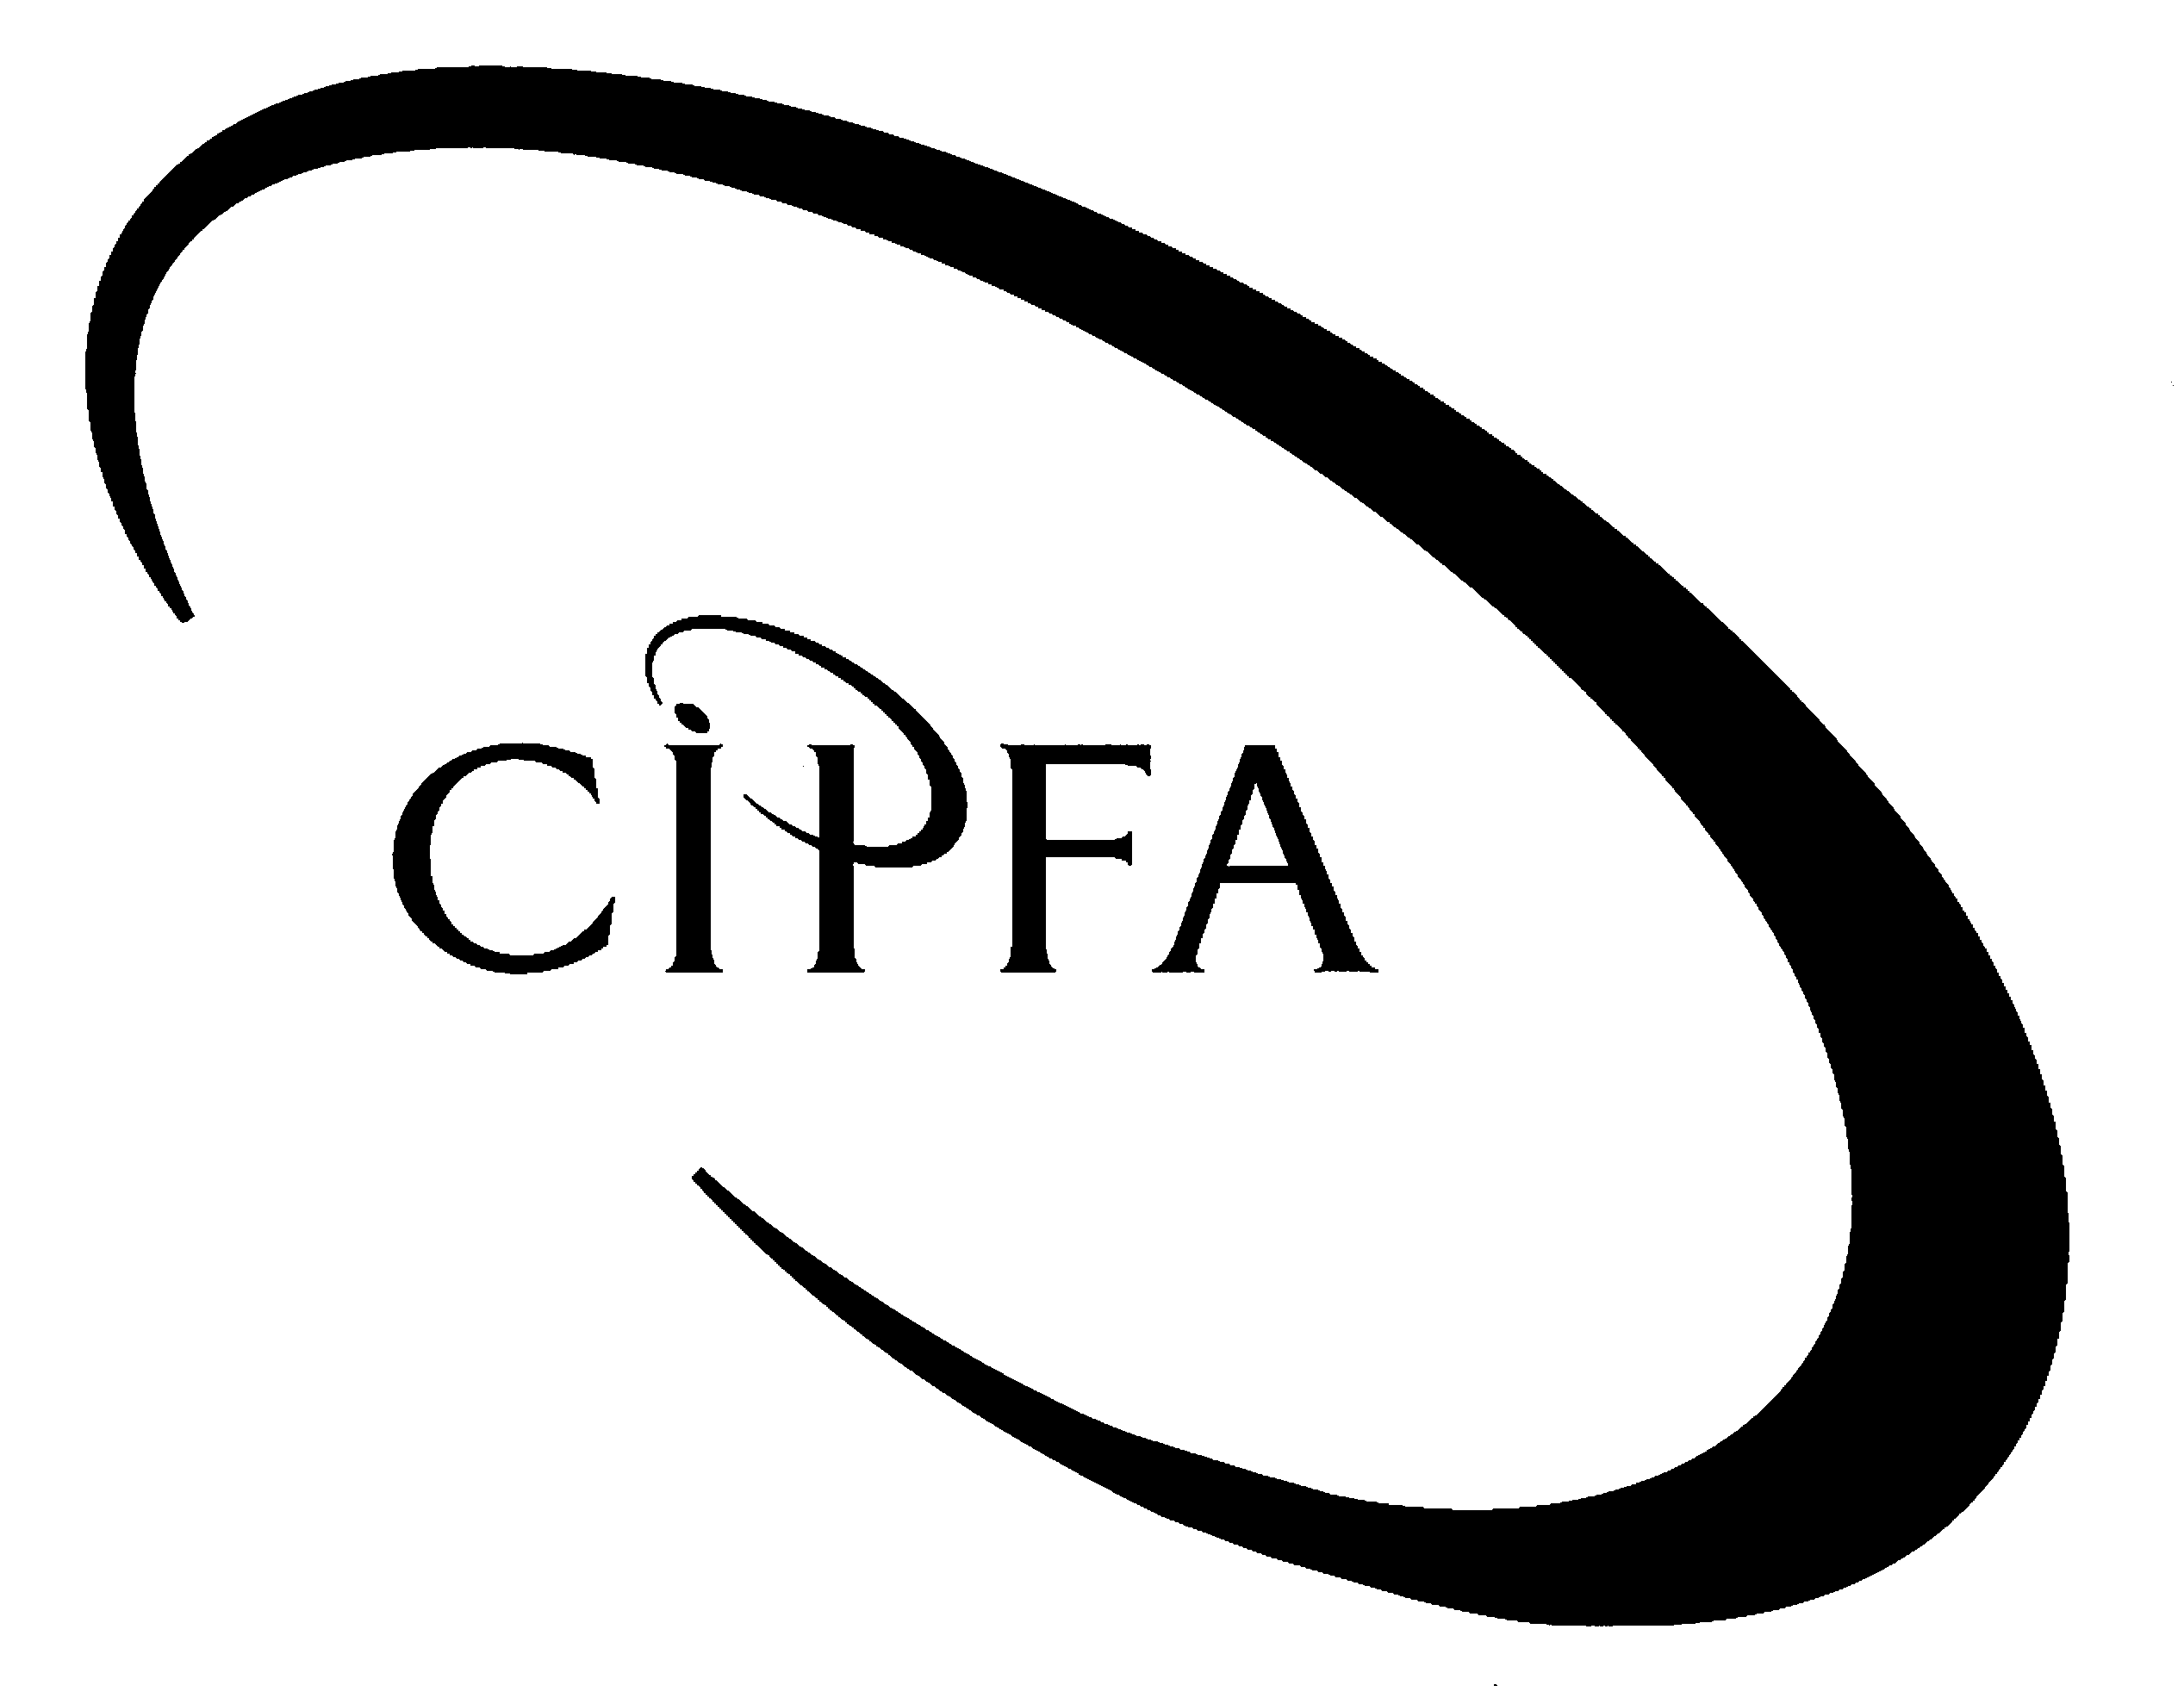

SECTION A (Compulsory)

As part of your duties as the new external audit team leader of Curritall NHS PCT, a medium sized Primary Care Trust, you are putting together some background material on the PCT and the audit environment in which your team will be operating. Most of the members of your audit team have either little audit experience at all or else not much experience of audit in the health sector.
1

Given this you have decided to set out guidance notes on a number of topics. The first deals with the definitions of some basic audit concepts. The first concept to be considered is materiality and you want to make sure your team understand both the overall concept of materiality and how it might apply to the accounts of the organisation they are about to audit.

Your manager is concerned with the level of awareness at your firm of the changes to the role and status of the Auditing Practices Board’s (APB) Statements of Auditing Standards (SAS) arising from the introduction of International Auditing Standards (IAS). He has asked you to prepare a short note for general distribution comparing the national and international standards’ setting process and explaining how firms ensure the application of auditing standards in their audits.

Having read through the standing files of the audit assignment you realise that some aspects of the description and evaluation of the IT/IS controls at the PCT have not been updated for some time. In particular the assessment of the environmental controls has not been amended since the recent relocation of the PCT’s mainframe computer. The IT department and mainframe now share a building called Riverside House with a local outpatient clinic, sharing all amenities and common areas.

Another area which needs some attention is the amount and type of work which you will need to do to support your opinion on the PCT’s statement on internal controls, which accompanies the annual financial statements. Your team have yet to assess the PCT’s risk management arrangements and you need to brief one of your audit team in risk management models in general and approaches to risk assessment they might expect to see within the organisation.

- Requirement for question 1

- Draw up briefing notes in a form suitable for use by your audit team in which you define audit materiality, distinguishing between its qualitative and quantitative aspects. Illustrate these aspects with examples relevant to a health sector audit. 8
1 mark for presentation

- Draw up notes in a form suitable for general distribution to other auditors in your firm on:

(i) The processes by which UK and international auditing standards are set; and 4

(ii) The ways in which an audit firm or function can ensure auditing standards are applied throughout their work. 4
1 mark for presentation

- Define what is meant by environmental controls in the context of IT audit and list the types of controls which these ought to include. Identify any particular risks which you think Curritall PCT’s mainframe computer might be exposed to in this regard and suggest how they might safeguard themselves against this risk. 10

(d) (i) Explain what the three approaches to risk assessment and management might be and outline the advantages of each method over the others. 6

(ii) Explain what is meant by risk mapping and how this aids the auditor or business manager in assessing and controlling risks to the organisation. 6

(40)

SECTION B (Answer three questions from this section)

You have been seconded to the Support and Development team of the local authority internal audit consortium for which you work. Your first assignment is to deliver a series of training lectures on particular techniques which auditors may adopt as a means of modernising their audit approach.
2

The first lectures are due to take place early next month and you need to outline the topics that you will cover in the first two lectures. The topics to be discussed are the role of Computer Assisted Audit Techniques (CAATs) and statistical sampling. Your manager has suggested that you structure your notes around the following headings:

  - What are they?

  - Why use them?

  - Examples of the techniques or approaches which are available and a brief explanation of how each of them might be used.

- Requirement for question 2

Prepare notes for your own use on the following topics indicating the main points which will be covered in your lecture.

(a) Computer assisted audit techniques. 10

(b) Statistical sampling for audit purposes. 10

(20)

Auditors’ involvement in the auditing of performance in the public sector has progressed in recent years from the carrying out of traditional value for money (VFM) examinations to reviewing and reporting on the performance reporting of the public bodies themselves. This may involve the audit of performance measures and indicators prepared by the public bodies.
3

- Requirement for question 3

(a) Define value for money and its constituent parts and give an example of each of these parts. 7

(b) What are the responsibilities of auditors with regard to VFM in the public services? 7

(c) What additional risks do auditors face as a result of having to carry out audits of performance measures and indicators? 6

(20)

Auditors employ a wide variety of evidence gathering techniques and an essential part of the process of planning an audit is choosing appropriate methods of gathering sufficient, good quality evidence.
4

- Requirement for question 4

(a) Explain the six techniques for obtaining audit evidence identified in Statement of Auditing Standard 400 – Audit Evidence. 6

(b) What considerations should the auditor have in mind when choosing an appropriate technique for gathering evidence? 4

(c) For each of the following situations describe the technique or techniques you would use to gather evidence on either the proper operation of controls or the accuracy of accounting or management records.

Operation of controls

(i) The cashier’s section is supposed to carry out a weekly bank reconciliation to ensure that the cash book is up to date and the balance on the bank ledger account is correct. 2

(ii) A computerised stock system is supposed to produce error reports on any request for items which have been ordered but are out of stock. 2

(iii) In order to protect valuable and attractive items (such as lap-tops and mobile phones) all such items are required to be stored or locked away out of sight out of office hours. 2

Accuracy of records

(iv) Management have been set a target of paying 95 per cent of all undisputed creditor invoices within 30 days of receipt. 2

(v) During discussions with management you have been verbally informed that a debtor balance comprising 10 per cent of all debtors is fully recoverable. 2

(20)

You are a CIPFA qualified audit manager working for a medium-sized private sector accountancy firm. The firm has been approached by three organisations who have asked your firm to consider taking them on as clients.
5
The senior partner in the firm has asked you to review the possibilities of taking on these potential clients and has provided you with the following information:

Potential Client A: A private limited company in the tele-marketing sector. Annual turnover is approximately £4,800,000. The Directors (who are also the majority shareholders) have asked if your firm would not only carry out an annual audit but also assist their finance department in designing and implementing new internal controls systems in anticipation of the expansion of their business over the next two years.

Potential Client B: A public limited company listed on the London Stock Exchange which supplies IT hardware. The audit fee envisaged would constitute a significant proportion of the audit firm’s total income. The plc has asked if the firm would be prepared to supply internal audit services as well. If the firm takes on both contracts then the plc would be prepared to provide the firm with computers at a 10 per cent discount.

Potential Client C: The local authority in whose area the firm is based has asked if the firm are prepared to take on the statutory audit. The authority has a policy of always using local businesses and suppliers wherever possible.

The senior partner would like to know, for each of the potential clients:

- The conditions (if any) which your firm would have to satisfy in order to become auditors of the organisation;

- The powers and rights you would expect to have or be given, should your firm accept the appointment;

- Your firm’s role as auditors – ie what would you expect the firm to have to do;

- Any other potential issues in taking the organisation on as a client.

- Requirement for question 5

Set out in a report to the engagement partner your views on the above in respect of:

(a) Client A. 6

(b) Client B. 6

(c) Client C. 7

Marks for presentation and format 1

(20)

