AUDIT & ASSURANCE

Diploma stage examination

6 December 2004

From 2.00 pm to 5.00 pm
plus ten minutes reading time from 1.50 pm to 2.00 pm

Instructions to candidates

Answer four questions: Question 1 from Section A and three questions from Section B. The marks available for each question are shown in italics in the right-hand margin

Where a question asks for a specific format or style, such as a letter or report, marks will be awarded for presentation and written communication.

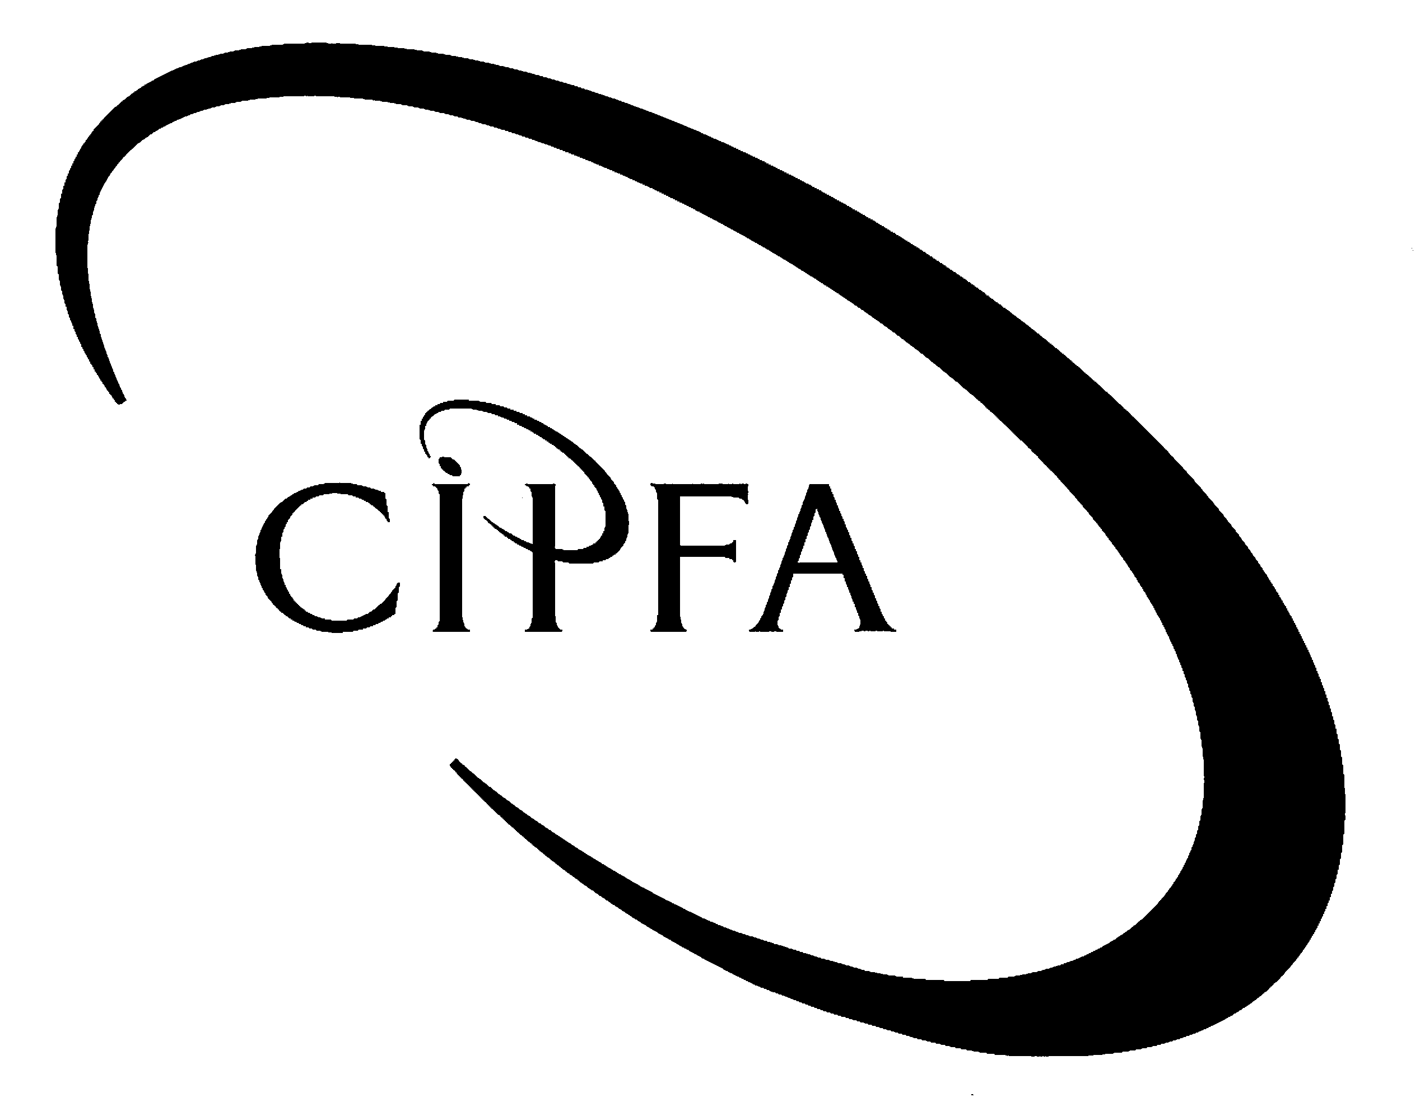

SECTION A (Compulsory)

1
You are a recently qualified CIPFA accountant working for a private sector audit firm. One of your first tasks following qualification is to lead a small audit team providing internal audit services to a medium sized local authority. Your firm provides such services to a number of other authorities but has only been supplying this authority for 9 months.

Your current assignments are: the preparation of the detailed work plans for the review of the council’s Leisure Services Directorate (the Directorate); and consideration of the decision by the council to develop a new computerised electoral register.

The Directorate has two main areas of activity. The first is the management of council-run playing fields, which are used by both local sports clubs and schools. The Directorate is also responsible for overseeing the leisure centre, which is operated by a commercial firm under a five-year contract with the council. The current contract has three years left to run.

Some of your team have already visited the offices of the Directorate to gather background information and this morning you received the following e-mail from the director of leisure services, Tim Leary.

From: Leary, Tim (DirLS) Sent: Monday 6 December/09.30
To: Internal Audit
Subject: Internal audit review

I’ve just had one of your staff in here for a chat about the forthcoming review. She was very pleasant and polite and I tried to help as much as possible. We went through the facts and figures and I gave her a whole load of data (budgets and management accounts for the playing fields; and contract schedules for the leisure centre) for the last two years as well as this year’s budget.

However I do think you might check out what information is already available before pestering me with questions. She kept going on about having to assess audit risk and I told her we already have a fully documented risk assessment in our business plan so you could save yourself some time and use that. Did I miss something or were we talking about different things?

Tim Leary

The council is in the process of developing a new computerised system for holding the electoral register. The Chief Executive has approved the decision to establish a new system in line with the council’s Information Technology strategy and an in-house project team has been formed to oversee the development and implementation. The proposed date for introduction of the new system is April 2006. Your manager at the firm, who acts as Head of Internal Audit (HIA) for the council, is undecided about the level of involvement which he should commit the audit team to in regard to this project.

You have also received a phone call from your manager. He has been speaking to the chair of the council’s audit committee who was complaining that the committee is not being kept fully informed about the activities of internal audit. So far the HIA has only attended two committee meetings: one in May of this year to discuss the annual work plan for internal audit; and another in October to discuss the results of the external audit. You manager says that the audit committee chair would like a more structured communication process to be established.

- Requirement for question 1

- Give four examples of the planning analytical procedures which you might carry out on the data supplied by the Director. What would you be looking for in the results? 8

- Draft a response to Tim Leary describing the differences between business risk and audit risk. 9

- Draft a memo to your manager outlining the two main approaches which your firm might adopt to involvement in the development of the new system and the advantages to both the organisation and to internal audit of each. 8

- In the context of IT audit what are application controls? Give examples of some application controls which you might expect to see in the proposed system. 6

- Prepare a note suggesting how internal audit might communicate with the audit committee on a formal basis. 5

- What standards are applicable to the work of internal audit in the local government sector? 4

(40)

SECTION B (Answer three from four questions)

The Auditing Practices Board (APB) issues Statements of Auditing Standards (SAS) which provide a compulsory framework of standards for all external auditors, in both the public and private sectors, with the responsibility for forming an opinion on financial statements.
2

One of the most important standards for external auditors is SAS 600 - Auditors’ Reports on Financial Statements. This governs the content and format of the auditors’ report, including the options which they have for expressing their opinion as to the truth and fairness of a set of financial statements.

- Requirement for question 2

(a) Apart from auditing standards, what other forms of guidance does the APB issue and what is their status? 5

(b) According to SAS 600, under what circumstances will external auditors issue a report containing a qualified audit opinion? 8

(c) Assuming that the amounts or matters involved are material and that corrections cannot be made to the statements, what opinion should external auditors give in the following circumstances? 7

(i) A central government agency has spent £250,000 of its £50 million budget on purposes for which it has no legal authority.

(ii) The finance department of a housing association has inadvertently destroyed the records relating to the salaries and wages of their maintenance staff and there are no other sources of evidence on which you can rely.

(iii) The computerised general ledger of a NHS Trust has become infected with a virus causing major damage and the backup procedures have failed. The accounts have been prepared on estimates but there is little or nothing to substantiate them.

(iv) A limited company has overprovided on depreciation, doubtful debts, restructuring costs and potential losses on long-term contracts so as to reduce the stated profit for the year.

(v) A company is negotiating with its merchant bankers to extend a line of credit on which it depends for its financial solvency. The company is solvent at the balance sheet date, but the line of credit is only secure for the first eight months of the next financial year.

(20)

The audit committee of the public sector body for which you work has recently recommended the establishment of an anti-fraud unit as part of the internal audit department. You have been chosen to form and run the unit and the Head of Internal Audit has asked for your views on how it should operate.
3

The body has a long history going back several years of minor internal frauds involving things such as fake expense claims and misappropriation of stores. The most serious fraud in the last year involved a junior manager who claimed accommodation expenses for overnight stays in hotels whilst actually sleeping in his camper van.

The total amount involved in this fraud was £2,500 and the manager in question was allowed to resign on condition he repaid the sum involved. You are aware that senior management outside the audit committee do not generally seem to take the problem of fraud very seriously.

- Requirement for question 3

(a) What are the responsibilities of internal auditors with regard to the prevention and detection of fraud and how might they fulfil them? 9

(b) Draft a memo to the head of internal audit stating:

(i) the reasons why you think management need to take the issue of fraud more seriously. 5

(ii) your suggestions for action to address the situation. 5

Marks for appropriate format 1

(20)

You have recently been asked to consider applying for the post of Head of Internal Audit (HIA) of your employer, a large local authority. You have spent the last few days compiling information about the way the audit function operates and have found the following.
4

The audit function is provided by staff based in-house. The IA section consists of 9 staff in total, 8 audit staff (including yourself) and one administrative support worker. The Head of Internal Audit post is classified as Grade 5; by comparison the chief executive is Grade 1, the finance director is Grade 2 and all other heads of department are either Grade 2 or Grade 3. The previous HIA had been in post for 15 years and was on very good personal terms with the heads of departments.

Of the other audit staff in the unit two are professionally qualified and four are studying for accountancy or audit qualifications. The other member of audit staff is on secondment from the ICT section and is providing computer audit expertise.

For budget monitoring and operational matters the internal audit section is part of the finance directorate. The section is physically located in offices rented in the centre of the authority’s main town, some three miles from the newly built civic centre where the rest of the finance directorate is based.

You notice that the audit manual which the section uses has not been updated since July 2001. It is also obvious from the files that many audit testing checklists and programmes are also out of date with references to systems that no longer exist.

The terms of reference of the internal audit function state that internal auditors have a right to inspect all documents and records and may seek explanations from any member of staff. All IA reports are addressed to the audit committee and the HIA has an automatic right to report to the Director of Finance, Chief Executive or Chair of the audit committee on any matter which they consider necessary. They also state that the audit committee must approve the annual work plan and only the committee can vary the scope of the work carried out by internal audit.

- Requirement for question 4

(a) What are the three main components of an effective internal audit function? 3

(b) What features of the situation described above do you consider contribute both positively and negatively to the potential effectiveness of the internal audit function? 12

(c) If appointed, what immediate steps would you take to address the negative factors? 5

(20)

Part of the Auditing Practices Board’s definition of internal control systems is that they are procedures adopted by the directors and management of an entity to assist in achieving their objectives of ensuring the orderly and efficient conduct of its business.
5

As such it is the responsibility of management to identify risks to their ability to ensure this and choose controls of a type which are appropriate to those risks. An integral part of auditors’ work is the assessment of risks and the examination, evaluation and testing of internal controls.

- Requirement for question 5

(a) List the eight types of controls which management may choose from and give an example of the type of risks for which each is appropriate. 8

(b) For each of the following examples for a public sector organisation, state what you consider to be one risk to management’s objectives as well as an example of a control which you think might help mitigate that risk: 8

(i) A large number of laptop computers has just been purchased for use by managers both in the office and at home.

(ii) New legislative requirements on health and safety have necessitated the appointment of additional safety inspectors.

(iii) There are large numbers of temporary staff employed during the summer paid by cheque on a weekly basis.

(iv) A decision has recently been taken to commission the installation of a new telephone system, using outside contractors.

(c) Apart from establishing or enhancing internal control systems, what other strategies might management adopt in managing risk? 4

(20)

