AUDIT AND ASSURANCE

December 2005

Diploma stage

MARKING SCHEME

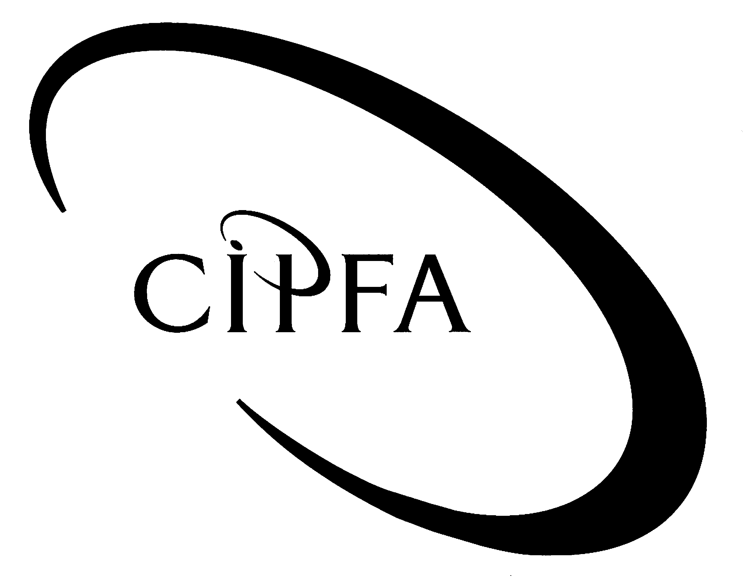

NOTE: In all cases marks will be awarded for appropriate answers, even if not directly covered by the marking scheme.

Question 1

(a) Letter to Director of Finance (NB. The answer is based on the law in England. Credit will be given for answers listing powers of auditors in other parts of the UK.)

(i) Powers of external auditors of local authorities:

- Right of access at all reasonable times to every document relating to the Council.

- Right to require information and explanations from individuals employed by the Council.

- Right to make a report to the members on their findings, including failure on the part of the officers of the Council to supply all the information and explanations which they consider necessary.

The above powers are shared with external auditors in the private sectors. The following relate specifically to local authorities:

- Power to make an ‘in the public interest report’.

- Power to turn a public interest report into an ‘immediate report’ to be issued before the conclusion of the audit.

- Power to:

  - consider the issue of an advisory notice

  - consider applying for judicial review

if a local authority makes or plans to make decisions involving unlawful expenditure or is about to take unlawful action causing a loss or deficiency.
1 mark per point made up to a maximum of 6

(ii) Powers of local electors:

- Right to inspect accounting statements and documents subject to the audit.

- Right to question the auditor about the accounts.

- Right to make copies of all or any parts of the accounts and other documents.

- Right to make objections to an item or items in the accounts.

1 mark per point up to a maximum of 3
1 mark for presentation
Total for part (a) - 10
(Pages 40 & 41)

(b) Risks facing organisations with high degree of devolved management

- Risks to value for money of eg multiple contracts with local suppliers for printing and copying.

- Possible breach of overall budgetary limits, if not properly set and controlled from the centre.

- Risk of area managers failing to comply with policy/legal/regulatory requirements, eg virement from ring-fenced funds.

- Information flows to centre for eg central accounting not timely or complete. May crucially affect audit timetable.

- Area managers’ own objectives clash with those of centre or other areas.

- Centre out of touch with local requirements in respect of those services retained centrally.

- Area managers’ pursuit of own objectives/targets may tempt them to bend the rules.

- Inconsistency of treatment of clients/customers receiving the same service.

1 mark per risk explained up to a maximum of 7

(c) (i) Organisational factors which may increase the likelihood of misconduct.

- Lack of management awareness of, and training in, responsibilities in relation to fraud and the environment.

- Lack of effective internal controls.

- Failure of management information systems to generate appropriate information to enable them to monitor the activity.

- Laxity of attitude by employees and management with regard to the security of assets, for example poor computer access controls.

- High or low turnover of staff, resulting in inadequate supervision.

- Backlogs of work, particularly regarding financial reconciliation.

- Under-employment of staff, providing employees with the opportunity to identify weaknesses in the systems.

- Inexperienced or junior staff being required to undertake duties in excess of their skills.

- Lack of management concern with regard to the welfare of staff, who in turn become discontented and attempt fraud.

- Management lacking in specialist skills (for example computer skills), resulting in ineffective control.

- Lack of formal documentation of procedures.

- ‘Segregation of duties’ is a particularly important guard against misconduct, as a potential fraudster should not be able to have control over all stages of a transaction.
1 mark per factor up to a maximum of 8
(page 204)

(ii) Factors which might be present in the Council:

- Devalued staff owing to disputes over travel expenses.

- High turnover/vacancies may lead to lack of adequate supervision.

- May in turn lead to backlog of work and failure to apply control procedures.

- Small local teams may mean poor or no segregation of duties.

- Lack of financial training may mean staff miss actual/potential frauds.

1 mark per factor up to a maximum of 4
Total for part (c) - 12

(d) Audit of creditors
(NB. The examples given in the marking scheme are indicative only and credit will be given for other, appropriate answers.)

(i) Detailed audit objectives (COVED).

- Completeness – All creditors outstanding at year end have been included in the balance sheet figure.

- Ownership – All creditor balances relate to the activities of the audited entity.

- Valuation – Creditor balances have been stated at the correct monetary amount outstanding as at the year end.

- Existence – Creditor balances included in the balance sheet relate to activities undertaken within the current financial year.

- Disclosure – Creditors have been analysed and disclosed in accordance with relevant standards, regulations and accounting policies.

(Pages 72-73)
1 mark for all 5 COVED objectives
1 mark for explanation of each detailed objective up to a maximum of 5

(ii) Substantive procedures:

- Completeness – Review material creditor payments in April and confirm that those that relate to current year have been included in the creditor balance.

- Ownership – For material balances included in the creditors listing trace back to a valid invoice or supplier statement and confirm relevance to authority.

- Valuation – For a sample of payments made in March taken from the cash book confirm that these have been posted to the creditor account by 31 March.

- Existence – Review material postings to creditor accounts in March and confirm that they relate to activities undertaken in current year.

- Disclosure – Sample creditor balances and confirm that they have been correctly classified as greater than or less than 1 year.

1 mark per procedure up to a maximum of 5
Total for part (d) - 11

(40)

Question 2

(a) External auditors’ work

Audit of financial statements

- Forming an opinion on whether the statements give a true and fair view/present fairly the finances of the audited entity and reporting that opinion to the appropriate body.

- In the public sector this is also taken to include forming an opinion on the regularity of the transactions underlying the statements.

Performance auditing

- Statutory requirements to carry out value for money (VFM) audits or other sector specific duties such as Best Value inspections.

Review of statements on corporate governance/internal controls

- Most organisations are required to prepare a statement on these matters.

- Carry out external audit review and report on the entity’s arrangement for internal control and risk management.

Review of standards of financial conduct

- Usually subsumed within corporate governance work now.

- Has always been considered part of the external audit’s function to review and report on aspects of probity and proper conduct of public business.

Certification of grant claims

- Many public and private sector bodies receive a significant amount of grant funding from other public sector bodies.

- Nearly always a requirement that the recipient’s auditors certify the amounts spent and the purposes for which the money was spent.

1 mark for each point made up to a maximum of 8
(pages 42-44)

(b) Audit, inspection and performance reporting

Audit
The audit of accounts and the underlying financial systems and processes, including regularity, corporate governance and probity.

Inspection
The process of periodic, targeted scrutiny to provide an independent check on standards and other professional or legislative requirements.

Performance reporting
Concerned with the value for money of service or projects as well as preparation and publication of performance information, eg performance indicators.

(page 216) 1 mark per definition up to a maximum of 3

(c) Issues arising with respect to inspection and performance reporting

Issues centre on aspects of:

Links with other inspection and review bodies

- Burden of review – proliferation of bodies increases costs of running them and the costs of complying with inspection and review regimes.

- Some bodies have multiple responsibilities, eg Audit Commission oversees financial audit and Best Value inspection regimes.

- Some attempts to co-ordinate activities of agencies, eg local services inspectorate forum; Scottish and Welsh joint forums.

Independence of review bodies

- Operational independence of review bodies is crucial for objectivity and reliability of process.

- Many review bodies are part of the organisation they review, eg Social Service Inspectorate is part of Department of Health.

- Problems of independence in these situations are similar to those of internal audit.

Responsibilities for improvements and changes

- All review and inspection agencies aim to improve and maintain quality of services.

- Some regulatory authorities may be able to compel compliance with recommendation – this may produce confusion as to advice given by auditors.

Skills and experience of auditors

- All agencies must have staff with necessary professional and technical skills to carry out functions and command respect.

- Skills of auditors traditionally lie in financial areas – may not be sufficient or appropriate if they are called on to go outside these areas.

- Many inspection and review agencies therefore employ multi-disciplinary teams for their work.
1 mark per point made to a maximum of 9
(pages 215-219)
(20)

Question 3

(a) General controls in IT audit context

General controls:

- those controls relating to the development, maintenance and operation of computer based systems;

- applicable to all IT systems present in the entity; and

- may be manual or automated.

Six categories:

- Organisational controls – such as clearly defined duties and responsibilities with regard to eg systems procurement, development and operation.

- Operational controls – over the processing of data within the IT systems to ensure its completeness, accuracy, timeliness and authorisation.

- File and software controls – especially those which protect electronic data from unauthorised use or alteration as well as accidental corruption or loss.

- Network controls – in multi-access or multi-user facilities to ensure only authorised users can get on to the system and once there only access appropriate areas of the system.

- Environmental controls – to protect the system against accidental or deliberate loss or interruption.

- Systems development controls – over the acquisition, development and implementation of new systems.

Up to 2 marks for definition plus 1 per category of control explained
up to a maximum of 8
(pages 227-228)

(b) Risks and possible management responses
(NB The examples given in the marking scheme are indicative only and credit will be given for other, appropriate answers.)

Operations staff to carry out routine upgrades
Lack of segregation of duties - could lead to weakening of systems change controls resulting in unauthorised amendments to the system.

Management should resist this proposal and keep the two functions separate.

Business continuity plan
New system not able to be supported by other trust’s hardware. Also new system may not be able to run other trust’s software.

Review continuity plan in consultation with partner trust.

On-line access to patient records
Risk of breach of patient confidentiality or Data Protection Act if patients able to view other records as well.

Ensure network access controls only permit access to records via a unique password which the patient controls.

Consult with Data Protection Officer on necessary notifications to Information Registrar.

New bespoke software
Risk of insufficient testing of new software prior to going live with the systems.

Review arrangements in the plan for testing, eg parallel running; pilot running; direct changeover.

Local Purchase of proprietary software
Risk to value for money if many managers buy the same software which could attract a discount if bought in bulk.

Devolve budgets for purchase but have co-ordinated procurement procedures.

Also risk of virus infection if local managers allowed to install software themselves.

Disable/prevent installation on PCs except by authorised systems support staff.

Movement of file store
Risk of loss/corruption/damage to data media if left in unprotected or unsuitable (e.g. hot and wet) environment.

Either keep the store where it is or ensure that a more suitable site is found/created.

1 mark per risk identified up to a maximum of 6
plus 1 mark per related action suggested up to a maximum of 6
Total for part (b) - 12

(20)

Question 4

(a) Combined Code – appointment and remuneration of directors:

- There should be a formal, rigorous and transparent procedure for appointment of new directors.

- All directors should receive induction training on joining the board and then regularly update and refresh their skills and knowledge.

- All directors should be subject to re-election at regular intervals.

- The board should ensure planned and progressive refreshing of the board.

- Levels of remuneration should be sufficient to attract, retain and motivate directors.

- A significant proportion of executive directors’ remuneration should be linked to company performance.

- There should be a formal and transparent policy for determining executive remuneration.

- No director should be involved in deciding their own remuneration.

1 mark for each point explained up to a maximum of 6
(Page 267)

(b) (NB The examples given in the marking scheme are indicative only and credit will be given for other, appropriate answers.)

(i) Letter to Finance Director:

- Code recommends that Board conducts an overall review of its own and other committees’ performance and decision making.

- This should also cover individual directors’ performance.

- Suggest that Board call for all such reviews and carry out their own assessment of committees and directors.

- Code requires that whole Board take responsibility for this. All D of F communications should be approved by Board first.

- Code suggests a dialogue with institutional shareholders. Consider asking them to attend board meetings on regular basis to discuss performance and corporate objectives.

- Code requires balance of executive and non-executive directors. At present execs can outvote non-execs. Consider appointing more non-execs, especially independent ones.

(ii) Letter to Accountancy Officer/Chief Executive:

- Non-involvement with operations is in accordance with best practice.

- Suggestion that the committee lack experience in financial/audit matters. Suggest training for committee members in their role or appointment of someone with relevant experience.

- Annual meetings and reviews are just within the limits of best practice, but probably ought to re-instate quarterly meetings with IA and consider frequency of EA meetings.

- One is not a substitute for the other. Whistle blowing is still an internal matter; PIDA protects disclosure where internal procedures are inadequate. Committee should give the proposal proper consideration.

- Accountant may advise the committee, but responsibility for review remains theirs.

- In view of possible lack of experience/awareness suggest getting the accountant to broaden scope of assistance.

1 mark for each point made or suggestion offered in each letter
Up to a maximum of 6 marks per letter
1 mark for use of appropriate format, style and tone per letter up to a maximum of 2

(20)

Question 5

(a) Information which a client and auditor might exchange:

- dates and times of audit visits
- places to be visited
- who will be carrying out the audit
- who they will expect to see
- which documents the auditors will need to look at
- where the auditors will be accommodated during the audit
- what the objectives of the investigation are
- extent of external auditors’ reliance on work of internal auditors
- audit fee
- problems found
- explanations offered
- solutions proposed
- action taken
- deadlines for reporting
- format and content of the final report
½ mark per point up to a maximum of 6
(page 105)

(b) Advantages of a formal communications strategy:

- Helps ensure that all essential information is communicated on a timely basis.

- Communication handled in a logical and efficient manner.

- Ensures both parties are aware of own and other’s responsibilities.

- Formal record against which to monitor progress for items cleared or still outstanding.

- Helps ensure that auditors only request relevant information and client is not overburdened with requests.
1 mark per point up to a maximum of 4
(page 105)

(c) Response to Director’s concerns:

- General expression of regret for any problems and assurance that in all parties’ interests to sort this out.

- Suggest drawing up/revising communications strategy in consultation with client to be followed in all cases.

- Hold briefing meetings with line managers at outset to discuss purpose/direction of audit.

- Document assignment objectives formally in statement of objectives agreed with client department.

- Establish information needs at start of audit and set out schedule of requirements (info/date/responsible officer).

- Appropriate use of graphics (charts/tables/graphs) essential – possible need for training for audit staff.

- Audit will be present at committee meeting to explain and provide additional information.

- Meet at end of audit with management to clear factual contents.

- Discuss recommendations with management and seek agreement on implementation prior to report being issued.

- Stress that matters of opinion and recommendations remain matters for audit to have final say on.
1 mark per point up to a maximum of 9
1 mark for presentation

(20)

