AUDIT & ASSURANCE

June 2005

Diploma stage

MARKING SCHEME

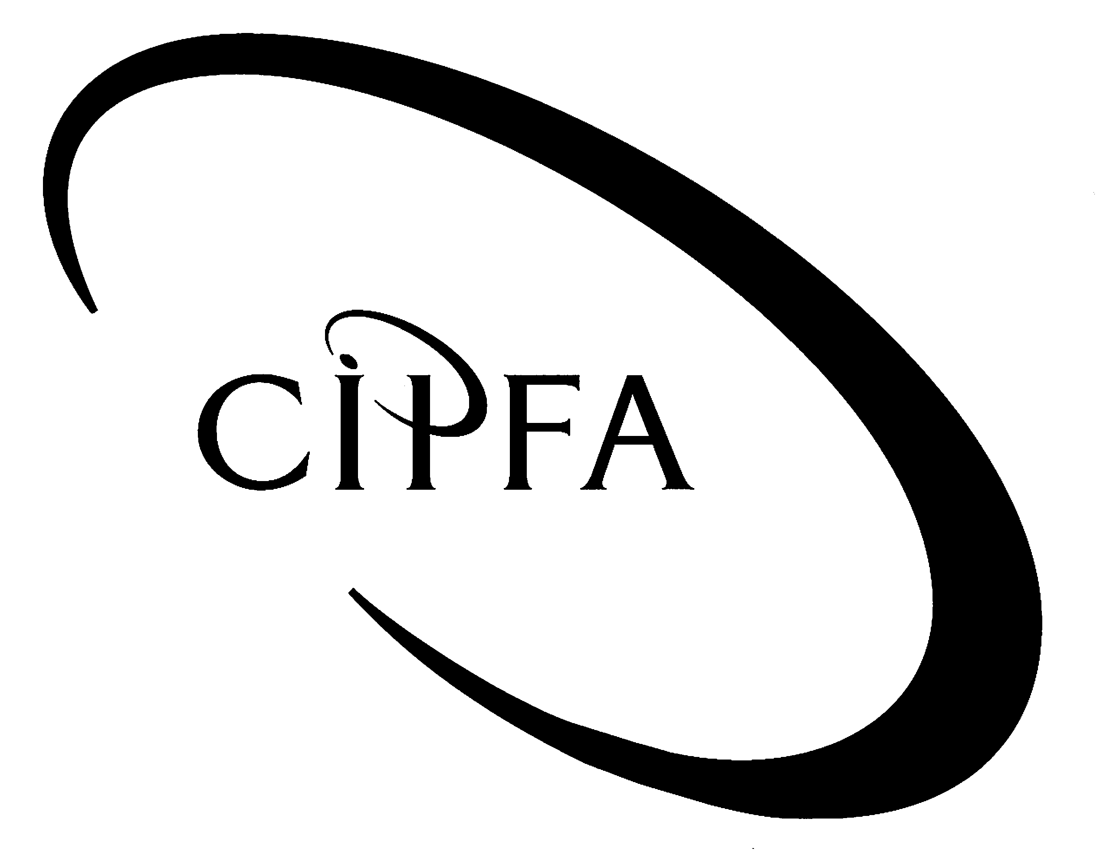

NOTE In all cases marks will be awarded to appropriate answers even if not directly covered by the marking scheme

Question 1

(a) Materiality

According to SAS 600/SAS 220:

A matter is material if its omission or misstatement would reasonably influence the decisions of a user of the financial statements/addresses of the auditor’s report.

Materiality has both qualitative and quantitative aspects.

Quantitative – material by amount

- The amount of monetary misstatement or omission which the auditors will tolerate before qualifying their opinion on the financial statements.

- Often set by reference to the I&E or balance sheet values eg a percentage of gross expenditure or total net assets.

Qualitative – material by context or nature

Context:

- The impact errors have in the case of special reporting requirements may mean even the smallest error could be material.

- Examples in the health sector could be errors which when corrected mean that statutory performance targets or limits are missed or breached.

Nature:

- Certain types of errors or omissions are considered more sensitive than others especially when the matter concerns public trust eg fraud or irregularity.

- In the health sector an example of this might be mismanagement of patients’ funds or personal property.

Up to 3 marks for definition, 1 mark per other point and
1 mark for presentation up to a maximum of 9

(Pages 17 & 18)

(b) Auditing standards

(i) Process

- UK – APB prepares discussion papers and exposure drafts on proposed topics.

- Consultation process with practitioners, CCAB bodies, representatives of groups especially affected (eg charities; financial services).

- Final draft of standard must be approved by at least three-quarters of the APB.

- International standards follow substantially same process but consultation by the International Auditing and Assurance Standards Board (IAASB) of the International Federation of Accountants (IFAC) is wider.
1 mark per point up to a maximum of 4

(ii) Application of standards:

- Incorporation of standards into firm’s/function’s audit manual and programmes.

- Use of standardised checklists at planning and completion stages of audit to ensure all requirements have been considered.

- Manager/team leader review of all work to ensure work is of quality required by standard and re-assess significant judgements.

- Quality assurance/peer review of completed audits to ensure all standards considered and met.

1 mark per point and 1 mark for presentation up to a maximum of 5
Total for part (b) - 9

(pages 21-24 & 38)

(c) Environmental controls:

Definition: controls designed to ensure:

- Computer resources are protected against loss or breakdown.

- If service lost or disrupted damage to organisation is minimised.

Up to 2 marks for definition

Types of control may include:

- Physical security.

- Fire precautions.

- Flood precautions.

- Power supply guarantees.

- Maintenance.

- Disaster recovery and business continuity.

½ mark per type with example up to a maximum of 3

(pages 244 & 245)

Particular risks which the PCT might face:

- Flooding – Riverside House suggest location near water. Safeguard by locating mainframe on 1st floor not basement.

- Physical security –access to clinic may increase risk of unauthorised access to computer areas. Safeguard by installing key card/key pad entry to sensitive areas.

- Power supply – if shared amenities does the mainframe may not have its own, separate power source. Safeguard by ensuring mainframe has its own secure power supply or consider emergency generator.

1 mark per risk and 1 mark for each description of a safeguard up to a maximum of 6
Total for part (c) - 10

(d) Risk management

(i) Risk assessment models

- Conceptual – overall judgemental assessment of risk factors. Advantage over other techniques is that it is quicker and cheaper.

- Analytical – combination of conceptual approach with a process of quantification of weighting of risk factors. Advantages are that it is more explicit in its assumptions than conceptual but remains largely intuitive.

- Statistical – using (often complex) statistical techniques to accurately quantify the likelihood and impact of risks materialising. Advantage is that it provides an absolute measure of risk to compare against costs of remedial action.

1 mark per model explained and 1 mark for advantage of each model up to a maximum of 6

(pages 279 & 280)

(ii) Risk mapping

- Analytical model of risk management in which grid is drawn up to assist in both assigning priority to risk and identifying management strategy.

- Following identification of objectives and risks, involves categorisation of risks according to:
- Likelihood of risk occurring; and
- Impact of risk on business if materialises

- Map categorise of risks into four (or nine) categories; software may assist in process and drawing of map.

- Low likelihood/low impact risk may be ignored.

- Low likelihood/high impact dealt with by contingency plans/insurance.

- High likelihood/low impact dealt with by internal controls to reduce likelihood to acceptable level.

- High likelihood/high impact – combination of controls and contingency. If cannot reduce likelihood or impact sufficiently may consider abandoning activity.

1 mark per point up to a maximum of 6
Total for part (d) - 12

(page 284)

(40)

Question 2

(a) Computer assisted audit techniques

What are CAATs?
Use of computer software to perform or assist the auditor in performing audit procedures to gather evidence.

Not the same as automation of routine processes eg planning documentation; standardised work programmes; timetabling of audit tasks.

Up to 2 marks for definition

Why use them?

- Increased extent of testing – faster and more accurate than manual processes.

- Perform manually impossible tasks – comparing millions of lines of computer code.

- Cost effectiveness – may be costly to start but can be used on many different audits.

- Eliminate repetitive tasks – frees up auditor time for areas where more judgement required.

- Increases auditor knowledge of system – in order to interrogate a computerised system properly the auditor needs to know how that system works.
1 mark for each point fully explained to a maximum of 5

Types of CAATs and how they can be used

- Data retrieval – to extract samples: calculate totals: data matching.

- Test data – to test the operation of controls in IT systems by inserting both valid and invalid data.

- Parallel simulation – to check the system by testing a copy of it, thus avoiding the risk of corrupting live data.

- Embedded test modules – using built in software to extract data as it is processed rather than after the transaction has taken place.

- Programme review – to test the source code of the IT system and examine how a particular piece of software is executed.

- Programme comparison – to compare the current version of software with the master copy for evidence of authorised (and unauthorised) amendments.

1 mark for each point fully explained to a maximum of 5
Maximum marks to be awarded for part (a) overall - 10

(pages 259-262)

(b) Statistical sampling

What is statistical sampling?

SAS 430 – use of techniques from which mathematically constructed conclusions about the population can be drawn.

May be distinguished from non-statistical or judgemental sampling although still a high level of judgement involved.

Up to 2 marks for definition

Why use it?

- Enables auditors to draw precise conclusions about eg level of error; error rate in population.

- Scientific and therefore defensible to clients.

- Reproducible, reliable results.

- Ensures consistency of standard of sampling across audits.

- Reduces amount of judgement necessary by auditor applying techniques so can be used by more junior staff.

1 mark for each point fully explained to a maximum of 5

Types of sampling techniques and how they can be used

Statistical techniques can be used with any type of sampling approach or selection method. 1

Approaches include:

- Attribute – testing of a sample to see if it possesses a particular characteristic eg testing of controls.

- Variables – to estimate the amount of error in a given population.

- Monetary Unit Sampling – particularly useful for tests of overstatement.

- Reciprocal populations – to test for understatement or completeness by sampling from the source population.

Selection techniques include:

- Random – use of random number tables to select items for testing.

- Interval – selecting every nth item in a population.

- Stratified – for testing non-homogeneous populations eg very few high value and lots of small value transactions.

- Cluster – for use in multi-location audits.

1 mark for each approach or technique with an example of how it might be used
to a maximum of 4
Maximum marks to be awarded for part (a) overall - 10

(pages 142-148)

(20)

Question 3

(a) Definition of Value for Money

Achieving the desired level and quality of service at the most economical cost. 1

Analysed into the three Es:

- Economy – acquiring resources of appropriate quality and quantity at the lowest price.

- Efficiency – maximising outputs from a given input OR minimising inputs for a given output.

- Effectiveness – outputs achieve the desired outcomes.

1 mark per ‘E’ together with explanation and 1 mark for an appropriate example
up to a maximum of 6
Total for part (a) – 7

(page 191)

(b) Auditors’ responsibilities for audit of Value for Money

Internal auditors

- Role is to assist management in their primary role of ensuring VFM.

- Will review systems and controls to identify risks to VFM and assess whether management’s controls are adequate.

- Report and recommend to management on ways in which value for money may be improved.

External auditors

- Usually have a statutory role to report externally on how well management have achieved VFM.

- eg NAO/ C&AG report to Parliament on VFM in central government and agencies.

- Audit Commission report on local authorities via Best Value and CPA.

- Responsibility for NHS VFM passed to Commission for Health Audit and Inspection from 1 April 2004.

(Credit to be given for mention of arrangements for other sectors and arrangements in Scotland and Northern Ireland subject to overall maximum)

1 mark point up to a maximum of 7

(c) Risks associated with audit of performance measures and indicators

- Overlap with other auditors/inspection agencies

- Appropriateness of auditor involvement in eg policy areas

- Lack of appropriate auditor skills

- Possible risks to auditor independence

- More scope for potential conflicts with management and policy makers

- Pressure on clients to manipulate results to achieve certain level of performance

- Changes to definitions over time may cause inconsistencies

- Reliability of source data; systems used to produce PIs may be weak

- Difficulty of maintaining good working relationship if auditors are seen to be criticising management’s performance

- Qualitative nature of some measures requires more exercise of judgement

- May also make some PIs more difficult to substantiate

1 mark for each point made to a maximum of 6

(20)

Question 4

(a) Six types of evidence gathering technique:

- Inspection – eg of documents or physical assets.

- Observation – eg of staff carrying out a control procedure.

- Enquiry – eg formal or informal questions asked of management.

- Confirmation – eg third party confirmation of the valuation of land and buildings .

- Computation. – eg recalculation of the depreciation charge.

- Analytical Procedures – eg comparison of financial or non-financial data to predict the output from the system.

1 mark for each technique explained to a maximum of 6

(b) Factors to consider in choosing a techniques:

- Cost of using technique – the more reliable the technique the more costly it is likely to be.

- Skills required to employ the technique – these may not be available or only at great cost.

- Reliability of evidence produced – eg observation – does the same thing happen when the auditor is not looking?

- Relevance of evidence to audit objectives – eg relevance of analytical procedures to the Regularity objective.

1 mark for each factor explained to a maximum of 4

(pages 136 – 137)

(c) Techniques for gathering evidence:

(Examples given are illustrative only – credit will be given for other appropriate techniques)

(i) Enquiry – ask the responsible staff member to explain the process to you to test their understanding.

Inspection of documentary evidence of reconciliation’s having been carried out regularly.

(ii) Dummy Data – attempt to place an order for an item you know is out of stock to see if the report is produced.

Inspection of a number of reports produced in the last months to ensure that appropriate action is taken on them.

(iii) Observation of the office after hours to see if such items are left out.

Inspection of asset records/losses register to see how many of such items have been reported lost in the last year.

(iv) Analytical procedure of the average creditors’ payment period ratio. The closer the average is to 30 days the less likely that 95 per cent are being paid within that time.

Recomputation of the time taken to pay a sample of invoices and estimation of the likely proportion paid within the 30 day target.

(v) Confirmation of the intention to pay the outstanding balance by writing directly to the debtor.

Inspection of correspondence between management and the debtor for evidence of intention to pay.

Up to 2 marks for appropriate techniques in each situation to a maximum of 10

(20)

Question 5

(a) Client A:

Conditions
Since company is below statutory threshold no audit is required under the Companies Act, although articles of association or lenders (eg bank) may require one.

Since any audit would be non-statutory any member of the firm could carry it out and sign off the audit (including you).

Powers and rights
Would depend on terms of engagement letter but would expect to have:
- Access to all documents and records
- Explanations from directors and employees
- Notice of and minutes of board meetings
- Power to report to ALL shareholders

Role as auditors
Audit (but not prepare) the financial statements of the company.

The assistance in setting up the internal controls system could be done but it would be better if different staff were responsible for this than those carrying out the audit.

Other issues
If expansion goes ahead it is likely that turnover will exceed the £5.6 million threshold for compulsory statutory audit. This would require the audit report to be signed by a registered auditor.
1 mark per point to a maximum of 6

(b) Client B:

Conditions
This company requires a statutory audit under the Companies Act. The person signing the audit report would have to be an auditor registered under the Companies Act (not CIPFA qualified at this time).

Senior Partner could if ICAEW/ICAS/ICAI/ACCA qualified and holding current practicing certificate.

Powers and rights
Set out in the Companies Act and largely as Client A but would include the right to attend and answer questions at General Meetings of the shareholders.

Role as auditors
Statutory audit of financial statements and report to shareholders.

Opinion on compliance with the Combined code (Corporate Governance rules) under the LSX listing rules.

Other issues
Supply of IA services would be allowed but potential for conflict of interest and lack of objectivity. Most large firms have split off consultancy arms to avoid this.

Fees from one client must not exceed a certain amount. Even if audit fee does not breach this charges for IA services may exceed maximum allowed.

Discounts on supplies should not be accepted – normal trade terms only.

Need to consider the plc’s audit committee’s policy on EA supplying non-audit services following the Smith report.

1 mark per point to a maximum of 6

(c) Client C:

Conditions
Firm must be on the list of auditors approved by the Audit Commission to carry out local authority audits.

LA has no power to appoint their own auditors.

Powers and rights
Essentially same as Companies Act with right to attend annual LA meeting to discuss accounts and answer electors’ questions.

Other legal powers under the Audit Commission Act 1998

- Public interest reports.
- Apply for judicial review of potentially illegal actions.

Role as auditors
Audit of annual financial statements.

Opinion on statement on internal controls.

Certification of grant claims from central government.

Validation of Best Value performance plans and indicators.

Examination of standards of financial conduct of members and officers.

Other issues
Any contract would last for 5 years and then highly likely would be rotated to another LA.

Essential need for audit team to have local government knowledge and experience.
1 mark per point to a maximum of 7
1 mark for presentation

(20)

