Sample Paper – 2008
Class – X
Subject – Social Studies

Maximum marks: 80 Time taken: 3hrs

1.There are 30 questions in all.

2. Attempting all the questions is compulsory.

3. There are 10 I mark question and internal choice has been provided in some areas.

4.Accurate and neat marking in case of maps is essential.

1. Which is the leading producer of bauxite in India? (1)

2. Name any 2 countries comprising Indo-China. (1/2+1/2 = 1)

3.Who wrote the book “ Istri Dharam Vichar” ? (1)

4.Mention any 2 provisions of the secularist ideals put forward
by the constitutional assembly? (1)

5. Define:
(a) Patriarchy (b) Casteism (1)

6.How are minerals formed in sedimentary rocks? (1)

7. Why was the scholars revolt started and when? (1)

8. Why is per capita income calculated differently in different
countries? (1)

9. When and why was the international earth summit launched
in Rio de Janeiro , Brazil. (1)

10. Name the nodal ministry which coordinates biological disasters. (1)

GROUP – A
11. Give a short note about the role of religious communities in the anti-imperialist struggle in Vietnam.

12. What were the effects of the second world war on Europe? (6)

GROUP – B

11. Give all the causes of great depression in Europe.

12. Why was hand labour preferred than machines in India? (6)

GROUP-C

11. Explain how print culture assisted the growth of nationalism in India.

12. Briefly explain the methods adopted by the producers in India to expand their market in India. (6)

13. “ Political parties play a vital role in democracy.” Justify the statement.(3)

14.Give the advantages of bio-technology in agriculture. (3)

15.How did the first world war promote the Indian industries? (3)

16. Write the characteristic features of Ho Chi Minh trail. (3)

17. What are the challenges faced by sugar industry and mention some of the products of sugar. (3)

18. Explain how caste influences politics in a democracy? (3)

19. Mention some of advantages of roadways over railways (4)

20. What are were the challenges faced by the newly elected republic in Vietnam. (4)

21. Who was Alluri Sitaram Raju? Mention some of his main
achievements. (4)

22.Read the following extract from the text book sand answer the following questions:

The independence day pledge 26 Jan , 1930. We believe that it is inalienable right of the indian people as of other people , to have freedom and to enjoy the fruits of their toil and have the necessities of life , so that they may full opportunities of growth. We believe also that if any government deprives a people of these rights and oppresses them , the people have a further right to alter it or abolish it. The british government in India has not only deprived the indian people of their freedom but has based itself on the exploitation of their masses , and has ruined India economically , politically , culturally and spiritually. We believe that therefore that India must severe the British connection and attain Purna Swaraj or complete independence.

(1) In what two ways was the british rule in India oppressive?

(2) Explain the immediate effects of lahore session of the congress on the indian National movements. (4)

or

Briefly explain how the physical factors influence the distribution of railways in India.

23. Why is sustainable development essential? What is the reason behing low infant mortality rate in Kerala. (4)

24. Explain the role of Central government in protecting people
from disasters. (4)

25. What was the vernacular press act ? Why was it passed?

(b) What was the role of women in Civil disobedience movement. (4)

26. MNC’s play a major role in globabilisation process. How? (4)

27. What are the steps taken in India to decentralise power ? (4)

28. Why is mineral conservation essential ?

(b) How does terrace farming restrict soil erosion in hilly areas. (4)

29.Answer the following map: ( 4 x ½ = 2)

(1) An iron and steel plant in Jharkhand
(2) Sofware technology park – Jaipur.
(3) Leading oil field in India.
(4) Nagarjuna sagar dam.

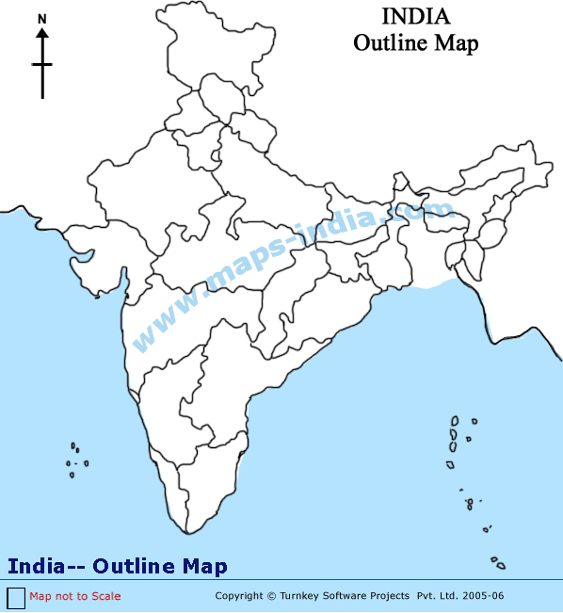

30. Answer the following questions: (4 x 1 = 4)

(5) Subash Chandra Bose airport.
(6) Place for no tax campaign.
(7) Oldest nuclear power station
(8) Amarkantak – Bauxite producing area.

ALL THE BEST

