Sample Paper – 2008
Class – X
Subject – Social Studies

Maximum marks: 80 Time taken: 3hrs

1. There are 30 questions in all.
2. Attempting all the questions is compulsory.
3. There are 10 marking question and internal choice has been provided in some areas.
4. Accurate and neat marking in case of maps is essential.

1 By whom was the printing press invented? 1
OR
Who wrote the first Bengali historical novel? 1
2 what is gully erosion? 1
3 Solar energy is becoming popular in rural and remote area in India. Why? 1
4 What factors determine the location of cement Industries in India?1
5 Give one difference between the movement started by martin luther king and the black power movement started later? 1
6. What is apartheid? 1
7. What is the first priority to democracy? 1
8. How is man closely related to environment? 1
9. Which organization has the motto of “Not Me But You”? 1
10. What do you mean by Germania? 1
11. “Anyone who had seen me reading would have compared me to man dying of thirst who was gulping down some fresh pure water….. Lighting my lamp with extra ordinary caution, I thew my self hungrily in to the reading.”
(a) What impression do you get about the auther from the extract?
(b) Accrording to mercier how does reading help the reader?
1+2= 3
12. why did the industrialists and urban dwellers force the abolition of corn laws? What were its effects? ½ + ½ = 3
13. Name any three inventions that helped in bringing in factory system of production. Describe any two effects of factory system?
½ + ½ = 3

Group B
12. Give any three reasons for rapid expansion of the city of Bombay after 1819? 3
13. How did the First World War led to the industrial growth in India? 3

Group C
12. Examine the role of technology in movement of goods from farms to markets? 3
13. State any three changes in world economy after the Second World War 3
14. What are the need and the formation of rescue and search team?
(b) Give two sings of forest bite and heat stroke? 3
15. What is your definition of good democracy? 3
16. Explain measures to remove disguised unemployment in the agricultural sector be protected? 3
17. Suggest some safe construction practices that can be follwed in:-
(1) Earth Quake prone areas
(2) Floods prone areas 3
18. Name the different natural and man made factor causing land slides. How should the sites in landslides prone areas be selected? 3
19. Name some of the famous women writers of 19th Century. What did the spread of print culture in 19th Century India means to women’s? 4
20. Analysis the factor responsible for the partition of India in 1947? 4
21. How have technology and economical developmental to more consumption of resource? 4
22. Explain the advantage of Decentralization of industry in India 4
23. What is decentralization? Why was there very little decentralization in effective term before 1992? 4
24. Discuss the pattern or structure of rural local self government and municipalities? 4
25. What is the definition of good Democracy? 4
26. Why tertiary sector is becoming important in economy? 4
27. How can labour in unorganized sector be protected? 4
28. Differentiate between private and public Sector? 4
29. Four main centers of over seas trades have been marked on the political map of India by number 1 to 4. Identify these centers and write their correct name on the lines marked? ½* 4 = 2
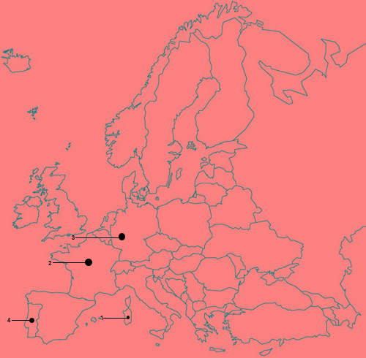

30. In the given political outline map of India eight features with serial 1 to ³ are marked identify these feature. ½ * 8 = 4
1. A soil type
2. Leading produce of pulses
3. Thermal power plant
4. An oil field
5. Center of cotton textile
6. East – West Corridor
7. A sea parts
8. A manganese mine.

SAI EDUCATIONAL SOCIETY
ASHISH MAHESHWARI
NILESH MISHRA
SECTOR - 3 FARIDABAD
CONTACT: - 9818120445

