SAMPLE PAPER – 2008
Class - X
SCIENCE (Theory)
Time: 2:30hrs mm60
================================================================================
General Instructions
1. The question paper comprises of two sections A and B. You are to attempt both
the sections.
2. All questions are compulsory.
3. There is no overall choice However, internal choice has been provided in all the
three questions of five marks category. Only one option in such questions is to be
attempted.
4. All questions of section A and all questions of section B are to be attempted
separately.
5. Questions 1 to 6 in section A and 17 to 19 in section B are short question. These
carry one mark each.
6. Questions 7 to 10 in section A and 20 to 24 in section B are short answer type
questions and carry two marks each.
7. Questions 11 to 14 in section A and 25 to 26 in section B are also short answer
type questions and carry three marks each.
8. Questions 15 and 16 in section A and question 27 in section B are long answer
type questions and carry five marks each.
================================================================================
SECTION A
1. Write Symbols of physical State and type of reaction
[a]₂₃
[b]₂₃₂₃ 1
2. Name the metal that can be burn in absence of air? 1
3 What will be the PH. of 0.02M H₂SO₄ 1

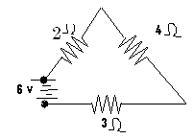
4. Find the total resistance in fig. 1

5 How is the amount of light entering the eye controlled? 1
6 If f₁ and f₂ are the focal length of two lenses, then the focal length of combination will be ----------1
7. . Draw structures of MgO. S_{8,} CO_{2,} and NaCl 2
8 .What is water of crystallisation. Give two examples. 1+1
9. Define Resistance? What factors affect the resistance? Relate these factors with resistance [1/2+1+1/2]
10. What is the direction of current conventionally? What is meant by electric circuit?
[ii]State ohm’s law, Draw its graph. 1+1
11. [i]An object of size 5cm is placed at a distance of 25cm from the pole of a concave mirror of radius of curvature 30cm. Calculate the distance and size of the image so formed. What will be the nature of image?
[ii] If magnification of convex lens is 5, what will be its focal length? 2+1
12. Why does the sky appear dark instead of blue to an astronaut? 3
13 7[i]. Draw structure of cyclohexane and benzene.
[ii] Sulphur is burn in air , gas evolved is dissolved in water , name the substance formed either it is an acid or base? 2+1
14. Complete the following chemical reactions:
. [i] ₃

[ii] ₃₂₅₂

[iii] HCHO+ HCN→ ------------------------------------------ 3.
15. [i] A person dissolved ammonium chloride in water, water becomes cool .Name the reaction, and tell whether the solution is acidic or basic
[ii]” Bhigona, Dhona ,Hogaya.”is said by some one about soap / detergents, is it true ,explain?
[iii] Are decomposition reactions are opposite of combination reaction? Write two examples [1+2+2]
Or
[i]Identify the hydrocarbon that turns bromine water colorless
CH₄, C₂H₆, C₂H₂, C₃H₄, C₂H₄
[ii]Name two metals which will displace hydrogen from dilute acids, but not with conc. acids
[iii]My mother fry some thing in vegetable oil in aluminum fry pane, for cleaning the fry pane she puts water and boil, she got surprised that oil becomes like ghee. Is it possible, explain the reason.
[iv] Women do not like to have an artificial jewelry, why?
[v] Bleaching powder (yellow) turns white when exposed to air? Write chemical reaction. [1x5=5]
16[i] Explain the working and principle of a DC motor with a neat diagram.
[ii] What is the frequency of AC in India? Explain the use of fuse 3+2
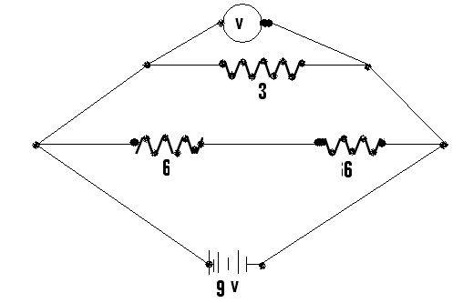
Or
[i]Find in this fig.
[a]Total resistance in the circuit.
[b] Current flow in 3 ohms resistance
[c]Total voltage across 3 ohms resistance

[ii] In a household electric circuit different appliances are connected in parallel to one another. Give two reasons. 3+2

SECTION B
17 Define fertilization. What is the function of testosterone? 1/2+1/2
18 . Write the full form of IUCD, OC, HIV, AIDS 1/4X4
19 Why hydrogen gas is better than CNG fuel? 1
20. What is the roll of villi in small intestine? And why carnivorous have shorter small intestine? 2
21 Write plants hormones and which of them is responsible for growth of tree 2
22. Write the importance of DNA copying in reproductions. 2
23. Write four qualities of an ideal source of energy 2
24 Write the aquatic organisms in order of who eats whom and form a chain of at least three steps. 2
25. How can you as an individual contribute or make a difference in the management of {i] water resources [ii] forest and wild life [iii] coal and petroleum. 3
26. Compare the functioning of alveoli in the lungs and nephroun in the kidney with respect to their structure and functioning. 3
27.[i] Distinguish between arteries and veins
[ii] Which chamber of heart pumps blood into lungs?
[iii] How do unicellular organisms dispose off their waste materials? 2+2+1
Or
[i]Draw a labeled diagram of Female reproductive system.
[ii] What happens when egg is not fertilized?
[iii]How does the embryo get nourishment inside the mother’s body? 2+2+1
ms_knl@yahoo.co.in
==============================================================================

