Sample Paper – 2008
Class – X
Subject - Science
Roll.No: ……………… Code: 086/4

- Please check that this question paper contains 5 printed pages
- Code number given on the right hand side of the question paper should be written on the title page of the answer book by the candidates.
- Please check that this question paper contains 27 questions.
- Please write down the serial number of the question before attempting it.

SCIENCE (THEORY)

Time : 2½ Hours Max. Marks : 60

General Instructions
- The question paper comprises of two sections A and B. You are to attempt both the sections.
- All questions are compulsory.
- There is no overall choice However, internal choice has been provided in all the three questions of five marks category. Only one option in such questions is to be attempted.
- All questions of section A and all questions of section B are are to be attempted separately.
- Questions 1 to 6 in section A and 19 to 21 in section B are short question. These carry one mark each.
- Questions 7 to 12 in section A and 22 to 24 in section B are short answer type questions and carry two marks each.
- Questions 13 to 16 in section A and 25 to 26 in section B are also short answer type questions and carry three marks each.
- Questions 17 and 18 in section A and question 27 in section B are long answer type questions and carry five marks each.

SECTION A

- Give an example of thermal decomposition reaction 1

- Danger signal light are red in colour. Give reason. 1

- The following data represents the temperature of the solution formed by the reaction of metals with dilute HCl solution.
Metal | Temperature of solution (⁰C)
A  B  C  D | 40.5  37.0  45.2  43.1
Identify the most reactive metal among these? 1

- Name the type of energy obtained from sea due to the temperature difference existing between different layers of water? 1

- Why cannot two magnetic field lines intersect at a point? 1

- Write any one defect of Mendeleev’s periodic table. 1

- Write the names of the following organic compounds. 2
(a)
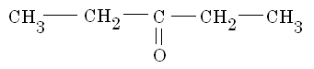
(b)
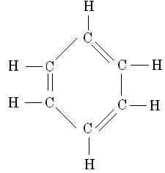

- a. Represent Ohm’s law graphically. 1
b. Mention any 2 factors on which the resistance of conductor depends? 1

- Draw the reflected ray in the following figures : 2

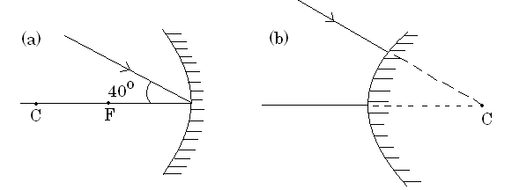

- Give any 2 uses of :
(a) baking soda (b) bleaching powder 2

- “Construction of big dams have certain problems associated with it.” Enumerate 2 reasons to justify this statement 2

- When a solution of sodium sulphate was added to Barium chloride solution in a test-tube, a white precipitate was found floating on the surface of the solution.
  - Identify the precipitate formed? 1
  - Write balanced chemical reaction for the above 1

- a. Compare the electrical conductivity of NaCl in its solid and molten states 1
b. Why is roasting done for sulphide ores? 1
c. Name the gas released when magnesium reacts with (a) dil.HNO₃
(b) conc. HNO₃ 1

- Study the following table
Group 16 | Group 17
--  B  -- | A  C  --

- Write the valencies of A and B 1
- Which is larger in size, B or C? 1/2
- Which among A and C is more reactive? 1/2
- Is C a metal or non–metal? 1/2
- Among A and B, which has a greater tendency to gain electrons? 1/2

- Which defect of vision is depicted in the below figure?
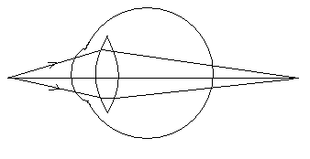
How does this defect arise? Draw a ray diagram to show how this defect can be corrected. 3

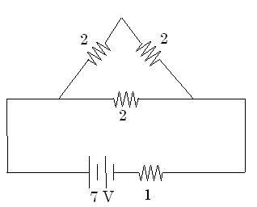
- Calculate the voltage and power across the 1Ω resistor in the following figure. 3

Ω Ω

Ω

Ω

- With the help of a neat labeled diagram, explain the principle of operation and working of an electric generator. 5

Or

A needle placed 45cm from a lens forms an image on a screen placed 90cm on the other side of the lens.
a. Identify the type of lens. 1/2
b. Determine the focal length and power of the lens. 1 1/2
c. What is the size of the image if the size of the needle is 5cm? 1
d. Draw a suitable ray diagram. 2

- a. What do ‘p’ and ‘H’ in pH stand for? 1
b. A solution ‘A’ has a pH value of 6 while another solution ‘B’ has a value 12. Which of these solutions have a higher concentration of OH– ions? 1
c. Sodium carbonate is treated with HCl solution and the gas evolved in passed through lime water. What changes do you observe? Support your answer with proper chemical equations. 3

Or

- Write the structural formula of ethanol. 1
- Which property of ethanol makes it suitable for use in medicines like tincture of iodine, cough syrups etc.? 1
- When ethanol was made to react with an acid in presence of conc.H₂SO₄, the following compound was obtained
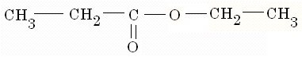
What is the above reaction known as? Name the acid which was used for this reaction. 1
- Give one physical and chemical property of the compound obtained. 2
SECTION B

- What advantage does vegetative propagation offer to horticulturists? [1]

- Name the digestive organ which is the site of complete digestion of proteins, fats and carbohydrates. [1]

- Consider the following food chain :
Grass grasshopper frog snake
Which of these organisms will be affected most by biological magnification? [1]

- Compare and contrast the nervous and hormonal mechanisms for control and coordination in animals? [2]

- Write the four main stakeholders of forests and wildlife? [2]

- Differentiate between homologous and analogous organs. [2]

- Why is the damage to ozone layer a cause of concern? What steps are beings taken to limit this damage? [3]

- a. Name the plant hormone which inhibits growth. [1]
b. What are the different methods of contraception? [2]

Or

a. Name two sexually transmitted bacterial infections [1]
b. How do auxins promote growth of tendril around a support? [2]

- The genotype of round and green seeds is RRyy and wrinkled and yellow seeds is rrYY. When these two are crossed
- What are the expected gametes from the parents?
- What kind of progeny do you expect in F₁?
- What are the recessive traits in F₁?
- Give the genotype of F₁ progeny?
- What is the expected ratio of wrinkled green in F₂? [1 x 5 = 5]

