SAMPLE PAPER – 2008
Class - X
SUBJECT - SCIENCE (Theory)
Time: 2:30hrs mm60
================================================================================
General Instructions
1. The question paper comprises of two sections A and B. You are to attempt both
the sections.
2. All questions are compulsory.
3. There is no overall choice However, internal choice has been provided in all the
three questions of five marks category. Only one option in such questions is to be
attempted.
4. All questions of section A and all questions of section B are to be attempted
separately.
5. Questions 1 to 6 in section A and 17 to 19 in section B are short question. These
carry one mark each.
6. Questions 7 to 10 in section A and 20 to 24 in section B are short answer type
questions and carry two marks each.
7. Questions 11 to 14 in section A and 25 to 26 in section B are also short answer
type questions and carry three marks each.
8. Questions 15 and 16 in section A and question 27 in section B are long answer
type questions and carry five marks each.
================================================================================

SECTION A
1 Identify the substances that are oxidized given in the following reaction
2Hg + O₂ → 2MgO 1
2. A shiny brown coloured elements ‘X’ on heating in air become black in colour. Name the element ‘X’ and the black coloured compound formed. 1
3 What is a universal indicator? What is its Use? 1
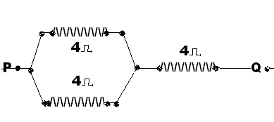
4. Find the total resistance between P and Q in fig. 1

5 How is the amount of light entering the eye controlled? 1
6 If f₁ and f₂ are the focal length of two lenses, then the focal length of combination will be ----------1
7. . Draw structures of MgO. S_{8,} CO_{2,} and NaCl 2
8 Give formula for Soda Ash, Plaster of Paris, Bleaching Powder., slaked lime 2
9. Define Resistance? What factors affect the resistance? Does resistivity changes with thickness of metal? [1/2+1+1/2]
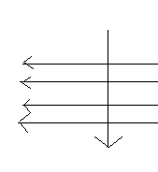
10. [a]An electron enters a magnetic field at right angles to it, as shown in fig. .The direction of the force acting on the electron will be (a) To Right (b) To Left (c) Out of the page (d) Inside the page 1

[b] State ohm’s law, Draw its graph. 1+1
11. [i]An object of size 5cm is placed at a distance of 25cm from the pole of a concave mirror of radius of curvature 30cm. Calculate the distance and size of the image so formed. What will be the nature of image?
[ii] If magnification of convex lens is 5, what will be its focal length? 2+1
12. Why does the sky appear dark instead of blue to an astronaut? 3
13 [i] Draw structures of cyclohexane and benzene.
[ii] Why silver solutions like silver bromide are stored in coloured bottles? 2+1
14. Complete the following chemical reactions:
. [1] CaSO₄.2H₂O ^{373K}→ --------------------- + -------------------
[II]CH₃COOH+ C₂H₅OH ^{H2SO4}→ ---------------------- + -----------
[IIICuSO₄+ H₂SO₄ ^{HEAT} → -------------+ ------------- +
15. [i] Carbonate and sulphide ores are usually converted into oxides during the process of extraction
[II] In the periodic table given below Lithium, Carbon, Oxygen and Neon are placed in their correct position. The positions of the nine other elements are represented by letters. These letters are not the symbol of any element.
3 | 4 | 5 | 6 | 7 | 8 | 9 | 10
Lithium |  |  | Carbon |  | Oxygen | L | Neon
X |  |  | E |  | G | Q
Y |  |  |  |  |  | R
Z |  |  |  |  |  | T
Answer the following questions (a) Give the letter of most reactive non- metal.
(b) Give the letter for the of smallest size metal
(c) Name the family of the elements represented by X, Y, Z
(d) Name one element in each case occurring in groups 2, 3 and 5
[iii] Are decomposition reactions are opposite of combination reaction? Write two examples [1+2+2]
Or
[i] Write Functional Groups of, Aldehyde, Carboxylic group.
[ii]Name two metals which will displace hydrogen from dilute acids, but not with conc. acids
[iii] Explain why a chlorine atom of atomic no. 17 is smaller than Sodium atom of atomic no. 11?
[iv] Why does silver chloride is stored in dark coloured bottles.

[v] Bleaching powder (yellow) turns white when exposed to air? Write chemical reaction. [1x5=5]
16 [i] Two lamps, one rated 100 W at 220 V, and the other 60W at 220 V, are connected in parallel to electric mains supply. What current is drawn from the line if the supply voltage is 220V?
[II] 100 J of heat are produced each second in a 4Ω resistance, Find the potential difference across the resistor?
[iii] What is the frequency of AC in India? Explain the use of fuse [2+1+1+2]
Or
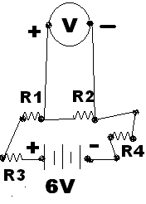
[i] Find in this fig IF R1=R2=R3=R4=7.5 ohms
[a]Total resistance in the circuit.
[b] Current flow in R4 ohms resistance
[c] Voltage across R2 ohms resistance

[ii] Why is much less heat generated in long electric cables than in filaments of electric bulbs?

[3+2]

SECTION B

17 Define fertilization. What is the function of estrogen? 1/2+1/2
18 Write the full form of IUCD 1
19 Why hydrogen gas is better than CNG fuel? 1
20. What is the roll of villi in small intestine? And why carnivorous have shorter small intestine?
2
21 Describe the post fertilization changes in the flower. 2
22. Write the importance of DNA copying in reproductions. 2
23. Write four qualities of an ideal source of energy 2
24 [i] Write the terrestrial organisms in order of who eats whom and form a chain of at least four steps. [ii]Write two differences between food chain and food web. 2
25. How can you as an individual contribute or make a difference in the management of
{i] Water resources [ii] forest and wild life 3
26. Draw the labeled diagram of human respiratory system and explain it briefly 3
27. [i] Distinguish between arteries and veins
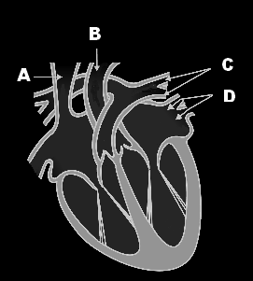
[ii] Write the parts A, B, C and D as shown in the diagram.

[iii] How do unicellular organisms dispose off their waste materials? 2+2+1
Or
[i]. Draw a labeled diagram of the longitudinal section of a flower.
[ii] What happens when egg is not fertilized?
[iii] Describe double fertilization in a flower 2+1+2

