SAMPLE PAPER - 2008
Class - X
SUBJECT – SCIENCE

Time: 2 ½ Hrs Maximum Marks: 60
General Instructions:

I) The question paper comprises of two sections A and B. You are to attempt both the sections.
ii) The candidates are advised to attempt all the questions of Section A separately and Section B separately.
iii) All questions are compulsory.
iv) There is no overall choice. However, internal choice has been provided in two questions of five marks category in Section A and one question of 2 marks category and one question of 3 marks category in Section B. You are to attempt only one option in such questions.
v) Marks allocated to each question are indicated against it.
vi) Questions 1 to 6 in Section A and 17 to19 in Section B are very short answer questions. These are to be answered in one word or one sentence only.
vii) Questions 7 to 10 in Section A and 20 to24 in Section B are short answer questions. These are to be answered in about 30 - 40 words each.
viii) Questions 11 to 14 in Section A and 25 to 26 in Section B are also short answer questions. These are to be answered in about 40 - 50 words each.
ix) Questions 15, 16 in Section A and 27 in Section B are long answer questions. These are to be answered in about 70 words each.

Section- A

1. What happen when Crystal of washing soda are exposed to air?
2. What do you meant by pole of spherical mirror?
3. What is to be done to make pure gold useful for making jewellary?
4. What is white light?
5. Why does use of ordinary soap cause irritation to skin?
6. How does the resistance depends on its radius?
7. What information is available from the following chemical equation:-
CaCo₃ + 2HCl Cacl₂ + H₂O + Co₂
8. What are the two methods of producing magnetic field? Which of these is better and why?
9. What is a universal indicator? What is its Use?
10. What factor would you consider while choosing an energy sources for a particular situation?
11. A metal X in the from of turning related with hot Concentrated dibasic acid and H₂Y and produce deep blue solution of salt of XY. When a wire metal Z is put in the solution of salt XY the deep blue colour was slowly discharged and colourless ZY salt was formed and X were generated. Explain the observation.

12. In the circuit diagram supposed the resister R₁, R₂ & R₃ have the value 5Ω, 10 Ω & 30 Ω respectively, which have been connected a battery 12V calculate : -
(a) The current through each resister
(b) The total current in the circuit.
(c) The total circuit resistance
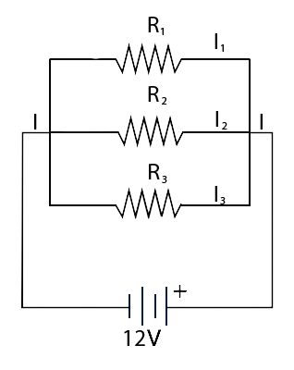

13. Write how the formation of Petroleum & natural gas took place in nature.
14. How will you explain – the phenomena of electromagnetic induction in one – coil when current passing through a neighboring coil increase or decrease?
15. Write in short about the Mundelein’s periodic table
OR
Explain electrolyte sefining of metal with the help of a suitable labeled diagram.

16 Three resistance R₁, R₂&R₃ are connected in series parallel. Find expression for
Equivalent resistance in each case.
OR
Describe an experiment in detail to study refraction of light through a prism.
Draw a neat diagram too. What do you mean by “angle of deviation”?

SECTION-B

17. What is meant by circulatory system?
18. Why brushing the teeth after eating is a good habit?
19 What are meaning?
20. Name the various theories of evolution proposed so for.
21. Name two types of drugs used in chemical method of population control?
22. How dental caries is caused?
23. What is the composition of nervous system in higher vertebrates?
24. What is the difference between vasectorny and tubectomy?
25. Explain the sex determination mechanism in human beings?
26. Draw and label diagram of brain with some briefly also?
27. What are the various evidence in favour of evolution?
OR
Describe the male reproduction system with label diagram?

SAI EDUCATIONAL SOCIETY
ASHISH MAHESHWARI
SECTOR – 3, FARIDABAD
CONTACT No: - 9818120445

