Sample Paper – 2008
Class – X
Subject – Mathematics

SECTION – A
2x10=20
- If prove that
- If A and B are acute angles and sin A = cos B, Prove that A + B = 90⁰.
- If Show that
- Find the value of c such that the equation 4x² - 2(c + 1) x + (c + 4) = 0 has real and equal roots.
- Prove
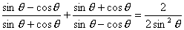
- Solve for x: 4x² – 4a²x + (a⁴ – b⁴) = 0
- The sum of first 15 terms of an A.P. is 105 and the sum of next 15 terms is 780. Find the first 3 terms of the A.P.
- Evaluate
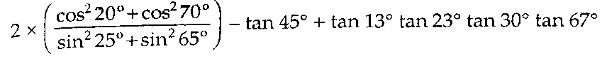
- Find the 20th term from the last term of the A.P. 3, 8,13,……………, 253.
- Find the sum of all natural numbers between 100 and 1000 (excluding both) which are divisible by 2 as well as 5.

SECTION-B
3X10=30
- If the list price of a book is reduced by Rs 5, a person can buy 5 more books for Rs 300.Find the original list price of the book.
- Find four numbers in A.P., whose sum is 20 and sum of their squares is 120.
- In a cricket match McGrath took one wicket less than twice the number of wickets taken by Bret Lee. If the product of the number of wickets taken by these two is 15, find the number of wickets taken by each.
- The angry Arjun carried some arrows for fighting with Bheeshm. With half the arrow she cut down the arrows thrown by Bheeshm on him and with six other arrows he killed the charioteer of Bheeshm. With one arrow each he knocked down respectively therath, flag and bow of Bheeshm. Finally with one more than four times the square root ofarrows he laid Bheeshm unconscious on an arrow-bed. Find the total number of arrows Arjun had.
- In a school, students thought of planting trees in and around the school to reduce air pollution. It was decided that the number of trees, that each section of each class will plant, will be the same as the class in which they are studying i.e., a section of class I will plant 1 tree, a section of class II will plant 2 trees, and so on till class XII. If there are 3 sections of each class, how many trees will be planted by the students of the school?

- In a flight of 2800 km, an aircraft was slowed down due to bad weather. Its average speed was reduced by 100 km/h and time increased by 30 minutes. Find the original duration of the flight.

- Sum of first ‘n’ terms of an AP is given by n² + 8n. Find the nth term of the AP. Also find its 100th term.
- If 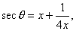prove that 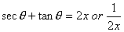
- On a pillar of 9 cubits high is perched a peacock. From a distance of 27 cubits a snake is coming to its hole at the bottom of the pillar. Seeing the snake, the peacock pounces upon it. If their speeds are equal, at what distance from the hole is the snake caught?
- Solve for “x” 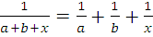

Er. VIKRANT AGGARWAL
(Lecturer, Ludhiana College of engineering & technology,
Lecturer – mathematics. Institute of chartered accountant of India.)
ANANYA INSTITUTE
2502, HIG FLATS, PHASE-II, DUGRI, URBAN ESTATE, LUDHIANA M-9915089502

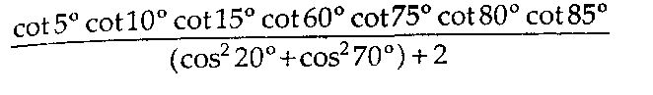

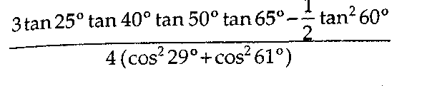
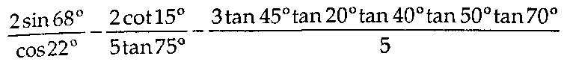

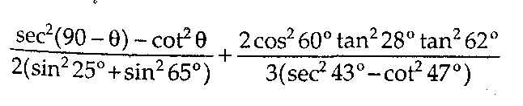
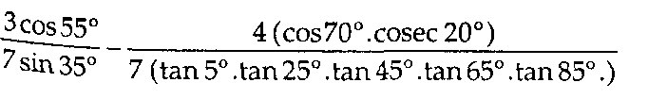

- Find the 11th term from the end of the A.P. 10, 7, 4, , - 62.
- Find the 20th term from the last term of the A.P. 3, 8,13, , 253.
- The angles of a triangle are in A.P. The greatest angle is twice the least. Find all the
angles.
- In a flower bed there are 23 rose plants in the first row, 21 in the second, 19 in the third
and so on. There are 5 rose plants in the last row. How many rows are there in the
flower bed?
- A sum of Rs 700 is to be used to give seven cash prizes to students of a school for their
overall academic performance. If each prize is Rs 20 less than its preceding prize, find
the value of each of the prizes.
- A manufacturer of T.V. sets produced 600 sets in the third year and 700 sets in the
seventh year. Assuming that the production increases uniformuly by a fixed number
every year, find
(i) the production in the first year (ii) the production in the 10th year (in) the total production in first 7 years.
- A contract on construction job specifies a penalty for delay of completion beyond a
certain date as follows : Rs 2000 for the first day, Rs 2500 for the second day, Rs 3000 for
the third day and so on, the penalty for each succeeding day being Rs 500 more than for
the preceding day. How much money the contractor has to pay as penalty if he has
delayed the work by 30 days ?
- In a school, students thought of planting trees in and around the school to reduce air
pollution. It was decided that the number of trees, that each section of each class will
plant, will be the same as the class in which they are studying i.e., a section of class I will
plant 1 tree, a section of class II will plant 2 trees, and so on till class XII. If there are
3 sections of each class, how many trees will be planted by the students of the school?

15. Some students planned a picnic. The budget for food was Rs 480. But eight of them
failed to go and thus the cost of food for each member increased by Rs 10. How many
students attended the picnic?
16. By a reduction of Rs 2 per kg in the price of sugar, Mohan can buy 2 kg sugar more for
Rs 224. Find the original price of sugar per kilogram.
- Distances from city P to city Q by two different routes are 81 km and 85 km. A car
taking the longer route travels on the average 2 km/h faster than one taking the shorter
route and completes the journey in 15 minutes less. Find the speeds of the two cars.
- In a cricket match Kumble took one wicket less than twice the number of wickets taken
by Agarkar. If the product of the number of wickets taken by these two is 15, find the
number of wickets taken by each.
- Find the value(s) of p for which the quadratic equation 2x² + px + 8 = 0 has real roots.
- The sum of S of n successive odd numbers starting from 3 is given by the relation
S = n(n + 2) Find n if the sum is 168.
- The height h metres of a stone, t seconds after being thrown vertically upwards is given
by h = 40£ - 5t². At what time is the stone at a height of 60 m?
- On a pillar of 9 cubits high is perched a peacock. From a distance of 27 cubits a snake is
coming to its hole at the bottom of the pillar. Seeing the snake, the peacock pounces
upon it. If their speeds are equal, at what distance from the hole is the snake caught?
- A swimming pool is filled with three pipes with uniform flow. The first two pipes
operating simultaneously, fill the pool in the same time during which the pool is filled
by the third pipe alone. The second pipe fills the pool five hours faster than the first
pipe and four hours slower than the third pipe. Find the time required by each pipe to
fill the pool separately.
- The numerator of a fraction is 1 less than its denominator. If 3 is added to each of the
3 numerator and the denominator, the fraction is increased by —. Find the fraction.
^{J} 28
25. The numerator of a fraction is 3 less than its denominator. If 1 is added to the
denominator, the fraction is decreased by —. Find the fraction.
^{J} 15
26. Out of a number of some Saras birds, one-fourth the numbers are moving about in lotus
plants, — th alongwith — th as well as 7 times the square root of the number move on a
hill and 56 birds remain in Vakula trees. Find the total number of birds.

38. A two digit number is seven times the sum of its digits and is also equal to 12 less than
three times the product of its digits. Find the number. (C.B.S.E. 2004 C)
39. The sum of the squares of two natural numbers is 34. If the first number is one less than
twice the second number, find the numbers. (C.B.S.E. 2005)
40. The sum of two numbers a and b is 15 and the sum of their reciprocals — and — is —.
a b 10
Find the numbers a and b. (C.B.S.E. 2005, 2006)
41. A two digit number is such that the product of its digits is 35. When 18 is added to the
number, the digits inter-change their places. Find the number. (C.B.S.E. 2006)
42. 7 years ago age of Varun was five times the square of the age of Swati. After 3 years, age
2
of Swati will be — of the age of Varun. Find their present ages. (C.B.S.E. 2006 C)
43. The difference of two numbers is 5 and the difference of their reciprocals is —. Find the
number. (C.B.S.E. 2007)
44. By increasing the list price of a book by Rs 10, a person can buy 10 less books for
Rs 1200. Find the original list price of the book. (C.B.S.E. 2007)
45. The numerator of a fraction is 1 less than its denominator. If three is added to each of
the numerator and denominator, the fraction is increased by —. Find the fraction.
^{y} 28
- The angry Arjun carried some arrows for fighting with Bheeshm. With half the arrows
he cut down the arrows thrown by Bheeshm on him and with six other arrows he killed
the charioteer of Bheeshm. With one arrow each he knocked down respectively the
rath, flag and bow of Bheeshm. Finally with one more than four times the square root of
arrows he laid Bheeshm unconscious on an arrow-bed. Find the total number of arrows
Arjun had. (C.B.S.E. 1996 C)
- A piece of cloth costs Rs 200. If the piece were 5 m longer, and each metre of cloth costed
Rs 2 less, the cost of the piece would have remained unchanged. How long is the piece
and what is its original rate per metre? (C.B.S.E. 1997)
- Rs 6500 were divided equally among a certain number of persons. Had there been 15
more persons, each would have got Rs 30 less. Find the original number of persons.
(C.B.S.E. 1997)
- An express train makes a run of 240 km at a certain speed. Another train whose speed is
12 km/h less takes an hour longer to cover the same distance. Find the speed of the
express train in km/hour. (C.B.S.E. 1997C)
- In a flight of 2800 km, an aircraft was slowed down due to bad weather. Its average
speed was reduced by 100 km/h and time increased by 30 minutes. Find the original
duration of the flight. (C.B.S.E. 1998)
- Two pipes running together can fill a cistern in 3 — minutes. If one pipe takes 3 minutes
more than the other to fill the cistern, find the time taken by each pipe to fill the cistern.
(C.B.S.E. 1998)
- A plane left 30 minutes later than the scheduled time and in order to reach the
destination 1500 km away in time, it has to increase the speed by 250 km/h from the
usual speed. Find its usual speed. (C.B.S.E. 1999)
- Rs 9000 were divided equally among a certain number of persons. Had there been 20
more persons, each would have got Rs 160 less. Find the original number of persons.
(C.B.S.E. 1999)
- If the list price of a book is reduced by Rs 5, a person can buy 5 more books for Rs 300.
Find the original list price of the book. (C.B.S.E. 2002)
- Two numbers differ by 2 and their product is 360. Find the numbers. (C.B.S.E. 2002 C)
- 300 apples are distributed equally among a certain number of students. Had there been
10 more students, each would have received one apple less. Find the number of
students. (CB.S.E. 2004)
- An aeroplane takes an hour less for a journey of 1200 km if its speed is increased by
100 km/h from its usual speed. Find its usual speed. (C.B.S.E. 2004)
- A two digit number is four times the sum of its digits and is also equal to twice the
nrndtirt of its dieits. Find the number. . (C.B.S.E. 2004 C)

