Sample Paper – 2008
Class – X
Subject – Mathematics
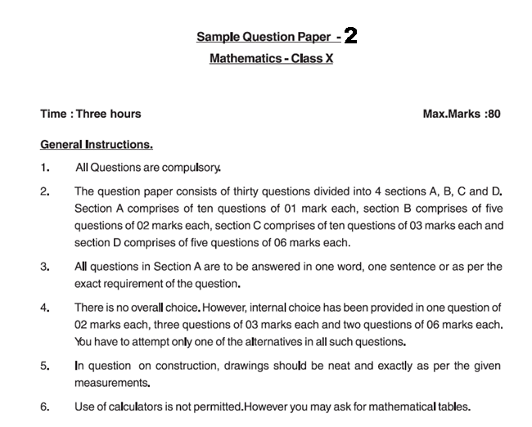
SECTION A
1. Check whether there is any value of n for which 4^{n} ends with the digit zero.
2. If HCF(16, x) = 8 and LCM (16, x) = 48, then the value of x is
3. The graph of y = p(x) are given in Fig below, for some polynomials p(x). Find the number of zeroes of p(x)
4. If 1 is one of the zeros of a polynomial x²—x+k, the value of k is
5. Find the value of k for which the system of linear equations
2x+3y=5 and 4x+ky=10
has infinitely many solution
6. Write the first three terms of the sequence a_{n}= 3n-2
7. If the ratio of area of two similar triangle is 1:49, find the ratio of corresponding sides.
8. D is a point on the side BC of a triangle ABC such that ∠ADC = ∠BAC. Show that CA² = CB.CD.
9. The length of a tangent from a point A at distance 10 cm from the centre of the circle is 8cm. Find the radius of the circle.
10. A student draws a cumulative frequency curve for the marks obtained by 40 students of a class, as shown in figure. Find the median marks obtained by the students of the class
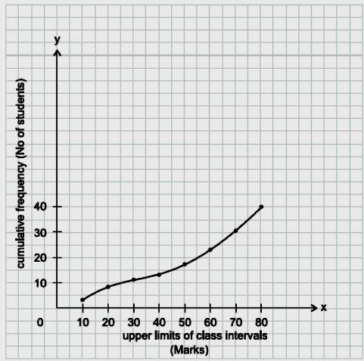

SECTION B
11. Show that any positive odd integer is of the form 6q + 1, or 6q + 3, or 6q + 5, where q is some integer.
12. Divide the polynomial p(x) by the polynomial g(x) and find the quotient and remainder
p(x) = x³ – 3x² + 5x – 3, g(x) = x² – 2
13. Check whether the following equation is quadratic: if so find the roots of the equation. (x – 2)² + 1 = 2x – 3
14. Find the 11th term from the last term (towards the first term) of the AP: 10, 7, 4, . . ., – 62.
15. In Δ OPQ, right-angled at P, OP = 7 cm and OQ – PQ = 1 cm. Determine the values of sin Q and cos Q.
SECTION C
16. There is a circular path around a sports field. Sonia takes 18 minutes to drive one round of the field, while Ravi takes 12 minutes for the same. Suppose they both start at the same point and at the same time, and go in the same direction. After how many minutes will they meet again at the starting point?
17. Find all the zeroes of 2x⁴ – 3x³ – 3x² + 6x – 2, if you know that two of its zeroes are √2 and − √2 .
18. Solve the following system of equation:
$\frac{\text{15}}{u}+\frac{2}{v}=\text{17}$ , $\frac{1}{u}+\frac{1}{v}=\frac{\text{36}}{5}$
19. Solve graphically the system of linear equation 2x+3y=12, 2y-1=x also find the vertices of triangle formed by these lines with y-axis
20. A spiral is made up of successive semicircles, with centres alternately at A and B, starting with centre at A, of radii 0.5 cm, 1.0 cm, 1.5 cm, 2.0 cm, . . . as shown in fig. What is the total length of such a spiral made up of thirteen consecutive semicircles? (Take π = )
21. Solve for x
$\frac{1}{p+q+x}=\frac{1}{p}+\frac{1}{q}+\frac{1}{x}$; $p+q≠0$
22. In Fig., DE || OQ and DF || OR. Show that EF || QR.
23. A ladder is placed against a wall such that its foot is at a distance of 2.5 m from the wall and its top reaches a window 6 m above the ground. Find the length of the ladder.
24. Draw a triangle ABC with side BC = 7 cm, ∠B = 45°, ∠A = 105°. Then, construct a triangle whose sides are times the corresponding sides of Δ ABC.
25. Prove the identity $(1+\text{cot}θ−\text{cos}\text{ec}θ)(1+\text{tan}θ+\text{sec}θ)=2$
Or
Find the trigonometric ratios for angles 30⁰, 45⁰ and 60⁰.
SECTION D
26. A motor boat whose speed is 18 km/h in still water takes 1 hour more to go 24 km upstream than to return downstream to the same spot. Find the speed of the stream.
Or
Two water taps together can fill a tank in 9 hours. The tap of larger diameter takes 10 hours less than the smaller one to fill the tank separately. Find the time in which each tap can separately fill the tank.
27. State and prove Pythagoras theorem. Using the theorem Prove that in an isosceles triangle ABC right angled at C, AB² = 2AC²

28. (i) Prove that the tangent at any point of a circle is perpendicular to the radius through the point of contact.
(ii) In Fig., XY and X′Y′ are two parallel tangents to a circle with centre O and another tangent AB with point of contact C intersecting XY at A and X′Y′ at B. Prove that AOB = 90°.
29. If the median of the given incomplete distribution is 35 and sum of all frequencies is 170, find the missing terms.
Variable | 0-10 | 10-20 | 20-30 | 30-40 | 40-50 | 50-60 | 60-70
Frequency | 10 | 20 | x | 40 | y | 25 | 15

30. The heights (in cm ) of 60 person of different age groups are shown in the following cumulative frequency table:
Height in cm | Less than 150 | Less than 155 | Less than 160 | Less than165 | Less than 170 | Less than 175
No. of persons | 8 | 18 | 27 | 42 | 52 | 60
Draw both the ogives and hence find the median.

