Sample Paper – 2008
Class – X
Subject – Maths

Lets do it better
Time allowed: 3 hours] [Maximum Marks: 80

General Instructions :
- All questions are compulsory.
- The question paper consists of 30 questions divided into four sections A, B, C and D. Section A contains 10 questions of 1 mark each, Section B is of 5 questions of 2 marks each, Section C contains 10 questions of 3 marks each and Section D is of 5 questions of 6 marks each.
- There is no overall choice. However, internal choice has been provided in two questions of two marks each, two questions of three marks each and one question of 6 marks each.
- In question on construction, the drawing should be neat and exactly as per the given measurements.
- Use of calculator is not permitted.

SECTION A
1. The system of linear equations 2x + 5y = k, k x + 15y =18 has infinitely many
solutions if the value of k is: (a) 3 (b) 6 (c) 9 (d) 18 (e) None of these

2. If the areas of two triangles ABC and DEF are 64 cm² and 121 cm². If EF
=13.2 cm. Length of BC is:
(a) 9.6 (b) 6.6 (c) 8.6 (d) 7.6 (e) None of these

3. A die is tossed once. The probability of getting a number divisible by 3 is:
(e) None of these
4. If the roots of the equation are equal then the value of k
is:
(a) (b) 24 (c) -2 (d) -3 (e) None of these

P.T.O.

5. Which of the following is not a quadratic equation:
(a) , (b) ,
(c) , (d)
(e) None of these
6. The number of terms between 12 to 99, divisible by 3 are:
(a) 30 (b) 29 (c) 31 (d) 40 (e) None of these
7. If the volume of a cube is 1728 cm³, the length of its edge is equal to:
(a)12 cm (b) 14 cm (c) 16 cm (d) 24 cm (e) None of these

8. The mean of 20 numbers is 15. If each number is multiplied by 7, then the new
mean is: (a) (b) 75 (c) 105 (d) 22 (e) None of these
9. If E be an event such that P(E) = , then P(not E) is equal to:
, (d) 2 (e) None of these
10. If and then x + y is equal to:
(a) 2 (b) 3 (c) 1 (d) 0.5 (e) None of these
SECTION B

11. Divide by , and verify the division algorithm.

12. A ladder is placed against a wall such that its foot is at a distance of 4.5 m
from the wall and its top reaches a window 6 m above the ground. Find the
length of the ladder.
13. Evaluate: $\frac{5{\text{sin}}^{2}{\text{30}}^{∘}+{\text{cos}}^{2}{\text{45}}^{∘}+4{\text{tan}}^{2}{\text{60}}^{∘}}{2\text{sin}{\text{30}}^{∘}\text{cos}{\text{60}}^{∘}+\text{tan}{\text{45}}^{∘}}$
Or
Without using trigonometric table Evaluate:
14. Solve the following equation:
Or
Find the sum and product of the roots of the following equation without
actually solving it : $\sqrt{3}$ax² = –10ax – 7$\sqrt{3}$
15. How many balls, each of radius 0.5 cm, can be made from a solid sphere of
metal of radius 10 cm by melting the sphere?
SECTION C

16. If m times the m^{th} term of an A.P. is equal to n times its n^{th} term, prove that
the (m +n)^{th} term of the A.P. is zero.
Or
Find the sum of the following A.P.
109 + 104 + 99 + ……………………+ (-6)
17. Determine graphically whether the given pair of equations is consistent or
not. 3x – 5y = 1; 2x – y = –3
If consistent, find the solution of the above equations.

18. Prove that:

Or,
Prove that

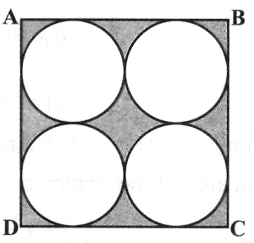
19. In the adjacent figure, ABCD is a

square of side 14 cm. Find the area of the shaded region.

20. Prove that any line parallel to parallel sides of a trapezium divides the non-
parallel sides proportionally (i.e. in the same ratio)

21. A bag contains 7 red balls, 8 white balls, 3 green balls and 4 blue balls. One
ball is drawn at random. Find the probability that the ball is:
- white
- red or green
- not green
- red or white
22. Solve for u and v:
4 u – v = 14 u v;
3 u + 2 v = 16 u v.

23. In triangle ABC, BC = 5.5 cm, AB = 4.6 cm, B =. Construct a triangle
similar to ABC, whose each side is of the corresponding sides of
the triangle ABC.

24. Calculate the median and mode of the following distribution?

C.I. | 20-30 | 30-40 | 40-50 | 50-60 | 60-70 | 70-80 | 80-90
f | 14 | 34 | 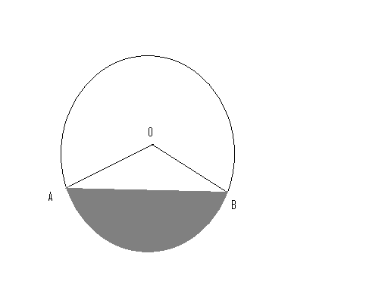  15 | 37 | 18 | 5 | 7

25. In the adjacent figure, radius of
The circle is 21 cm, if,
Find the area of shaded of region.

SECTION D

26. Prove the ratio of the areas of two similar triangles is equal to the ratio of the
square of their corresponding sides.
Using this theorem, prove that the ratio of the areas of equilateral triangles
formed on the side and diagonal of a square is 1:2.
Or
State and prove “Pythagoras Theorem”.
Prove that the sum of the square of the diagonals of a rhombus is equal to
the sum of the square of its sides.

27. From an aeroplane 1000 m high, a man observes the angles of depression of
two ships to be 60⁰ and 45⁰. If the ships are on the opposite sides of the
observer, find the distance between the ships.

28. The mean of the following frequency distribution is 26.5. If the total number of
observations is 100, find the frequencies f₁ and f₂.

Classes | 0-10 | 11-20 | 21-30 | 31-40 | 41-50
Frequency | f₁ | 14 | 21 | f₂ | 22

29. A bucket of height 16 cm and made up of metal sheet is in the form of
frustum of a right circular cone with radii of its lower and upper ends as 6 cm
and 15 cm respectively. Calculate:
- the height of the cone of which the bucket is a part.
- The volume of water which can be filled in the bucket.
- The slant height of the bucket.
- The area of the metal sheet required to make the bucket.

30. A and B jointly finish a piece of work in 15 days. When they work separately, A takes 16 days less than the number of days spent by B to finish the same
piece of work. Find the number of days taken by B to finish the work.

Chandan Singh Ghughtyal
Maths Faculty,
Chinmaya International Residential School
Coimbatore (T.N.)
09443061459
“Success or achievement is not the final goal. It is the 'spirit' in which you act that puts the seal of beauty upon your life.” Swami Chinmayananda
“Efficiency is the capacity to bring proficiency into expression”.

ALL THE BEST

