Comparison of key skills specifications 2000/2002 with 2004 standardsX015461July 2004Issue 1



Examiners’ Report/

Lead Examiner Feedback

January 2017

NQF BTEC Level 1/Level 2 Firsts in Children’s Play Learning and Development

Unit 1: Patterns of Development

(21486E)

**Edexcel and BTEC Qualifications**

Edexcel and BTEC qualifications come from Pearson, the world’s leading learning company. We provide a wide range of qualifications including academic, vocational, occupational and specific programmes for employers. For further information visit our qualifications websites at [www.edexcel.com](http://www.edexcel.com) or [www.btec.co.uk](http://www.btec.co.uk) for our BTEC qualifications.

Alternatively, you can get in touch with us using the details on our contact us page at [www.edexcel.com/contactus](http://www.edexcel.com/contactus).

If you have any subject specific questions about this specification that require the help of a subject specialist, you can speak directly to the subject team at Pearson.

Their contact details can be found on this link: [www.edexcel.com/teachingservices](http://www.edexcel.com/teachingservices).

You can also use our online Ask the Expert service at [www.edexcel.com/ask](http://www.edexcel.com/ask). You will need an Edexcel username and password to access this service.

**Pearson: helping people progress, everywhere**

Our aim is to help everyone progress in their lives through education. We believe in every kind of learning, for all kinds of people, wherever they are in the world. We’ve been involved in education for over 150 years, and by working across 70 countries, in 100 languages, we have built an international reputation for our commitment to high standards and raising achievement through innovation in education. Find out more about how we can help you and your learners at: [www.pearson.com/uk](http://www.pearson.com/uk)

January 2017

Publications Code XXXXXXXX

All the material in this publication is copyright  
© Pearson Education Ltd 2015

**General Comments**

Evidence from this series demonstrates that learners are now consolidating knowledge better. This is particularly relevant for those questions attracting a L1 or P mark. More learners appear to achieve a pass mark and there is a higher percentage of learners achieving higher grades attaining merit and distinction levels.

Further evidence demonstrates more elaborative learning taking place as learners are starting to be able to apply critical thinking skills and making appropriate links between theory and age related stage development.

There are instances where learners either misinterpret questions or do not read questions thoroughly. In some cases learners were referring to scenarios in previous questions. Questions asking learners to provide examples of cognition often responded with language and communication examples.

Interestingly learners seem more able to correctly identify age/stage appropriate milestones when presented in multiple choice format rather than in open questions.

The final question (19) (levels based) continues to prove a challenge for some learners as they attempt to provide responses that cover all areas of development or focus on the area of development that appears in the scenario (which asks them to focus on one other area)

Overall evidence however, suggests that more learners are achieving pass criteria with a higher number achieving merit/distinction. Those achieving higher grades were able to apply knowledge to practical situations in a focused manner making good links to other areas of development. Achievement is well within grade boundaries and it is pleasing to see that more learners are achieving pass/merit status with increasing number achieving distinction

Grade boundaries for this and all other papers can be found on the website on this link: htt://www.edexcel.com/iwantto/Pages/grade-boundaries.aspx

|  |  |  |  |  |  |
| --- | --- | --- | --- | --- | --- |
| **Grade** | **Unclassified** | **Level 1 Pass** | **Level 2** | | |
| **Boundary Mark** |  | **17** | **Pass** | **Merit** | **Distinction** |
| **24** | **31** | **39** |

Multiple Choice questions

There is evidence that many learners are achieving marks for these questions.

**Question 6**

|  |
| --- |
| **Targeted Specification Area: Learning Aim: B1** |

This question required learners to identify two aspects of fine motor development. Acceptable responses included movement of fingers, hand-eye coordination, pincer grasp drawing, writing and sewing.

Most learners were able to gain at least one mark for this question.

2 mark response

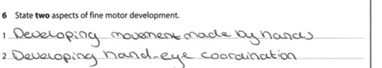

1 mark response

In this response the learner has gained one mark for scribbling with a pen or pencil.

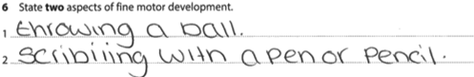

0 mark response

In this response the learner identified gross motor developmental skills therefore attracting no marks. This response epitomises the importance of learners reading the question carefully.

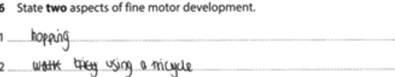

**Question 8**

|  |
| --- |
| **Targeted Specification Area: Learning Aim: B1** |

Question 8 required learners to identify expected gross motor milestones of a child aged 15 months by the time they reached 2 years.

A common response was ‘walk unaided/unsupported’. Credit was given if learner responses stated ‘walking’ even though it was not qualified as it was taken to infer ‘without support’.

Less than half of learners were able to identify a correct response for this question.

1 mark awarded

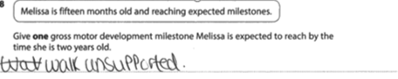

0 mark response

Some responses related to milestones achieved much later.

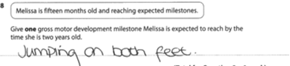

**Question 9a**

|  |
| --- |
| **Targeted Specification Area: Learning Aim: B1** |

Many responses focused on younger age ranges for this recall question. Most responses were quoted in years (not months) Few learners were able to achieve 1 mark for this response.

1 mark awarded

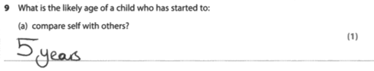

0 marks

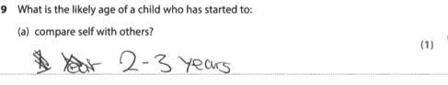

**Question 9b**

|  |
| --- |
| **Targeted Specification Area: Learning Aim: B1** |

For this question learners were required to identify the likely age of a child who could show hand preference. Again many responses focused on younger age ranges and few learners were able to cite the correct age. This question emphasises the importance of reading the question as it asked for when a child ‘has ***started to*:**’

1 mark awarded

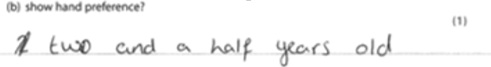

0 marks

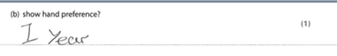

**Question 10**

|  |
| --- |
| **Targeted Specification Area: Learning Aim: A1** |

Question 10

This question asks the learner to provide two examples of how growth is ‘**determined’.** Fewer learners were able to correctly identify two ways growth is determined.

2 mark response

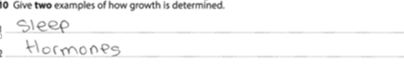

1 mark response

Some learners provided a correct response but some responses often provided a repetition in the second example.

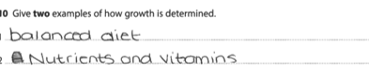

0 mark response

Some responses focused on **key aspects** of children’s growth or how growth is **monitored.**



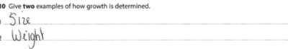

**Question 11a**

|  |
| --- |
| **Targeted Specification Area: Learning Aim: A2, B1** |

For this question learners were required to **give** two ways adults could support the communication and language development of a child aged four years old.

Many learners were able to gain 2 marks for this question and provided very elaborative examples. Learners were able to identify at least 1 good response.

2 marks awarded

This response shows how the learner has thought about the question and provided examples.

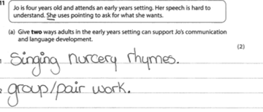

1 mark awarded

In this response the learner has provided a good response for the first example. In the second example, the specification does not state that Joe would be able to ‘read things’ Also the response is too similar to the first response

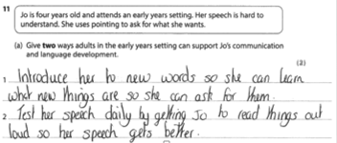

**Question 11b**

|  |
| --- |
| **Targeted Specification Area: Learning Aim: B1, C1** |

This question required learners to consider the way that Jo’s language delay may affect her emotional and social development. This question appears to be one learners struggle with most as they need to first identify the aspect of language that would be affected and make an appropriate link to an aspect of emotional/social development. Some learners repeated aspects of the question in their response e.g., ‘because of the language delay’ rather than focusing on ‘lack of vocabulary compared to peers’, ‘inability to construct sentences others could understand’ etc.,

4 mark response

Here the learner has provided two good examples.

Because others have difficulty in understanding what she is saying (1 language) she would struggle to make friends (1 social)

She may feel insecure (1 emotional) as people struggle to understand her (1 language)

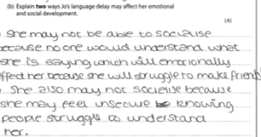

**Question 12**

|  |
| --- |
| **Targeted Specification Area: Learning Aim: B1, C1** |

This question required learners to describe one way Freya could support Carl’s (aged 9 months) physical development

Most learners were able to gain at least one mark for this question. Examples included encouraging to crawl and walk to develop fine/gross motor skills.

2 mark response

In this example the learner has identified that by placing toys around the room (adult support/providing resources) this will encourage Carl to crawl (age appropriate physical development)

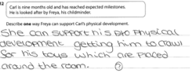

1 mark response

Here 1 mark has been awarded for ‘taking him to the park’ however no examples are given to show how this will support his physical development

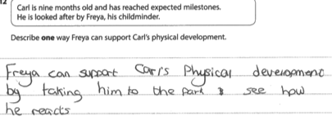

0 mark response

Some responses did not provide age appropriate examples

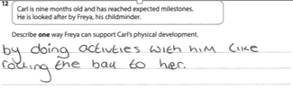

**Question 13a**

|  |
| --- |
| **Targeted Specification Area: Learning Aim: B1** |

This question asked for learners to identify milestones a child should reach between three and four years. Many responses gave examples of cognitive skills or language and communication skills of an older age range. Learners appeared to experience difficulty in differentiating between cognitive and language and communication skills. Less than 20% of learners were able to identify one correct response

1 mark response

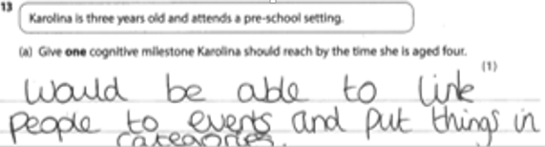

0 mark response

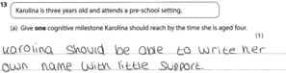

**Question 13b**

|  |
| --- |
| **Targeted Specification Area: Learning Aim: B1, C1** |

This question asked learners to **give** two ways that adults could support cognitive development of a three year old child. Some learners were able to achieve two marks for this question providing examples such as simple puzzles, problem solving and simple calculations.

2 mark example

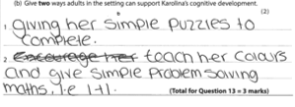

In some instances learners provided good responses however, failed to gain full marks as they repeated similar examples

1 mark example

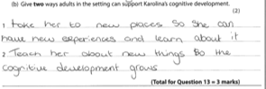

0 mark

Some responses failed to gain marks as the focus was on communication and language examples

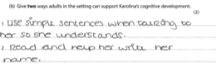

**Question 14**

|  |
| --- |
| **Targeted Specification Area: Learning Aim: C1** |

Question 14 asked learners to **give** two ways to support a child’s confidence. Many learners did well in this question gaining 2 marks. Many responses focused on providing activities that interested a child and encouraging friendships as well as maintaining proximity, bonding and supporting social interactions

2 mark

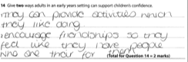

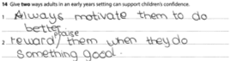

1 mark

Those gaining 1 mark, either only cited one example or provided a similar response

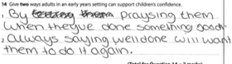

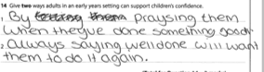

**Question 15**

|  |
| --- |
| **Targeted Specification Area: Learning Aim: C1** |

Question 15 asked learners to **identify** two ways to support a child’s hand-eye coordination. Some learners lost marks because they repeated aspects of the question (e.g., hand-eye coordination). Many learners however were able to identify two correct responses. Most common responses were throwing, catching, and kicking balls, sewing and bead threading.

1 mark response

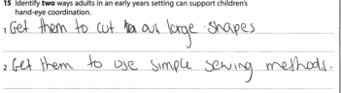

0 mark response

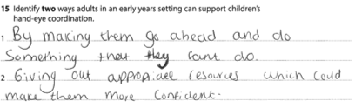

**Question 16**

|  |
| --- |
| **Targeted Specification Area: Learning Aim: B1, C1** |

Question 16 required learners to provide a **linked** response by **describing** two ways that adults could support the emotional and social development of a child aged three years.

About half of learners were able to achieve at least 2 marks for this question. The question required learners to provide one aspect of adult support (e.g., encourage bonding) and one linked response as to how it would support Sarang’s emotional and social development (e.g., to help him feel secure).

4 mark example

In this response, first example, the learner provides example of role play activities (adult support) that would help Sarang express his emotions (emotional and social) In the second example The adult support is ‘talking’ to Sarang which will ‘reassure’ Sarang (make him feel secure).

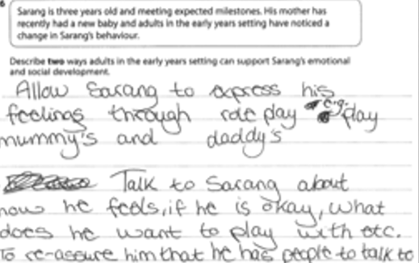

In this response the learner has provided some good examples. In the first example the adult support is to show Sarang pictures of emotions as this will help Sarang express his feelings. In the second example the adult supports Sarang’s interactions with others and the link to emotional and social is that he does not feel left out (so feels secure)

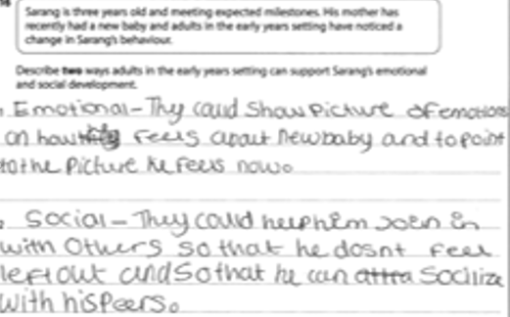

0 marks

Some responses failed to gain marks as the learner may have not understood the question fully. Here the learner has interpreted the question as if it asks for an explanation of the reasons for Sarang’s behaviour rather than how adults can support him to feel more secure in his environment.

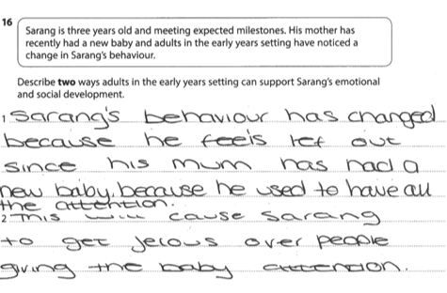

**Question 17**

|  |
| --- |
| **Targeted Specification Area: Learning Aim: A2, C1** |

Question 17 asked learners to **explain** two ways that supporting a child’s (aged 6 years) cognitive development would encourage their communication and language development.

Many learners struggle with this type of linked response question. Some learners were able to produce good examples although sometimes putting the communication link first.

4 marks

In this example the learner has stated ‘able to communicate by asking questions’ (Communication and language) it will develop their ‘understanding’ (cognitive) In the second response the learner has again provided the communication link first (talk about things) and then the cognitive link (remember)

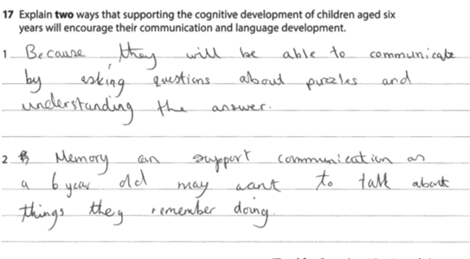

In this example the learner has given the cognitive example first (memory it could help them remember) and then the communication and language link (structure it into sentences)

In the second example the ‘imaginative’ aspect is linked to expanding their vocabulary ‘…new terms e.g., first class’.

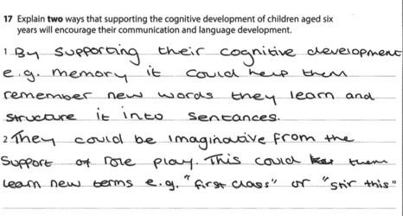

4 marks

In this response the learner has devised a useful and clear way to display their answer. They have started with the cognitive aspect (thoughts, imagination) and then have gone on to give examples of the link to communication and language.

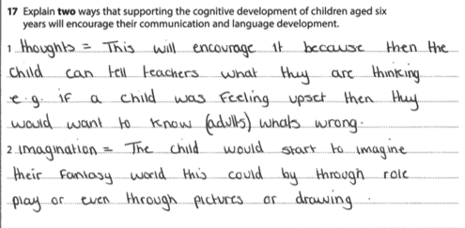

0 mark example

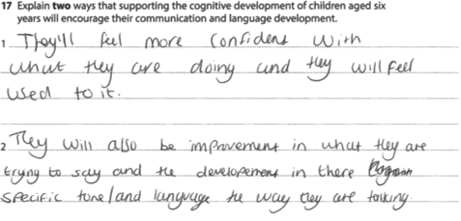

**Question 18**

|  |
| --- |
| **Targeted Specification Area: Learning Aim: A1, B1, C1** |

Question 18 was another question requiring a linked response. The question asks learners to **explain** how adults can support the gross motor development of a child aged five years.

Many learners were able to gain at least 2 marks for this question, though some seemed to struggle to provide appropriate linked responses

4 mark example

This response provides two good examples. In the first response the adult support is shown by providing a skipping rope which will strengthen her leg and arm muscles.

In the second response providing opportunities to do gymnastics will support balance and coordination

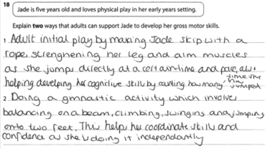

The following provides a good example. In the first response 1 mark for football and 1 mark for making bigger movements …strengthen her legs. In the second response 1 mark for climbing frame and 1 mark for increase strength in arms (as legs was accepted in first response)

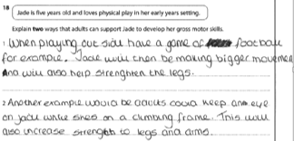

Here is another good example. 1 mark for sports such as football and 1 mark for using larger muscle movements. In the second response, 1 mark for obstacle course and 1 mark for encouraging locomotive movement.

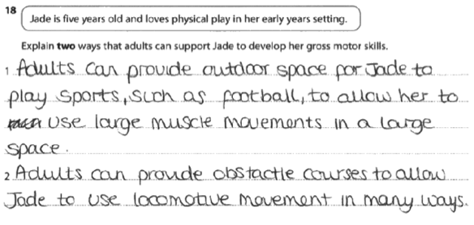

3 marks

In the first response of this example, the learner has said the adult can support Jade by providing opportunities to be outside (1) so this will develop her ‘big muscles’ (1) In the second example the adult can support development by providing bikes/scooters (1). However, no linked response that shows how this will support locomotion, balance and increase in movement of muscles is provided

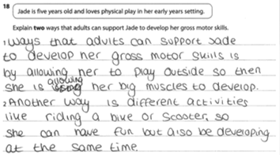

2 marks

Here the learner has provided some very good examples of the types of activities the adult can provide to support gross motor development. However no appropriate links have been provided showing how they support an aspect of gross motor development e.g., locomotion, balance, increase in large muscle strength

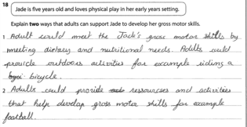

0 mark example

Here the learner has provided no example of adult support nor how it will support an aspect of gross motor development

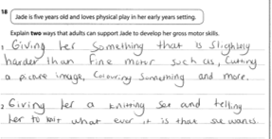

**Question 19**

|  |
| --- |
| **Targeted Specification Area: Learning Aim: ALL** |

In this final question learners were asked to draw on their knowledge of the whole unit in order to answer this question. The question asked how adults could use a role play activity (café) to support **one** other area of development for a four year old child.

There were some good responses to this question, and those gaining marks within the higher level mark band (3) were able to support their discussion with examples of how the role play activities could support **one** other area of development. Many responses used communication and language as a further area. This final question usually requires learners to focus on a specific age/ range so age appropriate examples should be provided. Those achieving lower marks either gave general examples that apply to any age, or non-age appropriate examples

Here is an example of a response that was awarded 7 marks. The learner has focused on language development. There are links to the role play activity with examples of how knowledge of words can be developed (menu etc). Although the learner has provided a few examples of physical development the main focus is on language and provides some good examples, though no age appropriate examples are provided.

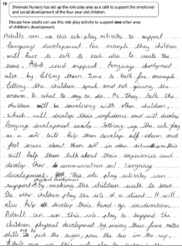

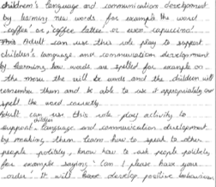

Those achieving marks in the middle level boundary (2) were able to demonstrate links to one other area of development and provide examples though examples provided may not have always related to the role play activity (café) and/or were not supported with age appropriate examples.

In this example the focus is on communication and language. Although there are many good examples provided e.g, developing vocabulary, more language, know how to communicate, ability to express their feelings and help others through language. There is no specific age appropriate examples nor any links to the role play (café)

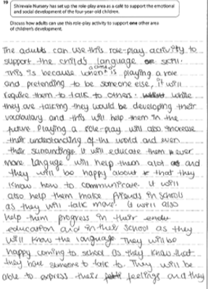

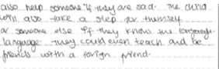

Some learners failed to gain marks as they only focused on emotional and social development which was in the question.

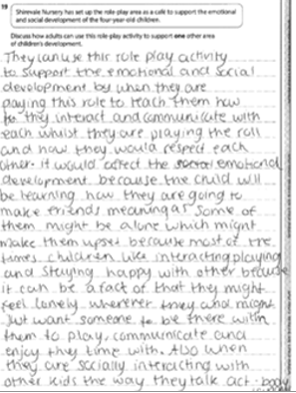

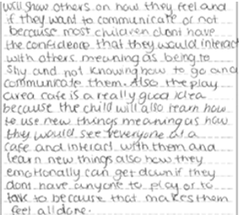

0 mark example

For more information on Edexcel qualifications, please visit 3_country_ofqual_without_curve_final

www.edexcel.com/quals

Pearson Education Limited. Registered company number 872828   
with its registered office at Edinburgh Gate, Harlow, Essex CM20 2JE