GCE TRAVEL AND TOURISM PORTFOLIO
MARKING GUIDE

INTRODUCTION

This Portfolio Marking Guide is designed to support assessors in preparing assessment tasks and making accurate decisions when marking evidence presented by learners for internally assessed units. This guide may also support teachers when preparing learners to engage with the assessment requirements.

The guide includes generic information on marking and information specific to each internally assessed unit of the GCE Travel and Tourism. For each unit, there is:

Guide to marking
This section sets out the tasks and mark band statements. The mark band statements are presented with the key differentiators that should be evident in learners highlighted.

Extracts of sample work
A task has been selected for each unit and an extract from one sample is presented. The extract has been selected to focus on one of the weaknesses found in evidence during moderation. The extract has annotation to highlight the strengths in the evidence and is supported by a commentary. The extracts are not selected to represent an exemplar way of presenting evidence. Assessors would benefit from focussing on the commentaries and noting where, through annotation, the key evidence could be located. This would be of most benefit if used in conjunction with Principal Moderator reports.

Sample assessment activities
These might include a sample assignment, pen portrait(s) or assessor documentation.

Feedback sheets
For use by assessors to capture summative assessment decisions and feedback. Each feedback sheet has been designed to enable assessors to highlight the key strengths and/or weaknesses in the evidence by having the key requirements highlighted.

GCE IN TRAVEL AND TOURISM

Internal Assessment
The assessment requirements for each unit are given in the specification under the section ‘Assessment Evidence’. Units are assessed through the completion of four tasks (except units 9 and 10) with each task focussed on one Assessment Objective. The Assessment Objectives, as stated in the specification are:

AO1 Demonstration of knowledge, understanding and skills
Candidates demonstrate knowledge and understanding of the specified content, and of related skills in vocationally related contexts.

AO2 Application of knowledge, understanding and skills
Candidates apply knowledge and understanding of the specified content, and of related skills in vocationally related contexts

AO3 Research and analysis
Candidates use appropriate research techniques to obtain information to analyse vocationally relevant issues and problems

AO4 Evaluations
Candidates evaluate information to make judgements, draw conclusions and make recommendations about vocationally related issues and problems

Tasks are specified for each unit at the end of the ‘what you need to learn’ section. These tasks, when completed, are assessed using the statements given in the ‘Assessment criteria’. There are three statements relating to each task: one for each of three mark bands. Assessors should judge which statement ‘best fits’ the quality of the work submitted. Attention should be given to the extent to which the candidate has addressed the task and, therefore, the Assessment Objective ie the skill(s) demonstrated.

The mid-point of the marks available for the mark band should be the starting point for the award of marks for each task (unless indicated otherwise). These are then adjusted according to the quality of the work within that mark band. The full detail of the mark band statement should be considered together with neighbouring mark band statement(s) ie if there are traits of a higher mark band, this should suggest a mark above the mid point, traits of a lower mark band should suggest a mark below the mid point.

On completion of all tasks for an internally assessed unit, the total number of marks awarded for a unit should be calculated. Internal standardisation should take place with an assessor objectively reviewing evidence from a sample of portfolios.

The skills required to be demonstrated are generally indicated through the use of ‘command verbs’. A glossary of these terms is shown here:

Describe | ‘paint a picture in words’. Set out what exists in narrative form.
Explain | Give reason(s) for a situation
Straightforward | Routine, easy
Complex | Complicated, different variables that may conflict
Analyse | Break into component parts and explain relationships
Range | Different types (usually minimum 3)
Evaluate | Make reasoned judgements against criteria
Assess | Make a reasoned judgement
Substantiate | Use evidence to support a reasoned conclusion

Unit 2 (6988)

The Travel and Tourism Customer

Task a)
A description of the needs of customers in one sector of the travel and tourism industry and an explanation of how organisations in that sector attempt to meet those needs.

Targeted Assessment Objective AO1 Demonstration of knowledge, understanding and skills

Mark band 1 | Mark band 2 | Mark band 3
A basic description of the needs of customers in one sector of the industry which lacks detail in terms of types of customer and the needs of those identified.  A basic explanation of how organisations in that sector attempt to meet those needs which is mainly descriptive and is limited in terms of specific examples. | A description of the needs of customers in one sector of the industry that has some detail in terms of types of customer and the needs of those identified. Some needs and types of customer are exemplified.  An explanation of how organisations in that sector attempt to meet those needs using some specific examples to support responses. | A comprehensive description of a wide range of needs of customers in one sector of the industry which is detailed and exemplified in terms of types of customer and the needs of those identified.  A thorough explanation of how organisations in that sector attempt to meet those needs using a range of examples to support responses.

The key differentiator in the first part of the task is the level of detail and exemplification provided in the descriptions of both the type of customer and the needs of the types of customer. The more detailed and exemplified the needs and the type of customer, the greater the potential to access the higher mark bands. The key differentiator for the second part of the task is the explanation. Descriptive evidence eg describing the provision of an organisation that different customer types might access is more in line with mark band 1. Candidates move across the mark band when understanding is shown through explanations. The use of examples is also a qualifier, providing it is used to support their responses, but not if presented in isolation.
Task b)
Evidence of involvement with customers in four real or simulated travel and tourism related situations demonstrating customer service skills by dealing with customers in different situations, including a complaint and completing documentation

Targeted Assessment Objective AO2 Application of knowledge, understanding and skills

Mark band 1 | Mark band 2 | Mark band 3
Customers have been dealt with in four real or simulated travel and tourism situations. Situations are mainly straightforward and routine. Customers main needs have been met in most situations. Appropriate communication skills have been demonstrated. Appropriate documentation has been completed but there may be some inaccuracies. Complaint is dealt with in part leaving issues unresolved. | Customers have been dealt with in four real or simulated travel and tourism situations. Situations are mainly complex. Some different types of customers in some different types of situations have been dealt with. In all situations, customers main needs have been effectively met. In some situations, supplementary needs have been met. Appropriate communication skills have been demonstrated and in some situations a customer focussed approach is evident. Appropriate documentation is completed accurately in all situations. Complaint is dealt with effectively but some issues may be unresolved. | Customers have been dealt with in four real or simulated travel and tourism situations. Situations are complex. A range of different types of customers in different types of travel and tourism situations have been dealt with by effectively identifying and meeting all of their needs. High levels of communication skills and a customer focussed approach to the situations are clearly demonstrated in all situations. Appropriate documentation is completed accurately for all situations. The complaint is dealt with fully showing sensitivity to the customer.

As this task relates to the candidates ability to interact effectively with customers there are a number of differentiators: their ability to meet needs (main and supplementary), deal with complaints, communicate effectively and to complete appropriate documentation accurately.

Task c)
Develop an appropriate methodology to research the standard of customer service within a travel and tourism organisation including documentation and the quality criteria to be used for evaluations

Targeted Assessment Objective AO3 Research and analysis

Mark band 1 | Mark band 2 | Mark band 3
A method is proposed for evaluating customer service. Some documentation is produced but this is limited in detail. Some quality criteria are used but there may be some irrelevancies. An explanation is given of why the methodology is appropriate for the selected organisation but this is mainly descriptive and has some omissions. | An appropriate method is proposed for evaluating customer service. Appropriate documentation for the selected method is produced to capture data. Appropriate quality criteria are used. An explanation is given of why the methodology is appropriate for the selected organisation, with some clear reasoning. | An appropriate method is proposed for evaluating customer service. Appropriate and detailed documentation for the selected method is produced that will aid the capture and analysis of data. Appropriate quality criteria are used. A comprehensive explanation of why the methodology is appropriate for the selected organisation with reasoning clearly presented.

The key differentiators in this task relate to the detail in the explanation of the methodology proposed. The detail could relate to the method, the quality criteria, the benchmark standards and/or the documentation to be used all, of which contribute to the methodology. The explanation should relate to the suitability of the methodology to the organisation. As indicated in the mark band statements, descriptions would equate to a mark from mark band 1. The quality of the documentation design is also a requirement of the task and can be used as a differentiator but mainly to determine a strength or weakness within a mark band.

Task d)
Evaluate the customer service in a travel and tourism organisation against quality criteria and make recommendations for improvements.

Target Assessment Objective AO4 Evaluations

Mark band 1 | Mark band 2 | Mark band 3
An evaluation of customer service in a travel and tourism organisation covering limited quality criteria and has limited detail or judgements. Conclusions made are straightforward and subjective. Some recommendations for improvement are made. | An evaluation of customer service in a travel and tourism organisation covering a range of appropriate quality criteria with some depth. Conclusions made have some reasoning, with some link to benchmark standards, and some substantiated. Recommendations for improvement are made and are mainly appropriate based on conclusions made. Some attempt is made to justify conclusions. | A comprehensive evaluation of customer service in a travel and tourism organisation covering a wide range of appropriate quality criteria in depth. Conclusions made are reasoned, linked to benchmark standards and substantiated. Recommendations for improvement are made and are based on findings of evaluation. These are justified.

As the task is used to address AO4 which requires learners to make reasoned conclusions and recommendations, these are the two key differentiators. ‘Evaluations’ that are descriptive with straightforward conclusions (ie with no or limited reasoning) would be considered mark band 1. Reasoned conclusions, therefore demonstrating meeting the assessment objective, are required for higher mark bands. In addition recommendations that are simplistic are at one end of the spectrum whereas recommendations that are described in some detail with some clear justification would be at the other end of the spectrum.

The sample work relates to task a)

People of different ages;
People in an accommodation will act differently, depending on their age. People with young children will need baby changing facilities, as they need to change their child regularly. They will also need entertainment that will entertain both the parents and the children at the same time, but if the adults want to go out on their own, there should be a special service available at reception so a professional member of staff can look after the children.

The needs of babies can be filled in an accommodation such as self-catering. An accommodation that needs to meet the needs of babies is a safe secure area of accommodation for the babies to stay.

A self-catering accommodation that could fill the baby's needs is in Cornwall. This fills the needs of people with babies, there is near car parking near by, so the parents will not have to carry the baby facilities far. There is also a cot available so the customer does not have to bring extra facilities so the baby can steep. There is also a microwave available, so baby food and milk can be heated. Time is very important when feeding a baby, as they need feeding more than adults do. This is why self-catering is better or a baby to stay in than places such as a hotel. Another type of accommodation that would meet the needs of people with babies is Holiday Parks.

Centre Parks provide items that meet the needs of babies including a cot and a high chair, which is provided in each room. This is good as it means that the parents do not have to take their own, meaning more comfort in the car. It also provides all the kitchen necessities including a microwave, which is commonly needed for heating up bottles.
Buggies are also available, so the parents do not have to bring there own or go without. This helps them as they can now take their baby places easily.

Teenagers will need entertainment so they are not bored and start being disruptive. Things such as sports etc that will keep them occupied. Game consoles and games need to be available at reception so if the teenagers want to, they can play on the games.

Teenagers also need certain needs when away. A type of accommodation that teenagers may stay in is a youth hostel, like the one in YHA Castleton. For teenagers, this youth hostel provides and meets the needs with things such as a games room, so they can enjoy the arcade games etc. There is also a TV lounge for teenagers who like to watch TV, and also shops such as cycle shops so that if they would like to ride a bike they can. There are also a variety of places for them to eat such as a restaurant, a cafe, and also self-catering.

Young couples will obviously need a double room, and also room service. For this, the will need a telephone in their room, so they can call down to request for room service. They will also need an en suite so they can have a bath or shower. They will may want to use the bar or restaurant in the evening to have a drink or meal and socialize.

People of different ages may decide to stay in a number of different types of accommodation, depending on how old they actually are.

They may want to see some kind of entertainment in the evening.

Older people need to get around the accommodation safely.

Older people may need special support such as hand railing, as they may have difficulty getting into and out of the bath. They may also need a telephone to call down as with their age, they may find it difficult to go down to reception for any requests. They may want evening entertainment such as bingo, as activities such as this, will let them enjoy themselves, but also will not tire them out.

Teenagers also need certain needs when away. A type of accommodation that teenagers may decide to stay in is a youth hostel, like the one in YHA Castleton. For teenagers, this youth hostel provides and meets the needs with things such as a games room, so they can enjoy the arcade games etc. There is also a TV lounge for teenagers who like to watch TV, and also shops such as cycle shops so that if they would like to ride a bike they can. There are also a variety of places for them to eat such as a restaurant, a cafe, and also self-catering.

Old aged pensioner, enjoy visiting, places such as Skegness, as it meets their own needs. The type of accommodation that OAPS may stay in is a caravan. This is because they are small, easy to get, round to, and it is all on one floor, so they do not have to worry about getting upstairs. At Skegness Water Park, it provides caravans with the easy access, and also may places to with activities for the older people to do. This includes golf, which many people men, and women find interesting. There is also a fishing lake near by so they can go and relax by the lake for a while. A hairdressing salon is on site so they can have their hair cut or dyed. On site, there is also a coffee shop, so whilst on their trip they can have a sit down and relax.

Cultural differences
People from different cultures, will also need certain additional requirements from the accommodation, without being offended.

Firstly, People from other cultures have different religious events, such as Diwali and the Chinese New Year. For events such as this, they have to live a completely different way of life. There will need to have a function room for them to celebrate these events, and If there is a big group of them, they can stay over night at the accommodation.

Also, in some religions, beef is not allowed to be eaten, as it is against the religion on Hinduism. Also vegetarian meals are common with some religions, so they should be provided with more of a choice of meals.

Secondly, as the accommodation may be catering for a number of different cultures, they should serve foods from many different countries such as China, Indian and Italian. Not only will people enjoy food from their own background, but also enjoy experiencing food from other cultures.

An example of a cultural accommodation is 'the jury inn Christ church.' This is a hotel that would cater the needs of the Christians, as it is opposite to Christ Church Cathedral. This meets the needs of the people who are Christian, as it is not too far for people who are visiting the Cathedral for a special event.

Another example is the Inbal Hotel in Jerusalem. It is located in walking distance from the religious sites. This meets the needs of people from different cultures, as those religious sites will be visited and want to be visited a lot by people with different religions.

The orchid hotel is a hotel that caters for vegetarians. This is good to customers from different cultures, as the guests who have food restrictions such as meat due to their religion, can eat meals with out having to worry about their religion.

It also provides a service where by if there's a specific time when people from a certain religion can eat, they can call down to reception and order for a meal of the customers choice to be brought up to the room

The Travel and Tourism Customer Task a) Extract Commentary

The candidate selected accommodation as the sector. They have addressed the task in totality with the description of the types of customer and needs and the explanation of how they are met for each type of customer. This is acceptable. Alternatively candidates can describe needs and types of customer and then as a separate activity explain how needs are met.

A range of types of customer was addressed and two types of customer are selected for an extract. In the sample work, annotation has been used to highlight when the candidate has described and/or exemplified a need and where the type of customer has been exemplified and/or described. These are some of the key differentiators for this task. For each type of customer the candidate has then attempted to explain how the sector meets the needs of customers by making reference to specific examples from the sector. Annotation has been used to highlight where examples are used and where explanations rather than descriptions are provided.

From the annotation it can be seen that the candidate has exemplified a number of needs for different types of customer but there is limited annotation indicating that the type of customer has been exemplified or described. There are also examples used and explanations given. Some of these explanations relate to general needs rather than needs related to the type of customer. When relating to the mark band statements it can be seen that this evidence would suggest the candidate would be working at mark band 2 if this quality was replicated across a wider range of customer types. They have described and exemplified different types of customer by age but more exemplification is needed and the candidate needs to be more explicit in their explanations. Exemplification is good but descriptions are not detailed.

Customer Service Situations Assessment Checklist

On the following two pages is an Assessment Checklist that could be used by assessors to assess task b) of the unit. It can be used as part of the learning process, for formative assessment (assessor, peer and self assessment) as well as for summative assessment.

The document is designed to be completed in three stages:

1. The top part of the front page is to record the details of the situation, including type of customer. Details of the situation, as presented to the candidate, should be inserted. Alternatively, these details can be attached to the form. This is completed prior to the assessment taking place.

2. The second page of the document is completed by the assessor describing the candidate performance. At this stage it is only a description that is required. There should be sufficient detail to determine quality of performance. Scrutiny of completed documentation will be needed to fully complete this stage.

3. Summative comments are added to the bottom of the front page. This should be signed and dated. If appropriate, the candidate can add their comments.

The document is designed so that any internal standardisation that takes place can be recorded.

There is no provision on the document for a mark to be awarded as the mark can only be determined when task b) is complete.

GCE TRAVEL AND TOURISM UNIT 2: THE TRAVEL AND TOURISM CUSTOMER

TASK b) CUSTOMER SERVICE SITUATIONS ASSESSMENT CHECKLIST

Candidate Name: _______________________________

Type of Customer
- Individual | - Business | - Group | - People of different ages
- Specific Needs

Situation
[Insert description of scenario here]

Assessment of candidate performance

Complexity

Meeting needs

Oral communication

Customer focus

Documentation

Complaint

Assessor Name: Signature Date

IV Name Signature Date

Candidate comments and feedback

Signed Date

Description of candidate performance
Complexity
Describe how coped with complexity of situation
Meeting customer needs
Information/assistance
Response to type of customer
Needs identified
Questioning

Communication
Language
Pitch and tone of voice
Pauses/silences
Body language
Listening

Customer Focus
Attitude
Friendly manner
Supplementary needs
Personal presentation
Working environment
Rapport

Documentation
Accuracy
Appropriate
Confidentiality

Unit 3 (6989)

Destination Europe

Task a)
For each type of destination, produce a map locating the appropriate European travel destinations popular with UK tourist, highlighting the relevant gateways and road and rail routes for these destinations from the UK. For each of the six types of destination, explain the features that differentiate them and the difficulties in categorising some destinations, giving examples.

Targeted Assessment Objective AO1 Demonstration of knowledge, understanding and skills

Mark band 1 | Mark band 2 | Mark band 3
Maps are produced for each type of destination that shows the location of appropriate European travel destinations. Some gateways and rail and road routes to destinations are also shown on maps. Maps will have little detail apart from the destinations and may have some omissions or minor errors in location. Explanation of features that differentiate types of destination is limited, and mainly descriptive. | Maps are produced for each type of destination showing the accurate location of appropriate key European travel destinations. All main gateways from UK are shown for different modes of transport. Major road and rail routes within Europe are also shown. Maps have some detail with few omissions. Locations may have some minor inaccuracies. Explanation of features relates to all types of destination and has some detail. There is an explanation of how these are used to categorise destinations. There is also an explanation of the difficulties of categorising destinations. | Detailed maps are produced for each type of destination showing the accurate location of appropriate key European travel destinations and some additional destinations where popularity is emerging. All main and some less important gateways from the UK are shown. Major road and rail routes within Europe are located. Maps have no significant omissions and all locations are accurate. Explanation of features is clear and detailed and relates to all types of destination. There is a clear and detailed explanation of how these features are used to categorise destinations with specific examples. There is also a clear and detailed explanation of the difficulties of categorising destinations using specific examples to illustrate this.

The knowledge part of this task is demonstrated by the learner when they show they know the destinations that are popular with tourists in each category, can locate them and locate the gateways and routes that access them. The key differentiators, for the first part of the task, therefore, relate to the accuracy of the locations and the appropriateness of the destinations and routes selected for inclusion. Detail provided on the maps is another differentiator for the first part of the task. The second part of the task is differentiated through the quality of the explanations. The more detailed the reasoning, the higher the mark band. Examples, when used to support the reasoned responses given, can also be used as a differentiator.

Task b)
Recommend a European destination that meets the needs of a tourist as given in a pen portrait. Describe the main features of the destination appeal and explain how the destination meets the needs of the tourist.

Targeted Assessment Objective AO2 Application of knowledge, understanding and skills

Mark band 1 | Mark band 2 | Mark band 3
The features of a destination are described with some detail. There may be little discrimination between features that exist and those that give it appeal. An explanation of how the features of a destination meet the needs of the tourist as specified in the pen portrait is limited and mainly descriptive. The explanation refers to tourists’ straightforward needs. | The key features that give a destination appeal are described in detail. There may be some minor irrelevancies. An explanation of how the features of a destination meet the needs of the tourist as specified in the pen portrait is given. There are some clear links between features available in the destination and the needs of the tourist. The explanation refers to some of the tourists’ complex needs. | The key features that give a destination appeal are described in detail with no irrelevancies. A thorough explanation of how a destination clearly meets the needs the tourist as specified in the pen portrait is given with clear links between the features available in the destination and all the complex needs of the tourist.

The differentiator in this task is the learner’s ability to show they can apply their knowledge and understanding of what gives a destination appeal. As a result, the detail in the description of the key features that give a destination appeal is one of the key differentiators. The second is in the explanation and how they have reasoned their links between features and tourist needs. Describing what is provided to meet the needs is mark band 1. It is only when reasoning how the features meet the needs, can mark band 2 be considered. Detailed explanations are not feasible when considering straightforward needs; hence complex needs would need to be considered for higher mark bands.

Task c)
Undertake research to find information to complete all tasks. Analyse the factors that have led to the growth in popularity and appeal of one European travel destination and how the destination has controlled factors to maximise their popularity and appeal

Targeted Assessment Objective AO3 Research and analysis

Mark band 1 | Mark band 2 | Mark band 3
Some research has been undertaken and is evidenced mainly through a bibliography. Sources directed or provided by others were used.  There is some basic analysis of the factors that have led to the popularity and appeal of a European travel destination but evidence tends to be descriptive. The destination chosen may be well established so some factors identified may be dated. There is some reference to how the controllable factors have been maximised but these are not clearly presented and tend to be covered superficially with little analysis. | Research has been undertaken using difference sources, some which were obtained independently. Some evidence of research is referenced.  There is some analysis of a variety of factors that have led to the popularity and appeal of a European travel destination. The destination chosen is one that has recently become popular so that factors identified are mainly current although some may be theoretical. There is also some analysis of how the controllable factors have been maximised by the destination to increase their popularity. The analysis is mainly clearly presented | Research has been undertaken using difference sources that have been obtained independently. Much of the evidence of research is referenced.  There is analysis of a wide range of factors that have led to the popularity and appeal of a European travel destination. The destination chosen is one that has recently become popular, with current and relevant factors identified and analysed. There is also clear and detailed analysis of how the destination has maximised the controllable factors to increase their popularity.

This task has two distinctly separate parts. The first relates to research and the key differentiator here relates to the extent to which learners have used different types of sources and then referenced those that were of value. The second part of the task requires analysis and so it is the extent of the analysis that would need to be the focus when determining the best fit mark band.

Task d)
Assess the suitability of different modes of transport to a European destination for a tourist whose needs and circumstances are provided in a pen portrait.

Target Assessment Objective AO4 Evaluations

Mark band 1 | Mark band 2 | Mark band 3
There is some assessment of the suitability of modes of transport to a European travel destination for a tourist as specified in a pen portrait, but evidence is mainly descriptive. Evidence is limited in terms of alternative modes of transport and factors considered. Access to destination might be straightforward and assessment refers to tourists’ straightforward needs. | There is an assessment of the suitability of different modes of transport to a European travel destination for a tourist as specified in a pen portrait. A range of factors and transport modes are considered. Destination may have some difficulty in access. Assessment refers to some of tourists’ complex needs. | There is an assessment of the suitability of different modes of transport to a European travel destination for a tourist as specified in a pen portrait. A range of factors and transport modes are considered. Destination may have some difficulty in access. Assessment refers to tourists’ complex needs.

This task requires learners to assess and so it is the extent of the reasoned judgements in the assessment that determines the best fit mark band.

The sample work relates to task a)
Conclusion.
To conclude you can see how hard it is to categories into certain destinations, because some times the destination can be two types of destinations or maybe more. For example France as a whole country has many different types of destinations within it but even place specific places in France like Normandy can be categorized as many different destination types, it can be categorised as a coastal destination or a heritage/cultural destination. However sometimes the certain feature can differentiate into specialised destinations for example Ibiza is only categorized as a coastal destination because of the certain landscape including the sandy beaches, also the hot climate it has also makes Ibiza categorised as a coastal destination, however you cant categorize Ibiza as any of the other destinations mentions above because it doesn’t have the type of features which is needed to be categorised in the other types of destinations, for example it doesn't have the type of landscape to be categorised as a country destination. So on this note when tourists go to a destination, they could be getting more than one category even though they might not be looking for that type of destination, for example a place like Rome which is a city and therefore the majority of people go to Rome for a city break, but this city break they go on can be full filled with a heritage/culture experience because of the history of Rome, some tourists can find this as a positive factor of there holiday because they get to experience more, but some tourists see this as a negative thing as well because the holiday type they are looking for is clashing with the other type of holiday destination which they probably don't want.

Heritage and cultural destinations.
Heritage and cultural destinations are specific cities, villages, towns and resorts, and these types of destinations are known for having maintained the history of its destination or the heritage of its destination as well, these types of destinations are also known for the culture this type of destination has and has kept. These types of destinations are popular because they offer tourist to learn about the history of the destination and gives them a tastes of what that destination was like in the past. Heritage destinations can include the following, a historic building, and castles, and also sites that have been linked to important events and finally a place, which has been associated with a famous person. A cultural destination on the other hand helps the tourist to see how people who live in that certain country live and the culture of that country. The different types of culture of the country can include the different styles of music, different styles of dance, the certain type of art the country has, the architecture the country has, literature, also the type of language country has and also the "type of food the country has as well, the culture of a country can also include the types of festivals that the country has going on or the crafts a certain country makes.

So from these points one of the most obvious and important features for a heritage and cultural destinations is the local culture including food and drink, which the country has. Reasons why this is important whilst visiting a heritage and cultural destination is mainly because when tourists visit these types of destinations they are actually looking for a difficult culture to discover that isn't like there own culture, so these types of destinations are mainly for tourists who are into different types of culture.

Cost of visiting and living is another feature tourist has to think about when visiting a heritage and cultural destination because they don't want the journey to be so expensive and because of this, if the journey to get to the destination was to expense, the majority of the tourist wouldn't visit the cultural and heritage destination they had in mind, but it the journey wasn't as expensive more tourist would visit the cultural and heritage destination they had in mind, also if the price isn't as expensive they can spend more money on activates that take place during there holiday, this could include going on exhibitions, visiting museums, visiting historic buildings or important sites. So the entrance of these activities might cost quite a bit, but because the tourist are actually looking for a heritage/cultural holiday they probably wouldn't mind the price. However it isn't just the cost of entering these places, the transportation to get to these sites is also something the tourist has to put in mind, so if they can find a cheaper way to get there it is better for them. So as you can see cost of living and visiting a heritage/ cultural destination is something the tourist has to put in mind before visiting so they know how much they need to take.

Accommodation is another feature tourists who are travelling to a heritage and cultural destination take in to account. However even though they could stay in the typical hotel or in apartments they could also find an accommodation with a historic background or an accommodation which holds the country's natural culture, and this would probably appeal more to the tourists who want to visit a heritage/cultural destination. An example of a hotel which holds a cultural background to it is the hotel in France called Chateaux et Hotels De France which provides its guest with a cultural experience that they probably wouldn't dream of, this hotel differentiates its self from the rest. However if the tourist is looking for a more historic based hotel there usually pretty easy to find in a heritage/ cultural destination, this is because accommodation providers know what tourist are looking for when visiting these types of destinations, so the majority of the hotels located in the destination provides its guest with a historic background, and usually the majority of the time the hotel they are staying at does have some significant meaning be hide it, what I mean by this is that sometime historic houses/buildings are transformed in to historic hotels. So as you can see, accommodation is something tourists put it to mind when visiting these types of destinations, but it isn't the price they generally worry about, it the meaning behind the accommodation which draws them in.

Finally natural n built attractions is the last feature of a heritage/ cultural destination. However in these types of destinations the majority of the time the tourists look for the built attractions such as museums, however some natural attractions that could possibly attract tourists is previous Battle grounds, or natural habitats which have a story behind them. But like I said before more tourists are attracted to the built attractions, these attractions could be built way before are time which is usually the case in heritage/ cultural destinations or they could have*been purposely built for the era the country could be famous for, for example the tapestry museums in Normandy, France. Reasons why they are attracted to these types of attractions is because the tourists gets to learn more about the culture of the destination and more about the people which lived in it.
To conclude I think the most important feature for heritage and cultural destinations is cost and visiting, this is because they will need to have the money to go and see the heritage and cultural attractions like museums for example. If they don't have enough money, there wouldn't be any point in going to a heritage and cultural destination because they won’t be able to see something different.

.
Destination Europe Task a) Extract Commentary

This extract relates to the second part of the task where candidates have to explain the features that differentiate the types of destinations. The extract is related to one category; heritage and cultural destinations.

Annotation is used to highlight where there is explanation and where examples are used to support the explanation. Some ‘features’ referred to are not features but factors that affect popularity and appeal and so are not appropriate. The candidate has identified natural and built attractions and accommodation. There is some explanation and some examples given. The extract of difficulties in categorising destinations also includes some explanation, particularly in relation to Ibiza. Although not factually correct, the rationale for the decision is given. The other two examples are not explained.

Explanation is the key to this part of the task. Without explanation candidates marks should be limited to mark band 1. As there are explanations then the candidate is showing they are working at mark band 2 provided this quality is sustained across all types of destination and extended into difficulties. To improve, the candidate needs to give more depth in the reasoning. They would also benefit from not wasting time on irrelevant details.
Sample Pen Portraits for Task b)

A family with two adults and two young children (7 and 8) are planning a two week holiday. The family enjoy hot weather, water sports and family entertainment.

A family with two adults and two children (4 and 16) are planning a two week holiday. This is their first visit overseas. The teenager is keen on a lively resort with lots of evening entertainment. The adults are keen to experience local culture but don’t want to go on excursions. They want to stay in the resort. They want an active holiday.

A couple are planning a honeymoon. They will be married in May and want a week relaxing somewhere romantic.

A couple are planning a honeymoon. They will be married in May and want to have a short break somewhere hot. They want to be able to get out and about to see the surrounding area which they hope will be cultural. They don’t want to hire a car.

A teacher is organising an educational visit for a group of year 10 students of art and design.

A teacher is organising an educational visit for a group of year 10 students of engineering. The group are based in the North West, can only be out of school for four days and will need to travel by coach. They want to use the coach within the destination as well as to the destination. The group are on a tight budget.

Unit 4 (6990)

Destination Britain

Task a)
Describe the roles of key travel and tourism organisations that support tourism to a selected area of the British Isles. Explain the interdependence and interrelationships of these organisations in supporting tourism to the selected area in the British Isles.

Targeted Assessment Objective AO1 Demonstration of knowledge, understanding and skills

Mark band 1 | Mark band 2 | Mark band 3
A description of the travel and tourism organisations that support tourism to the British Isles for a selected area. Some organisations may have limited detail provided and may not be specific to the area selected.  An explanation of the interdependencies and interrelationships of the organisations selected in an area of the British Isles. Explanation may be limited and mainly descriptive. | A detailed description of the main travel and tourism organisations that support tourism to the British Isles for a selected area. Organisations are specific to the area selected.  An explanation of the interdependencies and interrelationships of the organisations selected in an area of the British Isles. Explanation is detailed and relates to attracting tourists to the area. | A detailed and comprehensive description of the travel and tourism organisations that support tourism to the British Isles for a selected area.  A clear and detailed explanation of the interdependencies and interrelationships of the organisations selected in a region of the British Isles. Explanation clearly shows interdependencies and interrelationships in attracting tourists to the area

The knowledge part of this task is demonstrated through the descriptions they give. The more detailed the description, the greater the potential to move into higher mark bands. Lists and statements and theoretical comments relating to an organisation would suggest limited knowledge of their roles in supporting tourism to a local area and so would likely to be limited to lower mark bands. A limited range of organisations, for example focussing only on public sector, will limit the learners coverage of their local area and also, therefore, limit the potential mark band. The second part of the task requires learners to demonstrate understanding. This understanding will be demonstrated through an explanation rather than a description. Listing organisations that are members of a partnership or consortium or that have collaborated on a project would be considered descriptive. Only where reasoning for such partnerships and collaboration could higher mark bands be considered. All content should be in relation to how the organisations support tourism to the selected area.

Task b)
Produce an itinerary, including examples of different types of British destinations, to meet the needs of incoming tourist(s) as specified in a pen portrait. Locate the destinations on a map. Describe the features that give each destination in the itinerary appeal. Explain how the itinerary meets the needs of the tourist.

Targeted Assessment Objective AO2 Application of knowledge, understanding and skills

Mark band 1 | Mark band 2 | Mark band 3
Itinerary presented shows different types of destination and includes most of the important information required by the tourist. Destinations are located on a map with minor inaccuracies in location.  A description of the features that give each destination appeal with some minor features not addressed. There may be little discrimination between features that exist and those that give it appeal.  An explanation of how the itinerary meets the needs of the incoming tourist is limited and mainly descriptive | A structured itinerary that shows a range of appropriate types of destination. The itinerary includes all the relevant information required by the tourist. Destinations selected are accurately located on a map.  A number of features in each destination are described in detail. Key features of each destination are highlighted. There may be some minor irrelevancies.  An explanation is provided of how the selection of destinations in the itinerary meets the needs of the incoming tourist, with clear links between the tourists’ identified needs and the features provided in the destination within the itinerary. | A detailed and well-structured itinerary that shows a range of different and appropriate types of destination. Itinerary clearly communicates all of the relevant information required by the tourist. Destinations selected are accurately located on a map.  A detailed description of the key features that give each destination appeal. All features selected are relevant to the destination and visitor needs showing a thorough understanding of those features that give a destination appeal.  A thorough explanation of how the itinerary meets the needs of the incoming tourists with clear links between their needs and the features available in the destinations within the itinerary.

There are a number of parts to this task; an itinerary, a map, descriptions of features in selected destinations; explanation of appeal of selected destination. For the itinerary, the differentiators relate to the range of types of destination, the structure and detail provided. For the map, it is the accuracy of the location of the selected destinations. As this task requires learners to apply their knowledge and understanding of what gives a destination appeal, they should be able to select the features of the selected destinations that are appealing and describe that appeal in some detail. The final part of the task, the explanation, should clearly show how the learner has reasoned their links between features and tourist needs. Describing what is provided to meet the needs is mark band 1. It is only when reasoning how the features meet the needs can mark band 2 be considered.
Task c)
Research and analyse the scale of tourism to the British Isles in terms of visitor numbers, visitor spending, type of visitor and bed nights used.

Targeted Assessment Objective AO3 Research and analysis

Mark band 1 | Mark band 2 | Mark band 3
Research has been undertaken but this is limited in terms of the range of sources used. Evidence of research is likely to be presented in a bibliography with limited referencing. Sources used are mainly those that have been provided.  Basic analysis of the scale of British tourism from incoming tourists that tends to be mainly descriptive. Data used may have some irrelevancies or not used fully. | Research has been undertaken using a range of sources of information and shows referencing throughout. Some sources of information obtained independently.  Analysis of the scale of British tourism from incoming tourists. Analysis uses statistical data to determine the scale that is mainly appropriate. | Evidence of thorough research of statistical data to determine the scale of tourism to the British Isles from incoming tourists. There is a wide range of sources of information used that have been obtained independently and referenced throughout.  A thorough analysis of the scale of British tourism from incoming tourists. Analysis draws on relevant data with no irrelevancies and inaccuracies.

This task has two distinctly separate parts. The first relates to research and the key differentiator here relates to the extent to which learners have used different types of sources and then referenced those that were of value. The second part of the task requires analysis and so it is the extent of the analysis that would need to be the focus when determining the best fit mark band.

Task d)
Evaluate the factors that have affected the popularity and appeal of a selected destination and recommend how this destination can develop its future popularity and appeal to receive more incoming visitors.

Target Assessment Objective AO4 Evaluations

Mark band 1 | Mark band 2 | Mark band 3
An evaluation of some of the factors that have led to the popularity and appeal of a selected destination in the British Isles. Evaluation tends to have limited detail and be descriptive.  Some recommendations on how the selected destination can develop in the future to attract incoming tourists. Some of these may not be feasible. The recommendations may be suggestions rather than justified recommendations | A detailed evaluation of the main factors that have led to the popularity and appeal of a selected destination in the British Isles. The factors selected are linked well to how the destination has led to popularity and appeal. Some conclusions are substantiated.  Recommendations on how the selected destination can develop in the future to increase popularity and appeal to incoming tourists are provided with some detail. Recommendations are mostly relevant and feasible and some are justified. Either the main factors or recommendations for development show detail. | A critical evaluation of the main factors that have led to the popularity and appeal of a selected destination in the British Isles. Factors selected are appropriate and covered in detail. Conclusions drawn are mainly substantiated.  Justified recommendations on how the selected destination can develop in the future to increase popularity and appeal to incoming tourists. Recommendations are drawn from conclusions made in evaluation

This task requires learners to evaluate and so it is the extent of the evaluation that determines the best fit mark band. As AO4 requires learners to make reasoned conclusions it is the extent of reasoning in the conclusions drawn from the evaluation that determines the best fit mark band. The task also requires learners to make recommendations. For higher mark bands, these should be presented in some detail and should also be appropriate. In addition, the recommendations should start to show some justification as they move across the mark bands. Well justified recommendations (as would be required of mark band 3) can compensate in mark band 2 for weaknesses in the quality of the reasoned judgements in the evaluation section.

The extract relates to task d).

Accessibility
Derry is situated in the North West of Ireland, and it's very accessible to tourists. Derry is situated in Northern Ireland on the North West Coast at the head of the Lough Foyle. History and culture are the main reason for visitor coming to Derry. Derry's main customer is from the grey market.

The more accessible a destination is the easier it will be for tourists to get to. Derry is easily accessible as there are many gateways into Northern Ireland, for example, the Belfast airports, ports, train stations, bus terminals, and roads. Derry is located seventy five miles from Belfast, where there are two main airports, which makes Derry more accessible as it's only 1 1/2 hours to travel by car. Both these airports offer tourist transport links from the airport into Derry city by coach, e.g. Ulster bus goldliner and the Airporter.

We also have Derry's regional airport in Eligton situated just a few miles from the city centre, in which Ryanairs low cost airline fly's into, although this airport needs to be extended to allow larger aircrafts to land on its run way. The airport also runs a regular coach service which transports tourist into the city centre. This airport benefits Derry, as it has provided a direct link from UK and Republic of Ireland to Derry. I feel that Derry's road network needs improved, as we have no direct roads to ports and airports in Northern Ireland. The North West lacks a good road network, whereas in the North East lies main motorway. We also need to upgrade the railway system as it needs to be much more efficient for people to travel around Northern Ireland. There is only one rail link and it is not direct and the journey is too long.

There are a number of different methods of transport for tourists arriving in Northern Ireland who wants to visit Deny for example road, air, rail and sea.

There is easy access into Derry, as there is a train service, with regular services coming from Belfast to Deny and also a bus service. Visitors travelling from Dublin into Deny by train have to go to Belfast first. This is a draw back as many visitors arrive in Dublin by air, which means they need to get a link from Dublin to Deny, and railway services are not direct.

There is also a bus station, and regular services coming from a number of destination gateways in NI and the republic of Ireland, so if for example a tourist fly's into Dublin, then they can travel up to Deny using the Bus Eireann service or fly into the City of Deny Airport.
Deny is now accessible by air as there are several flights into the City of Deny airport. Flights come from Liverpool, London Stansted, Dublin and Glasgow. So if an American tourist was looking to visit Deny, it is accessible as there are connecting flights from these destinations into Deny City airport.

Looking to visit Derry, it is accessible as there are connecting flights from these destinations into Derry City airport. The airport managers are also trying to increase the number of flights into Derry city airport, which will attract more tourists from a variety of destinations particularly from mainland Britain. At present flights are limited because the airport needs to be extended. If this happened airport was extended, then there would be an increase of visitors to Derry.

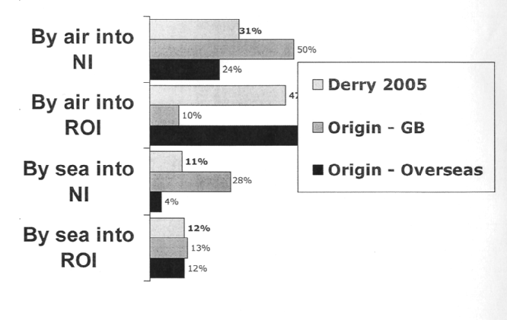

Recommendations
I feel there is further development that Deny could do in the future to further its popularity and appeal in order to receive more incoming visitors.

For example we need a better road network, all the money for development is being pumped into the east of Northern Ireland, leaving the west of Northern Ireland in need for road improvement. We would need a motor way or dual carriage way straight from Deny to Belfast. The only motorway link from Belfast is the M2 which stops at Toome (an hour's drive away from Deny). An improved road system would decrease the driving time to Derry making it even more accessible.
Destination Britain Task d) Extract Commentary

This extract relates to one of the factors that affect popularity and appeal, accessibility, and the associated recommendations.

Annotation highlights where there is evaluation to differentiate from description and where the recommendations have detail and justification. The evidence is evaluative and has some reasoning. A recommendation is stated and then described with some justification.

This candidate is clearly working at mark band 2 and with the reasoning to support the evaluation, the detail in the recommendation and the attempt to justify the recommendation, this is a strong mark band 2 piece of work. It has the potential for mark band 3 if sustained across a range of factors and the focus is on the reasoned evaluations so that the evaluation can be considered detailed. This task addresses Assessment Objective 4 so reasoned conclusions are critical.
Sample Pen Portraits for Task b)

An adult and three young children (under 8) want to visit Britain to experience a traditional seaside holiday. One of the children is very keen on Harry Potter and would like to visit some of the places associated with the novels. The adult will have access to a car but doesn’t want to drive for more than one hour each day to get to a new destination. They have one week available.

A French school is planning a visit to Britain to study the British countryside. They want to visit at least three different countryside areas in Britain but do only want to stay in one of these as the students will want to experience some of the towns and cities of Britain themselves. In addition to the countryside areas, the school would like the opportunity to see any typically British geographical features. They will stay in Britain for five nights and will have access to a coach, arriving into Britain at Dover.

Mr Guanacaste is travelling from Costa Rica to organise a conference on environmental conservation. He is looking for suitable destinations that could accommodate more than 1000 delegates travelling from all over the world. He will be visiting Britain with his family. He wishes to stay with his family (wife plus one teenager) in two possible destinations that could host the conference. He would like to stay for three days in each destination. He would also like to visit a destination that has already adopted measures to conserve the environment in Britain for possible use as a case study at the conference. In addition, his son is keen on surfing and would like to surf when visiting so the family would like to stay in a seaside destination for three nights. They are keen that this seaside destination also has some British heritage significance.

Unit 6 (6992)

Resort Operations

Task a)
Describe how tour operators organise resort operations to prepare and deal with customers in resort. Explain situations that require the resort office to liaise with their UK office.

Target Assessment Objective AO1 Demonstration of knowledge, understanding and skills

Mark band 1 | Mark band 2 | Mark band 3
A description of how tour operators overseas resort offices operate which is mainly theoretical and lacks detail.  An explanation of some situations when a tour operator’s overseas resort office liaises with the UK office. Tends to be descriptive and lack detail. Situations may be limited in detail and range. | A description of how tour operator resort offices operate that includes detail in terms of the depth of coverage of the activities of resort office and its operation. Appropriate tour operator examples given.  An explanation of situations when a tour operator’s resort office liaises with the UK office using examples to support the explanation. | A detailed description of how tour operator resort offices operate that includes in-depth coverage of the activities of the resort office and its operation. Appropriate range of tour operator examples given.  A detailed explanation of situations when a tour operator’s resort office liaises with the UK office using a range of examples to support the explanation.

The first part of the task requires description so it is the amount of detail provided in the description that is the key differentiator. The use of examples could be a strength within a mark band. For the second part of the task, explanation is the key differentiator. If candidates describe situations then mark band 1 would apply but where they explain situations, higher mark bands can be considered. Again, examples could be considered a strength within a mark band if these are used and not simply stated.
Task b)
Organise a present a welcome meeting. Sell an additional service, completing appropriate documentation. Handle a problem situation for a customer whose needs and circumstances are given to you.

Target Assessment Objective AO2 Application of knowledge, understanding and skills

Mark band 1 | Mark band 2 | Mark band 3
The welcome meeting is presented but may lack structure and depth of knowledge of the destination. There may be some inaccuracies in the materials or limited materials used.  Some selling skills used to sell an additional service completing some appropriate documentation. The selling situation may only consider some of the customers needs given in the pen portrait. There may be some inaccuracies in the documentation.  The problem situation is dealt with in part leaving some issues unresolved. Problem is straightforward. | A structured and organised welcome meeting which shows depth of knowledge of the destination and uses appropriate materials throughout. The welcome meeting shows interaction with the group and effective use of materials.  Appropriate selling skills used to sell an additional service completing appropriate documentation. The selling situation identifies the customer’s needs and sales opportunity and sells an appropriate product or service that meets the customer’s needs given in the pen portrait.  The problem situation is dealt with effectively with issues resolved. The problem dealt with is complex. | A well-structured and organised welcome meeting which shows in-depth knowledge of the destination, uses a wide range of appropriate materials effectively and engages the audience throughout.  Effective selling skills to sell an additional service accurately completing all appropriate documentation. The selling situation identifies the customer’s needs and sales opportunity and sells an appropriate product or service that meets all the customers needs given in the pen portrait.  The problem situation is dealt with fully and effectively with all matters and issues resolved. The problem situation is complex.

There are three parts to the task and for each part it is the ability to demonstrate the skill within an applied situation that is the discriminator. For the welcome meeting it is the organisation, the materials, the interaction and the depth of knowledge of the destination that all have to be taken into account. For the selling situation it is the candidates ability to identify and meet needs. The differentiator for the problem situation is how effectively it was dealt with.
Task c)
Research information needed to complete all tasks.

Target Assessment Objective AO3 Research and analysis

Mark band 1 | Mark band 2 | Mark band 3
Some research has been undertaken and is evidenced mainly through a bibliography. Sources directed or provided by others were used. | Research has been undertaken using different sources some of which were obtained independently. Some evidence of research is referenced | Research has been undertaken using a range of different sources that have been obtained independently. Much of the evidence of research is referenced.

The research skills that need to be evidenced relate to the range of types of sources accessed to complete tasks a), b) and c). The extent to which evidence shows they have researched independently and referenced their sources is critical. There must be evidence of using their research.
Task d)
Evaluate the significance of induction, training and product knowledge of overseas representatives delivering high quality customer service.

Target Assessment Objective AO4 Evaluations

Mark band 1 | Mark band 2 | Mark band 3
An evaluation of the significance of induction, training and product knowledge of overseas representatives delivering high quality customer service that is mainly descriptive and may lack detail. Not all parts are evaluated. The evaluation tends to be theoretical. | An evaluation of the significance of induction, training and product knowledge of overseas representatives delivering high quality customer service. Evaluation draws on examples of practice carried out by a number of tour operators. Some conclusions are substantiated. | A critical evaluation of the significance of induction, training and product knowledge of overseas representatives delivering high quality customer service. Evaluation draws on a wide range of examples of practice carried out by a number of tour operators. Conclusions drawn are mainly substantiated.

This task requires learners to evaluate. Descriptive evidence would equate with mark band 1. Where evidence is evaluative, with reasoned conclusions, higher mark bands can be considered. As AO4 requires learners to make reasoned conclusions it is the extent of reasoning in the conclusions drawn from the evaluation that determines the best fit mark band. Examples can be considered a strength within a mark band, provided they are used to support the reasoned conclusions made. Examples simply described are not appropriate.
This extract relates to Task a)

Task 2

Situations that require the resort office to liaise with their UK office.

The first resort office which I will describe how they liaise with their UK office is Thomson.

These are some of the situations which will result in the resort office making contact with their UK head office:

Dealing with emergencies
Some examples of emergencies which the resort would need to make contact with their UK head office include a medical emergency, transport delays and theft. It is vital that head office is contacted in these situations so that the resort can get information and advice where needed and to ensure that head office is fully aware of what is happening. In some circumstances such as a Tsunami, the head office would need to arrange alternative transport and inform the guest's relatives of the situation. During an extreme situation such as a guest becoming seriously ill there are several people who need to be informed. Head office will usually handle all communication with other parties as well as the resort. In less serious situations such as theft, the resort staff would handle the problem but inform head office of the situation and the outcome. In the event of an emergency, a customer service report form (CSR), should be completed. The customer is given the top copy of the CSR and the bottom copy is retained by the resort office.

Notification of customer details
When a customer is booked on to a package holiday, this process is co-ordinated through the resorts UK head office. All of the customers details of bookings need to be given to the staff in the resort so that are aware of how many guest's to expect and their specific needs. This is important so that the resort staff can make preparations for the number of guest's and so they can deal with special requirements such as a wheelchair user.

The second resort office which I will describe how they liaise with their UK office is First Choice. These are some of the situations which will result in the resort office making contact with their UK head office:

Customer satisfaction
Most tour operators will ask their customers to complete a customer satisfaction questionnaire at the end of their holiday. Sometimes this will be issued on the flight home, but reps usually hand the questionnaires out at the accommodation or on the return transfer to the airport. Questionnaires will be collected by the rep, usually the transfer rep, to head office. The results are then collated and analysed to help improve customer satisfaction. Many companies summarise the results of these questionnaires and use them in the next year's brochure to indicate the level of satisfaction of previous guests. An example of this is Thomson who uses their questionnaires to show the overall satisfaction of accommodation in their brochures such as Thomson Summer Sun.

Below is a theatrical example of an unsatisfied customer whose needs where not dealt with sufficiently:

"I was on holiday to Binasafua, Menorca and I was very shocked with the state of the accommodation. There were no plugs for the toaster or kettle in the kitchen; therefore I had to use them in the bedroom which is a dangerous situation as I had children in the accommodation with me. I constantly attempted to contact the resort representative but she was never around and I had to keep using my mobile phone to call her which led to me receiving a large phone bill. The representative took a long time to attempt to solve my problems and was not at all apologetic. On my return flight from Mahon airport I received a questionnaire in which I had to describe the customer service I received during my holiday. I was glad to see that the tour operators were trying to research issues within their accommodation premises and I hope that this problem does not repeat itself."

August 2005 Mrs Hastings
The resort rep should have handled the situation better. Firstly she should always be available and should check in on guests to ensure that they are settling in and have no issues. She could also be available via walkie-talkie which the reception should be able to contact her with. She should have made an effort to help the guests and check their room to observe any problems and organise alternative accommodation. She may even have to organise some compensation for the customers if their new accommodation is not to the same standard that they originally paid for. In this situation the rep would need to complete an accommodation switch form for the resort records.

Good customer service to guests within accommodation is important for tour operators as well as accommodation providers. This is because if the tour operator has recommended a specific hotel and the customer experiences problems, then the customer is not likely to consider using the same tour operator again or follow their recommendations.

Therefore it is vital that staff receive sufficient training so that they can gain knowledge of dealing with difficult situations such as an overbooking or even an emergency situation such as a hurricane. Staff should also be assessed regularly either by management staff or with customer questionnaires to ensure that they are maintaining a high level of customer service.

Up-dates
An example of an update which would cause a tour operator and a resort office to communicate with includes construction work. This is mainly common in developing resorts where an expansion has been made due to the high demand from tourists. Expansions may include accommodation and/or facilities within the resort. It is the role of the resort staff to inform head office of any building work and the amount of disturbance it is causing. If the noise is too disruptive, then head office must notify customers booked to visit the resort about the building work and may even have to arrange alternative accommodation. First Choice resort reps must complete a Building Report Form on a monthly basis, rating the building work on a scale of 1 to 10 on factors such as noise, pollution and times of disruption. Building works information report:

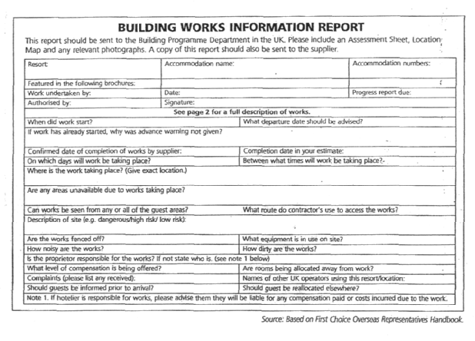
Bibliography
http://www.anyworkanvwhere.com/iobslist.php?submit_button=Search&c_key^O&i key
http://www.anyworkanvwhere.com/iobslist.php?submit_button=Search&c key=0&i_key =18
http://www.prospects.ac.uk/cms/ShowPage/Home page/Exploretypesof jobs/Types o f Job/p !eipaL?state=showocc&idno=235&pageno= 1
http://www.shgjobs.co.uk/job descriptions.asp http://www.firstchoice4iobs-co.uk/fe/tpi_firstchoiceQl.asp?newms=info4
Longman Vocational A-Level Travel and Tourism textbook
Collins Travel and Tourism AS textbook
Resort Operations Task a) Extract Commentary

This extract relates to the second part of task a) where the candidate is to explain the situations that require the resort office to liaise with the UK.

Annotation is used to highlight where there is explanation to differentiate from where there is description. Explanation is a key requirement of this part of the task. Descriptive evidence would lead to a mark from mark band 1 but explanations can gain marks from higher mark bands. As can be seen from the annotation, there is very limited explanation and the evidence is descriptive. Where there is explanation it has limited depth. Some of the content is not relevant. This does not affect the mark awarded but would not be considered.

As the evidence is descriptive, the candidate is working at mark band 1. As there is some limited explanation, this could be considered a strength to more beyond the mid point mark. To gain marks from higher mark bands, the candidate needs to move from description to explanation. For each example situation given, they should give an explanation.

Resort Operations Task b) Assessment Checklist

On the following six pages are three Assessment Checklists that could be used by assessors to assess task b) of the unit. There are three separate Assessment Checklists because there are three parts to the task, each of which will require different performance and, subsequently, assessor comments. The Assessment Checklists can be used as part of the learning process, for formative assessment (assessor, peer and self assessment) as well as for summative assessment.

Each document is designed to be completed in three stages:

1. The top part of each of the front pages is to record the details of the situation. Details of the situation, or pen portrait, as presented to the candidate, should be inserted. Alternatively, these details can be attached to the form. This is completed prior to the assessment taking place.

2. The second page of each of the document sis completed by the assessor describing the candidate performance. At this stage it is only a description that is required. There should be sufficient detail to determine quality of performance. The topics against which a description is required are taken from the ‘what you need to learn ‘section of the specification and the mark band statements.

3. Summative comments are added to the bottom of the front page. This should be signed and dated. If appropriate, the candidate can add their comments.

The document is designed so that any internal standardisation that takes place can be recorded.

There is no provision on the document for a mark to be awarded as the mark can only be determined when task b) is complete. Overall summative comments for the task can be added to a task feedback sheet. Examples of these are in this guide.

GCE TRAVEL AND TOURISM UNIT 6: RESORT OPERATIONS

TASK b) THE WELCOME MEETING

Candidate Name: _______________________________

Summary of pen portrait

Assessment of candidate performance

Structure and organisation of meeting

Knowledge of destination

Appropriateness of materials used

Effectiveness of use of materials

Audience interaction

Assessor Name: Signature Date

IV Name Signature Date

Candidate comments and feedback

Signed Date

Description of candidate performance
Structure and organisation of meeting
Structure
Preparation
Knowledge of destination
Property
Resort features
Excursions
Resort support organisations

Materials used
Leaflets and promotional materials
Information board
Information sheets
Rooming list
Excursions leaflet

Audience interaction
Questioning
Listening
Involvement

GCE TRAVEL AND TOURISM UNIT 6: RESORT OPERATIONS

TASK b) SELLING SITUATION ASSESSMENT CHECKLIST

Candidate Name: _______________________________

Situation
[Insert pen portrait here]

Assessment of candidate performance

Selling skills

Documentation

Meeting customer needs

Assessor Name: Signature Date

IV Name Signature Date

Candidate comments and feedback

Signed Date

Description of candidate performance
Selling skills
Building rapport
Questioning
Identifying needs
Presenting features and benefits
Overcoming objections
Closing the sale
Meeting customer needs
Main customer needs
Supplementary customer needs

Documentation
Accuracy
Appropriate
Confidentiality

GCE TRAVEL AND TOURISM UNIT 6: RESORT OPERATIONS

TASK b) PROBLEM SITUATION ASSESSMENT CHECKLIST

Candidate Name: _______________________________

Situation
[Insert pen portrait here]

Assessment of candidate performance

Effectiveness

Complexity

Assessor Name: Signature Date

IV Name Signature Date

Candidate comments and feedback

Signed Date

Description of candidate performance
Complexity
How was complexity dealt with
Determining the problem
Building rapport
Questioning
Listening
Empathy
Resolving the problem
Empathy
Exploring solutions
Investigating possibilities
Controlling the situation
Agreeing the solution
Follow up

Documentation
Accuracy
Appropriate
Confidentiality

Unit 8 (6994)

Current Issues in Travel and Tourism

Task a)
A research proposal that includes a description of the issue and a plan that shows the project aims and the research methodology adopted, including timescales and planned sources of reference.

Targeted Assessment Objective AO1 Demonstration of knowledge, understanding and skills

Mark band 1 | Mark band 2 | Mark band 3
A research proposal that identifies and describes with limited detail, the issue to be the focus of the research project.  The plan indicates how the project aims will be met and the research methodology to be used. The plan may lack clarity, be unrealistic in parts and have some omissions. | A research proposal that describes in some detail the issue to be the focus of the research project.  The plan describes in some detail how the project aims will be met and the research methodology to be used. All parts of the plan are clear and feasible. | A comprehensive research proposal that clearly identifies and describes in detail the scope and range of the issue to be the focus of the research project.  The plan explains how the project aims will be met and the research methodology to be used. The proposal and plan reflect the project aims and include a timescale where priorities concerning the research and collection of data are acknowledged. All parts of the plan are clear, relevant, appropriate and feasible.

There are two key differentiators. The first relates to the description of the issue that is proposed to be the focus of the research project. The second differentiator relates to the proposal itself. For mark band 3, the proposal must be explained. A description only would not gain access to higher than mark band 2. For mark band 2, that description must be in some detail. There are other differentiators but these are more likely to be used to determine strengths and weaknesses within a mark band rather than to determine the best fit mark band.
Task b)
Produce evidence of working independently and following a research plan to meet project aims and timescales and how changes to the plan were dealt with.

Targeted Assessment Objective AO2 Application of knowledge, understanding and skills

Mark band 1 | Mark band 2 | Mark band 3
Project has been completed with guidance from others.  The project meets most aims and timescales set including final completion by deadline stated.  Changes made to the plan were not updated and were often as a result of factors within their control. | Project has been completed with some guidance from others but mainly independently.  There is evidence that the proposed plan has been followed and indicated aims and timescales have been met.  Changes made to the plan were documented. These were mainly as a result of factors outside of their control and appropriate changes implemented. | Project has been completed independently.  The project plan has been followed and all aims clearly met and timescales adhered to.  The plan is regularly updated throughout the process with an indication of how aims and timescales met and any changes that were required. Contingencies were in place for any required deviations from the plan.

The task requires candidates to demonstrate their ability to apply their knowledge and understanding of research methodologies and research skills, by following a plan they have proposed. As a result, one key differentiator is related to that ability to apply that knowledge and understanding and the skills independently. Another key differentiator is through the evidence of following a plan, making changes as required.

Task c)
Undertake research as indicated in the plan for the project and analyse the issue and its affect on the travel and tourism industry or one of its component sectors

Targeted Assessment Objective AO3 Research and analysis

Mark band 1 | Mark band 2 | Mark band 3
Research has been undertaken that uses a limited range of sources that have mainly been directed. There is some use of the research methodology identified in the plan for the project.  There is some analysis of the issue and its effect on the travel and tourism industry or a specific sector of the industry but this is mainly descriptive. | Research has been undertaken that uses a range of sources, many of them identified and used independently. Sources are clearly referenced throughout. The sources used are as identified in the plan for the project.  There is a clear analysis of the issue and its effect on the travel and tourism industry or a specific sector of the industry. | A range of research techniques is used to obtain data and sources of information have been obtained independently. Sources are clearly and fully referenced throughout. Sources used exceed those identified in the plan for the project and the need for these additional sources is explained.  There is a clear and comprehensive analysis of the issue and its effect on the travel and tourism industry or a specific sector of the industry.

There are two parts to the task: research and analysis. The key differentiators in the research part of the task are the range of sources used, the extent of independence used in identifying and using those sources, the referencing of sources and the extent to which the sources were those identified in the plan. The key differentiator in the second part of the task is the level of analysis of the issue researched.

Task d)
Evaluate the project and research methodology with recommendations for approaches to be adopted for the future. .

Target Assessment Objective AO4 Evaluations

Mark band 1 | Mark band 2 | Mark band 3
There is an evaluation of the project. This is mainly superficial and subjective.  There is an evaluation of the research methodology with some awareness of the limitations of sources of information available to support the research project or some acknowledgement of their own limitations in terms of the range and depth of research undertaken.  Recommendations are made but these are limited in detail and are not always feasible and/or appropriate. | An evaluation that evaluates the project with some objectivity and some depth drawing valid conclusions that are mainly reasoned.  There is an evaluation of the research methodology that acknowledges the limitations of the research where appropriate and its effect on the outcomes of the research project.  Recommendations for improvement are made, some of them justified. Most have some detail and are appropriate. | A comprehensive evaluation that is objective and in depth with valid and accurate conclusions that are clearly reasoned.  Research methodology and data obtained is evaluated and where there are limitations these are clearly explained in terms of its effect on the outcomes of the research project.  Valid recommendations for improvement are made that are justified and presented in detail

As the task is used to address AO4 which requires learners to make reasoned conclusions and recommendations, these are the two key differentiators. The level of objectivity in the evaluations is one of the key differentiators together with the level of reasoning in the conclusions made. The key differentiators in the recommendations part of the task are the detail given in the descriptions of each and the justification given.

The sample work relates to task d)

Evaluating my project plan
In conducting this assignment, I created a strategic project plan to outline the primary and secondary research methodologies to be used in the project to help me answer my research question and explore the impact that the rapidly growing no-frills aviation industry is having on global warming and what this means for the travel and tourism industry.

From the experience which I have gained from following my project plan, I believe that the biggest and most beneficial advantage to me from using this project management tool was in being able to effectively order and prioritise each of the individual research aims in an ordered and structured way. The main way that I ensured that a comprehensively structured order was followed and adhered to throughout the project was by numbering each of the research aims, according to the order in which I wanted to analyse the findings later in the project, in my final report. By numbering each individual research aim, I believe that my project was significantly benefited through knowing exactly what order to conduct my research in, forming a clear and colloquial structure for my report. To illustrate this point further, one example of how creating a numbered structure benefited the running of my project was when researching the aim to "Research the number of tourists flying with no-frills airlines 5 years ago " which was essential to be carried out before researching "the average ticket price for a no-frills flight 5 years ago and compare with 2006". I believe that this was particularly important as without prioritising my research to investigate the numbers of tourists flying five years ago before identifying average ticket prices, this would have made it a lot harder for me to have identified if the numbers of tourists frying with a no-frills airlines is linked to the changing ticket prices for no-frills flights. With regard to writing my report, by carrying out my research in the strict order that I wanted to write my report in and the individual research aims. I believe that this helped to aid the quality and clarity of report by providing me with the research collected in the correct order, preventing me from having to spend a lot of time routing for the findings in my collected research which I will investigate later in this report. Furthermore, on a basic level, I also believe that by effectively prioritising my research aims, this helped to ensure that my research and analysis could be completed as quickly as possible. For example, when investigating similar research aims such as to investigate the number of no-frills passengers five years ago and to research the number of no-frills passengers today, by prioritising these two research aims in sequence, this meant that I was able to use the same or similar sources to obtain information to meet the two research aims. Therefore, in my opinion, the main benefit of this to me, was that I could save some time here by not having to revisit the same source twice. I believe that this was a result of my careful project planning which I spent a considerable amount of time on at the 'beginning of the project initially by taking time to think about the linkage between research aims and how this could potentially be used to obtain my research findings, whilst also allowing me to evaluate the no-frills airline and global warming situation in the correct order to allow me to reach appropriate conclusions.

Another significant benefit which I feel the use of the project plan brought to the execution of my report investigation and affected the successfulness of the outcome of my project as a whole was in the use of contingency planning. For example, initially at the beginning of the project when devising my contingency plan, I spent a considerable amount of time thinking about and making note of a number of problems that could potentially constrain the research investigation such as for example, not being able to identify what I initially set out to research, and the potential actions that I would take to overcome these unforeseen circumstances. To illustrate this point in greater depth, one example of when I had to use my contingency plan, built in to my project plan, was when researching the aim to identify the "average ticket price for a no-frills flight five years ago and compare with 2006 ". This is because, although I was able to identify some ticket prices in 2002, I was not successful in identifying the 'average' ticket price for a no-frills flight. To ensure the maximum validity of my research investigation here, I had to refer to my contingency plan and investigate the average cost of a no-frills flight today and compare this to the average cost of the almost identical flight with a traditional airline (BA, American Airlines and Virgin Airlines etc).

Although I will discuss this in greater depth shortly in my analysis of the research methodologies used, I believe that the above example is firm proof to illustrate that when I hit difficulty in my research methodology used and could not guarantee the complete validity of the data obtained, I was successful in referring to my project plan and seeking the alternative contingency stages to ensure that I was completely successful in answering and exploring my research question fully without limiting the scope of my investigation or resulting in any potential bias from occurring through limiting the range of research to analyse and evaluate.

A constraint that I believe my research plan did not take into consideration in the contingency planning' aspect of the plan was what to do if the representatives from the no-frills aviation industry did not want to give out any opinions to the public, as has been the case for Ryanair and many other no-frills airlines which I investigated. Therefore, on further extensive analysis of my project plan, I have identified that my plan only outlined to research the attitudes and opinions of the no-frills sector of the aviation industry. However, when I researched these opinions, I found that I was very limited in the amount of information available. Therefore, although not included in my project plan, I decided to use the recorded evidence of the attitudes and opinions of Sir Richard Branson, even though he does not own a no-frills airline currently. Therefore, in my opinion, this is a typical example of how I had to go back and amend my plan to ensure that my final report investigation had enough evidence from my findings to allow me to develop and further the critical analysis and reasoned conclusions in my report.

If I was to complete a similar project again in the future, I would therefore want to spend more time on my contingency planning for all aspects of the plan and research aims to be investigated, rather than only outlining contingency planning for those research aims which I initially anticipated as being likely to be harder to find a wide range of research sources for than others. However, I believe that in this situation in overcoming this limitation of my project plan, I have worked well by using my own initiative to work out a solution and then go back and revisit my original plan to amend it.

Current Issues in Travel and Tourism Task d) Extract Commentary

The extract is taken from an overall evaluation of the project presented by the candidate. The full evaluation included more than 20 pages and addressed the choice of issue, parameters set, project aims, timescales proposed, research methodologies, proposed sources and their validity together with the validity of the information obtained from different sources as well as additional sources used.

Annotation has been used to highlight where the candidate is evaluating to differentiate from where they are describing. Annotation also highlights where the evaluation is objective rather than subjective. From the annotation it can be seen that the candidate is clearly evaluating, making reasoned conclusions. One recommendation is made. This has limited detail but is clearly justified when taking all evidence holistically. The lack of detail is, however, a weakness.

The candidate is clearly working at mark band 3. If the recommendations had more detail, this candidate could be capable of achieving maximum marks, providing the remaining evidence for this task was showing the same level of skill.

SAMPLE ASSIGNMENT UNIT 8: CURRENT ISSUES IN TRAVEL AND TOURISM

Introduction
For this assignment you will work individually to investigate a current issue and use your findings to analyse the effect of the issue on the travel and tourism industry. In order to investigate your current issue you need to plan your research by producing a research methodology. Upon completion of your research and analysis, having updated your plan as you go along, you will evaluate the research methodology you chose. This assignment will break down the assessment requirements of the unit and give guidance in terms of how you can gain additional marks.

Task (a) (i)

You should submit a research proposal that includes a description of the current issue you have decided to investigate.

Tips:
Before you put together your research proposal, think carefully about the current issue you are going to investigate. Is it a current issue? Is it even an issue? You may want to do some basic research just to make sure that there is a range of information available on your current issue that you will be able to use. You have learned about this in class so take all of what you have learned into account.

Your research proposal should include the following
- A description of the issue.
- Its aims and parameters of the study

Gaining higher marks
- Choose an issue that is current (within the last five years)
- In your proposal ensure your current issue is clearly stated, its scope and range clearly outlined and described in some detail

Task (a) (ii)

There should be a plan that shows the project aims and the research methodology adopted, including timescales and planned sources of reference

Tips:
Always anticipate something might go wrong and put in your plan how you might deal with problems if they arise – have contingencies in place. Remember that ultimately you will be evaluating this plan so think about presenting it in a way that you can monitor your progress and add comments throughout. Remember it will be a working document so think about its utility.

Gaining higher marks
- Make sure your aims are specific – think SMART.
- Make sure it is clear how you are going to achieve your aims – the person reading this shouldn’t have to work it out for themselves – spell it out!
- Have you set timescales for every stage of your plan, are they realistic?
- Set priorities and describe and explain them
- Your plan must be realistic – don’t set yourself targets that you know you cannot achieve just because it looks good
- Remember to anticipate all potential problems and have contingencies in place

Task b)

Follow your research plan and work independently to meet your project aims and timescales. Keep a record of any changes you make to your plan.

Tips:
This task is all about your ability to show you know how to follow a plan so you have to have evidence you have followed your plan. Keep it updated regularly. Any time you have to change one thing, consider the impact it will have on the rest of the plan and update that as necessary. It should be a working document. You will need evidence that you have worked independently. You will need to prove to me that you have done this so that I can provide you with the evidence you need. Keep a record as you go along. Don’t think about this at the end. It is not a problem, if you don’t follow your plan exactly. You must keep a record though. Also you will need to explain why there are changes. Note those explanations as the changes occur – again, not at the end.

Gaining higher marks
- You must mainly follow the plan you have submitted
- You must work independently
- You must meet the aims you set at the beginning
- You must meet all of the key deadlines you set in your plan
- Your plan must be regularly updated
- As you work through your plan, if you anticipate that there will need to be changes in the future, contingencies are put in place
- You need to be able to show you have followed a systematic process
- Check your plan regularly, daily if possible, and update it where needed, including timescales, changes to aims, research methodology etc. It is a plan so it can be changed but you have to make the changes as you go along, making a note of why.
- This cannot be retrospective – you cant do this task at the end, it must be ongoing.

Task (c) (i)

You must undertake research

Tips:
Keep a record of all sources you use in research – even if you don’t find any relevant information. Make sure the records include all relevant information about the sources eg author, publisher, year, title etc. This will help you later to compile a bibliography and reference your sources if you use any of them. You could produce a research log categorising types of sources and use this to record all sources you have used and describe how it was used. Use different types of sources - don’t just rely on the internet. If you do find information on websites, note whether it is the website or a source provided by the website.

Gaining higher marks
- A wide range of sources must be used. These can be primary and/or secondary sources
- You must find your sources independently
- Sources will be fully and clearly referenced in your report
- You have used the sources you identified in your plan
- Where additional sources have been used these have been explained

Task (c) (ii)

Submit a report, analysing the issue and its effect on the travel and tourism industry or one of its component sectors

Tips:
Note that this task is about analysis. This means don’t just go into detail describing the issue. Look at how you can break it down and discuss how different aspects of the issue are affecting the industry. This means the organisations and not the tourist.

Gaining higher marks
- The issue must be clearly and comprehensively analysed in terms of its effect on the industry or a sector of the industry
- Your analysis must be based upon your findings from your research – refer to specific findings.

Task d)

Evaluate the project and the research methodology with recommendations for approaches to be adopted for future projects

Tips:
This goes back to your plan and how you used it throughout. If you kept note of changes, why they were happening as you went through you will find it easier to complete this task. You are also required to make recommendations. Do this after the evaluation. Go through your evaluation to find the weaknesses and make your recommendations from these.

Gaining higher marks
- The evaluation must be comprehensive and in some depth
- The evaluation must be objective so make sure you have evidence of what you are saying
- There must be clearly reasoned conclusions
- There will be an evaluation of the range and limitations of the research undertaken; did you carry out sufficient research? Did you focus too much on a particular type of research? Did any of the research restrict you? Were any sources contradictory?
- There will be a clear and thorough explanation of how the research has affected the outcomes of the project
- There will be a number of recommendations made. These will be detailed and appropriate and drawn from conclusions. They will also be justified.

Submission deadlines

Task a) must be submitted by xx/xx/200x. The research plan for this task will indicate the deadlines you are setting yourself for completing tasks b) and c). Task d) must be submitted by xx/xx/200x

Assessment

Each task will be assessed separately and given a mark. The mark will be given based on the quality of the work submitted. The criteria for assessment are shown on the unit assessment grid.

Unit 9 (6995)

Working in Travel and Tourism

Task a)
Participate in a team, working towards completion of a significant travel and tourism related task.

Targeted Assessment Objective AO1 Demonstration of knowledge, understanding and skills; AO2 Application of knowledge, understanding and skills

Mark band 1 | Mark band 2 | Mark band 3
A role has been taken within a team. The role may not be significant but as agreed by other team members.  Participation in the team has been effective although contribution may not be significant to completing the task.  The contribution of others within the team is recognised. | A significant role has been taken within a team.  Participation in the team has been effective with a valid contribution made to completing the task.  The contribution of others within the team is recognised and conflicts that arise are dealt with effectively  Evidence of involvement is drawn from a range of sources. | A significant role has been taken within a team.  Participation in the team has been consistently effective, with a significant contribution made to completing the task. Potential difficulties in meeting objectives are identified and alternative approaches suggested and adopted.  The contribution of others within the team is clearly acknowledged and support provided to others as required. Potential conflicts are identified and solutions proposed and implemented.  Evidence of involvement is drawn from a wide range of sources.

The task targets two Assessment Objectives and so is assessing both theory and application. The significance of the role taken and tasks completed are key to determining the best fit mark band. In addition, a key differentiator is the candidate’s team working skills, particularly in terms of dealing with conflict. The sources used as evidence of involvement is a final differentiator.
Task b)
Analyse the range of employment opportunities and the skills and qualities required for a successful career in the travel and tourism industry

Targeted Assessment Objective AO1 Knowledge, understanding and skills; AO3 Research and analysis

Mark band 1 | Mark band 2 | Mark band 3
Some research has been undertaken and is evidenced mainly through a bibliography. Sources used are those directed by others.  There is some basic analysis of the nature and range of employment opportunities and the skills and qualities required for a successful career in the industry that is mainly descriptive. | Research has been undertaken using different sources, some of which were obtained independently. Some evidence of research is referenced throughout the text, as well as in a bibliography.  There is an analysis of the nature and range of employment opportunities and the skills and qualities required for a successful career in the industry. A range of employment opportunities has been included in the analysis, which is mainly clear. | Research has been undertaken using a range of different sources that have been obtained independently. Much of the evidence of research is referenced throughout the text, as well as in a bibliography.  There is clear analysis of the nature and range of employment opportunities and the skills and qualities required for a successful career in the industry. A wide range of employment opportunities has been included in the analysis.

The task has two key differentiators: the research and the analysis. The research is differentiated by the range of sources used and the referencing of those sources in the text, together with the ability to research independently.

Task c)
Produce a detailed career development plan based upon a personal skills audit produced using information from a range of sources

Targeted Assessment Objective AO1 Knowledge, understanding and skills: AO4 Evaluations

Mark band 1 | Mark band 2 | Mark band 3
The career development plan lacks detail in some parts and may have some omissions although these are not significant. The focus of the plan may be on the short-term rather than medium-term future. The plan makes limited use of the personal skills audit. The personal skills audit lacks some detail and is mainly subjective. | The career development plan has some detail and some justification. There may be some omissions but these are not significant. The focus of the plan is on the medium term future. Use has been made of the personal skills audit to develop the career development plan. The personal skills audit is detailed and reasoned with some parts substantiated. Evidence is drawn from a range of sources. | The career development plan is comprehensive, well reasoned and fully justified making clear and sustained use of the personal skills audit. The focus of the plan is on long-term career goals. The personal skills audit is comprehensive and detailed drawing on evidence from a wide range of sources to fully substantiate conclusions.

The differentiators here relate to the detail presented in both the career development plan and the skills audit. In addition, the objectivity of the conclusions drawn, through the use of evidence from a range of sources is another differentiator.

Skill | Strengths | Weaknesses | Evidence
Oral communication | o Good communication skills, however varied depending on who I am with / working with  o Likes to talk to others, especially when working in a team / group  o Likes to voice opinion and contribute as much as possible | o Often speaks before thinking, which results in unnecessary comments  o Sometimes over speaks, and talks to much, often distracting others, while other times, doesn't speak up enough, for example, with an idea that might be useful | o Harvester- Manager's PSA about me - in particular speaking to other staff members  o Teamwork section (9.2) A-level Travel and Tourism Coursework -speaking with others in the team  o School presentations  - GCSE-English  - Key Skills presentation
Listening skills | o If interested in the topic, or whether the topic is relevant and important, listens intently  o Often able to use listening skills to make valuable contributions  o Does listen to others in a team, and hear what ideas they have | o Focus is a key weakness, and often gets distracted by others around  o Due to being easily distracted, especially by peers, key points are often missed which would have been helpful | o School report 2006/2007 – in particular the form tutors comment  o Teacher PSA - claimed that here there was room for improvement
Problem solving | o Can have an analytical mind and thinks before jumping in most of the time  o Any problems that do arise, I am often quick to use my judgement to sort it out as quick as possible | o Need to often listen to others opinions, before jumping in to solve any problems that do arise by myself | o Harvester PSA - often faced with number of problems, needed to be overcome  o Teacher PSA - sees my performance, in particular teamwork section, where problems arose
Teamwork | o Can be seen as an excellent team player, and played a 'Key role' in the Teamwork section of the coursework  o Likes to concentrate on others' opinions to help others out, again proved in the Teamwork section | o At times lacks maturity which affects my performance in a team / group  o Am often too quick to judge others and not myself | o Teacher PSA  o A-level - Travel and Tourism  o Travel and Tourism Teamwork section (9.2) evaluation
The sample work relates to task c)
Skill | Strengths | Weaknesses | Evidence
Leadership | o More seen of at work (part-time job) where I often take control of set sections to look to advise and help others  o Hard to comment on, as often the one being told what to do  o Am captain of my Sunday League Football team, in which I have gained a lot of leadership skills, in talking to others and sending out orders to get a job done | o Confidence is key here, as I need to have more confidence, especially when dictating orders to senior, or more experienced members of a team/group | o Sunday League Football Team (Headstone Manor) - captain of side  o Teamwork section (9.2) evaluation - 'lead the children through a number of tube stations, requiring confidence and courage'
IT skills | o Able to use various IT programs, including Microsoft Word, PowerPoint, Excel and Adobe  o 'Excellent ICT skills', combining facts and knowledge with a neat and tidy, presentable layout | o Need to make sure all work has been carefully proofread as mistakes are often noticeable | o Work Experience placement 2004 - Watford Football Club - end of week report  o AS level -ICT  o GCSE – BCS
Outgoing | o Very approachable with a likeable, enthusiastic personality  o Enjoys socialising with friends, and having a laugh and a good time when out | o Sometimes can be quiet  o Needs to be confident in speaking up, and join in more with social activities at work | o Harvester PSA-Manager's opinion regarding my personality and how outgoing I am
Assertive | o At times, can use own judgement and is more than capable of reacting quickly to problems, in order to deal with a number of different situations | o Unfortunately at wrong times, and needs to be able to be ready to use own judgement and be alert in all situations | - Captain of Sunday League football team (headstone Manor)  o London Trip evaluation – Took control of the financial aspects, as well as leading the 96 children around the different London Tube stations

Skill | Strengths | Weaknesses | Evidence
Time Management | o Can be good at prioritising and getting a task done on time  o Always meets deadlines despite last minute panics | o Does not spread work effectively and ends up with a number of last minute panics  o These last minute panics, especially with coursework, often affect the work being done, and marks can be lost | o Teacher PSA - recent coursework deadlines  o Harvester PSA - always looking to put important tasks first  o London Trip evaluation - making sure all duties were completed on time
Attendance | o Always on time whatever the occasion, whether is be school lessons, or work commitment  o 'Attendance is commendable' | o Missed a meeting with no apologies during the London Trip planning  o This hiccup was due to a lack of concentration at previous meetings about the forthcoming ones, which needs to be addressed in the future. | o Harvester PSA  o Teacher PSA  o London Trip Evaluation  o School Report 2006/2007  o Work experience 2004
Organisation | o Always prepared before starting work (at Harvesters) and knows exactly what needs to be done on the shift before-hand  o It seems I always give the impression I am in control | o Prioritising can be seen as an issue that needs addressing, as more often than not, important tasks are often left till 'later on', with 'easier' less important tasks taking priority | o London trip evaluation - finance responsibilities, along with knowing way around London  o Harvester PSA - prepared before shift starts
Personal Appearance | o Always smart in appearance, both at school and for my work commitment  o Always smart with tidy hair, clean shaven, smell nice and uniform always presented properly |  | o Harvester PSA  o Teacher PSA  o School Report 2006/2007  o Work experience 2004

The sample work relates to task c)

Working in Travel and Tourism Task c) Extract Commentary

The extract relates to the skills audit part of the task. Strengths and weakness are identified and there is evidence that a range of sources have been used to determine these. Some of the strengths and weaknesses have some detail but are not well reasoned or substantiated as there is no link between the statements and the evidence.

As reasoning and substantiation are key differentiators at mark band 2, it could not be said that the candidate was clearly working at this level. There are, however, some traits of the mark band 2 statement evident, mainly the range of sources used. There is some detail but this is not consistent. The candidate is working at high mark band 1 for this part of the task. Further reasoning is needed for each strength and weakness. If reference was made to the specific part of the sources used to draw the conclusion(s), this would give some substantiation.
SAMPLE ASSIGNMENT UNIT 9: WORKING IN TRAVEL AND TOURISM

Introduction
This is the first of three assignments for this unit. For this assignment you will be working as part of a team with others in the class although you will be assessed on your individual performance in the team.

The class will be divided into three teams. Each team will have a different activity they are working on. The activities are:

The Humberstone Group
You will be going to the school to deliver a training session to the year 10 leisure and tourism students. The training session will be either on customer service, welcome meetings or a European travel destination. It will be a two hour session

The Knighton Group
You will be arranging a visit for a group of overseas students that are coming to the town. You need to organise their programme and act as ‘representative’ throughout their stay. This will include meeting and greeting on arrival and dealing with any problems that may arise. They should also be given a familiarisation tour.

Belgrave Group
You will be working on a project set by the Discovery Museum. They want to find out customer attitudes to the extension and the new exhibits as well as the conference facilities they have introduced. You will need to develop a research methodology and use it to gain data that you can use to report back to the museum.

Initially, you have been allocated a group and project to work on. If you are unhappy with your group or project you must see me to discuss this within the next seven days. This can also include you making your own proposal for a project. You cannot change your group and/or project once we have started working on it.

Tasks
You are required to participate in a team, working towards completion of a significant travel and tourism related task.

Evidence
You must submit evidence that you have participated in a team. This will come partly from an observation record from your tutor. Evidence will also be any outcomes from your project that you have produced. You could also collect evidence from those you are working for in the form of a witness testimony and an evaluation from others in your team.

Assessment
There are 21 marks available for this task. The marks are awarded according to the criteria shown on the unit assessment grid.
UNIT 9 WORKING IN TRAVEL AND TOURISM

TASK b) OBSERVATION RECORD

Student Name: _____________________________

Context of team activity

Performance
Role

Effectiveness of contribution

Significance of contribution

Response to difficulties encountered

Relationship to others in team

Support provided

Handling of conflict

Supporting evidence

Signed (assessor) Name Date

Signed (student) Name Date
UNIT 9: WORKING IN TRAVEL AND TOURISM

TASK b) WITNESS TESTIMONY

Student Name: ____________________________________

Details of witness
Name:
Role:

Please describe below situations you observe where the above named student has dealt with others in their team eg conflict, offering support, proposing solutions, etc

Signed (witness) Name Date

UNIT 9 WORKING IN TRAVEL AND TOURISM

TASK b) PEER EVALUATION

Assessed student name: _____________________________

Name of student completing this form: ____________________

Describe below examples of situations where the assessed student actively participated as a member of a team.

In dealing with problems

In dealing with conflict situations

In moving the project forward

In supporting others

Signed (student) Name Dated

Unit 11 (6997)

Special Interest Holidays

Task a)
Show the geographical distribution of different types of special interest holidays on maps and describe and explain the geographical distribution and providers of special interest holidays.

Targeted Assessment Objective AO1 Demonstration of knowledge, understanding and skills

Mark band 1 | Mark band 2 | Mark band 3
Location of destinations for a limited range of special interest holidays will be described with little reference to the geographical distribution. A limited range will be provided. Some maps may have inaccuracies in selection of destination and location although some appropriate destinations are located. The explanation of geographical distribution will be mainly descriptive.  Some providers of special interest holidays are stated but their link to different types of special interest holidays may be limited. | The locations of a range of special interest holidays are described in some detail with clear reference to their geographical distribution. Maps are presented for appropriate destinations that are located accurately. There will be some detail. There is an explanation of the geographical distribution of a range of special interest holidays that makes reference to key features.  A range of different types of providers of special interest holidays are identified, some of them exemplified. | The locations of a wide range of special interest holidays are described in detail with clear reference to their geographical distribution. Maps show the appropriate world-wide destinations for a wide range of special interest holidays and their location and key features. Maps are detailed, fully labelled and accurate. A clear and comprehensive explanation is give of the geographical distribution of a wide range of special interest holidays that makes clear links between key features and the geographical distribution.  A wide range of providers of a wide range of special interest holidays is stated with examples of specific named products.

There are effectively three parts to this task: the maps, reference to geographical distribution and details of providers. Differentiators for the maps refer to range of types of special interest holidays, accuracy of location and detail. Geographical distribution is differentiated by the clarity and detail in the explanation. Details of providers is differentiated by the range identified and the examples of specific products given.
Task b)
An itinerary for a special interest holiday based at one destination and an explanation of how the itinerary meets the needs of tourists.

Targeted Assessment Objective AO2 Application of knowledge, understanding and skills

Mark band 1 | Mark band 2 | Mark band 3
An itinerary is submitted that may have some inaccuracies or omissions and limited detail. It is appropriate to tourists’ needs as provided in the pen portrait. There may be evidence to suggest that an existing itinerary or package has been used. The style of presentation may lead to information lacking clarity.  The explanation about appeal will be mainly descriptive and make limited links to tourists needs. Emphasis will be on their basic needs. | The itinerary will be realistic and appropriate to tourist needs. Itinerary will include all appropriate information, much of it described in detail. The itinerary will include many original elements. The itinerary will be presented in a style that is clear and easy to interpret.  There is an explanation of how the itinerary meets the needs of the tourist with clear links to specified needs, many of which are complex. | The itinerary will be realistic and clearly appropriate to tourists’ needs. There will be no inaccuracies or omissions. Information provided will be detailed and specific. The itinerary will be original. It will be presented clearly and in a style that is appropriate for the task.  There is a comprehensive explanation of how the entire itinerary meets the needs of the tourist with clear links to their complex needs.

The itinerary is differentiated by the originality of the elements, the detail in the content and the clarity in presentation. The second part of the task is differentiated by the explanation.

Task c)
Compare the features, tourist types and popularity of two different types of special interest holidays: one involving a tour and one based at one destination.

Targeted Assessment Objective AO3 Research and analysis

Mark band 1 | Mark band 2 | Mark band 3
Some research has been undertaken and evidence may be provided in a bibliography. The appeal and popularity of two different types of special interest holidays have been included but there is limited comparison. The conclusions are mainly subjective with little use of information or statistical data used in support. | Research has been undertaken using different sources, some of which are referenced. The appeal and popularity of two different types of special interest holidays have been compared. Conclusions are drawn from information and statistical data. Some findings are substantiated. | Independent research is evident and there is evidence from a range of sources of information, which are referenced. There is a comprehensive comparison of the appeal and popularity of two different types of special interest holidays that draws on information and statistical data obtained as a result of research undertaken. Findings are substantiated.

As with other AO3 tasks, the research element is differentiated by the range of sources used, the extent of referencing and the level of guidance and support needed to obtain data and information. This task requires a comparison and reasoning is a key requirement of any comparison at this level. Identifying similarities and differences would be considered ‘limited comparison’. The use of data is a key differentiator ie how they draw on the data to make their conclusions in comparison.
Task d)
Assess the factors influencing the popularity of two types of special interest holidays; one involving a tour and one based at one destination.

Targeted Assessment Objective AO4 Evaluations

Mark band 1 | Mark band 2 | Mark band 3
There is an assessment of the factors affecting the popularity and appeal of two different types of special interest holidays. This will be mainly subjective and descriptive with little supporting evidence and detail. Generalised comments are likely. | An assessment is made that considers a range of factors influencing the popularity of two types of special interest holidays. Evidence obtained through research is used to support the assessments made, some of which are in-depth. | A detailed assessment is made of a wide range of factors influencing the popularity of two types of special interest holiday. Statistical data and other evidence is used to substantiate assessments made.

The key differentiator is the candidates ability to demonstrate assessment. As the targeted Assessment Objective requires reasoned conclusions, the reasoning given when making the judgements and the extent to which these reasoned conclusions are substantiated by drawing on data, is critical when determining whether assessments have been made.

The sample work relates to task d)

An assessment of the factors that affect the popularity of the two types of special interest holidays featured

Life-work changes
There is a growing trend within the UK for working people to establish a life work balance, due to the long and stressful environments they are in, such as working in health care, teaching, management, prison officer, to name but a few (taken from Britain's 20 most stressful jobs- Based on research assessing 104 jobs, by Professor Cary Cooper at the University of Manchester's Institute of Science and Technology, in 1997. www.channel4.com/health/microsites/0-9/4health/stress)

There is an increased desire to spend more time with their families due to these stressful jobs. This factor will affect the popularity of skiing in the sense that the main type of tourists that take skiing holidays are families (see assessment 3 page 8) and so the popularity of this holiday will increase with the changes in life work balance, providing a holiday for which the whole family can spend it together. Also, a large majority of workers have quite a dull and unchallenging job and so these people are more likely to want to take an active type of holiday such as skiing, which allows them a valuable opportunity to enjoy something different and exciting to what they have to do every day. Skiing being such demanding sport on the physical side provides just that change many of these employees need to escape the repetitiveness of their working day. This tends to be the case in jobs such as office, administration and secretarial, where much of the working day is spent sat behind a desk. For those hard working parents, skiing allows them to take a break with their children whilst sharing a hobby they might be passionate about with their family as a whole, especially without having to worry about the pressures of home life, even for such a short time.

Cruises to Antarctica would most likely be set to increase with the changes to the work life balance due to the fact that people who usually have little time for holidays, will want the few holidays they do have to be of a high standard, and so this supports the trend towards more special interest holidays, such as cruises to Antarctica; where people get to experience something completely different and exciting. This type of cruising therefore will become very attractive to some workers, as it is a once in a lifetime type of holiday. However, the fact that some people have little time for holidays may in a sense dissuade them from choosing this particular type of holiday as they tend to be that "Most trips take about 10 days to 3 weeks from port to port, though occasionally longer or shorter trips are possible (www.coolantardtfca.com) and so the unknown aspect of how long the cruise could take, when people only tend to get an average of 2 weeks off at a time could result in people not choosing to take this type of .holiday.

Also it is less suited to those wanting to spend more time with their family as it isn't the type of holiday recommended for children to go on, although there are options available for families:

"National Geographic Endeavour might be best for those who want to bring the whole family, and we've been told 12 years old and up are best. There was a 9-year-old on our trip who honestly seemed quite bored at times." (www.cruisecritic.com)

Similarly to skiing holidays, this type of cruise offers a complete change from the mundane jobs many people have to go to day in day out, and this offers an escape from the boredom even if it's just for a short while.

There is also the issue of changing working hours, allowing people to take more holidays more often; this point is covered later, under the heading of changing holiday patterns.

Accessibility
The development of low cost airlines has been of massive benefit to a number of special interest holidays/especially skiing, as this increase in the number of airlines flying to remote and previously undiscovered areas of Europe, such as Bulgaria and Romania, has allowed the expansion of the ski market to less developed countries. This has in turn helped make them more popular with tourists from all over the world and in particular the UK, as can be seen below:
"But the biggest increase was seen in Bulgaria, up from 2.1% of the ski market to 2.8%. With its low prices attracting entry-level skiers this is a positive sign for the ski market."(Ski industry report from (www.ifyouski.com)
This thereby shows the fact that the eastern European countries are becoming more popular, especially since the removal of the iron curtain which have made these areas more accessible in the past. This report also states how:
"No frills carriers, combined with chartered and scheduled operators, helped develop the ski industry" (www.ifyouski.com)
This shows the importance of low cost airlines in the development, and in turn the appeal of the ski industry to tourists and suggests this increased accessibility to short haul destinations in Europe has only aided in the popularity of this type of holiday. Skiing holidays have even been made more accessible due to the improvements made in the local transport found in ski resorts, as many are located over an hour away from the arrival airport, and so other forms of transport need to be available to transfer people to their resorts,- The development of companies offering just transfers from the airport to the resort (both private and shared) has increased accessibility to even the most remote ski resorts, thereby helping to influence the popularity of skiing holidays.

The case with cruising in Antarctica is that improved access and communication to even the most remote areas of the world, like Antarctica has been made possible due to the introduction by many tour operators, such as specialists, discover the world (www.discover-the-world.co.uk) of the fly cruise option available to be able to travel to this particular area. This increased accessibility to such a remote area may have boosted the popularity of this type of holiday, as tourists want to take advantage of having perhaps a once in a lifetime opportunity to visit Antarctica, which has been made possible by cruise companies. The fact that flights are available from London to Ushuaia (South America) and from Manchester to Buenos Aires, (www.discover-the-world.co.uk) from which the cruise ship travelling to the Arctic will depart, shows just how easy it is to travel to Antarctica from the UK. This type of special interest holiday follows the idea of moving away from mass market tourist numbers to attracting low volume-high spending tourists as is seen in the fact that such small vessels travel to the Antarctic peninsula, yet holidays can easily cost around "$7,000 -$10,000 for a two-week cruise is a reasonable amount"(www.coolantartica.com). This shows that although this type of holiday has been made accessible to tourists, it is aimed at those tourists with a higher disposable income, however people must be able to afford it as can be seen by the increase in visitor number year upon year.

Availability of attractions and other tourist facilities
Ski resorts have taken full advantage of promoting their destinations for non-ski activities along with the main purpose of the visit to positively influence the popularity of this special interest holidays. Especially since it enables the needs of each member of both families and groups to be fulfilled by the holiday and thereby allows them to take the holiday together with both skiers and non-skiers alike. This idea of catering to a wide range of tastes will most certainly have increased the chances of people deciding to take skiing holiday's. The fact that there is a Top 10 list for non-skiers destinations suggests there are a large number of non-skiers who take skiing holidays and as shown below there are plenty of other attractions and facilities to keep them occupied:

"THE NON-SKIING- Jazz venue Club Les Cinq Rues (00 33 4 50 21 24 36) attracts major artists during the ski season. The Palais des Sports (00 33 4 50 2159 09) contains, among other things, an Olympic-size skating-rink and electric-powered ice bumper-cars. Shopping is the major pastime, with antique and jewellery shops, designer boutiques, and interior decoration outlets" found in Megeve, France" (www.aol.cntraveller.co.uk-special feature)
Also, assessment 2, page7, describes all the additional facilities available in the resort of Morzine-Avoriaz in France, and this shows how these attractions and other facilities have only aided in the popularity of skiing holidays to this particular region.

Similarly, the wide range of accommodation on offer in ski resorts allows for a number of different tastes and budgets to be satisfied with chalets, hotels, lodges and apartments all available in ski resorts, which can only help increase the popularity of skiing holidays, due to the choices available.
Special Interest Holidays Task d) Extract Commentary

The extract addresses two of the factors likely to affect popularity of two types of special interest holidays. Assessments are made and these are generally reasoned. When making assessments, the candidate is mainly referring to data and information in order to draw their conclusions. The data is limited and the reasoning in the assessment is not always in depth.

This candidate is working at mark band 2 and their use of information and the reasoning given in the assessments suggest that they are working towards mark band 3. To be clearly working at mark band 3, the candidate would need to be more consistent when giving reasoned conclusions, ensuring these are based on data and information.
PEN PORTRAITS

A family of four are looking for a winter sports holiday. One adult and one child are experienced skiers. The other adult has been skiing three times before but more than five years ago. The second child is a complete beginner. She is 7. They are wanting to spend a week over Christmas. They do not want to travel more than an hour to transfer from the arrival airport to the destination. They want a resort where there is guaranteed snow on the nursery slopes for the beginner and where there are blue and black runs for other members of the family.

A family of four are looking for a winter sports holiday. One adult and one child are experienced skiers, although the child prefers snowboarding. The other adult has been skiing three times before but more than five years ago. The second child is a complete beginner. She is 7. She will need ski school that is available all day or where there is a kids club when ski school is not taking place. They are wanting to spend a week over Christmas in an English speaking destination. They do not want to travel more than an hour to transfer from the arrival airport to the destination. They do not want to be part of a group transfer and do not want to use public transport. They want a resort where there is guaranteed snow on the nursery slopes for the beginner and where there are blue and black runs for other members of the family. The resort should also be good for snowboarding. The experienced adult would like to try mogul skiing. They want to stay self catering so would like a resort with lots of different types of restaurant. They would also like to participate in winter sports activities in the evening and so would like accommodation that is central. It should also be close to the ski lifts.

A couple are planning their retirement holiday. They want it to be somewhere special. They retire in July but they don’t need to go away immediately on retirement but certainly within 6 months. Their special interest is wildlife. They are happy to travel around to meet those aims, however, they would like to travel in comfort and the same applies to accommodation. They would like to be away for at least two weeks and during that time would like a few days where they can relax and unwind. They would like it to be mainly dry, especially when relaxing and in the mid 70s at least.

A couple are planning their retirement holiday. They want it to be somewhere special. They retire in July but they don’t need to go away immediately on retirement but certainly within 6 months. Their special interests are wildlife and culture. They want to see as many different examples of wildlife in their natural habitat as possible. They also want to experience local culture, including participating in a local festival or event. The couple have always been very active and participate in many sporting activities and are happy to travel around to meet those aims although they would prefer to stay in any one place for at least two nights. They would like to travel in comfort, however and the same applies to accommodation. They would be looking for an itinerary that includes bed, breakfast and evening meal. They like to try different types of food and would be very interested in eating local cuisine. They would like to be away for at least two weeks and during that time would like a few days where they can relax and unwind. They would like it to be mainly dry, especially when relaxing and in the mid 70s at least. They do not want it too hot, certainly not in the 90s.

Unit 12 (6998)

Travel Organisations

Task a)
Describe a selected organisation from within a chosen sector of the industry including the type, scale and structure of the organisation, as well as a description of its products and services. Explain how the products and services meet the needs of the organisations customers, identifying gaps in provision.

Targeted Assessment Objective AO1 Demonstration of knowledge, understanding and skills

Mark band 1 | Mark band 2 | Mark band 3
A description of a selected organisation from within your chosen sector of the industry. The description includes the type, scale and structure of your organisation. Details of scale and structure may be limited.  A range of products and services are described. Many of these have some detail although some have limited detail.  An explanation is provided of how the products and services meet the needs of different types of customers. There may be a limited range of customers considered and explanation may be basic and more descriptive.  Gaps in provision are identified with little link to customers or detail. | A description of a selected organisation from within your chosen sector of the industry. The description has detail in terms of type, scale and structure of your organisation.  A range of products and services provided by the organisation are described in detail.  A clear explanation is provided for how the products and services meet the needs of different types of customers. A range of customers are considered and the explanation clearly links to each type of customer.  Gaps in provision are described and linked to customers. | A comprehensive description of a selected organisation from within your chosen sector of the industry. The description has detail in terms of type, scale and structure of your organisation. Description is current and accurate.  A wide range of products and services provided by the organisation are described in detail.  An exemplified explanation is provided for how the products and services meet the needs of a wide range of customers with explanations clearly linked to the type of customer.  Gaps in provision are appropriate and described in detail and clearly linked to customers.

The key differentiators here are the detail given in the description, where a description is required, and the reasoning in the explanation. Where an explanation is required, descriptions are limited to mark band 1. Explanations clearly linking to different types of customers give access to higher mark bands.
Task b)
Propose a new or adapted product, service or facility for a selected organisation to fill the identified gap(s) in provision. Describe your proposal and explain how it meets customer needs.

Targeted Assessment Objective AO2 Application of knowledge, understanding and skills

Mark band 1 | Mark band 2 | Mark band 3
A proposal is submitted for a new or adapted product, service or facility. This may lack detail or is not appropriate to fill identified gaps in provision.  An explanation of the proposal is given but this may be limited in terms of its links to customers needs. | A proposal is submitted for a new or adapted product, service or facility. The proposal is appropriate to fill identified gaps and meet customer needs. There is a clear description of the proposal.  An explanation of the proposal is provided that makes clear links between gaps in provision and customer needs. | A proposal is submitted for a new or adapted product, service or facility. The proposal is appropriate to fill identified gaps and meet customer needs. There is a clear and comprehensive description of the proposal.  A thorough explanation of the proposal is provided that makes clear the link between gaps in provision and how it meets customer needs.

The differentiator for the proposal is the detail given in the description. The second part of the task requires an explanation and this is, therefore, also a differentiator.

Task c)
Undertake research for all tasks. Analyse the extent to which the legal and regulatory requirements have affected the operation of the chosen sector of the travel and tourism industry.

Targeted Assessment Objective AO3 Research and analysis

Mark band 1 | Mark band 2 | Mark band 3
Some research has been undertaken and is evidenced mainly through a bibliography. Sources used were those directed by others.  There is some basic analysis of the legal and regulatory requirements that have affected the operation of the chosen sector of the industry but evidence tends to be descriptive. There may be some key legal and regulatory requirements not considered or some are not appropriate to the sector. There is some reference to how the operations in the sector of the industry have been affected but these are not clearly presented. | Research has been undertaken using different sources some of which were obtained independently. Some evidence of research is referenced throughout the text, as well as in a bibliography.  There is some analysis of the legal and regulatory requirements that have affected the operation of a chosen sector of the industry. An appropriate selection of legal and regulatory requirements has been selected for analysis, most in some depth. The analysis relates to how the legal and regulatory requirements have affected operations within the sector and includes some exemplification. The analysis is mainly clear. | Research has been undertaken using a range of different sources that have been obtained independently. Much of the evidence of research is referenced throughout the text, as well as in a bibliography.  There is clear analysis of a wide range of appropriate legal and regulatory requirements that have affected the operation of the chosen sector of the industry. The analysis relates to how each has affected the operation of a sector of the travel and tourism industry. The analysis is well-exemplified and clearly presented.

As with other AO3 tasks, the research element is differentiated by the range of sources used, the extent of referencing and the level of guidance and support needed to obtain data and information. The research relates to all tasks. Demonstration of meeting the requirements of the mark band for one task only could provide access to the mark band but would be considered a weakness. The analytical part of the task is differentiated by the level of analysis presented.
Task d)
Evaluate the degree of influence held by key organisations in the sector and the connections between the sector and others in the travel and tourism industry.

Targeted Assessment Objective AO4 Evaluations

Mark band 1 | Mark band 2 | Mark band 3
There is an evaluation of the degree of influence held by key organisations in the sector but this is mainly descriptive. Some key organisations may be omitted and some less important organisations included. The evaluation makes some reference to statistical data but this is limited.  There is an evaluation of the connections between the sector and other sectors in the travel and tourism industry but this is mainly descriptive. There may be limited reference to some sectors of the industry. Judgements made may lack reasoning and be mainly subjective. | There is an evaluation of the degree of influence held by key organisations in the sector. Key organisations have been included. The evaluation makes use of statistical data, some of which is current. Data is interpreted mainly accurately.  There is an evaluation of the connections between the sector and other sectors in the travel and tourism industry. There are clear references to all key sectors of the industry although some ancillary sectors may not be included. Judgements made show some reasoning and some are substantiated. | There is a comprehensive evaluation of the degree of influence held by key organisations in the sector. Key organisations have been included. Other organisations are referred to in support of conclusions made. The evaluation makes use of a range of current statistical data. Data is interpreted accurately and used appropriately.  There is comprehensive evaluation of the connections between the sector and other sectors in the travel and tourism industry. There are clear references to all key sectors of the industry. Judgements made are reasoned and substantiated.

The key differentiator is the candidates ability to evaluate, as required by the Assessment Objective, making reasoned conclusions. The substantiation of conclusions is also a differentiator.

The sample work relates to task c)

Companies have to adhere to laws and regulations like any other sector. This is to ensure consumer safety and protection, legality of the company, and to ensure that customers aren't being victim of unscrupulous activities. This also distinguishes the best companies from the others to ensure that customers can choose the ones that best suit their needs.
Laws can be split into several categories: Consumer Law, Employment law and laws pertinent to the Aviation sector.

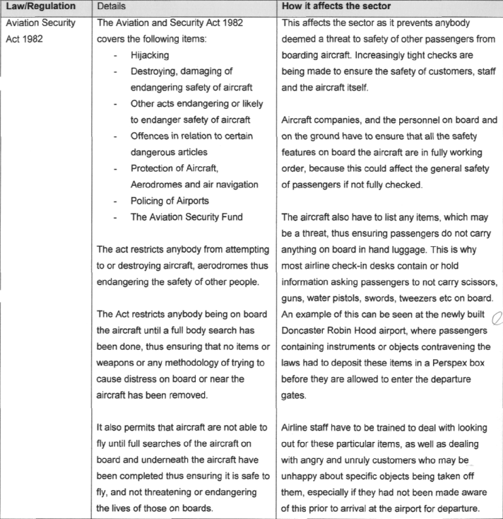

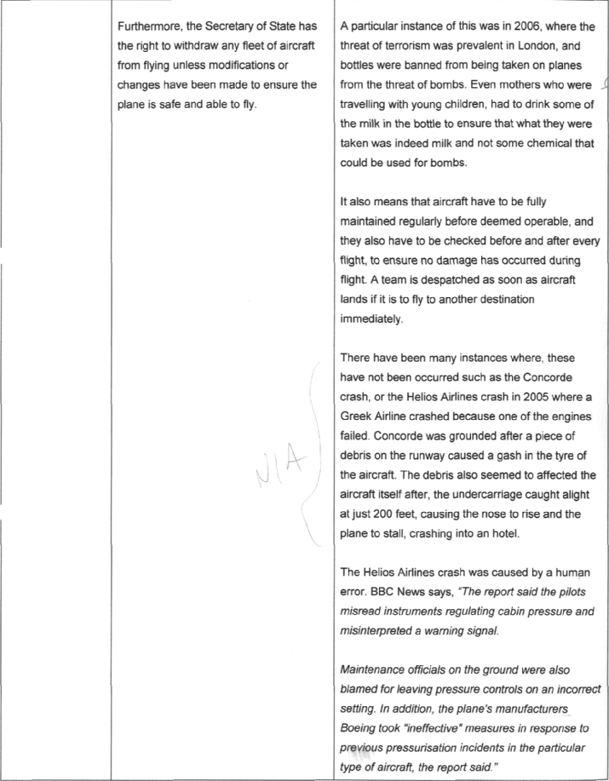

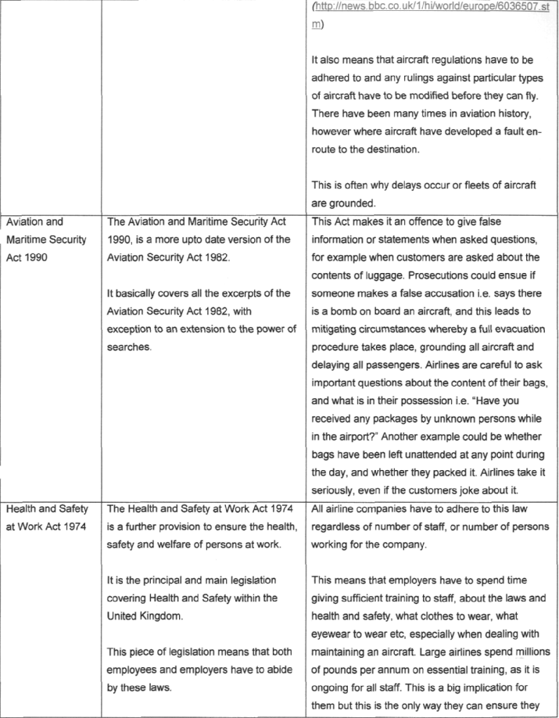
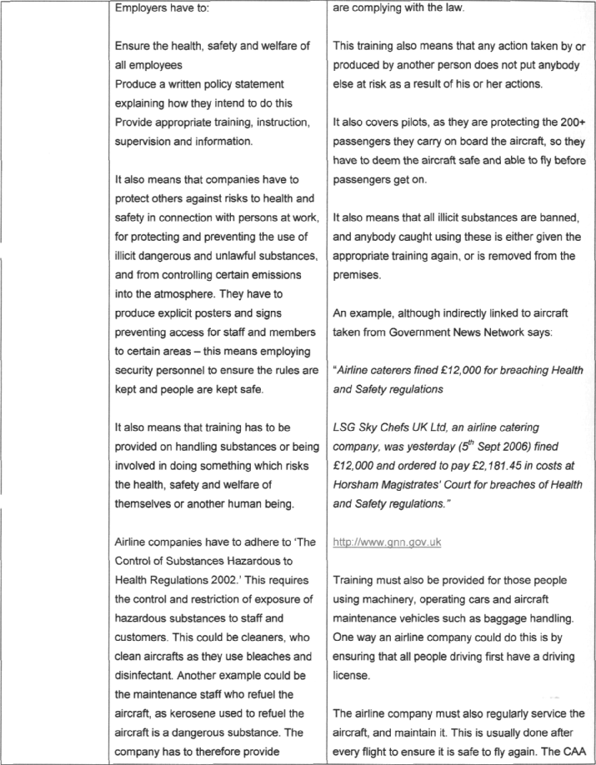
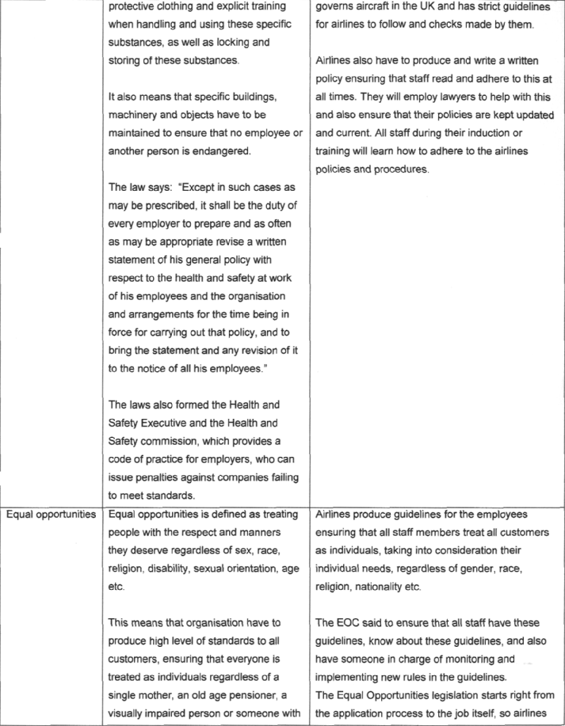
Travel Organisations Task c) Extract Commentary

The extract addresses three areas of legislation and regulation. Much of the content is descriptive rather than analytical but it does include some analysis. It is clearly related to the sector in terms of how the regulation/legislation affects the operations and specific examples are given.

This candidate is working at mark band 2. The analysis needs more clarity and detail to move into mark band 3 for this part of the task.
SAMPLE ASSIGNMENT UNIT 12: TRAVEL ORGANISATIONS

This is the fourth and final assignment for this unit. It is an individual assignment. You may work with others in the class for the research although you should note that this could affect the mark awarded for task c) in the unit as for the higher grades you must include evidence of research undertaken independently.

For this assignment you will be investigating and reporting on the visitor attractions sector of the travel and tourism industry.

Scenario
You are working for the Association of Leading Visitor Attractions (ALVA). ALVA have been asked to submit a report for the Parliamentary Tourism Select Committee on the influence of your members on the visitor attractions sector of the travel and tourism industry. Concern has been expressed that your members are too dominant and so are restricting their opportunities for growth.

The Chairman has asked you to prepare a report for him to prepare him for the committee meeting.

Task
Evaluate the degree of influence held by key organisations in the sector and the connections between the sector and others in the travel and tourism industry

In your evaluation ensure you make reference to:
- Key organisations in the sector
- Other types of organisations
- A range of current statistical data
- The connections between the sector and other sectors in the travel and tourism industry

In your evaluation also ensure you
- Accurately interpret the data you use
- Use your data appropriately
- Give reasoned conclusions
- Substantiate your conclusions

You should also include a bibliography of sources used in your research for the report. You should also reference sources where quotes are used.

Evidence
The report

Assessment
There are 18 marks available for this task. Marks are awarded according to the criteria in the unit assessment grid.

