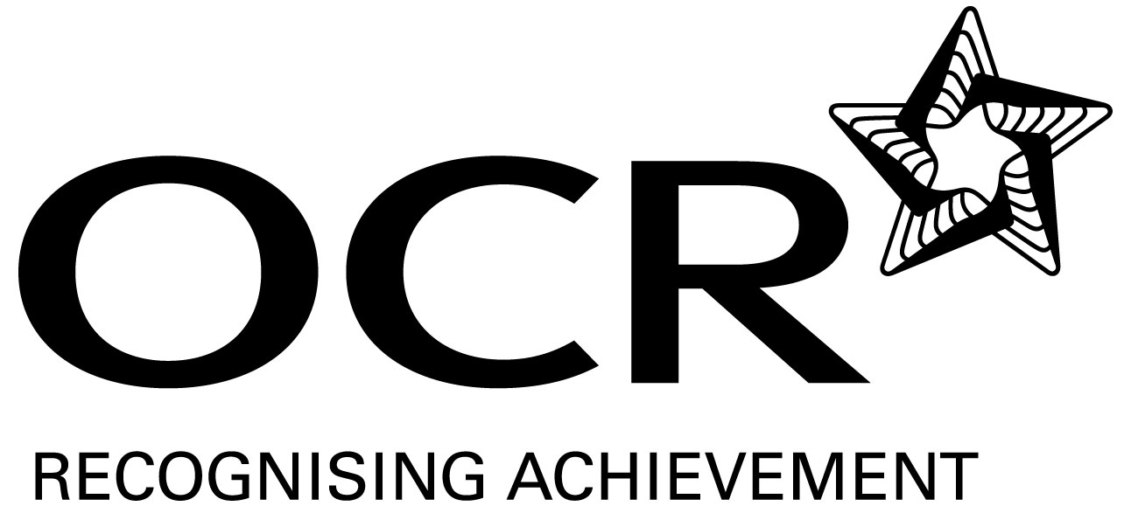
Support Material
GCE Modern Foreign Languages
OCR Advanced Subsidiary GCE in Portuguese: H196
Unit: F887

This Support Material booklet is designed to accompany the OCR Advanced Subsidiary GCE specification in Portuguese for teaching from September 2008.

Contents
Contents 2
Introduction 3
Portuguese H196: Listening, Reading and Writing 1: F887 5
Sample Lesson Plan: Portuguese H196 Listening, Reading and Writing 1: F887 8
Other forms of Support 9

Introduction

Background
A new structure of assessment for A Level has been introduced, for first teaching from September 2008. Some of the changes include:
- The introduction of stretch and challenge (including the new A* grade at A2) – to ensure that every young person has the opportunity to reach their full potential
- The reduction or removal of coursework components for many qualifications – to lessen the volume of marking for teachers
- A reduction in the number of units for many qualifications – to lessen the amount of assessment for learners
- Amendments to the content of specifications – to ensure that content is up-to-date and relevant.
OCR has produced an overview document, which summarises the changes to Portuguese. This can be found at www.ocr.org.uk, along with the new specification.
In order to help you plan effectively for the implementation of the new specification we have produced this Scheme of Work and Sample Lesson Plans for Portuguese. These Support Materials are designed for guidance only and play a secondary role to the Specification.

Our Ethos
All our Support Materials were produced ‘by teachers for teachers’ in order to capture real life current teaching practices and they are based around OCR’s revised specifications. The aim is for the support materials to inspire teachers and facilitate different ideas and teaching practices.

Each Scheme of Work and set of sample Lesson Plans is provided in:

- PDF format – for immediate use

- Word format – so that you can use it as a foundation to build upon and amend the content to suit your teaching style and students’ needs.

The Scheme of Work and sample Lesson plans provide examples of how to teach this unit and the teaching hours are suggestions only. Some or all of it may be applicable to your teaching.

The Specification is the document on which assessment is based and specifies what content and skills need to be covered in delivering the course. At all times, therefore, this Support Material booklet should be read in conjunction with the Specification. If clarification on a particular point is sought then that clarification should be found in the Specification itself.

A Guided Tour through the Scheme of Work


= Innovative Teaching Idea
All the teaching ideas contained in the SOW are innovative, but the icon is used to
Highlight exceptionally innovative ideas.

= Stretch & Challenge Activity
This icon is added at the end of text when there is an explicit opportunity to offer
Stretch and Challenge.

= ICT Opportunity
This icon is used to illustrate when an activity could be taught using ICT facilities.

Portuguese H196: Listening, Reading and Writing 1: F887
Suggested teaching time | 8 hours | Topic | Education and training: individual experiences, local and national concerns
Skills | Suggested teaching and homework activities |  | Suggested resources | Points to note
Listening | - Extract 1 (Brazilian) ‘Exame nacional do Ensino Médio’. Students listen to the extract for gist comprehension of what the various speakers say.  - Extract 2 (Portuguese) ‘Jovens e a Tecnologia’. Non-verbal answers.  - Extract 3 (Portuguese) ‘Alunos do básico e secundário querem fim dos exames nacionais’. Students watch the vídeo. |  | - Texts taken from the internet.  - Printed texts, from a text book, magazine or a past examination paper can be recorded by the teacher.  - Many texts are available on-line, eg http://video.globo.com , http://tek.sapo.pt and www.tvnet.pt.  - Many are also available on radio and television, eg RTP Internacional. | - For higher ability students, specific questions on the contents of the extracts can be asked.  - Portuguese and Brazilian terminology can be pointed to and entered in a list of vocabulary.  - Students can interview each other, in Portuguese, on their views on and experience of public examinations in the UK.  - Many are short, eg 2 minutes. The teacher can select extracts from the usually longer texts. This could be done weekly as a quick starter activity.
Speaking  = Innovative teaching idea  = Stretch and challenge opportunity idea  = ICT opportunity | - Exam-style role-play based on individual experiences of work and training.  - Students prepare a presentation on the importance of specific school subjects, eg Languages.  - Class discussion on school to work preparations. |  | - Extracts or short articles from Portuguese-language and English newspapers and magazines or past exam paper.  - Magazines and newspapers or the internet can be used for research eg the magazines Visão, IstoÉ, Veja and the sites indicated above. | - The teacher could work individually with students, or students could work in pairs, with one given the examiner’s role to prepare.  - Where possible, presentations can be prepared in pairs.  - Higher ability students can point to practices and their advantages and/or disadvantages in Portuguese- and non-Portuguese-speaking countries.
Reading  = Innovative teaching idea  = Stretch and challenge opportunity idea  = ICT opportunity | - Students read a variety of texts similar to those used for Listening and Speaking and answer general comprehension questions, in Portuguese. The same texts can be used to practice transfer of meaning.  - Independent study: students can find material in which young people describe their educational and work experiences.  - Portuguese-language text on public examination results with short answers required in Portuguese testing gist and detail. |  | - Magazines and newspapers or the internet.  - Internet news sites in addition to those mentioned above, eg www.portugaldiario.iol.pt and http://noticias.terra.com.br/educacao or extract from a magazine. | - Reading comprehension and transfer of meaning tasks should be set regularly from the start of the course.
Writing | - Students write a detailed CV for the purposes of a job application.  - Students summarise main points and write a reaction in response to an article on O Estatuto do Aluno (c150 words).  - Essay (c400-600 words) on Segurança nas Escolas. |  | - Text taken from a magazine or the internet. | - Exercises could be set regularly to enhance quality of language.  - Students should be encouraged to answer in detail and include recommendations for the future.
Consolidation | - Students should be tested regularly on the vocabulary associated with this topic.  - Students should be encouraged to read and listen independently.  - The teacher can provide lists of vocabulary.  - Past paper questions can be attempted in preparation for the examination. |  | - Students should be encouraged to compile their own lists of vocabulary from texts used or from the results of their independent research.  - Students can access websites that have been indicated above and others independently.  - Past papers.  - Texts previously used. | - Testing once a week can be done as a starter.  - Exercises could be set regularly for homework to consolidate knowledge of grammar and vocabulary.  - Students should be encouraged to use the full range of AS structures in their spoken and written answers.

= Innovative teaching idea
= Stretch and challenge opportunity idea
= ICT opportunity
= Innovative teaching idea
= Stretch and challenge opportunity idea
= ICT opportunity

Sample Lesson Plan: Portuguese H196
Listening, Reading and Writing 1: F887

Using grammatical markers
OCR recognises that the teaching of this qualification will vary greatly from school to school and from teacher to teacher. With that in mind, this lesson plan is offered as a possible approach but will be subject to modifications by the individual teacher.
Lesson length is assumed to be one hour.

Learning objectives for the lesson
Objective 1 | Students should be able to listen to a text for gist and detail.
Objective 2 | Students are able to use grammatical markers to find correct answers.
Objective 3 | Students consolidate topic-specific vocabulary, heard in context.

Insert Recap of previous experience and prior knowledge
- If possible, students should be asked in pairs to brainstorm vocabulary relating to Education. If not, the teacher can discuss the topic with the students.

Content
Time | Content
5-10 minutes | Brainstorm activity to revise vocabulary. Introduction of essential new vocabulary, pointing to main differences between European and Brazilian Portuguese.
10-15 minutes | Each student should be given a copy of a set of questions on the recorded extract to be played (from a piece from the internet or a past paper or a magazine). Some questions, aimed at the more able students, can be more demanding.
5 minutes | Students can give a rough understanding of the content of the text.
10-15 minutes | Students listen to the text, either individually or as a class, and tick the correct answers.
5 minutes | Pupils feed back their answers.

Consolidation
Time | Content
5-10 minutes | Students discuss some of the structures and vocabulary heard in the recorded texts that are conveyed differently in the written questions. If necessary, differences in the sounds of spoken European and Brazilian Portuguese could be discussed. New vocabulary is explained and noted.

Other forms of Support
In order to help you implement these new specification effectively, OCR offers a comprehensive package of support. This includes:

OCR Training

Get Ready…introducing the new specifications
A series of FREE half-day training events are being run during Autumn 2007, to give you an overview of the new specifications.

Get Started…towards successful delivery of the new specifications
These full-day events will run from Spring 2008 and will look at the new specifications in more depth, with emphasis on first delivery.
Visit www.ocr.org.uk for more details.

Mill Wharf Training
Additional events are also available through our partner, Mill Wharf Training. It offers a range of courses on innovative teaching practice and whole-school issues - www.mill-wharf-training.co.uk.

e-Communities
Over 70 e-Communities offer you a fast, dynamic communication channel to make contact with other subject specialists. Our online mailing list covers a wide range of subjects and enables you to share knowledge and views via email.
Visit https://community.ocr.org.uk, choose your community and join the discussion!

Interchange
OCR Interchange has been developed to help you to carry out day to day administration functions online, quickly and easily. The site allows you to register and enter candidates online. In addition, you can gain immediate a free access to candidate information at you convenience. Sign up at https://interchange.ocr.org.uk

Published Resources
Published Resources
OCR offers centres a wealth of quality published support with a fantastic choice of ‘Official Publisher Partner’ and ‘Approved Publication’ resources, all endorsed by OCR for use with OCR specifications.

Publisher partners
OCR works in close collaboration with three Publisher Partners; Hodder, Heinemann and Oxford University Press (OUP) to ensure centres have access to:

- Better published support, available when you need it, tailored to OCR specifications
- Quality resources produced in consultation with OCR subject teams, which are linked to OCR’s teacher support materials
- More resources for specifications with lower candidate entries
- Materials that are subject to a thorough quality assurance process to achieve endorsement

Oxford University Press (OUP) is the publisher partner for OCR GCE Modern Foreign Languages

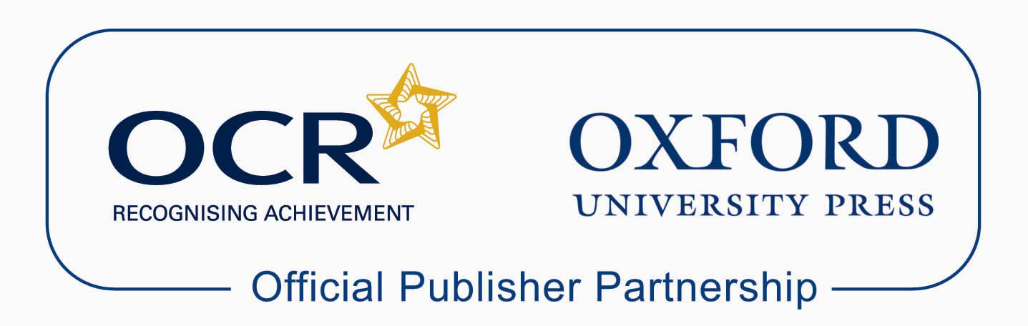

Approved publications
OCR still endorses other publisher materials, which undergo a thorough quality assurance process to achieve endorsement. By offering a choice of endorsed materials, centres can be assured of quality support for all OCR qualifications.

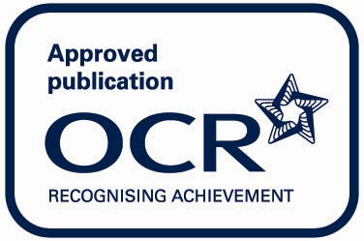

Endorsement
OCR endorses a range of publisher materials to provide quality support for centres delivering its qualifications. You can be confident that materials branded with OCR’s “Official Publishing Partner” or “Approved publication” logos have undergone a thorough quality assurance process to achieve endorsement. All responsibility for the content of the publisher’s materials rests with the publisher.

These endorsements do not mean that the materials are the only suitable resources available or necessary to achieve an OCR qualification. Any resource lists which are produced by OCR shall include a range of appropriate texts.

