The Strange Case of Mrs Hudson’s Cat
by Colin Bruce

Synopsis

Sherlock Holmes, and his trusty assistant Dr Watson rent a residence together in London. Mrs Hudson is the owner of the apartment. In the story, her cat, Henrietta is receiving a lot of unwanted attention from the local stray tom cats. As this frightens Mrs Hudson, Dr Watson and Holmes have been told to scare off any cats they may see approaching Henrietta.

One night, Holmes leaves the door ajar, and Henrietta escapes out into the fog of London. Sherlock and Dr Watson go off in search of the cat. On returning, they bump into an old friend, Lestrade, who seems puzzled.

Lestrade proceeds to tell the pair about his problem:

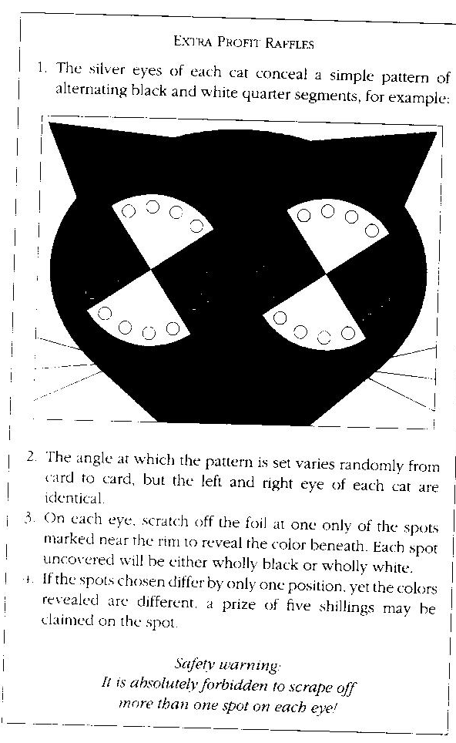
The trio discuss various theories about how to win the lottery, which are promptly foiled by tests already carried out at Scotland Yard, where Lestrade works.

After staying up all night, Holmes’s ideas are still disproved.

Eventually, the three of them, decide to consult with Professor Challenger at the Imperial College. They find Challenger in the basement standing over a set of apparatus. The equipment allows him to detect photons through polarizing filters. As Holmes explains the situation, it becomes clear that it is similar to what Challenger is working on.

As the professor explains what he has been investigating, it is evident that he may have the solution to Watson and Holmes’s problem.
“The two photons are like the left and right eyes of the cat. Setting the two filter angles corresponds to choosing sports to rub off. Setting the filters to the same angle is like rubbing the same spot off each eye, setting them to right angles corresponds to rubbing off spots at right angles, and so forth”.

As they figure out how this is practised, they realise that the inventor is above their abilities, and they all want to meet the person responsible.

What I thought:

I found this book quite challenging to read and understand, as I don’t know much about the theories talked about in the story. I did find it interesting in that they were able to come up with a number of hypotheses, which to me were quite logical, once explained. However the final conclusion was far beyond my knowledge.

