Book Review – The Case of the Missing Neutrinos by John Gribbin

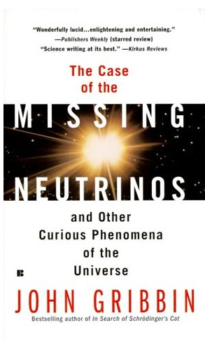
This book is essentially a series of short papers on some of the more curious elements of physics. I believe that this idea is very effective; as it means that the reader does not get bogged down on one specific subject, as the writer moves from topic to topic, spending only 15 or so pages on each problem.

I believe that this makes the book far more accessible and interesting to read, as it is put forward in small bite size chunks. For example, you can read about “waiting for the next ice age” in a few minutes, and then you don’t feel necessarily that you have to keep reading, as the next chapter is on an entirely different topic. This is not to say that the book feels like a mismatch of different papers, and you do get the feeling that this is one coherent book as John Gribbin finds a way to effectively link each chapter. He also finds good ways to incorporate history into the book, without getting bogged down in it, the historical information also being relevant and useful.

Overall this is a very compelling and interesting read, and it makes you think about physics. This book answers questions, but also asks a lot with the clear intention to activate a curious mind. For example, the book made me question many things that I have never previously considered, for example whether if they had survived would the dinosaurs have developed into beings much like ourselves, and would aliens resemble us rather than the fantastical ideas dreamt up by science fiction? Gribbin came up with some fascinating arguments and suggestions for the answer of this problem, but resolved that there is no definitive answer, so left it open for the reader’s own interpretation.

The author writes in a clear and concise manner, although that said, I do not feel that this book is for the casual reader. There are a few quite difficult concepts and terminology is often quite advanced, so I think that the reader would at least need to be of an AS level to appreciate the language used.

