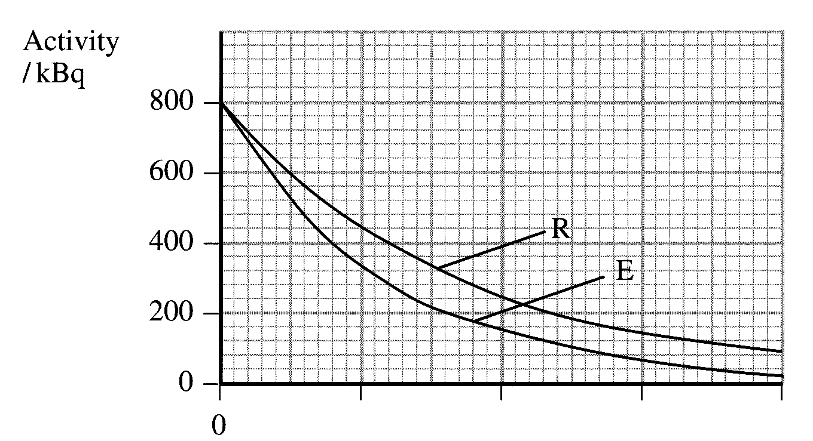
4. (a) Graph R shows the radioactive
decay of technetium ^{99m}Tc which
has a radioactive half-life of 6 hours.
Graph E shows the observed decay
of the same isotope when it is used
in a tracer investigation in a patient.
(i) On a copy of this graph, label
the x-axis. [1]
(ii) Use graph R to add a scale and units
to the x-axis. Show how you did this on
your copy of the graph. [2]
Use graph E to calculate the biological half-life
of the isotope in this investigation. [3]

(b) (i) Molybdenum ⁹⁰₄₂Mo decays to ^{99m}Tc by beta-minus emission.
Write a balanced nuclear equation for this decay. [1]
(ii) In what is radioactive molybdenum produced? [1]
(iii) Describe and explain the process of elution that is used to extract the ^{99m}Tc from an elution cell. You may be awarded a mark for the clarity of your answer. [4]
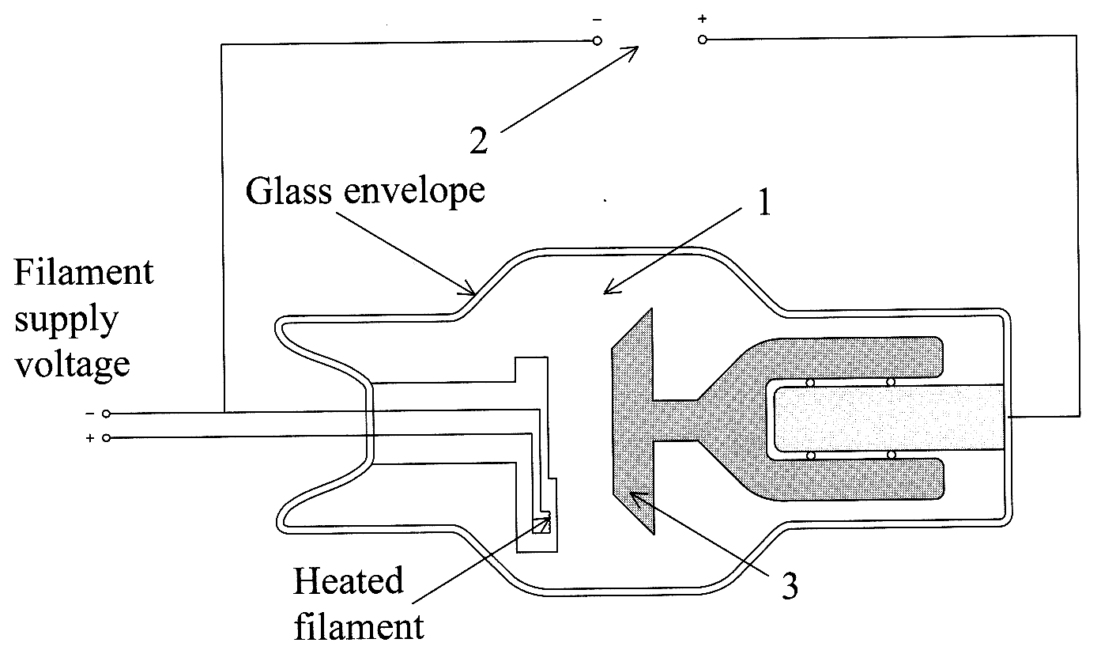
(iv) Technetium ^{99m}Tc decays by gamma emission.
Write a balanced nuclear equation
for this decay. [1]
(v) The product of this decay has a
half-life of 210 000 years.
Explain the importance of this
long half-life when ^{99m}Tc is
used as a tracer. [2]

(c) In X-ray diagnosis the
absorption of keV X-rays is
highly dependent on Z.
(i) State what Z represents in this context. [1]
(ii) Explain the relevance of the value of Z
in the production of radiographic images. [2]
The diagram shows a rotating anode X-ray tube.
(iii) Name and explain the function of the numbered parts
of the X-ray tube. [6]
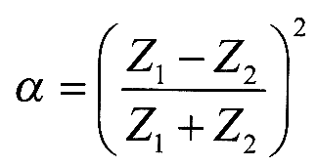
(d) In ultrasonic diagnosis the reflection coefficient a can be written as:
(i) State what is represented by Z₁ and Z₂ in this equation. [2]
(ii) Show that the units of Z are kg m² s⁻¹. [2]
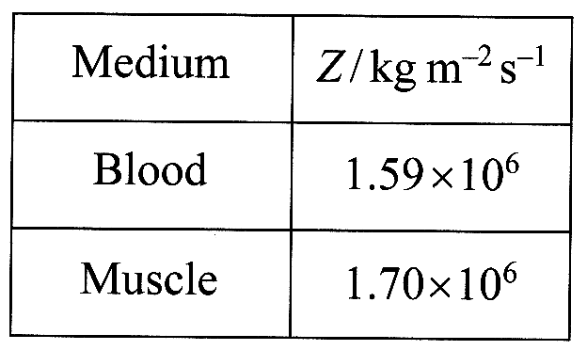
(iii) Calculate the reflection coefficient using the data
given opposite. [2]
(iv) Hence find the percentage of the incident ultrasound that
will be transmitted through a muscle-blood boundary. [2]

Total 32 marks

