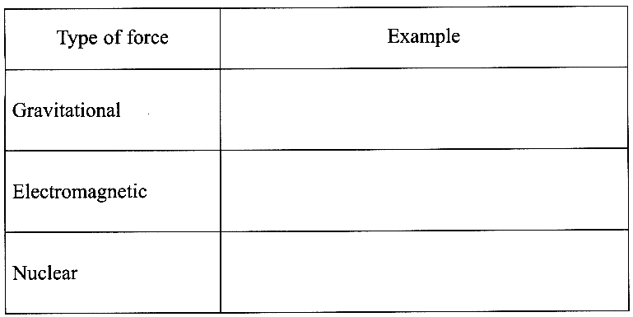
1. Complete the table opposite by giving one example
of each type of force. (3)

The diagram below shows forces acting on the Sun and
the Earth. These forces form a Newton's third law pair.
State three properties of these forces which are
necessary for them to be a Newton's third law pair. (3)
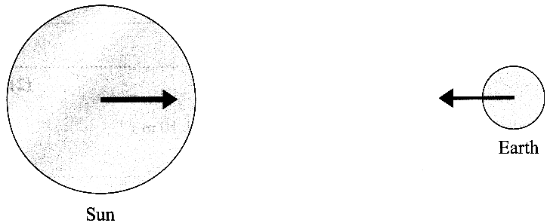

2. A man is pushing a shopping trolley at a speed of 1.10ms⁻¹ along a horizontal surface. There is a constant frictional force opposing the motion. The man stops suddenly, letting go of the trolley, which rolls on for a distance of 1.96 m before coming to rest. Show that the deceleration of the trolley is approximately 0.3 m s⁻². (3)
The total mass of the trolley and its contents is 28.0kg. Calculate the frictional force opposing its motion. (2)
Calculate the power needed to push the trolley at a steady speed of 1.10 m s⁻¹. (2)
The man catches up with the trolley.
Calculate the steady force he must now apply to it to accelerate it from rest to 1.10m s⁻¹ in 0.900 s. (3)
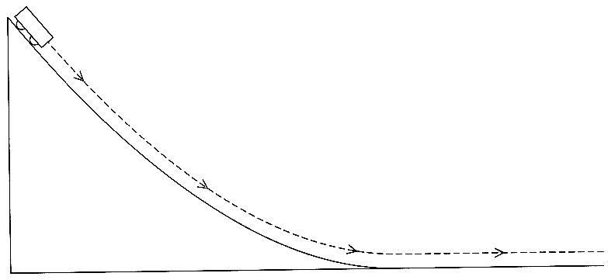
3. A Physics teacher is demonstrating conservation
of energy. She sets up a curved runway releases an
initially stationary trolley from the top.
She tells the class that, as the trolley runs down the
slope, its gravitational potential energy is converted into
kinetic energy. Explain why this is only
approximately true. (1)

Describe an experiment she could perform to find
out what percentage of the gravitational potential
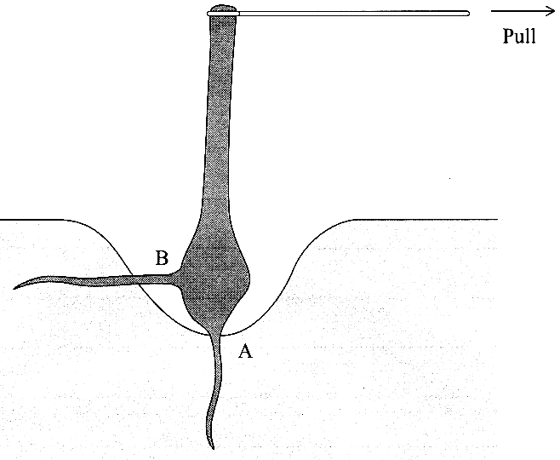
energy lost is actually converted tokinetic energy. Your answer should include:
(i) any additional apparatus required (add this to a copy of the diagram),
(ii) how the apparatus is used,
(iii) how the results are analysed. (6)

4. A gardener is trying to remove a tree stump. He has dug away the
soil around it, but it is still anchored by a vertical root at A
and a horizontal root at B.
The gardener pulls horizontally on the top of the stump with a force
of 310 N, but it does not move.

The second diagram shows some of the horizontal forces on the stump.
Force X is the tension in the root at B.
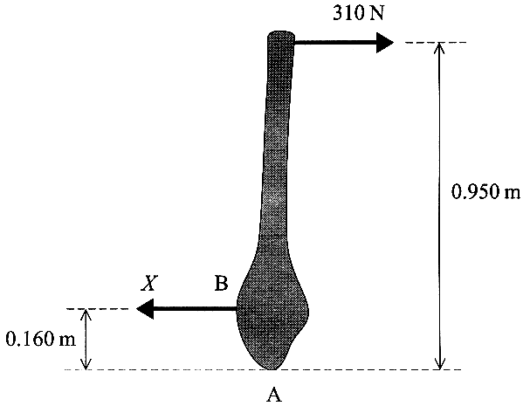
One horizontal force is missing from the diagram.
Add an arrow to a copy of this diagram to represent this force and label it Y. (1)

Using the principle of moments, determine force X.
(You should ignore the vertical forces on the tree stump.) (2)

Explain why, in this moments calculation, it is reasonable to ignore the
vertical forces on the stump. (1)

Calculate force Y. (2)

If a tree stump is to be removed, it is a mistake to cut it off very
close to the ground first.
Using the concept of moments, explain why. (2)

5. A model truck A of mass 1.2 kg is travelling due west with a speed of 0.90 m s⁻¹.
A second truck B of mass 4.0 kg is travelling due east towards A with a speed of 0.35 m s⁻¹.
Calculate the magnitude of the total momentum of the trucks. (2)
The trucks collide and stick together. Determine their velocity after the collision. (3)
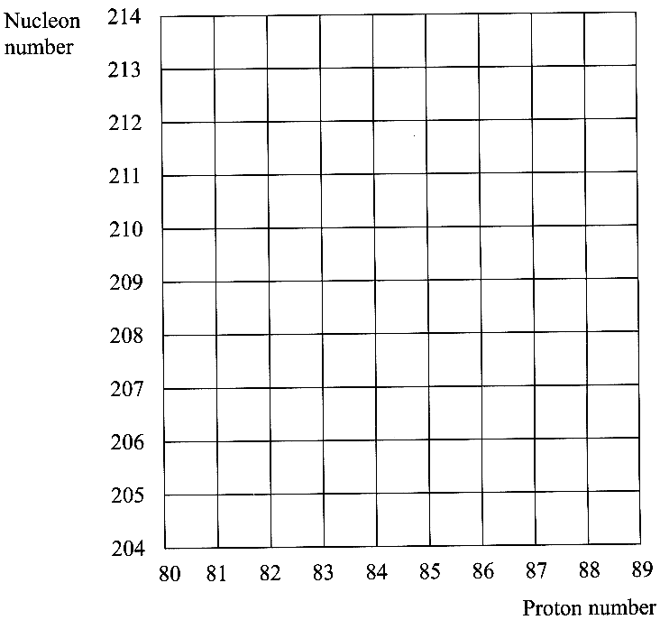
6. What are isotopes? (1)
A nucleus of an isotope of polonium (symbol Po)
has 84 protons and 126 neutrons. Mark the position
of this nucleus on a copy of the grid opposite, and label it Po.

This isotope of polonium decays by alpha particle
emission into an element X. Starting from Po, add a
line to your copy of the grid to represent this decay. (3)

This isotope of polonium is thought to emit only
alpha radiation.
Describe how you could check this experimentally. (3)

7. The range of nuclear radiation in matter depends on
how strongly the radiation ionises matter.
Explain the meanings of the terms 'range' and 'ionises'. (2)

State and explain the qualitative relationship between
range and ionising ability. (2)

Beta radiation from a certain source can be stopped
completely by a sheet of aluminium 3.0 mm thick.
Calculate the mass of a square sheet of aluminium of this thickness measuring 1.0m x 1.0m.
(Density of aluminium = 2.7 x 10³ kgm⁻³ ) (2)

To a fair approximation, the ability of any sheet of material to stop beta radiation depends only on the mass per square metre of a sheet of the material. Estimate the thickness of lead sheet needed to stop the same beta radiation completely.
(Density of lead = 11.3 x 10³ kgm⁻³ ) (2)
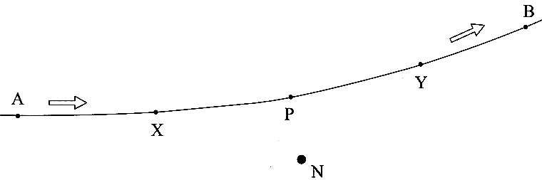
8. In the Rutherford scattering experiment, fast-moving alpha particles were fired at a thin gold foil.
What observations from this experiment suggested that the atom has a small, massive nucleus? (2)

The first diagram opposite shows the path
followed by one alpha particle which passes
close to a gold• nucleus N.

Add arrows to a copy of this diagram at points X and Y
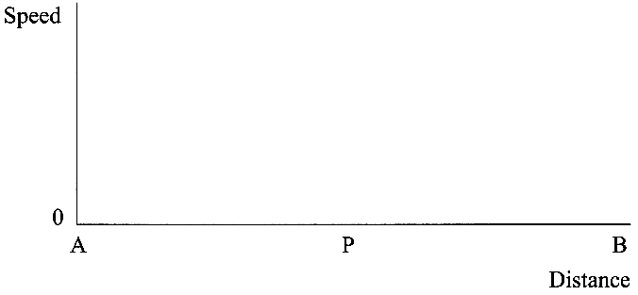
to show the direction of the force on the alpha particle
when it is at each of these points. (1)

The speed of the alpha particle was the same at points A and B.
On a copy of the axes opposite, sketch a graph showing how
the speed would vary with distance along the path from A to B.. (2)

With reference to the forces you added to the previous diagram,
explain the shape of the graph. (2)
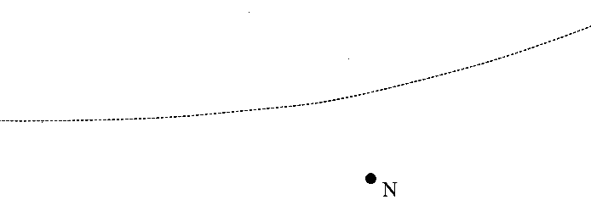
The diagram opposite shows the path of the alpha particle again.
Add a line to a copy of this diagram to show the path which
would be followed by an alpha particle which was travelling
initially along the same line as before, but more slowly. (1)

The evidence for a small, massive nucleus from Rutherford scattering might have
been less convincing if the alpha particles used had been of lower energy.
Suggest how the observations would have changed if lower energy alpha particles had been used. (1)

TOTAL FOR PAPER: 60 MARKS

