Topic B - Solid Materials

2. (a) Typical stress-strain curves for two metals, A and B, up to their breaking points are shown below.

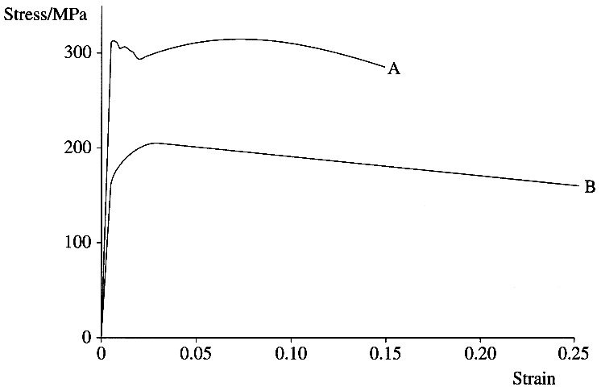
Which metal is stiffer? Justify your answer. (1)
Stating appropriate magnitudes where possible, explain which metal is (i) stronger (ii) more ductile (2)
The two metals are mild steel and copper. Identify A and B. (1)
Estimate the work done per unit volume in stretching material A to its breaking point. (3)

High carbon steel can be made harder and more brittle if it is quench hardened.
State what is involved in this process. (2)

(b) Draw a labelled diagram of the apparatus you could use in a school laboratory to determine the Young modulus of copper in the form of a wire. (3)
Suggest an appropriate length for the wire being tested.
How would you determine the cross-sectional area of the wire? (3)

State the unit of k, the constant of proportionality in Hooke's law. (1)
Show that for a wire of length l and cross-sectional area A the Young modulus E = k l / A. (3)

(c) Describe how a pre-stressed reinforced concrete beam is produced. You may be awarded a mark for the clarity of your answer. (4)

(d) Read the short passage below and answer the questions about it.

Copper deforms and breaks at stresses much lower than its 'theoretical' strength. Most successful attempts to increase the strength of crystalline materials have centred upon stopping the movement of dislocations by introducing defects into the lattice or by creating a tangle of dislocations. Weak materials can also be strengthened by including tough filaments such as glass fibres in them. Unfortunately, increasing the number of obstacles also interferes with the movement of electrons in the material. A new family of composites has been developed featuring much finer filaments which are much more closely spaced. A tangle of ultrafine niobium filaments (10 nm thick) in copper increases the copper's strength ten-fold. The filaments occupy only 18% of the volume and the high conductivity and ductility of the copper are retained.

Draw labelled diagrams to show the way in which a dislocation in a lattice moves. (3)

State two differences between the filaments in the new and traditional composites. (2)

Calculate the ratio
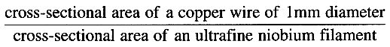 (2)

State two advantages of using ultrafine niobium filaments to strengthen copper wire. (2)

(Total 32 marks)

