1. Bubble chambers can be used to observe the tracks of charged particles through magnetic fields. As charged particles pass through the liquid they cause ionisation which triggers the formation of bubbles, recording the tracks of the particles.
The photograph below shows the spiral track of an electron in a bubble chamber

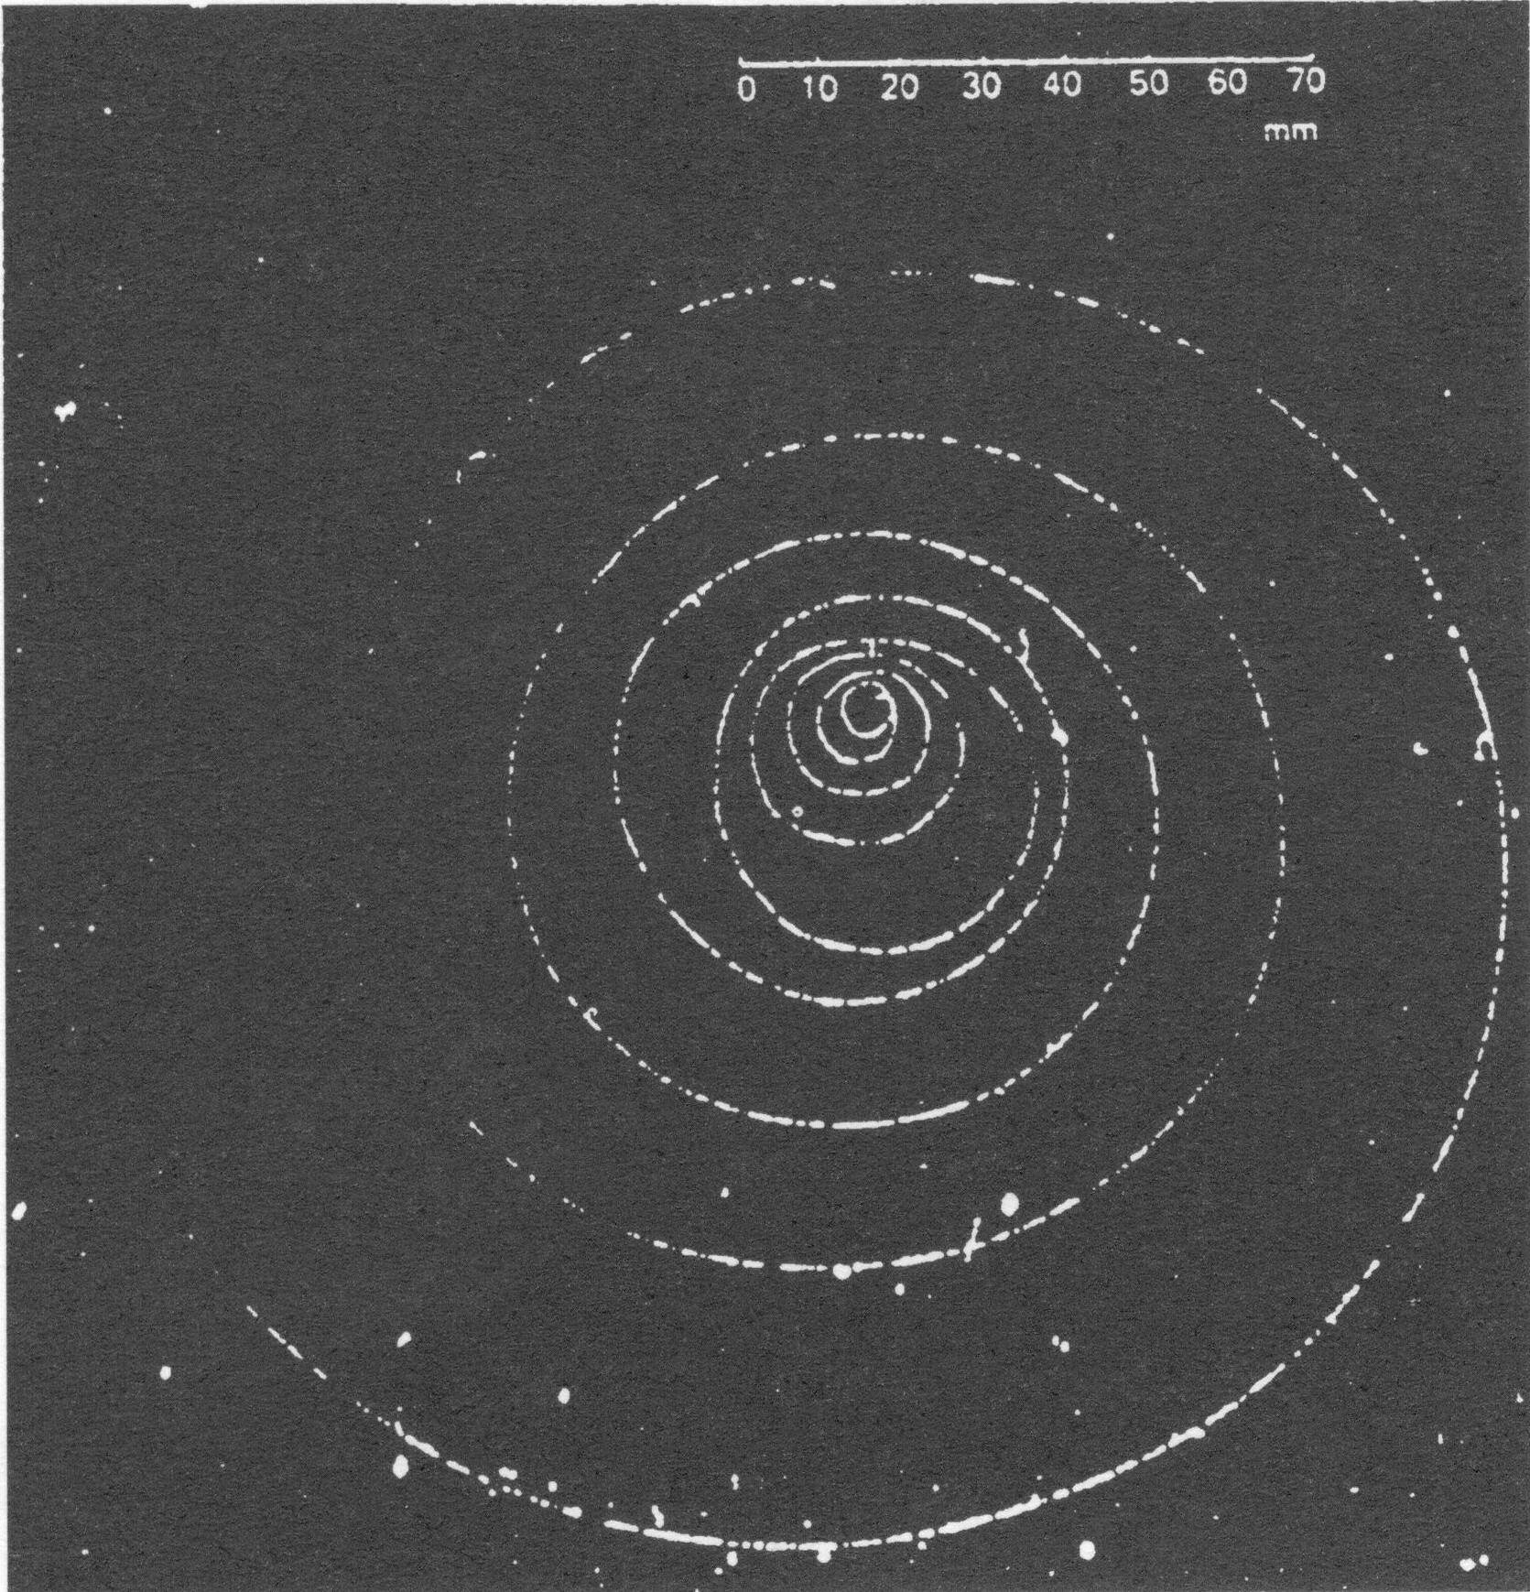

State whether the electron is travelling clockwise or anticlockwise.

(1)
Explain why the track is curved, and why it has a spiral shape.

(3)
Take measurements from the photograph to estimate the maximum momentum of the electron in kg m s± (Magnetic flux density = 4.0 T)

Momentum =...............kg m s~
(3)

The diagram below shows a second set of tracks, produced by an event which occurs at point X.

It is thought that the event which occurs at X is:

photon → electron + positron

Give two ways in which the tracks are consistent with this interpretation.

(2)

Explain how this event obeys two conservation laws.

(2)
(Total 11 marks)

2. In the TV system used in Europe, the picture consists of 625 lines scanned 25 times a second. Each line is divided into 864 pixels. To reconstruct each pixel in full colour, each pixel must be sampled in three separate colours. Each sample is transmitted as an eight bit code.

Calculate the number of bits that the system described above would need to transmit each second.

Number of bits = ___________________
(2)

Figures 1 and 2 illustrate an important step in a digital TV system. (For this illustration there are four bits per sample rather than eight.) Describe and explain what the figures illustrate.

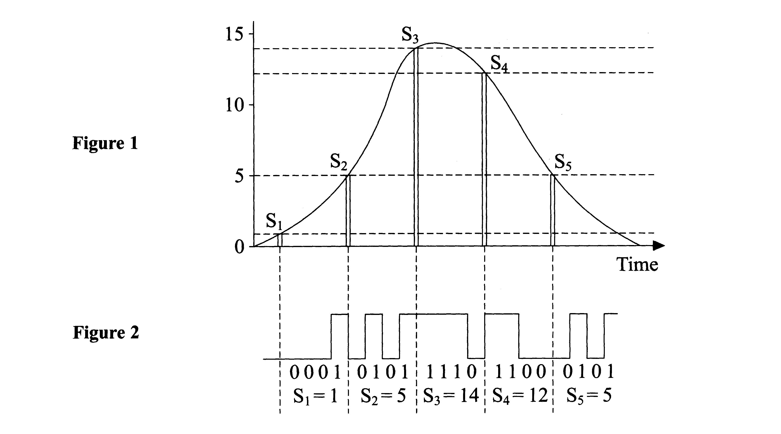

(5)

Explain how quantisation introduces distortion into the information being transmitted.

(1)

There are both advantages and disadvantages in using an eight bit code for each sample rather than a four bit code. State one advantage and one disadvantage in using the eight bit code.

Advantage

Disadvantage

(2)

(Total 10 marks)

3. A person at the equator of the Earth is moving in a circle and therefore must have a centripetal acceleration.

Explain why a person moving in a circle must have an acceleration.

(1)

Show that the centripetal acceleration of a person at the equator is about 0.03 m
(Radius of the Earth = 6.4 x 106 m.)

(3)

For a person standing at the equator, the force R from the ground is slightly different from their weight mg as shown below. State and explain which of these forces is the larger.

(2)

The size of the force R provides a measure of the apparent strength of the gravitational field. Show that the apparent field strength g at the equator differs from that at the poles by about 0.3%.

(1)

The time of swing T of a simple pendulum depends on the local value of g. Theory shows that a certain percentage variation in g causes half that percentage variation in T. This causes pendulum clocks to run at different rates in different places. Calculate by how many seconds each day a pendulum clock at the equator will differ from one at the pole.

Difference = ____________________ s
(2)

(Total 9 marks)

4. To restore a regular heart rhythm to a patient in an emergency, paramedics can use a machine called a defibrillator. The defibrillator uses a capacitor to store energy at a voltage of several thousand volts. Conducting `paddles' are placed on either side of the patient's chest, and a short pulse of current flows between them when the capacitor is discharged.

The graph below shows voltage against charge for the capacitor used in a defibrillator.

With reference to the graph, show that the energy stored in a capacitor is given by the formula W= ½ QV.

(2)

Calculate the energy stored by the capacitor when charged to 5000 V.

Energy= ........................

(1)

The graph below shows how voltage varies with time as the capacitor is discharged across a test circuit that has a resistance equivalent to that of the patient's chest.

Use the graph to find the time constant for the circuit.

Time constant = _________________
(2)

The total resistance of the circuit, including the paddles and chest, is 47 Ω. Calculate the capacitance of the capacitor.

Capacitance = _________________
(2)

The energy delivered to the patient's chest is selected by the operator from these dial settings: 50 J, 180 J, 380 J. This is achieved inside the machine electronically, by allowing the discharge to proceed for an appropriate length of time.

On one particular setting, the discharge lasts for 2.0 ms. Calculate the energy left in the capacitor at this time.

(2)

Some energy loss occurs and roughly 60% of the energy leaving the capacitor during the discharge actually goes into the patient. Find which setting the operator has selected.

Energy setting = ___________________
(2)

(Total 11 marks)
5. One type of particle detector at CERN consists of a thin wafer of silicon. On both sides of the wafer are aluminium electrodes, with a voltage of 100 V across them. The electrodes are 300μm apart. When a particle enters the wafer, it creates an electron/hole pair as shown (a hole acts like a positive electron).

Use E = V/d to calculate the electric field in the silicon wafer.

Electric field =.........................
(2)
Calculate the force due to this field on an electron in the wafer.

Force =..................................
(2)
Indicate on the diagram the direction of this force on the free electron shown. Explain why the force has this direction.

(2)
The hole can move in the direction of the electric field, provided that it can gain enough energy from the field to move it from one atom to the next. The distance between atoms is 2.8 x 10⁻¹⁰ m. Calculate how much energy the hole gains in moving this distance in the direction of the field.

Energy = ____________________
(2)
(Total 8 marks)

6. A railway company wishes to set up a fibre optic link along the track between Birmingham and London. The link is 150 km in length, and the most suitable fibre has an attenuation coefficient of 4.0 x 10⁻⁴ m⁻¹.

In order to maintain the quality of the signal, its intensity I must never fall below 50% of its original value I₀. Regenerators are placed at intervals along the fibre to boost the intensity back to I₀. Calculate the minimum number of regenerators needed along the link.

(Total 5 marks)

7. The dynamo torch, Figure 1, is operated by successive squeezes of the handle. These cause a permanent magnet to rotate within a fixed coil of wires, see Figure 2. Harder squeezes rotate the magnet faster.

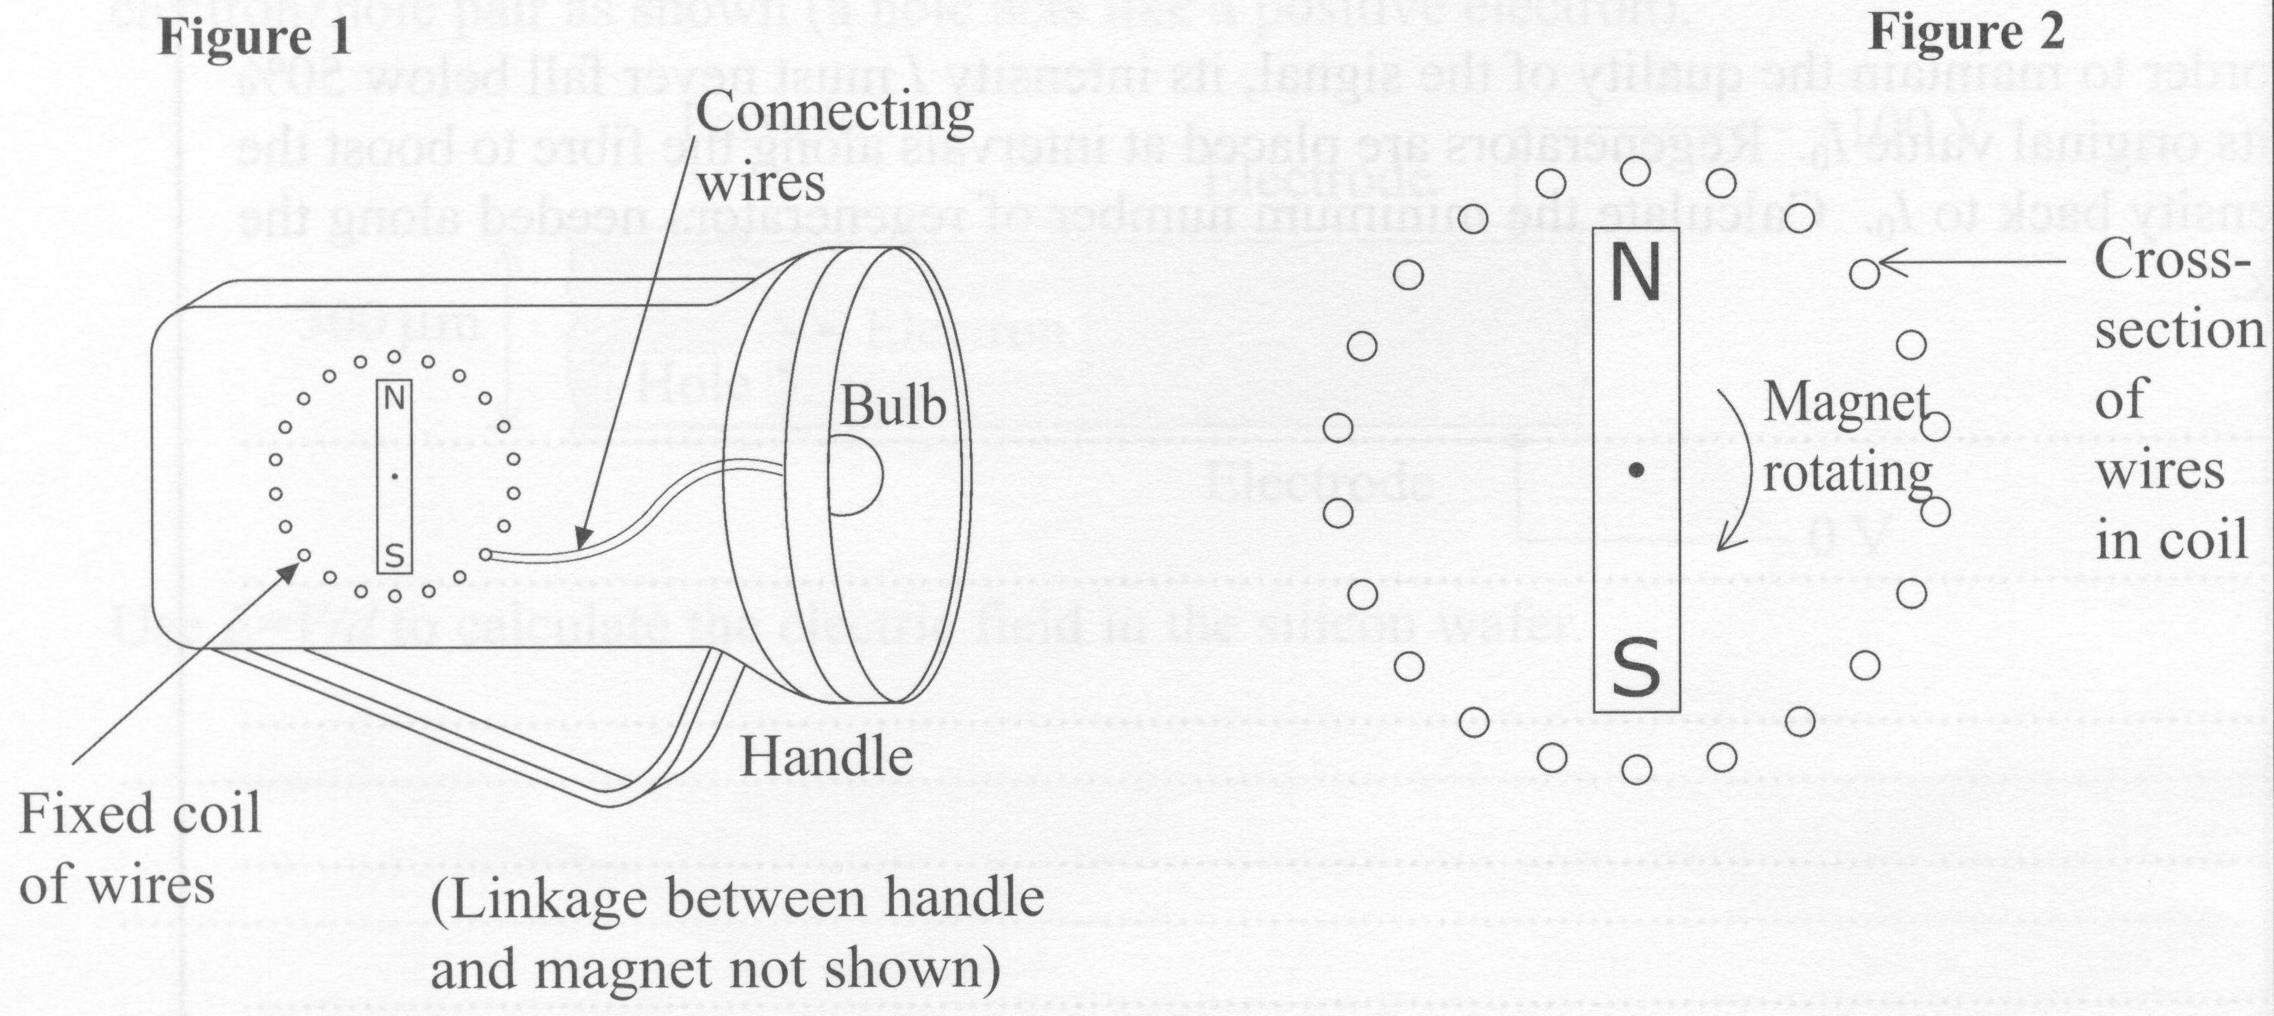

On Figure 2 sketch the field of the permanent magnet.

Discuss the physics of how the torch works and the factors which affect the brightness of the bulb.

(Total 6 marks)

