1. A lorry accelerates from rest.

The graph below shows how the momentum of this lorry varies over the first minute.

Define momentum.

(1)
State the physical quantity represented by the slope of this graph .

(2)

Determine the magnitude of this quantity at t = 20 s.

(2)
Explain the shape of this graph.

(2)

2. The photograph shows a transformer which has been cut in half. The transformer consists of primary and secondary coils wound around the same laminated iron core. The diagram shows a cross-section of the iron core and the two coils. One coil consists of a few turns of thick wire. The other coil has many turns of thinner wire.

Explain how an e.m.f. is induced in the secondary coil.

(3)

The transformer in the photograph has one coil with 32 turns of thick wire, and the other with 5 12 turns of thin wire. Either coil can be the primary. with the other being the secondary. Describe the function of the transformer when the 512 - turn coil is the primary.

(2)

When in use, the 32-turn coil always carries the greater current. Explain why this is so.

(2)
Explain why this coil is made with much thicker wire.

(2)
Suggest a reason why the core is made of thin laminated sheets of soft iron.

(3)

3. Give two reasons why Compact Discs (CDs) are now preferred to tapes by most people who buy recorded music.

(2)

The diagram below shows a CD with a scale alongside. Make suitable measurements and then calculate the area of the disc on which digital information can be stored.

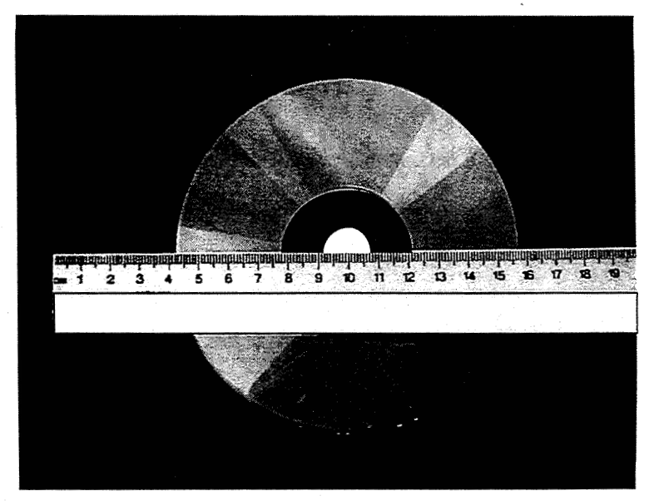

Area for storage = …………………………………….. m²
(3)

The "bumps" for each digital bit on the surface of a CD are laid down along a spiral track around the disc. Dimensions are as follows:

Length of bump along track = 0.97 μm
Width of track = 2.1 μm

Show, using your answer for the area for storage, that the disc can store about 4 gigabits (4 x 10⁹ bits) of digital information.

(2)
Sound is stored in digital form by sampling the analogue waveform 4.4 000 times each second, and encoding each sample into a 16-bit number.

Explain why 44 000 samples each second is an appropriate sampling rate.

(2)
Normally two stereo channels are recorded. Use this fact and the other information above to estimate the playing time available on a 4 gigabit music CD.

(3)

4. Consider the electric field near a single proton. Calculate the distance r from the single proton at which the field has a value 5 x 10¹⁰ V m⁻¹.

r = …………………………………………..
(3)
Using your knowledge about atoms, comment on whether your answer for r is reasonable.

(1)

5. Some radioisotopes for use in hospital treatments have short half-lives. These radioisotopes are manufactured in the hospital where they will be used. Some hospitals use a relatively cheap machine such as a cyclotron to produce a beam of high enemy protons. This beam is allowed to collide with the target material to produce the radioisotope.

In a cyclotron, the protons are accelerated by a high frequency alternating voltage. A uniform magnetic field, of strength 200 mT, causes the protons to follow a circular path which increases in radius as the protons gain kinetic energy.

Immediately before the protons leave the cyclotron they are moving in a circular arc of radius 1.5 m.

Show that the speed of these protons is about 10% of the speed of light .

(3)

Calculate the approximate time taken for the proton to complete the last semi-circle of its orbit.

Time = ..........................................................
(2)
Hence calculate the frequency of the accelerating p.d.

Frequency = .................................................
(1)

6. Most types of microphone detect sound because the sound waves cause a diaphragm to vibrate. In one type of microphone this diaphragm forms one plate of a parallel plate capacitor. As the diaphragm plate moves, the capacitance chances. Moving the plates closer together increases the capacitance. Moving the plates further apart reduces the capacitance.

This effect is used to produce the electrical signal. The circuit shaven below consists of a 3 V supply. an uncharged capacitor microphone C, a resistor R, and a switch S.

The switch S is closed. Sketch a Graph of the voltage across the capacitor microphone against time. Assume that the capacitor microphone is not detecting any sound.
(3)

Explain why movement of the diaphragm causes a potential difference (the signal) across R.

(4)

7. The results of particle collisions are observed using particle detectors. Sometimes the products of these collisions are themselves unstable and decay to give further particles; the products of decay can be photons.

In one collision, a stationary πº meson is produced which then decays to give two gamma ray photons. The rest mass of the meson is 135 MeV / c².

πº → γ + γ

Calculate the wavelength of each photon.

Wavelength=............................................
(5)

8. A mass spectrometer is used to determine the relative amounts of ions of different masses in a sample of material.

A diagram of a new type of mass spectrometer is shown below. In this mass spectrometer. a very short pulse of laser light is directed at the sample of material, which becomes ionised. Each ion has a charge of +1.6 x 10⁻¹⁹ C. This happens mid-way between a pair of parallel charged plates.

The time the ion takes to reach the detector depends on its mass. Thus the material in the original sample can be analysed.

Describe the movement of an ion from the sample to the detector. Hence explain why the time an ion takes to reach the detector depends on its mass. You should include relevant equations.

(7)

