Paper 2

1 (a) Define density and pressure.
density …………………………………………………………………………………………..
pressure…………………………………………………………………………………….. [2]

(b) Use the definitions which you have given in (a) to derive the equation

p = ρgh

for the pressure p at a depth h in a fluid of density ρ.

……………………………………………………………………………………………………………………………………………………………………………………………………………………………………………………….[3]

(c) Use your answer to (b) and Fig. 1.1 to explain why any object submerged in water is easier to lift than when not submerged.

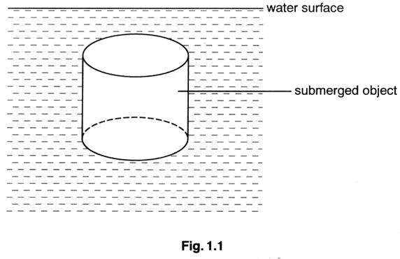

…………………………………………………………………………………………………………………………………………………………………………………………………………………………………………………………………………………………………………………………………………………………………………………………………………………………..[3]

2 Fig. 2.1 shows an electrical circuit in which the internal resistance of the battery is negligible.

Complete Fig. 2.2 by giving the electrical quantities for each of the components in the circuit. You are advised to start by completing the column for component A.

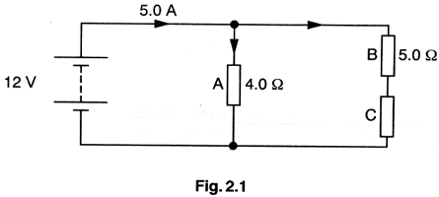
[9]

circuit component | A | B | C | whole circuit
potential  difference/V |  |  |  | 12
current/A |  |  |  | 5.0
power/W
resistance/Ω | 4.0 | 5.0
 |  | Fig.2.2

3 An aircraft flies with its wings tilted as shown in Fig. 3.1 in order to fly in a horizontal circle of radius r. The aircraft has mass 4.00 x 10⁴ kg and has a constant speed of 250 ms⁻¹.

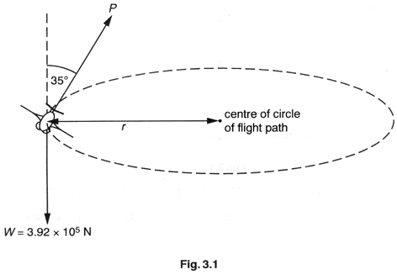
With the aircraft flying in this way, two forces acting on the aircraft in the vertical plane are the force P acting at an angle of 35º to the vertical and the weight W.

(a) State the vertical component of P for horizontal flight.
vertical component of P = …………………………………..N [1]
(b) Calculate P.

P = ……………………………………N [2]

(c) Calculate the horizontal component of P.

horizontal component of P =…………………………………N [1]

(d) Use Newton's second law to determine the acceleration of the aircraft towards the centre of the circle.

acceleration = ………………………m s⁻² [2]

(e) Calculate the radius r of the path of the aircraft's flight.

r = ………………………………..m [2]

4 (a) The waves of different frequency pass through the same point. Figs. 4.1 and 4.2 show the displacement-time graphs for the waves. On Fig. 4.3, sketch the resultant displacement showing the superposition of these two waves. [2]

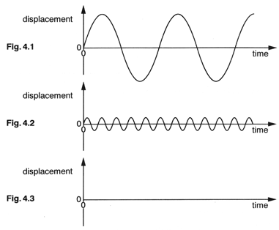

(b) Sketch on Figs. 4.4(i) and 4.4(ii) the diffraction of waves through gaps which are

(i) large compared with the wavelength,
(ii) small compared with the wavelength.

[3]
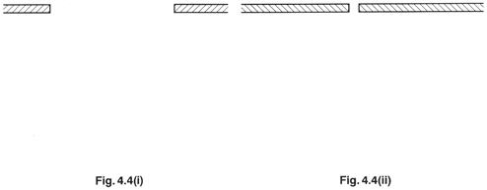

(c) Two microwave sources A and B are in phase with one another. They emit waves of equal
amplitude and of wavelength 30.0 mm. They are placed 140 mm apart and at a distance of
810 mm from a line OP along which a detector is moved, as shown in Fig. 4.5.

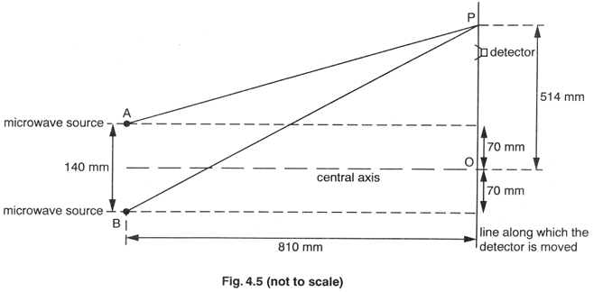
(i) Using Pythagoras' theorem, it can be shown that the distance AP is 923.7 mm. Calculate the number of wavelengths between source A and point P.

number of wavelengths between A and P = …………………..[1]

(ii) Show that there are 33.3 wavelengths between source B and point P.

[2]

(iii) 1. State what intensity of microwaves will be received by the detector when it is at P.
…………………………………………………………………………………..

2. Describe how the intensity of reception varies as the detector is moved from P to the point O on the central axis.
…………………………………………………………………………………………………………………………………………………………………………………………………………………………………………………………………………………………………………………………………………………………..[3]
5 The primary coil of a transformer has 1000 turns and is connected to a 230V r.m.s. supply. The secondary coil has 40 turns and may be connected, through a switch and a diode, to a 9.0 V rechargeable battery, as illustrated in Fig. 5.1.

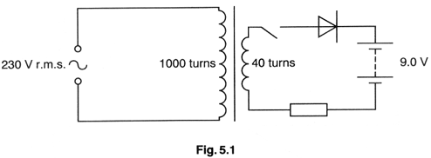

(a) Initially the switch is open. Considering both the transformer and the diode to be ideal, calculate

(i) the r.m.s. potential difference across the secondary,

r.m.s. potential difference = …………………………..V

(ii) the peak potential difference across the secondary.

peak potential difference = …………………………….V
[4]
(b) The switch is now closed so that the battery is being recharged.

(i) Suggest why the diode is necessary in the secondary circuit.
………………………………………………………………………………………………………………………………………………………………………………………………………………………………………………………………………………………………
(ii) Suggest why the resistor is necessary in the circuit.
………………………………………………………………………………………………………………………………………………………………………………………………………………………………………………………………………………………………

[4]

6 (a) Describe the phenomenon of photoelectric emission.

………………………………………………………………………………………………………………………………………………………………………………………………………………………………………………………………………………………………………………………………………………………………………………………………………………………………………………………………………………………………………………………………………………………………………………………………………………………………………….[3]

(b) Give the meaning of the following terms, as used in describing the photoelectric effect.

(i) photon
………………………………………………………………………………………………………………………………………………………………………………………………

(ii) work function energy
………………………………………………………………………………………………………………………………………………………………………………………………

(iii) threshold frequency
………………………………………………………………………………………………………………………………………………………………………………………………
[4]
(c) Calculate the energy of a photon of light of wavelength 5.89x 10⁻⁷m.

energy=………………………………J [3]

7 A specimen fiber of glass has the same dimensions as a specimen of copper wire.

The length of each specimen is 1.60 m and the radius of each is 0.18 mm. Force-extension graphs for both specimens are shown in Fig. 7.1.
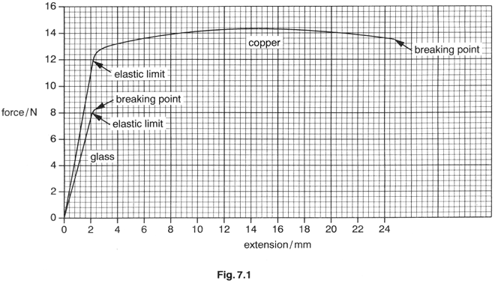

(a) (i) State which of the two materials is brittle…………………………………………..

(ii) Explain which feature of Fig. 7.1 leads you to your answer in (i).
……………………………………………………………………………………………………………………………………………………………………………………………...
[2]

(b) Using the graphs and the data given, determine

(i) the area of cross-section of each specimen,

area of cross-section = ……………………………..m² [1]

(ii) the Young modulus of the glass,

Young modulus = …………………Pa [4]

(iii) the ultimate tensile stress for copper,

ultimate tensile stress = ………….. [2]

(iv) an approximate value for the work done to stretch the copper wire to its breaking point.

work done= …………………..J [3]

8 Read the passage below and then answer the questions that follow.

When a structural engineer is designing a building there will be occasions when a beam has to be used to bridge a gap. The width of the gap is called the span. The engineer makes calculations to ensure that the beam is strong enough to withstand any forces applied to it, and to ensure that there is not too much sag in the beam. This question concerns how the choice of beam is made.
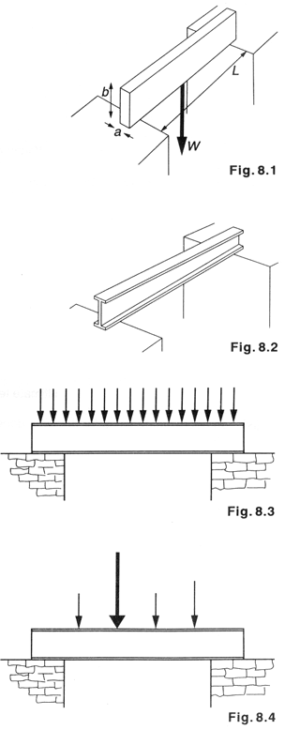

Sometimes, when the loading is small, a plain wooden beam is sufficient, as shown in Fig. 8.1. A beam such as this, loaded at its centre, will undergo a maximum depression x given by

$$x=\frac{{\text{Wl}}^{3}}{{\text{kab}}^{3}}$$

where W is the load at the centre, a is the width and b is the depth of the beam and k is a constant.

When greater loads or greater spans are required, a steel beam may be used. In order to minimize the amount of steel required the shape of the beam used is as shown in Fig.8.2.

Sometimes, the loading of the beam is uniform along its length, as shown in Fig.8.3.

Sometimes, with complex loading (Fig. 8.4), the moments of the forces have to be calculated.

(a) (i) State two reasons why the structural engineer has to make calculations when using a beam to bridge a gap.
1………………………………………………………………………………………….
2…………………………………………………………………………………………..

(ii) Write down the reason given in the passage for making the steel beam the shape shown in Fig. 8.2.
………………………………………………………………………………………………………………………………………………………………………………………………

(iii) The cross-sectional area of the beams shown in Fig. 8.5 are the same.

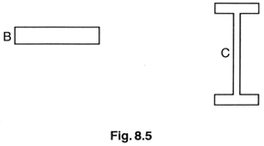

Suggest why, for beams of the same length, one would sag more than the other.
………………………………………………………………………………………………………………………………………………………………………………………………………………………………………………………………………………………………………………………………………………………………………………………………
[5]

(b) A wooden beam has width 0.05 m, depth 0.10 m and spans 3.0m. Calculate the maximum load which it can support at its centre for a maximum depression of 0.010 m. Take k to be 3.6 x 10¹⁰ Pa for this wood.

maximum load = …………………….N [3]
(c) A steel beam, loaded uniformly as in Fig. 8.3, is allowed to sag by a maximum of 1/360 of the gap it is spanning. A particular beam is used to carry a load of 33000 N and to span a gap of 4.20 m. A quantity B, known as the bending moment for this loading pattern is given by

$B=\frac{\text{WL}}{B}$ and the depression x at the centre is given by

$x=\frac{{\text{BL}}^{3}}{c}$ where c has the value 3.35x10⁸Nm³.

Calculate

(i) the amount x_{max} by which the beam is allowed to sag,

x_{max} = ……………………m

(ii) the bending moment B,

B = ………………………….

(iii) the actual amount x of sag.

x = ………………………………m
[5]

(d) A beam across a gap is shown in Fig.8.6, together with values of the forces acting and their distances from X.

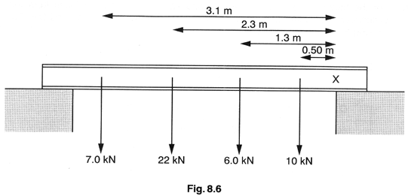

Calculate the total moment of the forces shown about point X.

total moment = ……………………. [4]

(e) The final check on the suitability of any beam is to ensure that it is strong enough. This is done, using a table of values, to find the allowable bending stress

(i) For the beam in (c), two constants P and Q, without units, are found from the dimensions of the beam and the gap it is spanning. For this beam P = 21 and Q = 170. Use Fig. 8.7 to find the allowable bending stress.

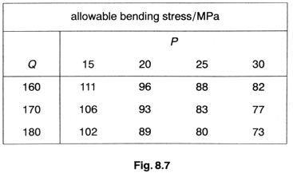

allowable bending stress = ………………. MPa

(ii) The beam is safe to use if

$\frac{\text{bending moment}}{\text{allowable bending stress}}$ < 2.0 x 10⁻⁴ m³

Use this relationship to determine whether the beam is safe under these conditions.

$\frac{\text{bending} \text{moment}}{\text{allowable bending stess}}=$

Is the beam safe? ………………… [3]

Quality of language [4]

