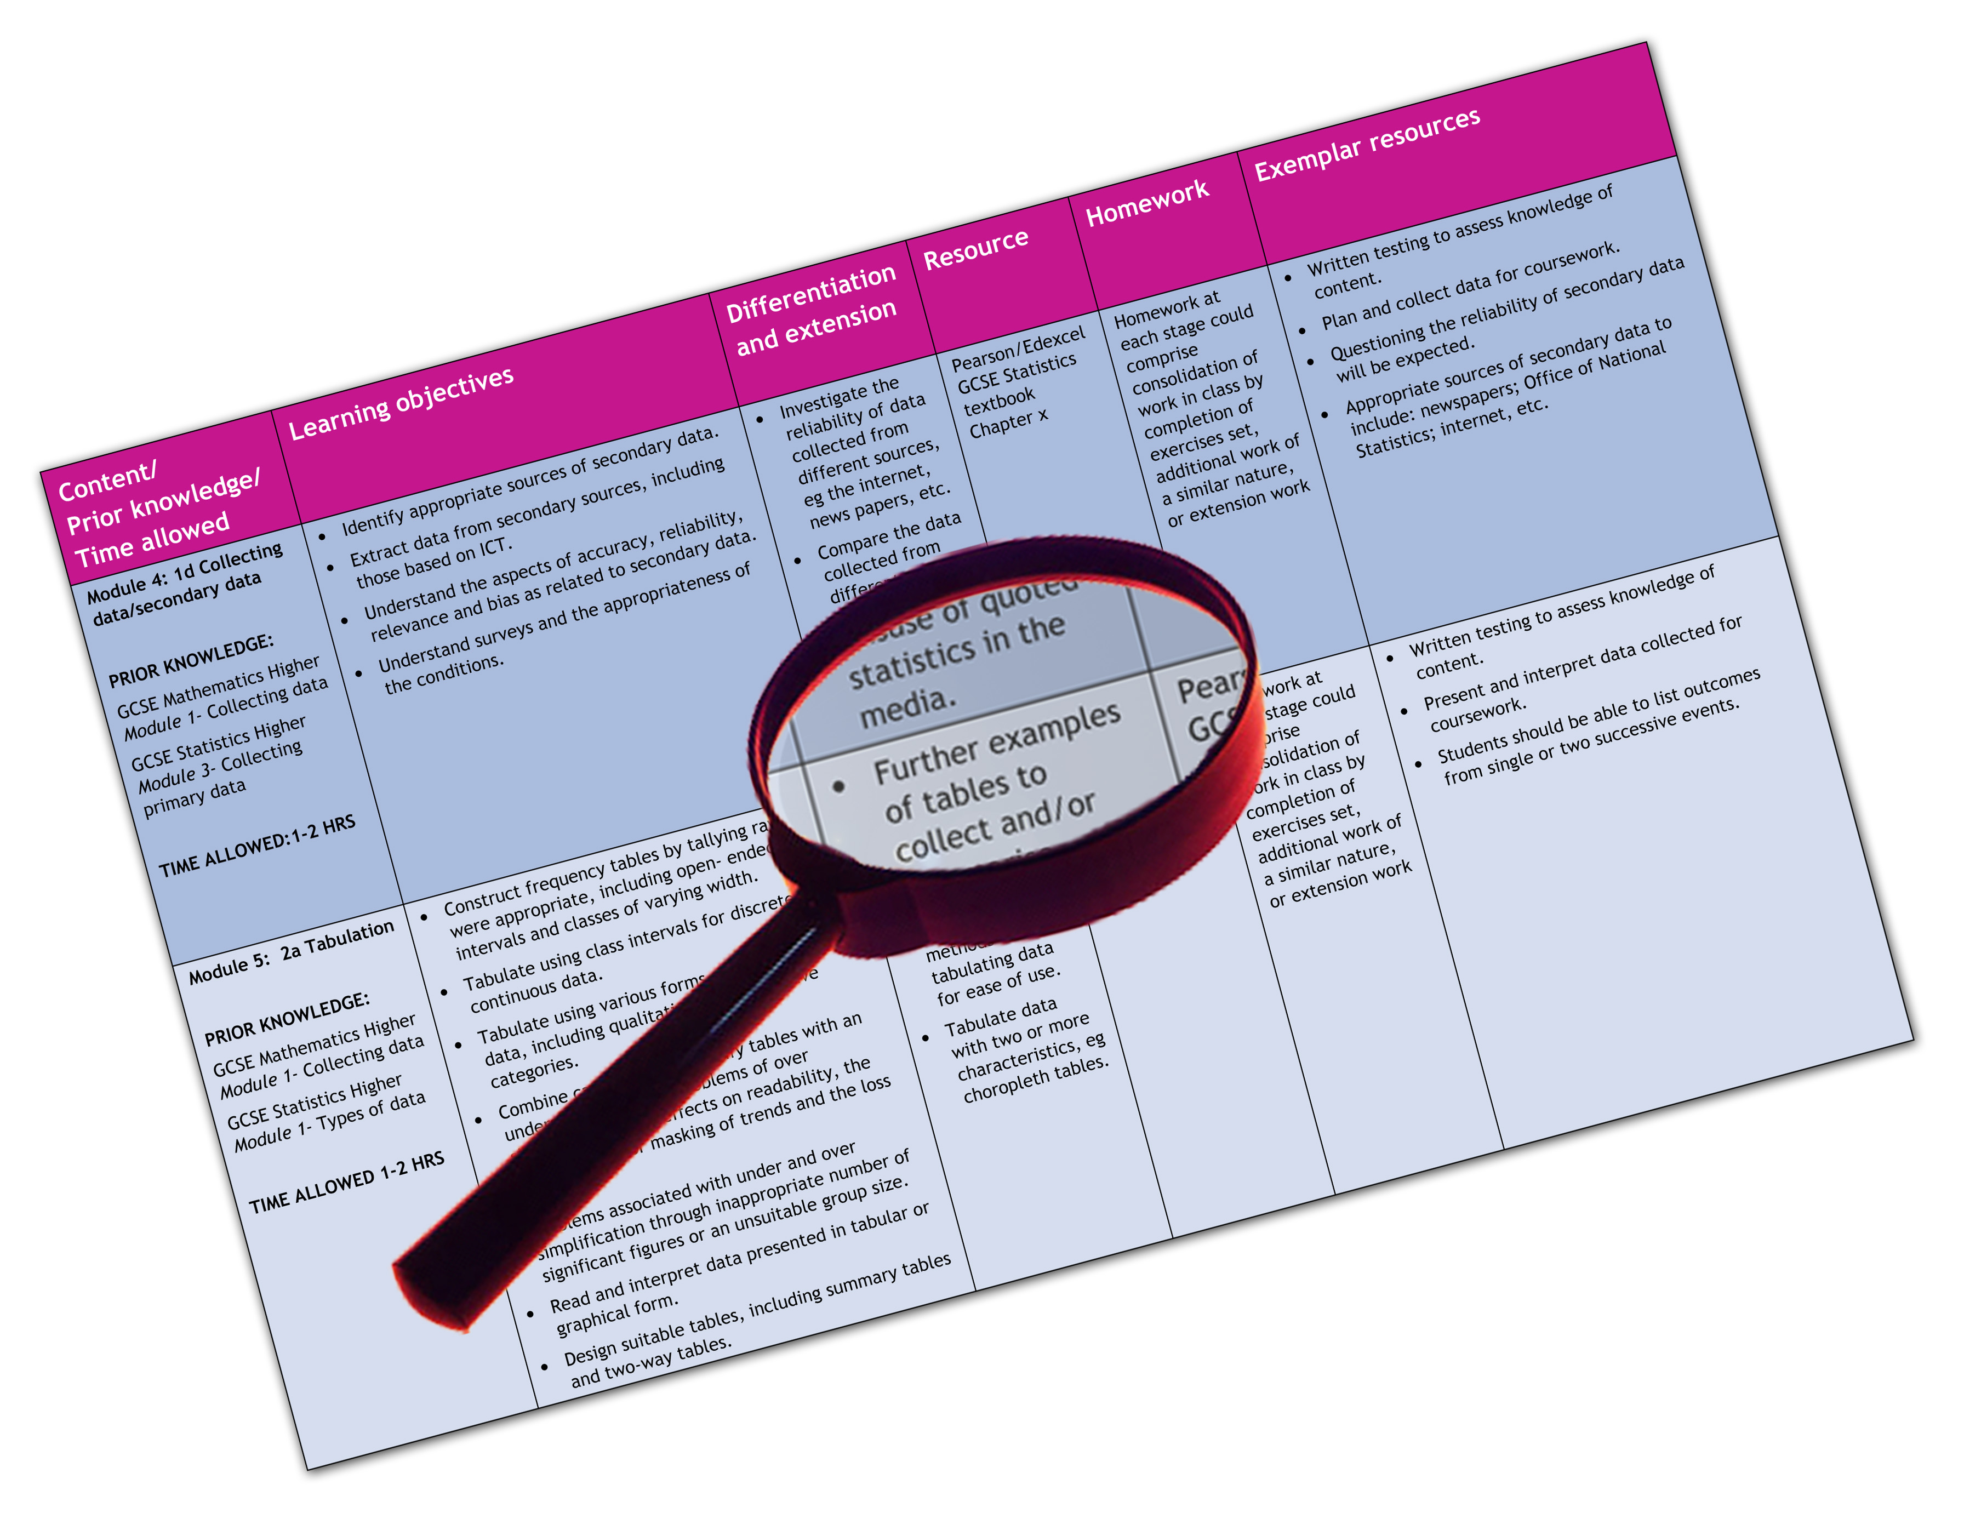


Edexcel GCE 2008 Physical Education
We are happy to provide this scheme of work for you to amend and adapt to suit your teaching purposes.

We hope you find this useful.
Editable scheme of work

Detailed help on resources

Week by week content coverage

Exemplar activities

Learning outcome

Practical support to help you deliver this Edexcel specification
Scheme of work
This scheme of work has been produced to help you implement this Edexcel specification. It is offered as an example of one possible model that you should feel free to adapt to meet your needs and is not intended to be in any way prescriptive. It is in editable word format to make adaptation as easy as possible.
Teaching resource exemplars
The scheme of work contains suggestions for resources that you can use to support your teaching. These are suggestions only of material you may find useful and you are encouraged to use a wide range of resources that suit the needs of your students.
Other Edexcel teaching resources
Pearson Education produce a wide range their own teaching resources including:
- GCE PE AS Student Book
- GCE PE A2 Student Book
- GCE PE AS Teachers Resource PackGuide
- GCE PE AS Teachers Resource PackGuide
You’ll find details of all of these at http://www.edexcel.com/quals/gce/gce08/pe/Pages/default.aspx
We are also working with a range of Publishers to support you, textbooks have been produced to support this subject by Hodder Education, Folens and Heinemann Educational Publishing.
Edexcel Subject Advisors
Edexcel has a team of specialist subject advisors available to help you with implementation of this specification. You can contact them by email or phone.
Email: PEandSportSubjectAdvisor@edexcelexperts.co.uk
Phone: 0844 576 0036
Edexcel Additional Support
- Ask the Expert — puts you in direct email contact with over 200 of our senior subject experts
- Edexcel's community — these message boards are designed to enable you to access peer-to-peer support from fellow Edexcel teaching and delivery staff in schools and colleges.
This shows how a term-by-term or week-by-week approach to the content can be organised ie the basis of a scheme of work.
Pre-Planning
In Physical Education there is no “perfect Model” that all centres can follow because there are so many variables and these may include:
- Facilities
- Centre — Boys, Girls or mixed centre
- Number of students
- Options that can be offered on-site in the centre programme
- Off-site activities which need to be videoed because they take place outside the centre
- Time-table, number and length of lessons
- Staff expertise.
Specification content
Unit 3
Students will learn the theoretical parts of the course better if they are taught these topics through practical activity. This ‘hands-on’ approach to learning will help the candidates when they come to answer their written examination. We have offered Unit in 2 pathways to match the information as laid out in the specification but centres may also want to split this suggested scheme further to reflect the traditional strands of A2 PE and we have identified these in the table – exercise physiology strand (ExPhys), Sport Psychology Strand (SpPsy) and elite support strand ( ELS)

Short Term Preparation
Week | Content coverage | Strand | Theory | L & T Activities | Resources
1 | Sports Science – an introduction to the disciplines | Ex phys  Sp Psy  ELS | Overview of role sport science plays in the support of elite athletes  Overview of assessment of unit 3  Introduction of key terminology | Use of video clips showing how teams  prepare for global competitions – eg  teams warming up/team talks | Glossary of key terms – e-spec getting started
2 | Short Term Physiological Preparation | ExPhys | Introduction of key terminology  Overview of warming up  Overview of sources of energy for exercise  Short term acclimatisation | Review of warm up stages  Application to students own sports  Activity | Student Book Chapter 1  Teachers Guide Worksheets  1.1 - 1.5
3 | Warming Up | ExPhys | Stages of warm up  Types of stretching  Intensity and duration of warm ups | Application to students own sports activity | Student Book Chapter 1  Student task pp 7  Teachers Guide Worksheets  1.6 to 1.8

Week | Content coverage | Strand | Theory | L & T Activities | Resources
4 | Energy Production for sport | ExPhys | Review of aerobic and anaerobic energy production  Theory of 3 energy pathways linked to sports activity | Applied learning – sporting practical linked to each energy pathway  Application to sporting activities in students own sport | Student Book Chapter 1
5 | Dietary manipulation | ExPhys | Dietary manipulation  Practice of carbo –loading  Hydration before and during sports activity  Practice of creatine loading | Students can keep diet diaries – research diet linked to sporting activities – compare | Student Book Chapter 1  Student task pp 18  Student task pp 20  Teachers Guide Worksheets 1.9 1.10
6 | Short term acclimatisation | ExPhys | Environmental factors that influence preparation and competition  Heat adaptation  Hydration planning  Effects of altitude | Students to research case studies show  how elite teams and performers  acclimatise to be able to compete in  different environments | Student Book Chapter 1  Teachers Guide Worksheets  3.1
7 | Short Term psychological preparation | SpPsy | Introduction of key terminology  Overview of motivation and stress control  Strategies used in short term psychological preparation  Overview of external influences that can influence short term preparation | Students can undertake questionnaires to determine their own stress levels | Student Book Chapter 2  Student task pp 32  Teachers Guide Worksheets  2.1

Week | Content coverage | Strand | Theory | L & T Activities | Resources
8 | Motivation | SpPsy | Types of motivation  Effect on sport  Link to different sporting activity  Difference between pressure on amateur and professional sports performers | Research different types of motivation – how do these relate to students own sport and role | Student Book Chapter 2
9 | Anxiety | SpPsy | Anxiety – cognitive and somatic – differences and links  Effects on short term preparation  Choking in sport | Students undertake SCA tests – compare  results – are there any trends in terms  how athletes who are more anxious  choosing particular sports | Student Book chapter 2  www.brianmac.co.uk/scat.htm
10 | Stress Control | Sp Psy | Coping strategies  Linked to warm up phase | Active learning - Students to experiment  with different relaxation techniques | Student Book Chapter 2  Apply it pp 34  Teachers Guide Worksheets  2.2
11 | Short Term strategies to cope with stress | Sp Psy | Practical strategies  Benefits of each/ suitability for different sports activities | Active learning - Students to experiment  with different relaxation techniques | Student book Chapter 2

Week | Content coverage | Strand | Theory | L & T Activities | Resources
12 | Aggression & assertion | SpPsy | Definition of each  Theories behind aggression in sport  Effect on performance  Coping strategies | Use of video clips (from Youtube) and/or  Images of aggressive sports actions –  students to decide whether actions are  aggression or assertion | Student book chapter 2
13 | Mental rehearsal | SpPsy | Use and theory  Examples to include use of visualisation and imagery | Active learning – students can experiment with mental rehearsal techniques  Produce a review of the use of mental rehearsal in their own sport/role | Student book chapter 2
14 | Relaxation techniques | Sp Psy | Use of pre game rituals relaxation technique somatic and cognitive | Active learning – students can experiment with pre game rituals/techniques  Review of sports magazines/media to  identify examples of case studies of  rituals | Student book chapter 2
15 | External influences | Sp Psy | Theory of home advantage  Crowd effect  Importance of competition and effect on performance | Apply theory to own sport  Identify why home advantage may  benefit teams/individuals in a range of  sports | Student book chapter 2  Student task pp 36

Week | Content coverage | Strand | Theory | L & T Activities | Resources
16 | Social facilitation | SpPsy | Theory of social facilitation  Effect on sport  Application to different sporting activities | Apply theory to own sport  Identify how social facilitation may  affect teams/individuals in a range of  sports | Student Book chapter 2
17 | Evaluation Apprehension | SpPsy | Theory of evaluation apprehension  Effect on sport  Application to different sporting activities | Apply theory to own sport  Identify how evaluation apprehension  may affect teams/individuals in a range  of sports | Student Book chapter 2
18 | Strategies to cope with external influences | Sp Psy | Type of strategies used  Benefits of each  Application to a range of sporting activities and context | Active learning – students can experiment with coping strategies  Produce a review of the use of coping strategies in their own sport/role | Student Book chapter 2
19 | Short term technical preparation | ELS | Factors that affect selection of kit and equipment  Environmental and cultural factors that affect short term preparation | Review of sports magazines/media to  identify examples of case studies of  factors that affect kit and equipment | Student Book chapter 3  Student task pp 46  Teachers Guide Worksheets  3.1

Week | Content coverage | Strand | Theory | L & T Activities | Resources
20 | Ergogenic aids | ELS | Overview of the term ergogenic  Review of terms drugs and supplements  Use of ice vests ergogenic aids in the warm up phase | Review of sports  magazines/media to  identify examples of case studies  of the use of ergogenic aids in  short term preparation | Student Book chapter 3  Student task pp 50  Teachers Guide Worksheets 3.2
21 | Drugs & Supplements | ELS | Need for dietary supplementation  Issue of drug taking in sport  Case studies linked to sporting activities | Class debate on the use of drugs in sport | Student Book Chapter 3
22 | Use of holding camps | ELS | Theory of holding camps  Overview of the process and strategies that are used in holding camps  Analysis of pros and cons of holding camps  Examples/case studies of holding camp use | Active learning – visit to UKSI centre  Review on internet media sites  to find examples of holding  camps used before global sports  competitions | Student Book Chapter 8  http://www.uksport.gov.uk/pages/winning_medals_home/  Teachers Guide Worksheet 3.3
23 | Pre Game rituals | ELS | Theory of pre game rituals  Overview of the process and strategies  Analysis of pros and cons of pre game rituals  Examples/case studies of pre game rituals used by elite performers | Review on internet media sites  to find examples of pre game  rituals used before global sports  competitions | Student book chapter 8

Week | Content coverage | Strand | Theory | L & T Activities | Resources
24 | Fatigue – the concept | Ex Phys | Definition of fatigue – effects on performance  How body responds to fatigue -  Central governor theory | application to students own sporting activity | Student Book Chapter 4
25 | Fatigue – the effect on the body systems | Ex Phys | Depletion of fuels (PC & glycogen)  Waste product accumulation (lactic acid)  Effects of dehydration  Effects of electrolyte loss | Active learning – students undertake  range of practical sports activities to  investigate different levels of fatigue | Student Book Chapter 4  Teachers Guide Worksheet 4.2
26 | Recovery – the concept | Ex Phys | Timephases of recovery  Initial phase of recovery – cooling down. Lactic acid removal restoration of ATP/PC and glycogen stores  Longer phase (24 hours) DOMS | Tracking of recovery after sports activity – first few hours to 24 hours | Student Book Chapter 4
27 | Recovery – The strategies | Ex Phys | Use of ergogenic aids to aid recovery  Ice baths compression clothing  Analysis of pros and cons of recovery strategies | application to students own chosen sporting activity  Class debate on the use of ergogenic aids  such as compression clothing – is their  any proof of their benefits or are athletes  simply following fashion | Student Book Chapter 4

Week | Content coverage | Strand | Theory | L & T Activities | Resources
28 | Exam preparation – revision of short term preparation | Ex Phy/Sp Psy/ELS | Review of Unit content  Practice exam question | Revision notes  Key word tests  Exam question practice  Flash cards | Specimen questions – e-portfolio  Student book – exam cafe sections
29 | Exam preparation – revision of short term preparation | Ex Phy/Sp Psy/ELS | Review of Unit content  Practice exam question | Revision notes  Key word tests  Exam question practice  Flash cards | Specimen questions – e-portfolio  Student book – exam cafe sections
30 | Exam preparation – revision of short term preparation | Ex Phy/Sp Psy/ELS | Review of Unit content  Practice exam question | Revision notes  Key word tests  Exam question practice  Flash cards | Specimen questions – e-portfolio  Student book – exam cafe sections

Long Term Preparation & Managing Elite Performance
Week | Content coverage | Strand | Theory | L & T Activities | Resources
1 | Managing elite performance | ELS | Overview of managing elite performance  Introduction of key terminology  Intro to international sports case studies | Groups of students undertake initial  research and review of international case  studies | Glossary of key terms – espec getting started  Student Book Chapter 8  Teachers Guide Worksheet 8.3
2 | History and development of elite support | ELS | Need for elite sports support  Link to development of nation building and shop window  Development of professional sports performers  Political and cultural effects on elite sports preparation | Students can research in small groups the  needs of athletes from a range of sports –  present findings to whole class | Student Book Chapter 8
3 | The academy model of elite sports preparation | ELS | Review of terminology academy/centre of excellence  Role in supporting elite athletes  Needs of elite athletes | Review use linked to own sport  Argue pros and cons of an academy model  If no academy model currently in student’s chosen sport – justify why one should be introduce  If students chosen sport does have an academy system – present an analysis | Student Book Chapter 8  Teachers Guide Worksheet 9.2
4 | Elite Sports study – East Germany | ELS | Overview of East German elite sports system  Use of talent identification  Sports Schools and centres of excellence  Issues of systems – political/use of drugs  Legacy of East German sports system | Students could in smaller groups research  elements of East German Model – the  present to rest of group  Use one of numerous documentaries  available on internet to give background  to East German model | Student Book Chapter 8  Student task pp 154  Teachers Guide Worksheet 8.1

Week | Content coverage | Strand | Theory | L & T Activities | Resources
5 | Elite sports study – Australia | ELS | Overview of Australian elite sports system  Use of talent identification  centres of excellence – role of AIS  Political background linked to Olympic failure in 1976  Legacy of Australian elite sports system | Students could in smaller groups research  elements of the Australian sports system  – then present to rest of group | Student Book Chapter 8
6 | Elite sports study – U.S.A. | ELS | Overview of USA elite sports system  Role of education system in nurturing elite sports talent  Issues of systems – win at all costs dominance  Legacy of USA elite sports system | Students could in smaller groups research  elements of the USA sports system  – then present to rest of group | Student Book Chapter 8  Teachers Guide Worksheet 8.2
7 | Case study – International study | ELS | Preparation and support for Task 4.2  Role of school and education systems | Overview of research methods | Student Book Chapter 10  See Unit 4 scheme of work
8 | Case study – International study | ELS | Preparation and support for Task 4.2  Elite sports model – professional sports system | Students to undertake an initial research review and present justification of study culture | Student Book Chapter 10  See Unit 4 scheme of work

Week | Content coverage | Strand | Theory | L & T Activities | Resources
9 | Comparative review | ELS | What can the UK learn from other elite sport systems? | Students in groups can research and  present elements such as use of sports  search, sports boarding schools,  academic scholarships, draft into  professional sport | Student Book Chapter 8
10 | Use of technology in developing elite performance | ELS | Role of technology in training analysis  Enhancement and evaluation of sporting performance  Concept of sports science and support | Application to chosen sport and/or role | Student Book Chapter 9  Student task pp176
11 | The role of national agencies in athlete preparation | ELS | Role of national agencies  Sporting and political agencies  Case studies | Link to international study  Students present pictorial revision sheet  which shows different type of support for  elite athletes | Student book chapter 9  Teachers Guide Worksheet 9.3
12 | Long term physiological preparation | Ex Phys | Overview of key long term adaptations  Adaptation linked to time  Benefits of adaptation  Links to training planning and fitness analysis | Link to development plan in Unit 4  Application of possible adaptation linked  to chosen sport/role and fitness targets | Student book Chapter 5  Student task pp 78

Week | Content coverage | Strand | Theory | L & T Activities | Resources
13 | Aerobic adaptations to training | Ex phys | Adaptation of cardiac function – benefit to sporting performance  Adaptation of vascular system – benefit to sporting performance  Adaptation to respiratory system - benefit to sporting performance  Adaptations to other body systems | Small groups research and review  different adaptations and present to  rest of class | Student book Chapter 5  Student task pp 84
14 | Anaerobic adaptations to training | Ex phys | Increase in anaerobic stores  Adaptation to anaerobic enzymes  Adaptation to lactate tolerance – effects on sporting performance | Small groups research and review  different adaptations and present to  rest of class | Student book Chapter 5
15 | Adaptations linked to training methods | Ex Phys | Include following types of training  Continuous; interval; plyometrics/power training; circuit; weight; resistance; speed; fartlek; core stability; SAQ; stretching | Small groups research and review  different training methods and present to  rest of class | Student book Chapter 5
16 | Long term psychological preparation | Sports Psych | Overview of long term preparation  Definition of long term  Application to psychological training | Link to development plan in Unit 4  Students given a key topic from LT  psychological preparation – give a short  period 15mins to research topic and then  present to rest of group | Student book Chapter 6

Week | Content coverage | Strand | Theory | L & T Activities | Resources
17 | Goal Setting | SpPsy | Use and role of goal setting  SMART principles  Use of performance profiling | Students apply SMART principles to their  own goal setting | Student book Chapter 6
18 | Attribution theory | SpPsy | External and internal factors that can be attributed to success and failure  Weiner’s two dimensions of attribution  Applied attribution theory | Review of sports media – apply comments  from coaches/managers/performers to  attribution theory | Student book Chapter 6  Teachers Guide Worksheet 6.2
19 | Achievement Motivation | Sp Psy | Definition and theory of achievement motivation  Nach and Naff principles applied to sporting performance  Intrinsic and extrinsic factors and their affect on motivation | Application to students own chosen sport  Produce a pictogram of athletes linked to  NAFF/NACH | Student book Chapter 6  Teachers Guide Worksheet 6.1
20 | Skill development and tactics | Sp Psy | Use of Visualisation in long term psychological training | Active learning – students can experiment with visualisation techniques  Produce a review of the use of visualisation in their own sport/role | Student book Chapter 6

Week | Content coverage | Strand | Theory | L & T Activities | Resources
21 | Use of ritual | Sp Psy | Use of ritual in long term psychological training  Case/studies examples of elite performance and use of ritual | Review of earlier sessions on use of ritual – apply theory to sport psychology  Review on internet media sites  to find examples of ritual used before  global sports competitions  Video clips of rugby Haka’s | Student book chapter 6  Student task pp119
22 | Skill Training | Sp Psy | Training for decision making  Visual awareness training | Active learning – students can experiment  with techniques outlined in chapter 6  Produce a review of the use of skill  training technique in their own  sport/role | Student book chapter 6  Student tasks- pp122 pp123
23 | Group Cohesion | Sp Psy | Definition and theory of group cohesion  Tactics used to develop group cohesion  Application to sporting activity | Use of DVD’s such as behind scenes of  British Lions Tours to identify examples  of team building  Active learning –  students take part in group building  activity | Student book chapter 6  Student tasks- pp132
24 | Long term technical development | ELS | Role of mechanical/biomechanical science in improving sporting talent  Role of mechanical analysis and feedback in developing technique | Small groups research and review  different methods and present to  rest of class | Student Book Chapter 7  Teachers Guide Worksheet 7.1

Week | Content coverage | Strand | Theory | L & T Activities | Resources
25 | Refining technique | ELS | Importance of technique improvement  Perfect model  Technique as part of long term training | Apply examples from chosen sport – use  of BBC Sports Academy website to  develop range of case studies and  examples | Student book chapter 7  Student task pp 138
26 | Use of feedback in refining performance | ELS | Use of technology and feedback in developing elite performance  Use of video and computer software  Case study – use of prozone in elite team sports | Use internet sites of companies such as  prozone to research how feedback is  developing in elite sport | Student book chapter 7
27 | Use of ergogenic aids in long-term preparation | ELS | Ergogenic aids and their use in long term training  Use of force plates, pedometry, heart rate monitoring and GPS technology | Review on internet media sites  to find examples of technology used in  training used before global sports competitions | Student book chapter 7  Student task pp 144  Student task pp 145

Week | Content coverage | Strand | Theory | L & T Activities | Resources
28 | Exam preparation – revision of short term preparation | Ex Phy/Sp Psy/ELS | Review of Unit content  Practice exam question | Revision notes  Key word tests  Exam question practice  Flash cards | Specimen questions – e-portfolio  Student book – exam cafe sections
29 | Exam preparation – revision of short term preparation | Ex Phy/Sp Psy/ELS | Review of Unit content  Practice exam question | Revision notes  Key word tests  Exam question practice  Flash cards | Specimen questions – e-portfolio  Student book – exam cafe sections
30 | Exam preparation – revision of short term preparation | Ex Phy/Sp Psy/ELS | Review of Unit content  Practice exam question | Revision notes  Key word tests  Exam question practice  Flash cards | Specimen questions – e-portfolio  Student book – exam cafe sections

