Reciprocal trigonometric functions
$\text{cosec }x=\frac{1}{\text{sin}x}$ $\text{sec}x=\frac{1}{\text{cos}x}$ $\text{cot}x=\frac{1}{\text{tan}x}$
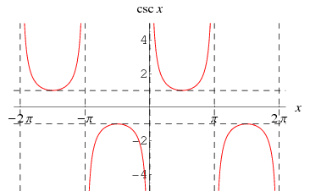 | $$y=\text{cosec }x$$
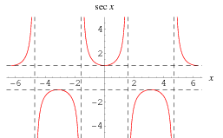 | $$y=\text{sec}x$$
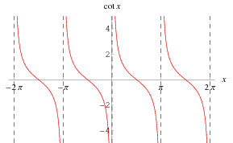 | $$y=\text{cot}x$$

Pythagorean identities

$$\begin{aligned}{\text{sin}}^{2}x+{\text{cos}}^{2}x≡1 \\ {\text{tan}}^{2}x+1≡{\text{sec}}^{2}x \\ 1+{\text{cot}}^{2}x≡{\text{cosec}}^{2}x\end{aligned}$$
Compound Angle formulae (FB)
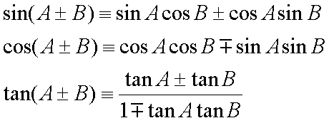

Double angle formulae

$$\begin{aligned}\text{sin}2A≡2\text{sin}A\text{cos}A \\ \text{cos}2A≡{\text{cos}}^{2}A−{\text{sin}}^{2}A=1−2{\text{sin}}^{2}A=2{\text{cos}}^{2}A−1 \\ \text{tan}2A≡\frac{2\text{tan}A}{1−{\text{tan}}^{2}A}\end{aligned}$$
Inverse trigonometric functions
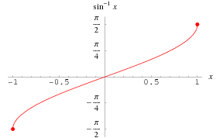 | $$y={\text{sin}}^{−1}x$$
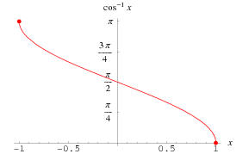 | $$y={\text{cos}}^{−1}x$$
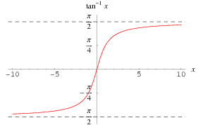 | $$y={\text{tan}}^{−1}x$$

