Mechanics 2 results that are not given in the examination booklet

You are also expected to recall or derive Mechanics 1 results that are not given in the examination booklet.

Friction

when sliding takes place
when no sliding takes place

Centre of mass

Work, energy and power

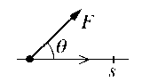

Work done by a constant force,

Kinetic energy =

Work done against gravity = mgh

Power

The work energy principle

The total work done by the forces acting on a body is equal to the increase in the kinetic energy of the body.

Mechanics 2 results that are not given in the examination booklet (page 2)

Impulse

Impulse for constant F

Impulse = change in momentum

Impacts

Newton’s Experimental Law

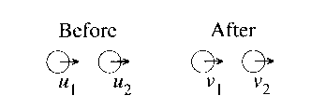

where e is the coefficient of restitution

