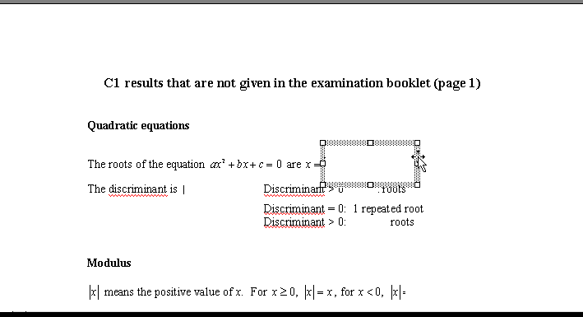
CLOZE sheets - how to use

At the most basic level these are just paper copies of the formula sheets, with blanks you can fill to check that you know the formlae required.

If the files can be displayed on an LCD projector or (even better) used with an interactive whiteboard then you can reveal the true answers as you go through the test.
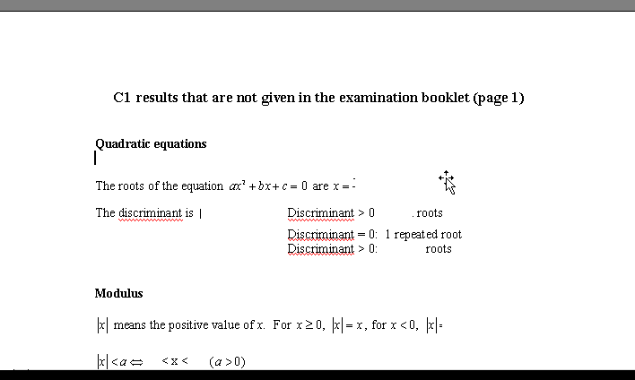
If you move the mouse around near the blank, the mouse will change to a cross (see below) when it finds the edge.

If you then click the outline of the textbox should come up shaded.

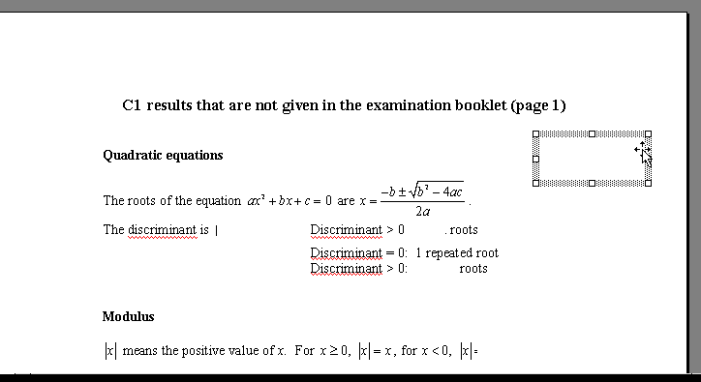
The box can then be dragged aside revealing the answer underneath

Provided you don’t save the file after you have used it - it will always be back at the starting position when you open the file.

