A2 Mathematics Coursework C3
Year 12

Numerical solutions of equations

Solving 0 = x⁵+x-5 using the “Change Of Sign” Method

The method I will use to solve 0 = x⁵+x-5 is the Change of Sign Method involving the Decimal Search method. I have drawn this graph using the Autograph Software, and the print screen of this is below:

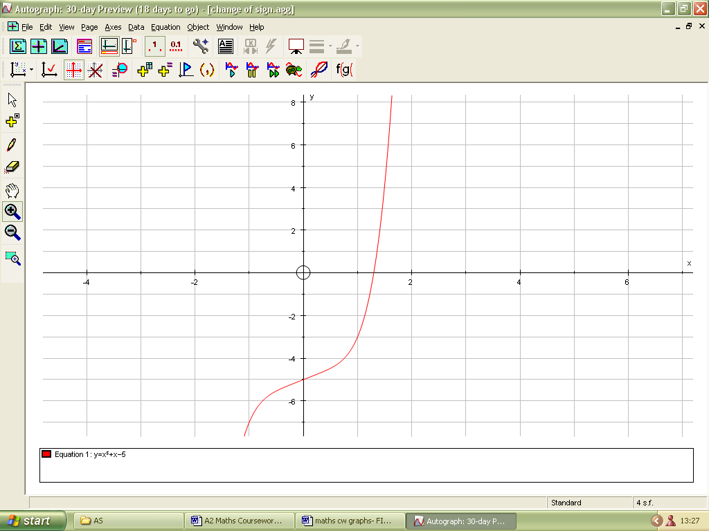

This is the root of this equation that I need to find. See Figure 1

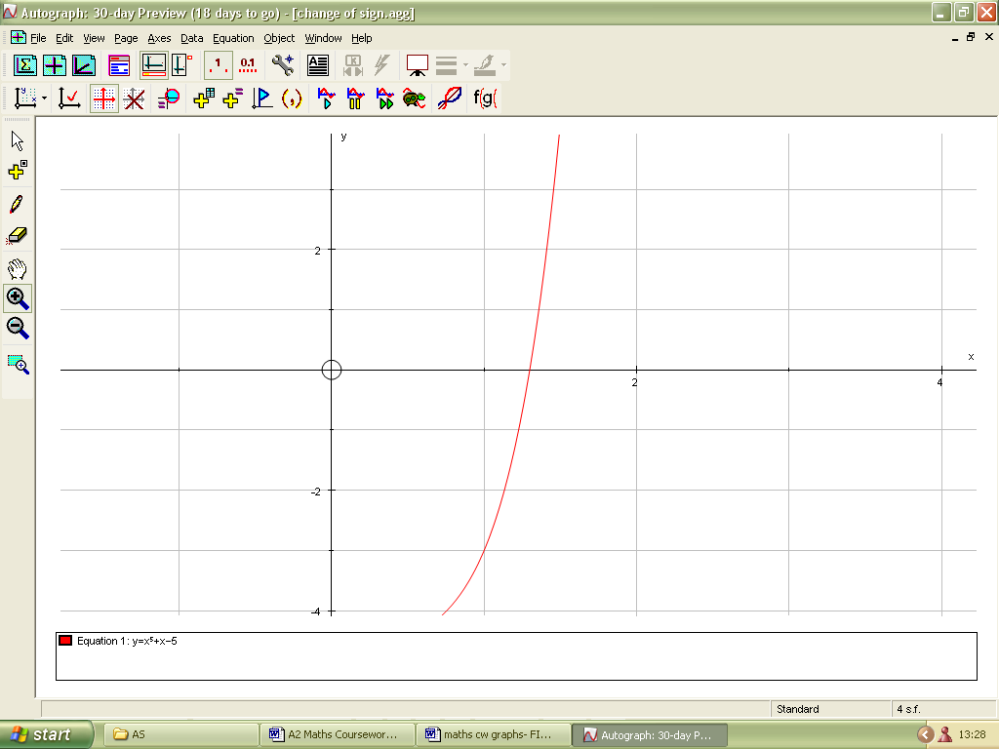

From my graph above, I can see that the root of this equation is between x =1 and x = 1.5. The table of x values and f(x) values is shown below. I can work out the f(x) values by substituting the x-values into the equation.

x | 1 | 1.1 | 1.2 | 1.3 | 1.4 | 1.5
f(x) | -3 | -2.28949 | -1.31168 | 0.01293 | 1.77824 | 4.09375

From my table of values above, it is clear that the change of sign from negative to positive occurs between x = 1.2 and x = 1.3. So, I can narrow these values down further to find another change of sign.

x | f(x)
1.21 | -1.19626
1.22 | -1.07729
1.23 | -0.95469
1.24 | -0.82837
1.25 | -0.69824
1.26 | -0.56420
1.27 | -0.42616
1.28 | -0.28403
1.29 | -0.13769
1.30 | 0.01293

I can see that the change of sign is between x = 1.29 and x = 1.30.

x | f(x)
1.291 | -0.12283
1.292 | -0.10792
1.293 | -0.09296
1.294 | -0.07797
1.295 | -0.06293
1.296 | -0.04784
1.297 | -0.03271
1.298 | -0.01754
1.299 | -0.00233
1.300 | 0.01293

The change of sign is in the interval [1.299, 1.300]

x | f(x)
1.2991 | -0.000805
1.2992 | 0.000720
1.2993 | 0.002244

The root of this equation lies in the interval [1.2991, 1.2992]. This means that I can take the root to be x = 1.29915 (5 decimal places).

The maximum error of the root would be 0.00005

However, there are some functions for which the Decimal Search method would not work. An example is (1.55x+3.4)⁴=0. This would not work because the curve is touching the x-axis, so there would not be a change of sign. The graph of this function and the calculations are below:

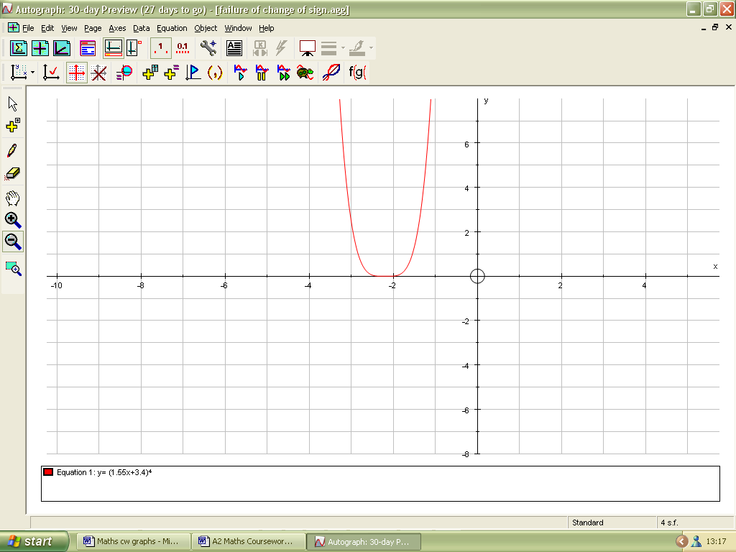
I would not be able to find this root because there is no change of sign. See Figure 2

I can see that the root lies between x = -2 and x = -3.

x | f(x)
-2 | 0.00810000
-2.1 | 0.00044205
-2.2 | 0.00000001
-2.3 | 0.00074120
-2.4 | 0.01048576
-2.5 | 0.05090664
-2.6 | 0.15752961
-2.7 | 0.37973325
-2.8 | 0.78074896
-2.9 | 1.43766095
-3.0 | 2.44140625

As I have rightly guessed, there is no change of sign according to my calculations above. This is because the equation has an even power in it. Therefore, the Decimal Search method has failed to find the root of (1.55x+3.4)⁴=0.

Solving 0=x⁴+x-1 using the “Newton-Raphson” method

As stated above, the equation I will use for the “Newton-Raphson” method is x⁴+x-1=0. I can see from the graph that two roots need to be found using this method. The graph of this is below (or see Figure 3).

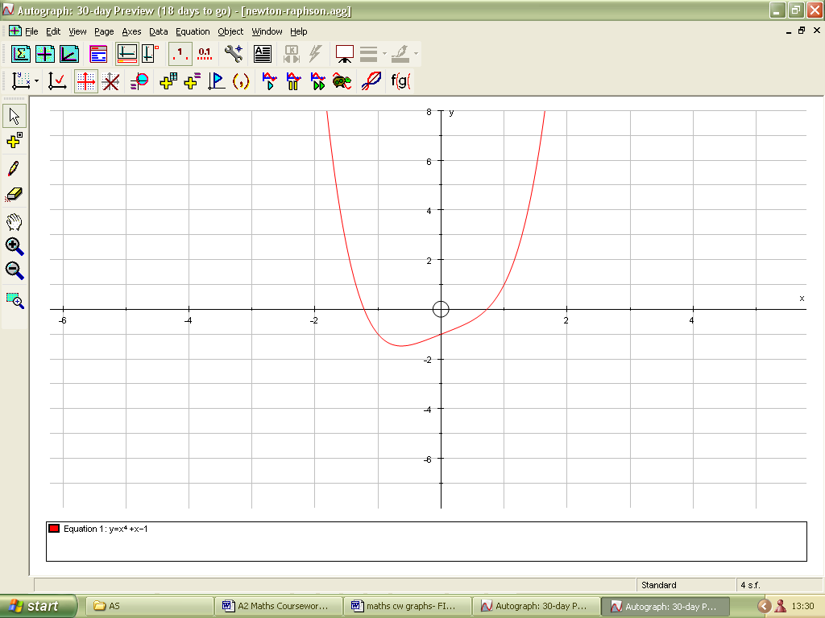
I would need to find these two roots of this equation

The iterative formula for the “Newton-Raphson” method is:

x_{n+1}=x_{n}- f(x_{n})
f’(x_{n})

For my equation, f’(x_{n}) = 4x³+1 when my function is differentiated to find the gradient function. The iterative formula I will use to find the roots of this function is:

x_{n+1} = x_{n}- x_{n}⁴+x_{n}-1
4x_{n}³+1

I will start by finding out the negative root first. By looking at the diagram (see Figure 3), I can see that my starting value (x₁) is –1.5.

x₁ = -1.5
x₂ = -1.295 (I substituted x₁ = -1.5 into the iterative formula to get the value for x₂)
x₃ = -1.227690 (I substituted x₂ = -1.295 into the iterative formula to get x₃)
x₄ = -1.220812
x₅ = -1.220744
x₆ = -1.220744085
x₇ = -1.220744085

I can see some convergence from x₅. There has been no change in the x-values between x₆ and x₇ for this number of decimal places. I know that this method for finding the root has worked.

My negative root is x = -1.220744 (6 decimal places)

Now I will find the positive root of this function. The starting value (x₁) is approximately 1.5 when f(x)=0.

x₁ = 1.5
x₂ = 1.116379
x₃ = 0.862068
x₄ = 0.745761
x₅ = 0.725049
x₆ = 0.724492
x₇ = 0.724491959
x₈ = 0.724491959

I can see some convergence from x₆. There has been no change in x-values between x₇ and x₈ for this number of decimal places. It is clear that another root has been successfully found using this method.

My positive root is x = 0.724491959 (9 decimal places)
The error bound is: 0.0000000005

However, the Newton-Raphson method would not work with the graph below:

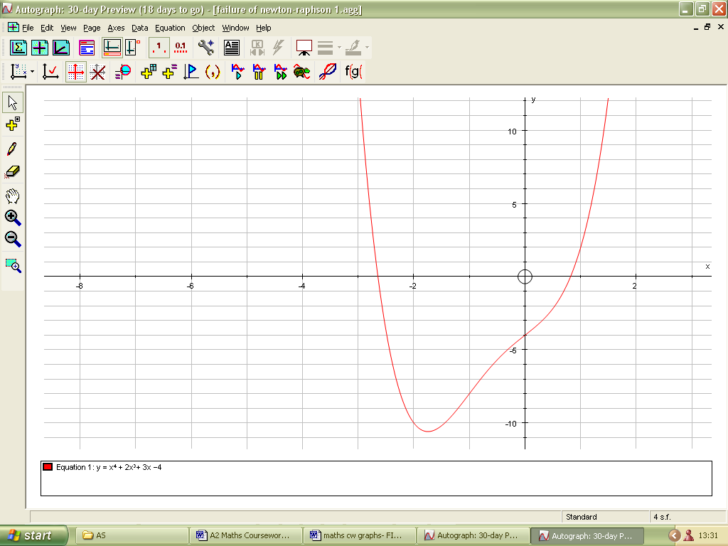
I wish to find this root

If I start from the turning point of the curve, I do not think it will converge (see Figure 4). The equation for this function is 0 = x⁴+2x³+3x-4 f’(x) = 4x³+6x²+3

The iterative formula is: x_{n+1} = x_{n}- f(x_{n})
f’(x_{n})

So the iterative formula for this equation is: x_{n+1} = x_{n}- x_{n}⁴+2x_{n}³+3x_{n}-4
4x_{n}³+6x_{n}²+3

On my diagram of this function, I have taken my x₁ value to be about –1.6

x₁ = -1.6
x₂ = 3.682591
x₃ = 2.658976
x₄ = 1.899865
x₅ = 1.353797
x₆ = 1.003365
x₇ = 0.847116
x₈ = 0.819172
x₉ = 0.818390
x₁₀ = 0.818389
x₁₁ = 0.818389

From that, I can quite clearly see that there is a convergence beginning to show towards the positive root. However, my aim was to find the negative root, and I could not find it. Therefore, the Newton-Raphson method has failed to find that particular root, even though the starting value was close to it.

Another example where the Newton-Raphson would not work is the function (x+2^{1/2})^{1/2} ln (x+2^{1/2}) = 0. The graph and calculations of this is below:

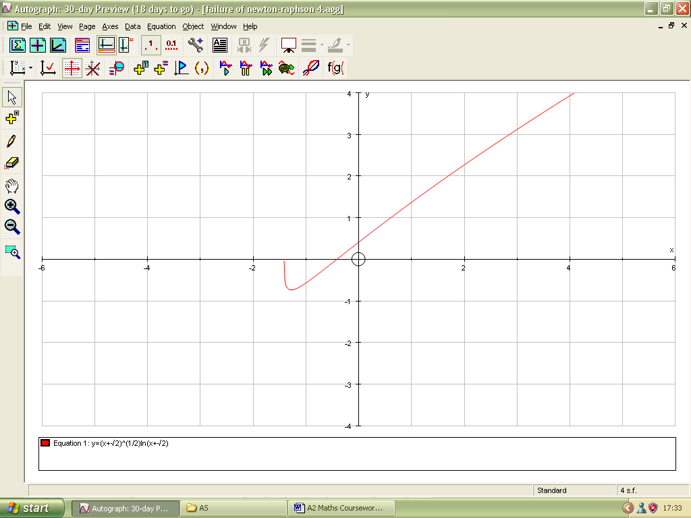
I wish to find this root

The function is: (x+2^{1/2})^{1/2} ln (x+2^{1/2}) = 0

f’(x) = ((x+2^{1/2})^{1/2} X 1 ) + (ln (x+2^{1/2}) X ½ (x+2^{1/2}) ^{-1/2})
x + 2 ^{1/2}

(x+2^{1/2})^{1/2} + ln (x+2^{1/2}) (x+2^{1/2}) ^{-1/2}
(x+2^{1/2})¹ 2

1 + ln(x+2^{1/2})
(x+2^{1/2})^{1/2} 2(x+2^{1/2}) ^{1/2}

= 2+ ln((x+2^{1/2})
2(x+2^{1/2}) ^{1/2}

The iterative formula for the Newton-Raphson method is:

x_{n+1} = x_{n} = f’(x_{n})
f’(x_{n})

x _{n+1} = x_{n} - 2(x+2^{1/2})ln(x+2^{1/2})
2 + ln(x+2^{1/2})

I choose my starting value of x (x₁) to be about –1.3.

x₁ = -1.3
x₂ = -4.22079
x₃ = not defined
x₄ =

Another example where the Newton-Raphson method would fail is with the function x³-5x+0.1=0. The graph of this, along with the calculations is shown below:

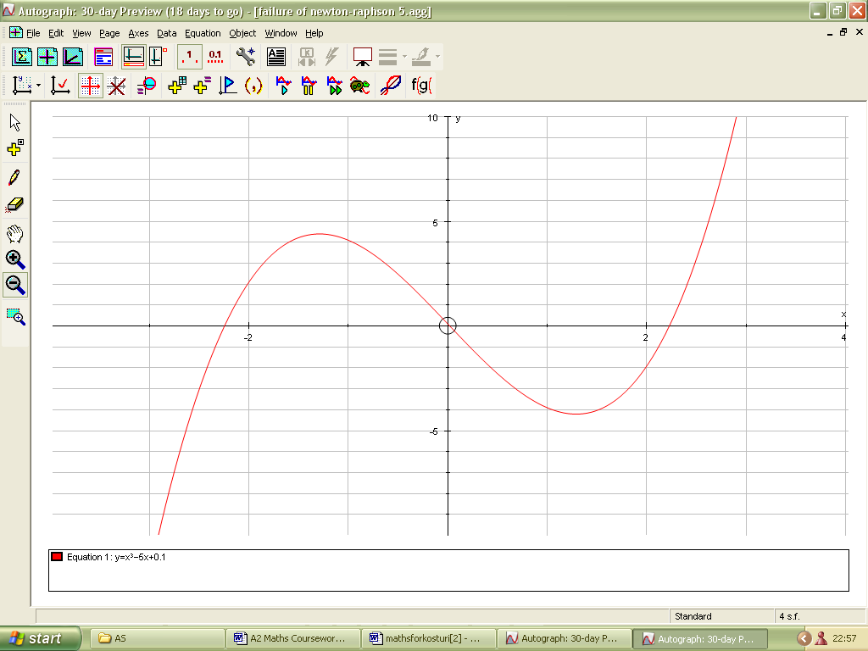
I wish to find this root

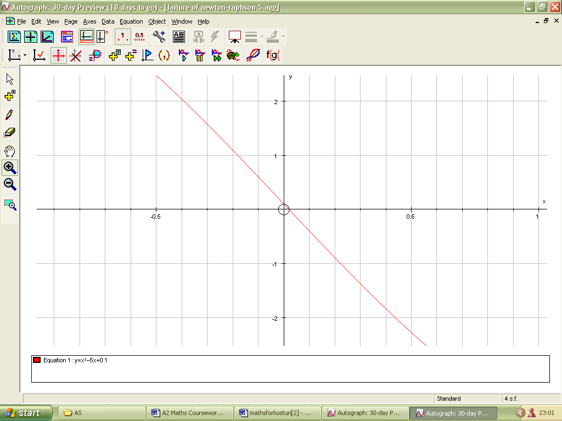
(This is the same graph as the one on previous page). I wish to find this root

f(x) = x³-5x+0.1 f’(x) = 3x²-5

The iterative formula for the Newton-Raphson method is: x_{n+1} = x_{n}- f(x_{n})
f’(x_{n})

My iterative formula is: x_{n+1} = x_{n}- x³-5x+0.1
3x²-5

I will take my starting value of x (x₁) to be 1.1.

x₁ = 1.1
x₂ = -1.870073
x₃ = -2.400053
x₄ = -2.259618

I can see that there is no convergence to the positive root I am looking for. Therefore, the Newton-Raphson method has failed to find that particular root despite taking a starting value close to it. This is shown graphically in Figure 6b.

Solving 0= x⁵+4x²-2 using the “Rearranging method”

The graph of this is shown below (or see Figure 5):

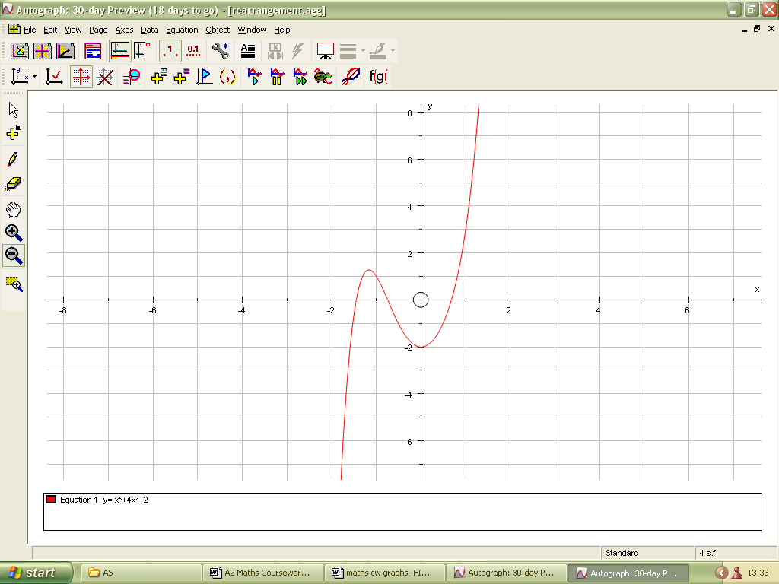
I wish to find this root

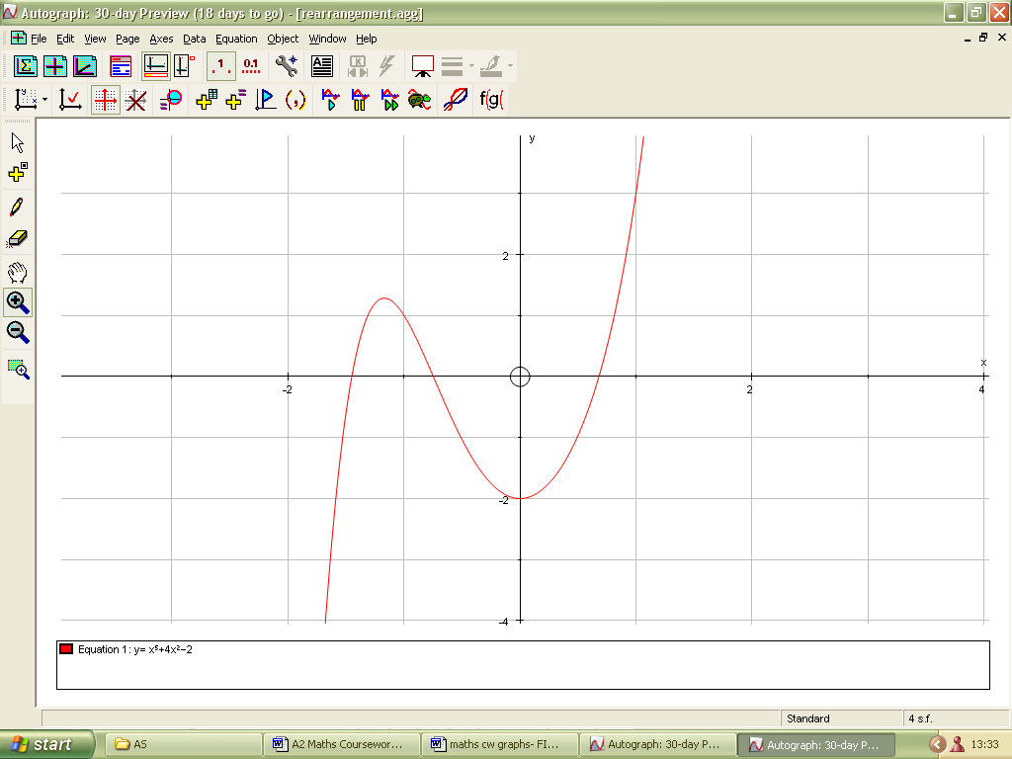
I wish to find this root

I will rearrange f(x)=0 in the form of x = g(x). As my equation is 0= x⁵+4x²-2, there are possible rearrangements of this. I will only pick out two possible rearrangements.

Rearrangement 1: 0= x⁵+4x²-2
-x⁵= 4x²-2
x⁵= -4x²+2
x= (-4x²+2)^{1/5}

On the Autograph software, I will draw the equation y= g(x)= (-4x²+2)^{1/5} and the line y = x. This is shown below (or see Figure 6):

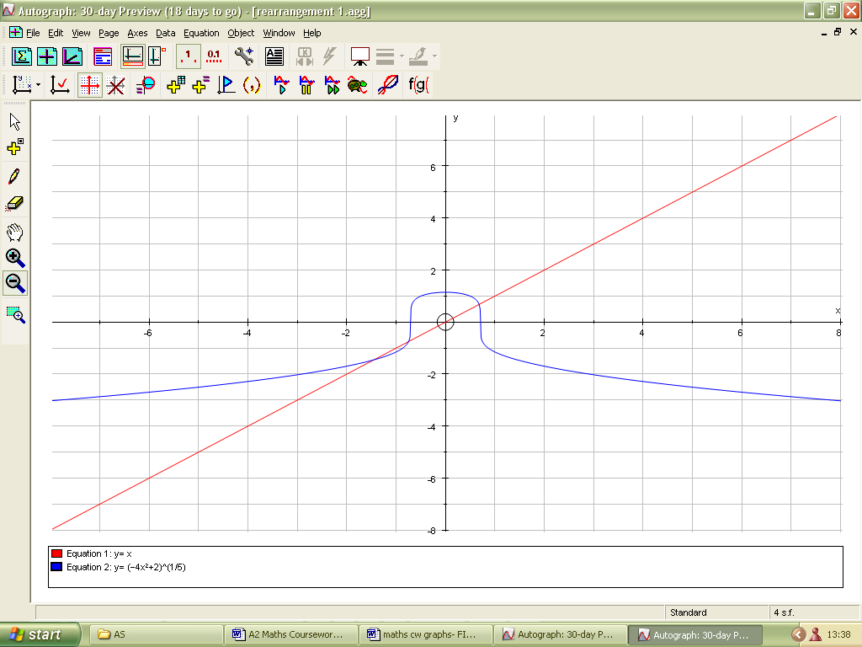

Rearrangement 2: 0= x⁵+4x²-2
-4x²= x⁵-2
4x²= -x⁵+2
x²= (-x⁵+2)/4
x= ((-x⁵+2)/4))^{1/2}

On Autograph software, I will draw the equation y = g(x) = ((-x⁵+2)/4))^{1/2} and the line y = x. This is what it looks like below (or see Figure 7):

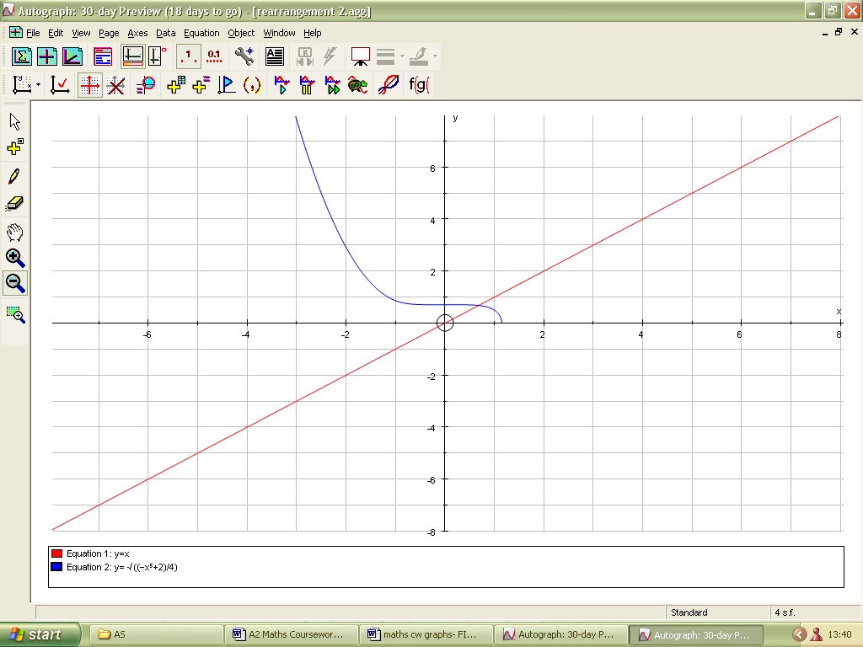
I wish to find this intersection

I can see from the diagram directly above for Rearrangement 2 that g’(x) is between 1 and –1, so there should be a convergence.

Therefore, my chosen rearrangement is Rearrangement 2, which is: x = ((-x⁵+2)/4))^{1/2}
So my iterative formula for this rearrangement is: x_{n+1}= ((-x_{n}⁵+2)/4))^{1/2}

I can see from my graph above that the point of intersections of the two lines is between x = 0 and x = 1. So my starting value for x (x₁) would be 0.5.

x₁ = 0.5 (I substitute x₁ = 0.5 into iterative formula to get x₂)
x₂ = 0.701561 (I substitute x₂ value into iterative formula to get x₃)
x₃ = 0.676396
x₄ = 0.681619
x₅ = 0.680600
x₆ = 0.680802
x₇= 0.680762
x₈ = 0.6807698
x₉ = 0.6807683
x₁₀ = 0.6807686
x₁₁ = 0.6807685
x₁₂ = 0.6807685

I can see a convergence from x₈, and there is no change between x₁₁ and x₁₂ for this number of decimal places. I know that this method has worked successfully to find a root. This is shown graphically in Figure 7.

My root is: x = 0.68077 (5 decimal places).

I know that using Rearrangement 2 helped me find a root of 0=x⁵+4x²–2. However, Rearrangement 1 of this function would not have helped me find the same root. This is explained with a diagram of Rearrangement 1 and its iterative formula below. This failure is shown graphically in Figure 6:

I would not be able to find this root using this rearrangement because the gradient of
y=(-4x²+2)^{1/5} is bigger than 1.

Rearrangement 1: 0= x⁵+4x²-2
-x⁵= 4x²-2
x⁵= -4x²+2
x= (-4x²+2)^{1/5}

The iterative formula is: x_{n+1}= (-4x_{n}²+2)^{1/5}

From the graph above and from Figures 6 I can see that the point of intersection between y = x and y = g(x) = (-4x²+2)^{1/5} is between x = 0 and x = 1. Like before, I will take my starting value of x (x₁) to be 0.5. The same process of substituting values of x into the iterative formula, as in the last Rearrangement is carried out here.

x₁ = 0.5
x₂ = 1
x₃ = -1.148698
x₄ = -1.268010
x₅ = -1.346816

I can immediately see that there is no convergence in this rearrangement towards the particular root I am looking for, that I found in the previous rearrangement (Rearrangement 2). Therefore, I have found a rearrangement of the same equation (Rearrangement 1) where the iteration has failed to converge to the required root.

Comparison of methods

I will now use the equation 0=x⁵+4x²-2 that I solved using the Rearrangement method and see if I can find the same root using the other two methods- the Decimal Search method and the Newton-Raphson method. I will start off with the Decimal Search method.

From the graph 0=x⁵+4x²-2, I can see that the root lies between x = 0.5 and x = 1

x | f(x)
0.5 | -0.96875
0.6 | -0.48224
0.7 | 0.12807

I can see that the change of sign is between x = 0.6 and x = 0.7.

x | f(x)
0.61 | -0.427140
0.62 | -0.370787
0.63 | -0.313156
0.64 | -0.254226
0.65 | -0.193971
0.66 | -0.132367
0.67 | -0.069387
0.68 | -0.005007
0.69 | 0.060803

The change of sign is between x = 0.68 and x = 0.69

x | f(x)
0.680 | -0.005007
0.681 | 0.001510

The change of sign is between x = 0.680 and x = 0.681

x | f(x)
0.6801 | -4.355665x10⁻³
0.6802 | -3.704544x10⁻³
0.6803 | -3.053279x10⁻³
0.6804 | -2.401872x10⁻³
0.6805 | -1.750322x10⁻³
0.6806 | -1.098629x10⁻³
0.6807 | -4.467927x10⁻⁴
0.6808 | 2.051866x10⁻⁴

The change of sign is between x = 0.6807 and x = 0.6808

x | f(x)
0.68071 | -3.816012x10⁻⁴
0.68072 | -3.164083x10⁻⁴
0.68073 | -2.512140x10⁻⁴
0.68074 | -1.860182x10⁻⁴
0.68075 | -1.208210x10⁻⁴
0.68076 | -5.562232x10⁻⁵
0.68077 | 9.577756x10⁻⁶

I can see that the change of sign is between x = 0.68076 and x = 0.68077

As there is a change of sign, I can finally say that the root of this function is in the interval [0.68076, 0.68077]. Therefore, using this method, I can take the root of this equation to be x = 0.680765, which is similar to the answer I got when finding the same root using the “Rearrangement method”.

I will now use the Newton-Raphson method to find the same root for this function.

0=x⁵+4x²-2 f’(x) = 5x⁴+8x

The iterative formula for the Newton-Raphson method is: x_{n+1}=x_{n}- f(x_{n})
f’(x_{n})

So my iterative formula is: x_{n+1}=x_{n}- x_{n}⁵+4x_{n}²-2
5x_{n}⁴+8x_{n}

I think that a good starting value for x₁ would be 1.2
x₁ = 1.2
x₂ = 0.887083
x₃ = 0.720596
x₄ = 0.682450
x₅ = 0.680772
x₆ = 0.680769
x₇ = 0.680769

I can see a definite convergence from x₆. So the root is x = 0.680769 which is similar to what I obtained when finding the same root using the Rearrangement method and the Decimal Search method.

I have now found the same root using the Decimal Search method, the Rearrangement method and the Newton-Raphson method. It is now possible to compare these three methods in terms of ease and the speed of convergence.

I found that the Decimal Search method was the simplest out of the three, as it does not involve any iterations, so mistakes with iterative formulas and rearrangements are not applicable as with the other two methods used. This method is very advantageous because it immediately provides intervals for the root which I can work towards to obtain an answer, and with each interval, I can work out what the error bounds are straight away. As there are no complicated iterations involved, this method is very easy to use on the calculator and mistakes on the calculator are far less likely to occur than for the other two methods (the Newton-Raphson method and the Rearrangement method). However, this was a very time-consuming method to do on a calculator. Although I only used a calculator for this coursework, it would have been quicker and more efficient if I had used Excel for the Decimal Search method.

Both the Newton-Raphson method and the Rearrangement method were fixed point estimates and involved an iterative process. Therefore, these methods were very similar. However, these two methods differ because there is a specific formula for the Newton-Raphson method. Although the Newton-Raphson method was more complicated than the Rearrangement method, it gave a much more rapid rate of convergence. In fact, the Newton-Raphson method gave the most rapid rate of convergence to 6 decimal places, whereas, for the Decimal Search method, it took me very many calculations to converge to 5 decimal places. So, the Decimal Search method gave the slowest rate of convergence. These two methods were not as time-consuming as the Decimal Search method because it did not involve having to find a change of sign in many particular intervals; there was already a convergence towards the particular root I wanted. However, it was really easy to make mistakes on the calculator due the order of the terms in the iterative formulae.

I used the Autograph software to draw these graphs. This was so much quicker than drawing the graphs by hand, and Excel does not have the facilities to draw such advanced graphs. The Autograph software was very easy to use and it also helped me to find out which rearrangement of a function were suitable (when carrying out the Rearrangement method) and in which interval the root was in (when using the Decimal Search method).

