Question Number |  | Scheme |  | Marks
1. | (a) | , and correct method for finding A or B |  | M1
 |  | A = 1, B = 2 |  | A1 A1 (3)
 | (b) | f ′(x) = $−\frac{1}{(x+2)^{2}}−\frac{2}{(x−1)^{2}}$ |  | M1 A1
 |  | Argument for negative, including statement that square terms are positive for all values of x. (f.t. on wrong values of A and B) |  | A1 ft (3)
 |  |  |  | (6 marks)
2. | (a) | Attempt to use correctly stated double angle formula, or complete method using other double angle formula for cos2t with to eliminate t and obtain y = |  | M1
 |  | or any correct equivalent (even y = cos 2 (cos |  | A1 (2)
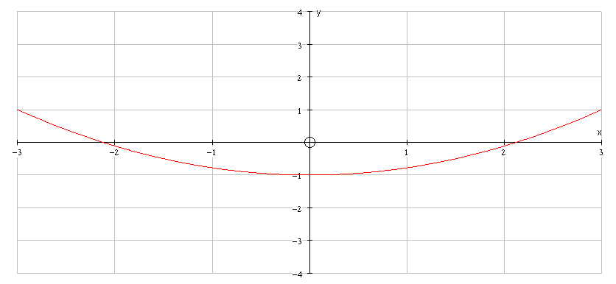 | (b)
 |  |  | shape | B1
 |  |  | position including  restricted domain  –3 < x < 3 | B1 (2)
 |  |  |  | (4 marks)
3. |  | $\int{\frac{\text{cos}θ}{{\text{cos}}^{3}θ} dθ}$, = $\int{{\text{sec}}^{2}θ\begin{matrix} \\ dθ\end{matrix}}$ |  | M1 A1, M1
 |  | = tan θ (+ c) |  | B1
 |  | = (+c) = $\frac{x}{\sqrt{(1−x^{2})}}$ (+ c) (*) |  | M1 A1
 |  |  |  | (6 marks)
4. |  | Estimate for M² = $\frac{0\text{.}\text{25}}{2}$[(48² + 29²) + 2(207² + 37² + 161²)] |  | M1 B1 M1
 |  | Evaluating this estimate to 17 900 (awrt) |  | M1 A1
 |  | M ≈ 134 (133.9), (130) |  | A1
 |  |  |  | (6 marks)

Question Number |  | Scheme | Marks
5. |  | Volume = π$\int{{\left(1+\frac{1}{2\sqrt{x}}\right)}^{2}dx}$ | M1
 |  | $\int{{\left(1+\frac{1}{2\sqrt{x}}\right)}^{2}dx}$= $\int{\left(1+\frac{1}{\sqrt{x}}+\frac{1}{4x}\right) dx}$ | B1
 |  | = $\left[x+2\sqrt{x}+\frac{1}{4}\text{ln}x\right]$ | M1 A1 A1ft
 |  | Using limits correctly | M1
 |  | Volume = π $\left[\left(8+\frac{1}{4}\text{ln}4\right)+3\right]$ | A1
 |  | = π $\left[5+\frac{1}{2}\text{ln}2\right]$ | A1
 |  |  | (8 marks)
6. | (a) |  | M1 A1
 |  | , (*) no wrong working seen | A1 (3)
 | (b) | Separating the variables | M1
 |  | Integrating to obtain OR | M1 A1
 |  | Using limits correctly or finding c | M1
 |  | , or equivalent | A1
 |  | Rearranging to give . | M1A1 (7)
 | (c) | V = 225 | B1 (1)
 |  |  | (11 marks)

Question Number |  | Scheme |  | Marks
7. | (a) | or (from product rule) |  | M1 A1
 |  | Solve $\frac{dy}{dx}$ = 0 to obtain (2, ¼ ) , and (–2, –¼ ) [(2 and –2) only = A1] |  | M1 A1 A1  (5)
 | (b) | When x = 2, $\frac{d^{2}y}{{dx}^{2}}$= –0.0625 < 0, thus maximum |  | B1 M1
 |  | When x = –2, $\frac{d^{2}y}{{dx}^{2}}$ = 0.0625 > 0, thus minimum |  | B1 (3)
 | (c) | 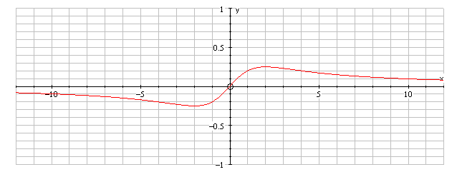
 |  |  | Shape for –2 x 2 | B1
 |  |  | Shape for x > 2 | B1
 |  |  | Shape for x <2 | B1 (3)
 |  |  |  | (11 marks)
8. | (i) | cos x cos 30 – sin x sin 30 = 3(cos x cos 30 + sin x sin 30) Use of cos(x ± 30) |  | M1
 |  | ⇒ √3 cos x – sin x = 3√3 cos x + 3 sin x Sub. for sin 30 etc  decimals M1, surds A1 |  | M1, A1
 |  | i.e. –4 sin x = 2√3 cos x → tan x = – $\frac{\sqrt{3}}{2}$ (*) Use tan x = $\frac{\text{sin}x}{\text{cos}x}$ |  | M1, A1cso (5)
(ii) | (a) | LHS = $\frac{1−(1−2{\text{sin}}^{2}θ)}{2\text{sin}θ\text{cos}θ}$ Use of cos 2A or sin 2A; both correct |  | M1; A1
 |  | = $\frac{\text{sin}θ}{\text{cos}θ}$ = tan θ (*) |  | A1 cso (3)
 | (b) | Verifying: 0 = 2 – 2 (since sin 360 = 0, cos 360 = 1) |  | B1 cso (1)
 | (c) | Equation → 1 = $\frac{2(1−\text{cos}2θ)}{\text{sin}2θ}$ Rearrange to form $\frac{1−\text{cos}2θ}{\text{sin}2θ}$ |  | M1
 |  | ⇒ tan θ = $\frac{1}{2}$ |  | A1
 |  | i.e. θ = 26.6° or 206.6° (Accept 27°, 207°) |  | M1 A1 (4)
 |  |  |  | (13 marks)

Question Number |  | Scheme | Marks
9. | (a) | Any two of | M1
 |  | Solve simultaneous equations to obtain = 2, or = 1 | M1 A1
 |  | Lines intersect at (2 , 5 , 4) | M1 A1
 |  | Check in the third equation or on second line | B1 (6)
 | (b) | line perpendicular | M1 A1 (2)
 | (c) | P is the point ( 3, 7, 3) [ i.e.  = 2] and R is the point (4, 6, 8) [i.e.  = 3] | M1 A1
 |  |  | M1 A1 ft
 |  | The area of the triangle = | M1 A1 (6)
 |  |  | (14 marks)

