Question number |  | Scheme |  | Marks
1. | (a) | log_{q}16 = log_{q} 2⁴, ∴p = 4 log_{q} 2 i.e log_{q} 2 = $\frac{p}{4}$ |  | M1, A1 (2)
 | (b) | log_{q} (8_{q}) = log_{q} 8 + log_{q} q |  | M1
 |  | = … + 1 |  | B1
 |  | = 3 log_{q} 2 + … |  | M1
 |  | ∴log_{q} (8_{q}) = $\frac{3}{4}$p + 1 |  | A1 (4)
 |  |  |  | (6 marks)
2. | (a) | (2 – px)⁶ = 2⁶ + $\left(\begin{matrix}6 \\ 1\end{matrix}\right)$2⁵(–px) + $\left(\begin{matrix}6 \\ 2\end{matrix}\right)$2⁴(–px)² Coeff. of x or x² |  | M1 $\left(\begin{matrix}n \\ r\end{matrix}\right)$okay
 | (b) | = 64 + 6 × 2⁵(–px); + 15 × 2⁴(–px)² No $\left(\begin{matrix}n \\ r\end{matrix}\right)$ |  | A1; A1
 |  | 15 × 16p² = 135 ⇒ p² = $\frac{9}{\text{16}}$ or p = $\frac{3}{4}$ (only) |  | M1, A1
 |  | –6.32p = A |  | M1
 |  | ⇒ A = –144 |  | A1 ft  (their p (> 0))
 |  |  |  | (7 marks)
3. | (a) | Centre is at (3,-4) |  | B1
 |  |  |  | M1 A1 (3)
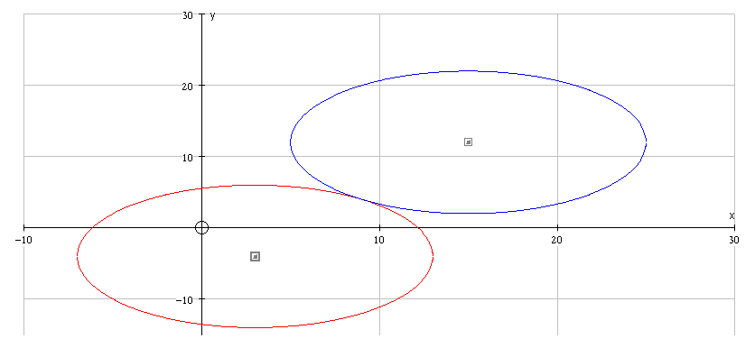 | (b) | 1st circle |  | B1
 |  | 2nd circle |  | B1
 |  | Circles touching |  | B1
 |  | At ( 9 , 4 |  | B1 (4)
 |  |  |  | (7 marks)

Question number |  | Scheme |  |  | Marks
4. | (a) | 360  −1 |  | Scales (−1, 1 and 360) | B1
 |  |  |  | Shape, position | B1 (2)
 | (b) | (0, 0.5) (150, 0) (330, 0) |  |  | B1 B1 B1 (3)
 | (c) | $\left(x+\text{30}=\right)\text{}\text{210}°\text{}\text{or}\text{}\text{330}°$ One of these |  |  | B1
 |  | x = 180° , 300° M: Subtract 30, A: Both |  |  | M1 A1 (3)
 |  |  |  |  | (8 marks)
5. |  | B X  60°  r 30  A | sin 60° = $\frac{3}{r}$ or r = 2x, 4x² = x² + 3², x = √3 |  | M1
 |  | B X  60°  r 30  A | r = $\frac{6}{\sqrt{3}}$ or r = 2√3 |  | A1 (2)
 | (b) | Area = $\frac{1}{2}$r²θ ^{c} or $\frac{θ°}{\text{360}°}$× πr ² = , $\frac{1}{6}$ × π × 12 = 2π (cm²) |  |  | M1, A1 (2)
 | (c) | Arc = r²θ ^{c} or $\frac{θ°}{\text{360}°}$× 2πr = , $\frac{1}{6}$ × 2π × 2√3 |  |  | M1
 |  | Perimeter = Arc + 2r = , $\frac{2\sqrt{3}}{3}π$+ 2 × 2√3 = $\frac{2\sqrt{3}}{3}$(π + 6) (cm) (*) |  |  | M1, A1 cso (3)
 |  |  |  |  | (7 marks)
6. | (a) | Uses the remainder theorem with , or long division, and puts remainder = 0 to obtain |  |  | M1
 |  | or any correct equivalent (allow more than 3 terms) |  |  | A1
 |  | Uses the remainder theorem with x = 1, or long division, and puts remainder = 7 to obtain |  |  | M1
 |  | or any correct equivalent (allow more than 3 terms) |  |  | A1
 |  | Solves simultaneous equations to give p = −7, and q = −14 |  |  | M1 A1 (6)
 | (b) | Then 6x³ − 7x² − 14x + 8 = (2x − 1)(3x² − 2x − 8 |  |  | M1 A1 ft
 |  | So f(x) = (2x – 1)(3x + 4)(x – 2) |  |  | B1 (3)
 |  |  |  |  | (9 marks)

Question number |  | Scheme | Marks
7. | (a) | $$\frac{a}{1−r}=\frac{\text{1200}}{1−r}=\text{960}$$ | M1 A1
 |  | 960 (1 − r) = 1200 r = − $\frac{1}{4}$ (*) | A1 (3)
 | (b) | T₉ = 1200 × (- 0.25)⁸ (or T₁₀) | M1
 |  | Difference = T₉ − T₁₀ = 0.0183105…− (− 0.0045776…) | M1
 |  | = 0.023 (or − 0.023) | A1 (3)
 | (c) | S_{n}= $\frac{\text{1200}\left(1−{\left(−0\text{.}\text{25}\right)}^{n}\right)}{1−\left(−0\text{.}\text{25}\right)}$ | M1 A1 (2)
 | (d) | Since n is odd, (− 0.25)^{n} is negative, | M1
 |  | so S${}_{n}$ = 960 (1 + 0.25^{n}) (*) | A1 (2)
 |  |  | (12 marks)
8. | (a) | (x − 3)² + (y − 4)² = 18 (accept (3√2)² | M1 A1 (2)
 | (b) | Use y = x + 3 to obtain (x − 3)³ + (x − 1)² = 18 | M1
 |  | And thus 2x² − 8x = 8 | A1
 |  | Solve quadratic, to obtain x = 2 ± √8, y = 5 ± √8 | M1, A1ft, A1ft  (5)
 | (c) | Distance = $\sqrt{((2 √8)^{2} + (2√8)^{2}}$ = 8 | M1 A1 cso (2)
 |  |  | (9 marks)

Question number |  | Scheme | Marks
9. | (a) | A: y = 1 B: y = 4 | B1 (1)
 | (b) | $\frac{\text{d }y}{\text{d }x}=\frac{2x}{\text{25}}$ = $\frac{2}{5}$ where x = 5 | M1 A1
 |  | Tangent: y − 1 = $\frac{2}{5}$(x − 5) (5y = 2x − 5) | M1 A1 (4)
 | (c) | x = $5y^{\frac{1}{2}}$ | B1 B1 (2)
 | (d) | Integrate: $\frac{5y^{32}}{32}\text{}\left(\frac{\text{10}y^{32}}{3}\right)$ | M1 A1ft
 |  | [ ]⁴ − [ ]₁ = $\left(\frac{\text{10}×4^{32}}{3}\right)−\left(\frac{\text{10}×1^{32}}{3}\right)$, = $\frac{\text{70}}{3}$ (23$\frac{1}{3}$, 23.3) | M1 A1, A1 (5)
 |  |  | (12 marks)

