Question Number | Scheme | Marks
1.  2. | (a) $\frac{1}{2}\frac{\text{dv}}{\text{dt}}=\frac{1}{2}g−2v$  $⇒5\frac{\text{dv}}{\text{dt}}=\text{49}−\text{20}v$ (*)  (b) $\int{\frac{5\text{dv}}{\text{49}−\text{20}v}}=\int{\text{dt}}$ (separate variables)  $\frac{−5}{\text{20}}\text{ln}\left(\text{49}−\text{20}v\right)=t$ (+c)  $t=0,v=0⇒c=−\frac{1}{4}\text{ln}\text{49}$ (attempt to get c)  $t=\frac{1}{4}\text{ln}\left(\frac{\text{49}}{\text{49}−\text{20}v}\right)$  $t=1:1=\frac{1}{4}\text{ln}(\frac{\text{49}}{\text{49}−\text{20}v})$ (correct use of logs/exp)  $→v≈2\text{.}\text{41}{\text{ms}}^{−1}$ or $2\text{.}4{\text{ms}}^{−1}$  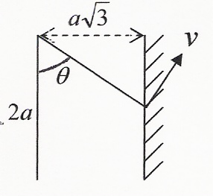  (a) Energy: $\frac{1}{2}m\left(\frac{\text{37}\text{ga}}{5}−v^{2}\right)=\text{mg}\text{.}2a\left(1−\text{cos}θ\right)$  Using $θ=\frac{π}{3}$ & solve: $→v=\sqrt{\frac{\text{27}\text{ga}}{5}}$ (*)  (b) Impact: $u_{1}=\text{ev}\text{sin}\text{30}$  KE loss $=\frac{1}{2}m\left(v^{2}{\text{sin}}^{2}\text{30}−e^{2}v^{2}{\text{sin}}^{2}\text{30}\right)$  $\left[+\frac{1}{2}{\text{mv}}^{2}{\text{cos}}^{2}\text{30}−\frac{1}{2}{\text{mu}}_{2^{2}}\right]=\frac{3\text{mga}}{5}$  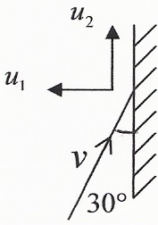  [Using $u_{2}=v\text{cos}\text{30}$ if necessary & ]  reducing to equation in (m, g, a) e alone  $\frac{3\text{mga}}{5}=\frac{1}{2}m\text{.}\frac{\text{27}\text{ga}}{5}\text{.}\frac{1}{4}\left(1−e^{2}\right)$  Solve for e: $→e=\frac{1}{3}$ | M1  A1  (2)  M1  A1  M1  M1  A1  (5)  Total 7 marks  M1 A1  M1 A1  (4)  M1 A1  M1 A1  A1  M1 A1  (7)  Total 11 marks

Question Number | Scheme | Marks
3. | (a)  (i) v_{Q} = _{Q} v_{P} + v_{P}  |v_{Q}|²$={\left(\text{10}\text{cos}\text{30}\right)}^{2}+{\left(\text{16}−\text{10}\text{sin}\text{30}\right)}^{2}$  $=\text{75}+\text{121}$  $⇒$ |v_{Q}|$=\text{14}{\text{ms}}^{−1}$  (ii) $\text{tan}θ=\frac{\text{16}−\text{sin}\text{30}}{\text{10}\text{cos}\text{30}}$ (o.e.)  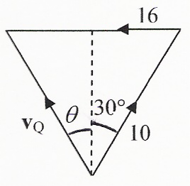  $θ≈$ 51.8°, $⇒$ bearing 308° (nearest degree)  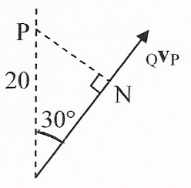  (b) At nearest approach: $\text{PN}=\text{20}\text{sin}\text{30}$  = 10 km  (c) $\text{Time}=\frac{\text{20}\text{cos}\text{30}}{\text{10}}≈1\text{.}\text{732}$ hrs  $⇒\text{Time}≈4\text{.}\text{44}$ pm (AWRT)  Alternatives  (a) Use of cosine rule in velocity vector triangle.  (b) & (c) Use of scalar product of relative velocity and relative position or differentiating magnitude of relative position vector squared to find the minimum distance and time at which it occurs. | M1 A1  A1  M1  A1, A1  (6)  M1 A1  A1  (3)  M1 A1  A1  (3)  Total 12 marks
Question Number | Scheme | Marks
4. | (a) R() $m\frac{d^{2}x}{{\text{dt}}^{2}}=\text{mg}−T−2mω\frac{\text{dx}}{\text{dt}}$ (4 terms)  $m\frac{d^{2}x}{{\text{dt}}^{2}}=\text{mg}−\frac{2{mω}^{2}a}{a}\left(e+x\right)−2mω\frac{\text{dx}}{\text{dt}}$  $→\frac{d^{2}x}{{\text{dx}}^{2}}+2ω\frac{\text{dx}}{\text{dt}}+2ω^{2}x=0$ (*)  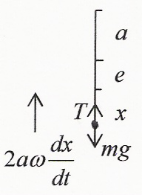  (b) $x=e^{−ωt}\left(A\text{cos}ωt+b\text{sin}ωt\right)$  $t=0,x=0⇒A=0$  $\frac{\text{dx}}{\text{dt}}=−{ωe}^{−ωt}\text{.}B\text{sin}ωt+e^{−ωt}\text{.}Bω\text{cos}ωt$ (use of product rule)  $t−0,\frac{\text{dx}}{\text{dt}}=U:U=Bω⇒B=\frac{U}{ω}$  (c) $\frac{\text{dx}}{\text{dt}}=−{\text{Ue}}^{−ωt}\text{sin}ωt+{\text{Ue}}^{−ωt}\text{cos}ωt=0$  $⇒\text{tan}ωt=1$ (solve for $\text{tan}ωt$)  $⇒t=\frac{π}{4ω}$ | M1 A1  M1  M1 A1  (5)  B1  M1  M1 A1  (4)  M1  M1  A1  (3)  Total 12 marks
Question Number | Scheme | Marks
5. | 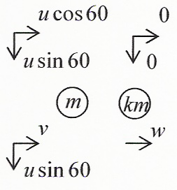  (a) $\text{CLM}\left(↔\right):\text{mu}\text{cos}\text{60}=\text{mv}+\text{kmw}$  $\text{NLI}:\frac{1}{2}u\text{cos}\text{60}=w−v$  Solve for w:$\left(1+k\right)w=\frac{1}{2}u\left(1+\frac{1}{2}\right)$  $⇒w=\frac{3u}{4\left(k+1\right)}$ (*)  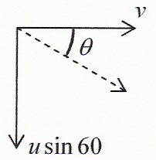  (b) Solve for v $→v=\frac{u\left(2−k\right)}{4\left(k+1\right)}$  $\text{tan}θ=2\sqrt{3}=\frac{u\text{sin}\text{60}}{v}$  $=\frac{u\sqrt{3}}{2}\text{.}\frac{4\left(k+1\right)}{u\left(2−k\right)}$  Solve k: $→k=\frac{1}{2}$  (c) $k=\frac{1}{2}⇒v=\frac{u}{4},w=\frac{u}{2}$  KE loss $=\frac{1}{2}{\text{mu}}^{2}−\left(\frac{1}{2}m\text{.}\frac{u^{2}}{\text{16}}+\frac{1}{2}m\text{.}\frac{3u^{2}}{4}+\frac{1}{2}\text{.}\frac{1}{2}m\text{.}\frac{u^{2}}{4}\right)$  $=\frac{1}{2}{\text{mu}}^{2}\left(1−\frac{1}{\text{16}}−\frac{3}{4}−\frac{1}{8}\right)$  $=\frac{1}{\text{32}}{\text{mu}}^{2}$ | M1 A1  M1 A1  M1  A1  (6)  M1 A1  M1 A1  M1 A1  (6)  B1  M1 A1  A1  (4)  Total 16 marks
Question Number | Scheme | Marks
6. | (a) PE of R $=−\sqrt{2}\text{mga}\text{cos}2θ$ (+c) (1)  PE of LH mass $=−\frac{3}{2}\text{mg}\left(2a−2a\text{sin}\left(\text{45}+θ\right)\right)$ (+c) (2)  PE of RH mass $=−\frac{3}{2}\text{mg}\left(2a−2a\text{sin}\left(\text{45}−θ\right)\right)$ (+c) (3)  V = (1) + (2) + (3) (in terms of $θ$ etc.)  $=−\sqrt{2}\text{mga}\text{cos}2θ−\frac{3}{2}\text{mg}\left[4a−a\sqrt{2}\left(\text{cos}θ+\text{sin}θ+\text{cos}θ−\text{sin}θ\right)\right]$  $=−\sqrt{2}\text{mga}\text{cos}2θ−\frac{3}{2}\text{mga}\left(−2\sqrt{2}\text{cos}θ+4\right)$  $=\sqrt{2}\text{mga}\left(3\text{cos}θ−\text{cos}2θ\right)$ + constant (*)  (b) $\frac{\text{dV}}{dθ}=\sqrt{2}\text{mga}\left(−3\text{sin}θ+2\text{sin}2θ\right)$  $\frac{\text{dV}}{dθ}=0⇒2\text{sin}2θ−3\text{sin}θ=0$  $⇒\text{sin}θ\left(4\text{cos}θ−3\right)=0$  $⇒θ=0,$ or $θ=±\text{arccos}\frac{3}{4}\left(±0\text{.}\text{723}\right)$  (c) $\frac{d^{2}V}{{dθ}^{2}}=\sqrt{2}\text{mga}\left(−3\text{cos}θ+4\text{cos}2θ\right)$  $\text{cos}θ=\frac{3}{4}:\frac{d^{2}V}{{dθ}^{2}}=\sqrt{2}\text{mga}\left(−3\text{.}\frac{3}{4}+4\left(2\text{.}\frac{9}{\text{16}}−1\right)\right)$  $=\sqrt{2}\text{mga}\left(−\frac{9}{4}+\frac{1}{2}\right)$  <0  Unstable | B1  M1 A1  A1  M1  M1  A1  (7)  M1 A1  M1  M1  A1, A1  (6)  M1 A1  M1  A1  (4)  Total 17 marks

