Paper Reference(s)
6674/01
Edexcel GCE
Pure Mathematics P4
Further Pure Mathematics FP1
Advanced Level
Tuesday 28 June 2005 − Afternoon
Time: 1 hour 30 minutes

Materials required for examination Items included with question papers
Mathematical Formulae (Green) Nil

Candidates may use any calculator EXCEPT those with the facility for symbolic algebra, differentiation and/or integration. Thus candidates may NOT use calculators such as the Texas Instruments TI 89, TI 92, Casio CFX 9970G, Hewlett Packard HP 48G.

Instructions to Candidates
In the boxes on the answer book, write the name of the examining body (Edexcel), your centre number, candidate number, the unit title (Pure Mathematics P4 or Further Pure Mathematics FP1), the paper reference (6674), your surname, other name and signature.
When a calculator is used, the answer should be given to an appropriate degree of accuracy.

Information for Candidates
A booklet ‘Mathematical Formulae and Statistical Tables’ is provided.
Full marks may be obtained for answers to ALL questions.
This paper has 8 questions.
The total mark for this paper is 75.

Advice to Candidates
You must ensure that your answers to parts of questions are clearly labelled.
You must show sufficient working to make your methods clear to the Examiner. Answers
without working may gain no credit.
1. (a) By expressing $\frac{2}{4r^{2}−1}$ in partial fractions, or otherwise, prove that

$\sum_{r = 1}^{n}{ \frac{2}{4r^{2}−1}}$ = 1 – $\frac{1}{2n+1}$.
(3)
(b) Hence find the exact value of $\sum_{r = \text{11}}^{\text{20}}{ \frac{2}{4r^{2}−1}}$.
(2)

2. Given that 1 + 3i is a root of the equation z³ + 6z + 20 = 0,

(a) find the other two roots of the equation,
(3)
(b) show, on a single Argand diagram, the three points representing the roots of the equation,
(1)
(c) prove that these three points are the vertices of a right-angled triangle.
(2)

3. Find the general solution of the differential equation

(x + 1)$\frac{dy}{dx}$ + 2y = $\frac{1}{x}$, x > 0.

giving your answer in the form y = f(x).
(7)

4. f(x) = 1 – e^{x} + 3 sin 2x

The equation f(x) = 0 has a root α in the interval 1.0 < x < 1.4.

(a) Starting with the interval (1.0, 1.4), use interval bisection three times to find the value of α to one decimal place.
(3)
(b) Taking your answer to part (a) as a first approximation to α, apply the Newton-Raphson procedure once to f(x) to obtain a second approximation to α.
(4)
(c) By considering the change of sign of f(x) over an appropriate interval, show that your answer to part (b) is accurate to 2 decimal places.
(2)

5. z = –4 + 6i.

(a) Calculate arg z, giving your answer in radians to 3 decimal places.
(2)

The complex number w is given by w = $\frac{A}{2−i}$, where A is a positive constant. Given that ⎢w ⎢= √20,

(b) find w in the form a + ib, where a and b are constants,
(4)
(c) calculate arg $\frac{w}{z}$.
(3)

6. (a) On the same diagram, sketch the graphs of y = ⎢x² – 4 ⎢ and y = ⎢2x – 1 ⎢, showing the coordinates of the points where the graphs meet the axes.
(4)
(b) Solve ⎢x² – 4 ⎢= ⎢2x – 1 ⎢, giving your answers in surd form where appropriate.
(5)
(c) Hence, or otherwise, find the set of values of x for which of ⎢x² – 4 ⎢> ⎢2x – 1 ⎢.
(3)

7. (a) Find the general solution of the differential equation

2$\frac{d^{2}x}{{dt}^{2}}$ + 5$\frac{dx}{dt}$ + 2x = 2t + 9.
(6)
(b) Find the particular solution of this differential equation for which x = 3 and $\frac{dx}{dt}$ = –1 when t = 0.
(4)

The particular solution in part (b) is used to model the motion of a particle P on the x-axis. At time t seconds (t ≥ 0), P is x metres from the origin O.

(c) Show that the minimum distance between O and P is $\frac{1}{2}$(5 + ln 2) m and justify that the distance is a minimum.
(4)

8. Figure 1

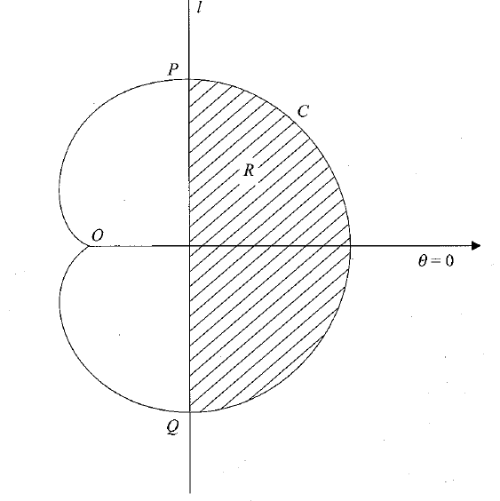
C

The curve C which passes through O has polar equation

r = 4a(1 + cos θ ), –π < θ ≤ π.

The line l has polar equation

r = 3a sec θ, –$\frac{π}{2}$ < θ < $\frac{π}{2}$.

The line l cuts C at the points P and Q, as shown in Figure 1.

(a) Prove that PQ = 6√3a.
(6)

The region R, shown shaded in Figure 1, is bounded by l and C.

(b) Use calculus to find the exact area of R.
(7)

TOTAL FOR PAPER: 75 MARKS
END

