January 2005

6683 Statistic S1

Mark Scheme

Question Number | Scheme Marks
Faulty
0.03

Goodbuy
0.85 0.97
Not faulty
Faulty

0.15 0.06
Amart
Tree (both sections) M1
0.94 labels & 0.85,0.15 or equiv. A1
Not faulty 0.03,0.97,0.06,0.94 A1
(3)

valid path & their values, correct M1,A1∫
% or 1931/2000 or equiv. or awrt 0.966 A1
(3)
(Total 6 marks)

Question Number | Scheme Marks
B1B1B1
(3)
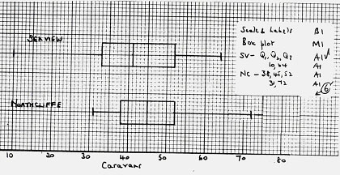
(6)
Median of Northcliffe is greater than median of Seaview.
Upper quartiles are the same
IQR of Northcliffe is less than IQR of Seaview
Northcliffe positive skew, Seaview negative skew
Northcliffe symmetrical, Seaview positive skew (quartiles)
Range of Seaview greater than range of Northcliffe
any 3 acceptable comments B1B1B1
(3)

On 75% of the nights that month B1
both had no more than 52 caravans on site. B1
(2)
(Total 14 marks)

Question Number | Scheme Marks
sensible scales B1
labels B1
shape B1
(3)

Question Number | Scheme Marks
Positive; context OK B1;B1g
(2)
use of formula, cao M1A1
(1793 only M1A1)
(2)
division, 1.028 M1A1
(SR 1.028 B1 only)
(2)

B1
Use of formula including root, 13.3 or 13.9 M1A1
(SR 13.3 or 13.9 B1 only)
(3)
34-36, 87-89 strict limits,3sf or better B1B1
(2)

All values between their 35.7 and their 87.7 so could be normal. Reason required B1
(1)
(Total 15 marks)

Question Number | Scheme Marks
verification / use of M1
cso A1
(2)

sum of 3 probabilities M1
0.4 or A1 seen (2)
(2)
use of M1
A1
(2)
3xtheirs-4 M1
A1 seen (2)

(OR
M1
cao A1)
(2)
(Total 8 marks)

AB  C918  16  564  19  7  25  Question Number | Scheme Marks
6 B1
subtract M1
4,5,7 A1
subtract M1
16,19,25 A1
box & 918 B1
(6)

B1∫
(1)
OR M1
=0.978 0.978 A1∫
(2)
conditional prob M1
A1∫
(2)
theirs from B x M1
or equivalent cao A1
(2)
(Total 13 marks)

Question Number | Scheme Marks
(Discrete) Uniform B1
(1)
e.g.Tossing a fair dice / coin B1g
(1)

Useful in theory – allows problems to be modelled B1g
not necessarily true in practice B1h
(2)
Carry out an experiment B1g
to establish probabilities B1h
(2)
(Total 6 marks)

Question Number | Scheme Marks
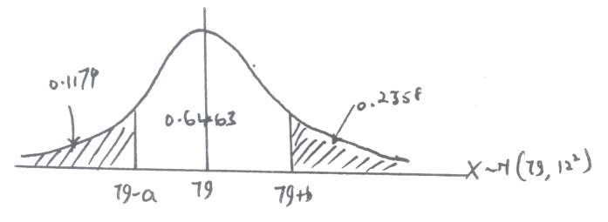 | standardise 79, 12 or 79, 144 M1  + or -0.75, 0.2266 A1A1  (3)  standardise both, 79& 12 only M1  + or -1.25&1.42, 0.8166 Accept 0.8160-0.8170 A1,A1  (3)  Shaded area = M1A1 =0.1179 cso A1  (3)  0.7642 B1 implied  standardise LHS = z-value, all correct M1A1  3sf A1  (4)  (Total 13 marks)

