Paper Reference(s)
6674

Edexcel GCE
Pure Mathematics P4
Advanced/Advanced Subsidiary
Tuesday 29 June 2004 − Afternoon
Time: 1 hour 30 minutes

Materials required for examination Items included with question papers
Answer Book (AB16) Nil
Graph Paper (ASG2)
Mathematical Formulae (Lilac)

Candidates may use any calculator EXCEPT those with the facility for symbolic algebra, differentiation and/or integration. Thus candidates may NOT use calculators such as the Texas Instruments TI 89, TI 92, Casio CFX 9970G, Hewlett Packard HP 48G.

Instructions to Candidates
In the boxes on the answer book, write the name of the examining body (Edexcel), your centre number, candidate number, the unit title (Pure Mathematics P4), the paper reference (6674), your surname, initials and signature.
When a calculator is used, the answer should be given to an appropriate degree of accuracy.

Information for Candidates
A booklet ‘Mathematical Formulae and Statistical Tables’ is provided.
Full marks may be obtained for answers to ALL questions.
This paper has eight questions.

Advice to Candidates
You must ensure that your answers to parts of questions are clearly labelled.
You must show sufficient working to make your methods clear to the Examiner. Answers
without working may gain no credit.

1. (a) Show that $\sum_{r = 1}^{n}{(r+1)(r+5)}$ = $\frac{1}{6}$n(n+ 7)(2n + 7).
(4)
(b) Hence calculate the value of $\sum_{r=\text{10}}^{n}{(r+1)(r+5)}$.
(2)

2. f(x) = 2^{x} + x − 4.

The equation f(x) = 0 has a root α in the interval [1, 2].

(a) Use linear interpolation on the values at the end points of this interval to find an approximation to α.
(2)
(b) Taking x = 1 as a first approximation to α, apply the Newton-Raphson procedure once to f(x) to obtain a second approximation to α.
(4)

3. The complex number z = a + ib, where a and b are real numbers, satisfies the equation

z² + 16 − 30i = 0.

(a) Show that ab = 15.
(2)
(b) Write down a second equation in a and b and hence find the roots of

z² + 16 − 30i = 0.
(4)

4. Find the complete set of values of x for which

|x² − 2| > 2x.
(7)

5. Given that z = 1 + √3i and that $\frac{w}{z}$ = 2 + 2i, find

(a) w in the form a + ib, where a, b ∈ ℝ,
(3)
(b) the argument of w,
(2)
(c) the exact value for the modulus of w.
(2)

On an Argand diagram, the point a represents z and the point B represents w.

(d) Draw the Argand diagram, showing the points A and B.
(2)
(e) Find the distance AB, giving your answer as a simplified surd.
(2)

6. (a) Find the general solution of the differential equation

$\frac{dy}{dx}$ + 2y = x.
(5)

Given that y = 1 at x = 0,

(b) find the exact values of the coordinates of the minimum point of the particular solution curve,
(4)
(c) draw a sketch of this particular solution curve.
(2)

7. (a) Find the general solution of the differential equation

$\frac{d^{2}y}{{dt}^{2}}$ + 2$\frac{dy}{dt}$ + 2y = 2e^{−t}.
(6)
(b) Find the particular solution that satisfies y = 1 and $\frac{dy}{dt}$ = 1 at t = 0.
(6)

8. Figure 1

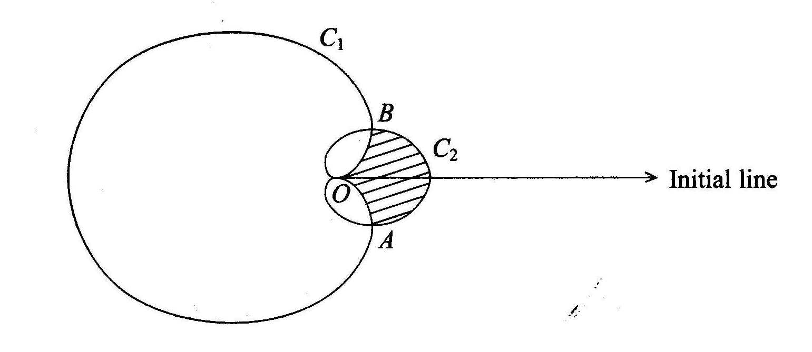

Figure 1 is a sketch of the two curves C₁ and C₂ with polar equations

C₁ : r = 3a(1 − cos θ ), −π ≤ θ < π

and C₂ : r = a(1 + cos θ ), −π ≤ θ < π.

The curves meet at the pole O, and at the points A and B.

(a) Find, in terms of a, the polar coordinates of the points A and B.
(4)
(b) Show that the length of the line AB is $\frac{3√3}{2}$a.
(2)

The region inside C₂ and outside C₁ is shown shaded in Fig. 1.

(c) Find, in terms of a, the area of this region.
(7)

A badge is designed which has the shape of the shaded region.

Given that the length of the line AB is 4.5 cm,

(d) calculate the area of this badge, giving your answer to three significant figures.
(3)

END

