Question Number | Scheme |  | Marks
1. | (a) | All arcs must be traversed twice. (So no arc needs repeating more than twice.) All valencies therefore even. | B1 |  | (1)
 | (b) | e.g. CECAEFEAFABFBACDBDGFGDC | M1 | A1
 |  |  | A1 |  | (3)  4
2.  D  C  B  A  F  E | (a) |  | B1 |  | (1)
F  E  B  C  D  A | (b) | planar, so product can be built | M1  A1  A1  A1 |  | (4)  5

Question Number | Scheme |  |  | Marks
3. |  | (a) | Add A to 3, B to 4, C to 1 and F to 5 in a distinctive way | B1 |  | (1)
 |  | (b) | e.g. D – 3 = A – 1 = C – 4 = B – 2  C.S. D = 3 – A = 1 – C = 4 – B = 2  E – 5 = F – 6  C.S. E = 5 – F = 6  A = 1 B = 2 C = 4 D = 3 E = 5 F = 6 | M1  A1  M1  A1  A1 |  | (2)  (3)  6
A  4.  G  B  C  D  F  E  H  I  K  L  J |  | (a) | e.g. | M1  A1  A1  A1  A1  A1 |  | (6)
 |  | (b) | D will only be critical if it lies on a longest route.  ABEG – 14  ACFG – 15  ACDEG – 13 +  So D critical if $x ≥ 2$ (must be not >) | M1  A1 |  | (2)  8
5. |  | (a) | Bin 1 – 75+20  Bin 2 – 70 +20  Bin 3 – 60+40  Bin 4 – 50+35  Bin 5 – 20  5 Planks needed: cost £15  Wastage = 5+10+0+15+80 = 110cm | M1  A1  A1  A1  A1 |  | (5)

Question Number | Scheme |  |  | Marks
or  5.  (cont) | (b) | Bin 1 (1.5m) – 75+70 Bin 1 (1m) –75+20  Bin 2 (1.5m) – 60+50+40 Bin 2 (1.5m) –70+60+20  Bin 3 (1m) – 35+20+20+20 Bin 3 (1.5m) –50+40+35+20  Cost £11  1.5m lengths better value than 1m lengths to use as many as possible |  | M1  A1  A1  A1 |  | (4)  9
6. | (a) i  ii  iii  (b)  (c) |  | A connected graph with no cycles, loops or multiple edges  A tree that includes all vertices  A spanning tree of minimum total length  E.g.  - In Kruskal the shortest arc is added (unless it completes a cycle), in Prim the nearest unattached vertex is added  - There is no need to check for cycles when using Prim, but there is when using Kruskal  - In Prim the tree always “grows” in a connected fashion  - Kruskal starts with the shortest edge, Prim with any vertex  BH, NF, HN, HA, BE, NC; length = 48 | B1  B1  B1  B1  M1 | A1; | (3)  (1)  A1
C  E  9  B  5  7  H  F  6  N  8  A  13 |  |  |  | A1 |  | (4)

Question Number | Scheme |  | Marks
6. (cont)  50  80  70  130  60 | (d) | New cable – 390m | B1  M1 | A1 | (3)  11
7. | (a) |  | B1, | B1 | (2)
42  47  32  S  41  F₁  F₂  R₁  R₂  R₃  T  10 | (b) |  | M1  A1 | A1 | (3)
 | (c)
 |  |  | M1
 |  |  | A1
 |  |  | A1 |  |  | (3)

Question Number | Scheme |  |  | Marks
7.  (cont) | (c)  (cont.) |  | e.g. S F₁ A E R₁ T – 7  S F₁ B E R₁ T – 5  S F₁ B G R₁ T – 1  S F₂ C D B G R₂ T - 4 | DM1  A1  A1  A1 |  | (4)
F₁  A  E  R₁  B  G  D  F₂  C  R₃  R₂  19  8  10  15  19  13  32  12  21  7  10  30  12  6  25  8 | (d) | e.g.  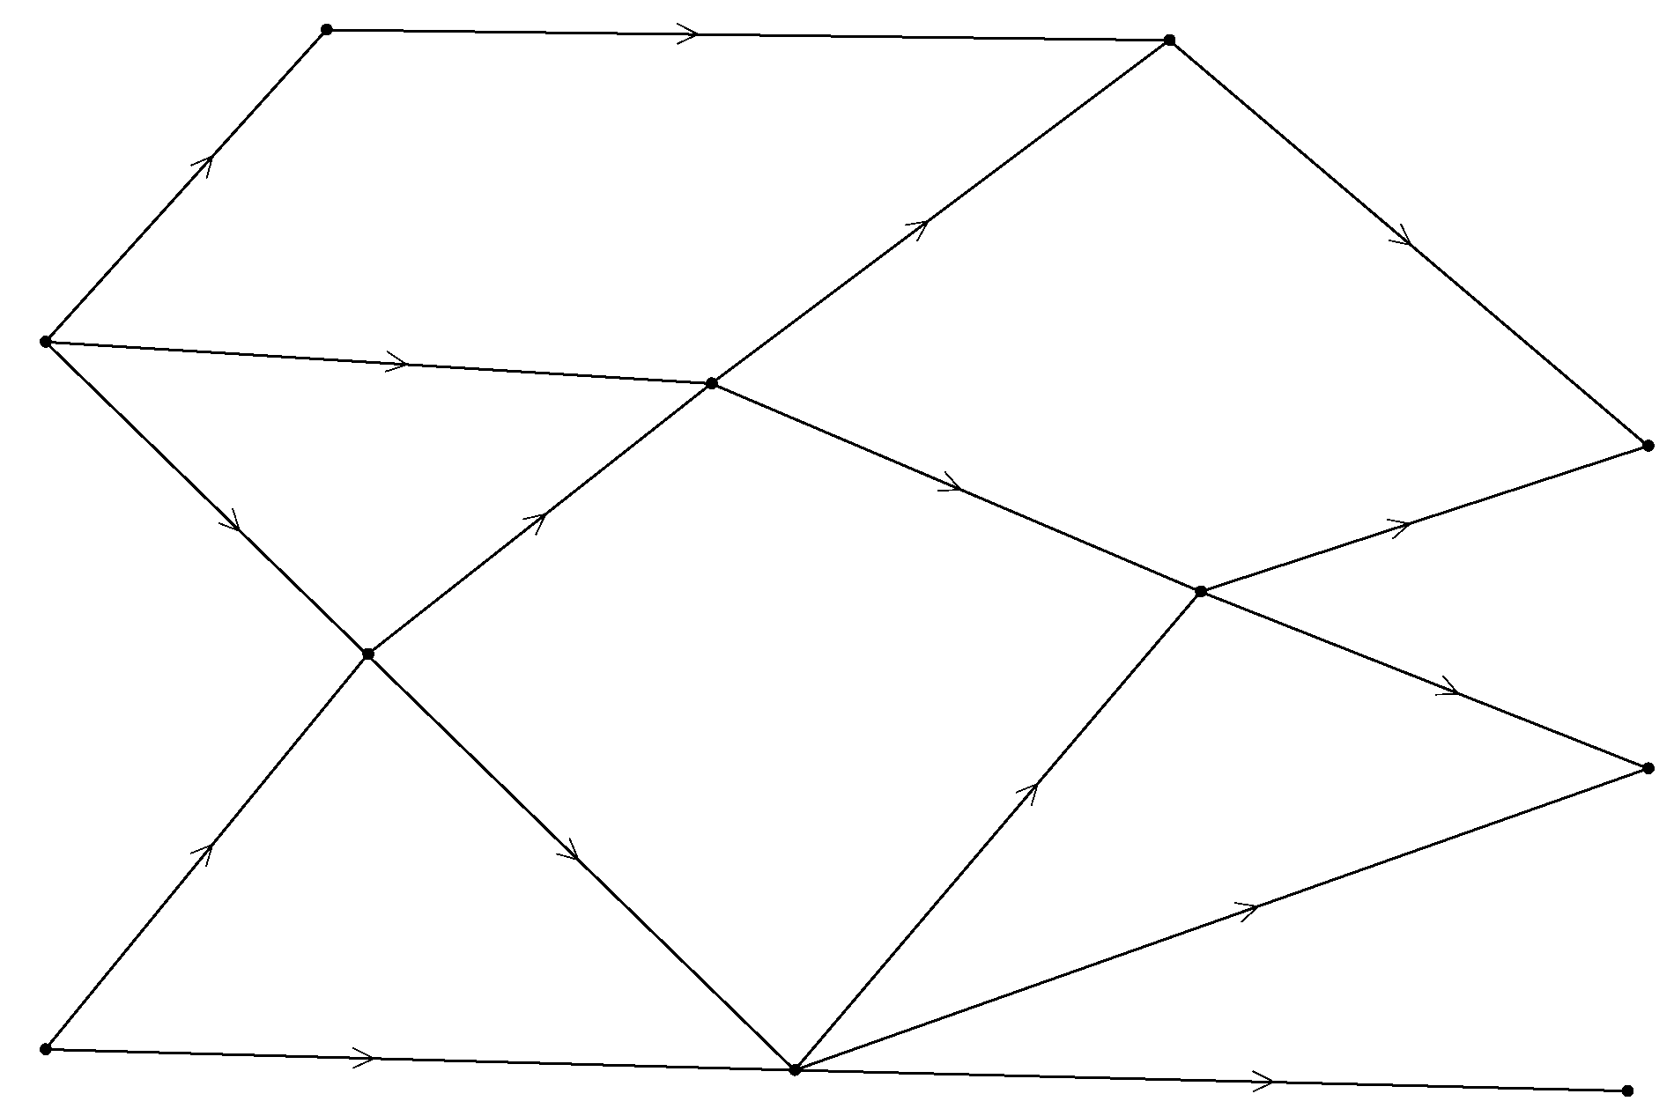 |  | B1
 |  | Max Flow 82 |  | B1 |  | (2)
 | (e) | e.g.  $F_{1}$ A, BE, BG, CG, CR₂, CR₃ (=82)  Or ${\text{ER}}_{1}$, BG, CG, CR₂, CR₃ (=82) |  | M1 | A1 | (2)  16

Question Number | Scheme |  |  | Marks
8. | (a) |  |  | B1
 | (b)  i | x + 2y + 4z + s = 24 |  | B1
 | ii  (c) | $s (≥ 0)$is the slack time on the machine in hours  1 Euro |  | B1  B1 |  | (4)
 | (d) |  |  | M1 | A1  A1 | (3)
 | (d) |  | R₁-6R₂ | M1 | A1  A1 | (3)
 | (d) |  | R₂4 | M1 | A1  A1 | (3)
 | (d) |  | R₃+4R₂ | M1 | A1  A1 | (3)
 |  |  |  | M1 | A1  A1 | (3)
 |  |  | R₁2 | M1 | A1  A1 | (3)
 |  |  | R₂- ½ R₁ | M1 | A1  A1 | (3)
 |  |  | R₃+R₁ | M1 | A1  A1 | (3)
 |  | Profit = 31 Euros  medium large |  | M1 | A1 | A1  (3)
 | (e)  (f) | Cannot make ½ a lamp  e.g. (0, 10, 0) or (0, 6, 3) or (1, 7, 2)  checks in both inequalities |  | B1  B1  B1 |  | (1)  (2)  16

