Subject PURE MATHEMATICS Paper no. P3
Question number | Scheme | Marks
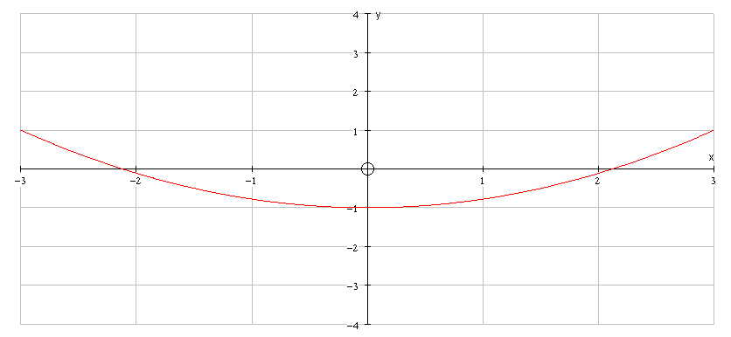  1. | Attempt to use correctly stated double angle formula, or complete method using other double angle formula for cos2t with to eliminate t and obtain y =  or any correct equivalent.(even y =cos2(cos  shape  position including  restricted domain  -3 < x < 3 | M1  A1  (2)  B1  B1  (2)
2. (a)  (b) | Remainder = p + q + 18 = p + 21 (=1) | M1 , M1  M1  A1  (4)  B1√ ft on p  (1)
Subject PURE MATHEMATICS Paper no. P3
Question number | Scheme | Marks
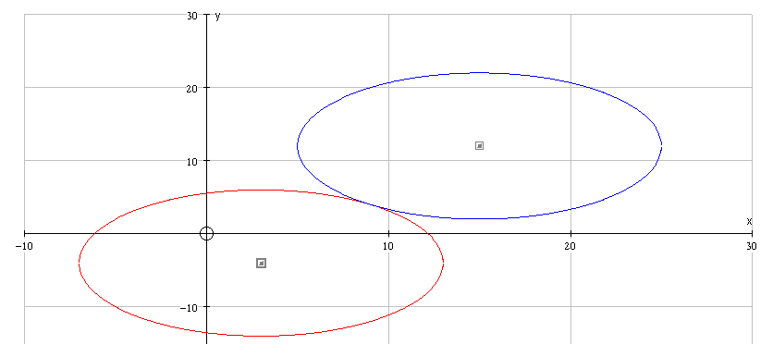  3. (a)  (b) | Centre is at (3,-4)  1st circle  2nd circle  Circles touching  At ( 9 , 4 ) | B1  M1 A1  (3)  B1  B1  B1  B1  (4)
4. (a)  (b) | Substitutes into derived expression to obtain  Eliminates one variable to obtain, for example,  and obtains y (or x)  Substitutes y to obtain x (or y)  Obtains coordinates (-2,1) and (2,-1) | M1 (B1) A1  M1  A1  (5)  M1  M1  A1, A1  (4)

Subject PURE MATHEMATICS Paper no. P3
Question number | Scheme | Marks
5. (a)  (b) | At A = 0  (essential to see intermediate line before given answer) | M1,A1  dM1  A1  (4)  M1  M1 A1  M1  A1  M1  A1  (7)
Subject PURE MATHEMATICS 6673 Paper no. P3
Question number | Scheme | Marks
6. (a)  (b)  (c)  (d) | ( or stated in above form or column vector form.  Area of  or given in alternative form with attempt at scalar product  , therefore the lines are perpendicular.  and AD:DB = 2:-1 (allow 2:1) | M1A1  M1 A1  (4)  M1  M1  A1  (3)  M1  A1  (2)  M1, A1  (2)
Subject PURE MATHEMATICS 6673 Paper no. P3
Question number | Scheme | Marks
7. (a)  (b)  (c)  (d) |  | M1  M1  A1  (3)  M1,  M1 A1  A1  (4)  B1  B1  B1  (3)  M1 A1  (2)
Subject PURE MATHEMATICS 6673 Paper no. P3
Question number | Scheme | Marks
8. (a)  (b)  (c) | Method using either  or  A = 1  C=10 , B=2 or D=4 and E = 16  or  or  Either  Or  = | M1  B1  A1, A1  (4)  M1  M1A1√ A1√A1√  (5)  M1  A1  M1 A1  A1  M1A1  (7)  M1 A1  M1 A1 A1  M1A1  (7)

