OCR

OXFORD CAMBRIDGE AND RSA EXAMINATIONS

Advanced Subsidiary GCE
ECONOMICS 2883

THE NATIONAL AND INTERNATIONAL ECONOMY

Friday 26 JANUARY 2001 Morning 1 hour 30 minutes

TIME 1 hour 30 minutes

INSTRUCTIONS TO CANDIDATES

Write your name, Centre number and candidate number in the spaces provided on the answer booklet.
Answer all questions.
The final question has alternative parts. You should only answer one of them.
Write all your answers on the separate answer booklet provided.
If you need to use additional answer sheets, fasten these sheets securely to the answer booklet.

INFORMATION FOR CANDIDATES

The number of marks is given in brackets [ ] at the end of each question or part question.
The quality of your written communication will be taken into account in marking your answer to the question labelled with an asterisk (*)•
You are advised to spend about 30 minutes writing your answer to part (f).

Budget boost for the economy

In the March 2000 Budget, the Chancellor of the Exchequer, Gordon Brown, announced a range of tax changes and increased government spending on education and the National Health Service.

Unexpectedly large tax revenues gave the Chancellor the opportunity of increasing government spending or cutting tax rates or a combination of both. He decided to make only small tax cuts but relatively large increases in government spending.

Some economists claimed that the boost to aggregate demand caused by Gordon Brown’s fiscal policy decisions would force the Bank of England to raise interest rates to slow the economy. They expressed concern that recent interest rate rises had already pushed the value of the pound to a fourteen year high against major European currencies. Any further tightening of monetary policy, they argued, would hit exporters.

Table 1

Budget information and forecasts
1999 2001
(Actual) (Forecast)
Economic growth 2 2.25- 2.75
(% per annum)
Inflation 2.25 2.5
(% per annum)
Increase in consumer spending 4 2-2.5
(% per annum)
Increase in government spending 3.5 2.75
(% per annum)
Increase in investment 5.25 3.75-4.25
(% per annum)
Balance of payments: current account -12.25 -21
(£bn)

(a) (i) Distinguish between fiscal policy and monetary policy. [4]
(ii) Explain one reason why tax revenue may increase when incomes rise. [3]
(b) (i) Describe how economic growth is measured. [4]
(ii) Explain one possible cost of economic growth. [4]
(c) (i) State the components of aggregate demand. [2]

(ii) Explain the effect that an increase in interest rates is likely to have on two of the
components of aggregate demand. [6]

(d) The passage mentions a change in government spending (line 2). Using an aggregate demand and supply diagram, analyse the effects of an increase in government spending on
output and the price level. [7]

(e) Selecting information from Table 1, discuss whether the performance of the UK economy was
expected to improve between 1999 and 2001. [10]

*(f)

Either (i) Discuss alternative economic policies for promoting economic growth. [20]

Or (ii) Discuss the arguments for, and against, protecting domestic industries from foreign
competition. [20]

18 JUNE 2001 2883
Balance of Payments Concerns

In the second half of the year 2000, it was generally thought that the UK economy was performing well with low and stable inflation, falling unemployment and high economic growth. However, concerns were raised about the UK’s international trade performance. In July 2000, the trade in goods deficit with the rest of the world increased from £2.4bn to £3bn as imports rose and exports fell.

Some UK producers blamed the high value of the pound, especially against European currencies, for this situation, claiming that it was making their goods and services uncompetitive at home and abroad. Support for this view came in August 2000, when the value of the pound against the dollar fell below $1.45 for the first time since 1993. Exports to the United States of America (USA) rose to their highest level for three years. This was attributed to both the fall in the exchange rate and a
rise in US incomes.

However, despite the higher exports to the USA, UK exporters still faced a number of actual problems and potential problems at the end of 2000. The value of the pound remained high against the euro, the single currency of twelve of the European Union (EU) members, and UK exporters were experiencing difficulties recruiting skilled labour. In addition, UK exporters were concerned about the prospect of higher interest rates and the threat from the US government to place higher tariffs on a greater range of EU products.

Geographical pattern of UK trade in 1999
Destination of Source of
UK exports of goods UK imports of goods
(£bn) (£bn)

Trading areas:
European Union (EU) 97 103
Other Western Europe 7 11
United States of America (USA) 28 28
All Other Countries 34 50

Table 1

(a) Define what is meant by
(i) an exchange rate [2]
(ii) low and stable inflation. [3]
(b) Explain the likely effect of a high exchange rate on:
(i) UK exports [3]
(ii) UK imports [3]
(iii) UK aggregate demand. [3]
(c) Explain two benefits of ‘low and stable inflation’ (line 2). [4]

(d) (i) Using Table 1, compare the UK’s trade position with the European Union and its trade
position with the USA. [4]

(ii) What effect might the imposition by the USA of a tariff on UK manufactured goods have
on the UK’s trade with the USA? [4]

(iii) Give two other methods of protection, apart from tariffs, that could have been used by
the USA. [2]
(e) (i) Explain one reason why the Bank of England may raise interest rates. [2]

(ii) Using an aggregate demand and supply diagram, analyse the effects of a rise in interest
rates on the economy. [10]

*(f)

Either (i) Discuss the effectiveness of supply-side policies in improving UK economic
performance. [20]
Or (ii) Discuss the potential costs and benefits of economic growth. [20]

21 JANUARY 2002 2883

A changing employment problem

In July 2000, aggregate demand in the UK continued to increase, largely driven by increases in consumption (see Table 1). This caused unemployment to fall by 22,700 to 3.7 per cent of the labour force, its lowest level since November 1975.

After thirty years of concern about a lack of jobs, the focus was switching to concern about a lack of workers. A recent survey by the London Chamber of Commerce and Industry found that two out of three firms were struggling to find the right workers. Skill shortages were being experienced in both high and low paid jobs, including computer software specialists, teachers, nurses, medical laboratory technicians and fruit pickers.

A lack of labour creates a number of problems. It can slow down economic growth, create inflationary pressure and cause balance of payments difficulties. The problems are set to become more acute due to population changes. With an ageing population, more pensioners would have to be supported by a smaller pool of workers.

These concerns led the UK government to consider allowing more foreign workers into the country to increase the labour force and plug the gaps in the skills base. It also resulted in the government increasing its spending on training initiatives designed to raise the productivity of existing workers.

In the absence of an increase in the quantity or quality of the labour force, there was concern that the government would have to reduce aggregate demand, or at least the rate of growth of aggregate demand.

The introduction of deflationary fiscal and monetary policy measures would have an impact not only on the UK economy but also on the UK’s trading partners, especially in the rest of the European Union and the USA.

UK household income and consumption patterns, 1994-9
Household disposable Household consumption
income (£bn) (£bn)
1994 482 431
1995 495 438
1996 506 457
1997 525 473
1998 526 491
1999 544 51

Table 1

(a) Define what is meant by
(i) aggregate demand [2]
(ii) unemployment [2]
(iii) the balance of payments. [2]
(b) (i) How might a lack of labour ‘slow down economic growth’ (line 10)? [4]
(ii) Apart from an increase in output, explain two benefits of a fall in unemployment. [4]

(c) (i) Describe how ‘allowing more foreign workers into the country’ (lines 15-16) would affect
long run aggregate supply. [2]
(ii) Identify any two other causes of a change in long run aggregate supply. [2]

(iii) Using an aggregate demand and supply diagram, analyse the effect of a rise in
consumption on the economy. [8]

(d) (i) State and explain what relationship you would expect to find between changes in
disposable income and consumption. [4]
(ii) To what extent does the information in Table 1 support this expected relationship? [4]

(e) Explain one way in which a rise in UK interest rates may have an impact on the US economy.
[6]

*(f) Either (i) Discuss the effectiveness of fiscal policy measures in reducing aggregate demand. [20]
Or (ii) Discuss whether an inflation rate of 5% might cause problems for the UK economy. [20]

11 JUNE 2002 2883

Boom, Boom... Bust? A Tale of Two Economies

In 2001 for the first time in eight years, the annual change in real GDP of the United States (US) economy was negative. As the domestic US economy experienced a downturn, the number of people out of work increased. The Federal Reserve, the US central bank, reacted to the decline in economic activity by cutting its interest rate to just 2% in October 2001, the lowest level for forty years.

In the United Kingdom (UK), the Monetary Policy Committee of the Bank of England responded by reducing its interest rate to 4%. High levels of consumer spending, in particular, were helping to keep UK aggregate demand rising. It was feared that falling business confidence would have a negative effect on consumption and investment, and that aggregate supply, as well as aggregate demand, would be affected by the expected downturn. Compared to the US, the economic performance of the UK was relatively strong at this time but the Bank was concerned that the UK economy would be adversely affected by the US recession.

Table 1 below shows the annual growth rate in real GDP and the average unemployment rate for the US and the UK economies from 1996 to 2001. Here, the US unemployment measure is based on the Labour Force Survey approach, whereas the UK unemployment figure is based on the claimant count.

Selected statistics on the US and UK economies, 1996 —2001

UNITED STATES UNITED KINGDOM

% change in real % unemployment % change in real % unemployment
GDP rate GDP rate
3.6 5.4 2.6 6.2
4.4 5.0 3.5 5.5
4.3 4.5 2.6 4.7
4.2 4.2 2.3 4.3
5.0 4.0 3.0 3.7
—0.1 4.6 ¹ 0.6 ¹ 3.5 ¹

Note: ^{1.} forecasts

Table 1

What is meant by the following economic terms as they appear in the text:

(i) investment (line 10); [2]
(ii) aggregate supply (line 10); [2]
(iii)recession (line 13)? [2]

(b) (i) What is meant by ‘real GDP’ (see Table 1)? [2]

(ii) Use the data in Table 1 to compare what happened to real GDP in the US and the UK
economies between 2000 and 2001. [4]

(c) (i) Describe what is meant by the ‘claimant count’ measure of unemployment (line 17). [2]

(ii) To what extent is it possible to compare the unemployment rates between the US and UK economies as shown in Table 1 (see lines 14—17)? [2]

(d) (i) Explain how changes in an economy’s real GDP would usually be expected to affect its
rate of unemployment. [4]

(ii) To what extent does the data relating to the UK economy (see Table 1) support this
relationship? [6]

(e) In 2001, the US Federal Reserve cut interest rates on various occasions, reaching a forty year low in October (see lines 3—5).

(i) What evidence is there in Table 1 to suggest why these interest rate cuts were made? [2]
(ii) Apart from a cut in interest rates, explain two other measures that the government
could have used to stimulate aggregate demand. [6]
(iii) Using an aggregate demand and aggregate supply diagram, analyse the effect of a fall
in aggregate demand on an economy. [6]

*(f)

Either (i) Discuss the effectiveness of monetary policy in achieving an increase in aggregate
demand in an economy. [20]

Or (ii) Discuss the alternative policies a government may use to improve a deficit in the
balance of payments. [20]

January 2003

The death of inflation?

In December 2001, the UK saw its annual inflation rate fall to 0.7%, its lowest level since April 1960. In 2001, the UK economy was in a generally healthy state, particularly compared with other industrialized countries (see Table 1). Economic growth was relatively high, and unemployment, estimated by both the claimant count and the Labour Force Survey measures, was below that of many other industrialised countries.

Some economists argue that low inflation is here to stay. They point to lower inflationary expectations, increased international competitiveness and technological advances as proof of this. They also claim that measures of inflation tend to
exaggerate its level.

If inflation does remain low, the Government will have more opportunity to concentrate its policy measures on achieving its other macroeconomic objectives of economic growth and low unemployment. In pursuit of these objectives, Gordon Brown, the Chancellor of the Exchequer, is particularly keen to increase productivity. Higher productivity would raise the UK’s long-run economic performance and increase its ability to achieve a sustained rise in production without inflation. Other economists, however, argue that inflation remains a real risk. If consumer spending remains high, investment increases or the value of the pound falls, there may be upward pressure on prices.

There is also some concern that if the USA falls further into recession, there may be more pressure on its government to move further from free trade towards protectionism. This may have an adverse effect on the world economy as a whole.

A comparison of economic performance in 2001
Germany Ireland Japan UK
% change in real GDP 0.7 5.1 -0.4 2.2
(economic growth)
% unemployment rate 7.9 3.8 5.0 5.1
% change in consumer 2.4 4.0 -1 .6 1.2
prices (inflation rate)
Source: National Institute Economic Review, April2002

Table 1

(a) Distinguish between:
(i) production and productivity (lines 14—16). [2]

(ii) the claimant count and the Labour Force Survey measures of unemployment (lines 4—5). [2]
(b) (i) Give one macroeconomic policy objective not mentioned in the passage. [1]

(ii) Identify two supply-side policies that a government could use to achieve its
macroeconomic policy objectives. [2]

(iii) Selecting information from Table 1, and excluding the UK from your answer, discuss
which of the remaining three economies performed best in 2001. [6]
(c) (i) Explain what is meant by a fall in the inflation rate. (line 1) (2)
(ii) Describe how the retail price index (RPI) is calculated. (4)
(d) (i) Explain two reasons why investment may increase (line 18). (4)

(ii) Using an aggregate demand and supply diagram, analyse the effect of an increase in
investment on the economy. (8)
(e) (i) Describe one possible benefit the USA might gain from free trade. (3)
(ii) Assess one argument that the USA might give for protecting one of its industries. (6)

(f)*

Either (I) Discuss the impact an increase in demand for UK exports might have on the
government’s macroeconomic policy objectives. (20)

Or (ii) Discuss the policies a government could use to reduce unemployment. [20]

June 2003

UK’s trade in goods and services balance (thn) 1995—2001
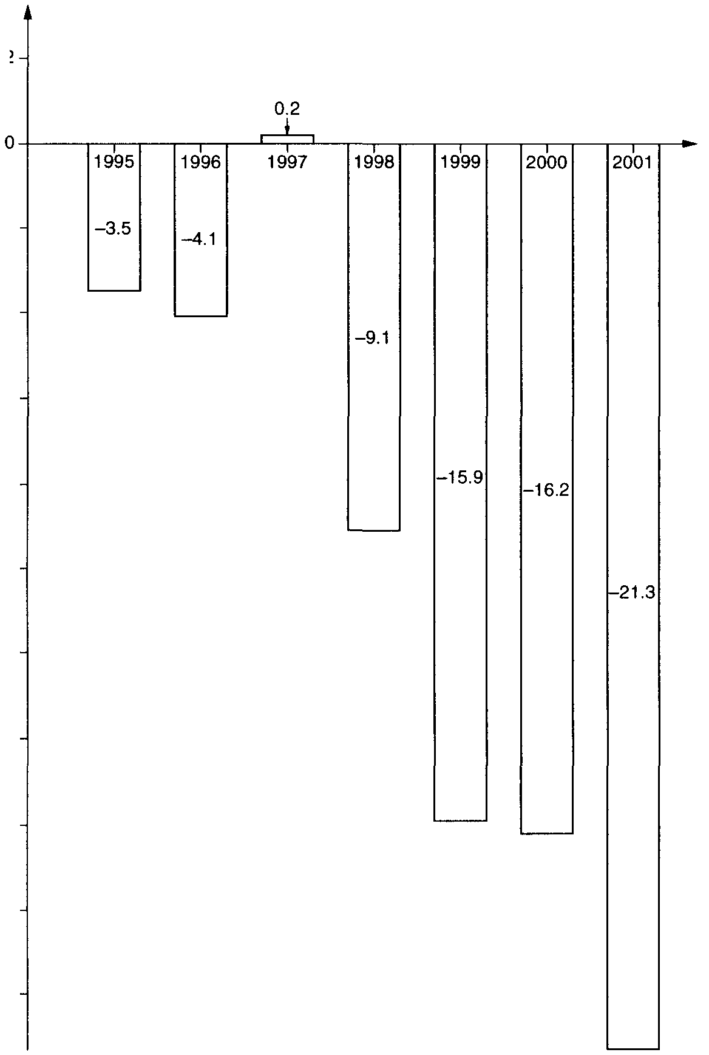
Figure 1

UK’s economic performance and prospects

The Chancellor of the Exchequer, Gordon Brown, started his 2002 Budget statement by reviewing the country’s economic performance and prospects:

‘Five years ago, this Government’s first Budget set out long-term objectives and far-reaching reforms to achieve economic stability and higher employment. In the last year, the UK has experienced the lowest 5 inflation and lowest interest rates since the 1960s. For the first time for half a century, the unemployment rate in the UK is lower than in the United States, Japan and the rest of the European Union; and in the year just ended, the UK had the highest economic growth of any of our major competitors. While Germany grew by 0.6%, the United States by 1.2%, the 10 eurozone by 1.5% and Japan contracted by 0.5%, the UK grew by 2.2%. We will continue with a sound and long-term approach to fiscal policy. We will also press ahead with supply-side policies to increase productivity and remove barriers to growth.’

What the Chancellor did not comment on was the country’s trade in goods and 15 services position (see Figure 1).
(a) Define the following terms:
(i) inflation (2)
(ii) unemployment (2)
(iii) supply-side policies. (2) (b) (i) State the components of aggregate demand. (4)

(ii) Explain the effect a reduction in interest rates may have on any two components of
aggregate demand. (8)

(c) (i) Using Figure 1, describe the trend in the UK’s trade in goods and services balance
between 1995 and 2001. (3)
(ii) Comment on two possible reasons for this trend. (8)

(d) Using information from the Chancellor’s Budget statement, compare what happened to output in the United States, the UK and Japan in 2001. [4]

(e)* Using aggregate demand and supply analysis, discuss the effect of an expansionary fiscal
policy on the economy. [12]

