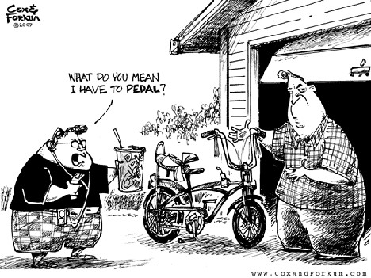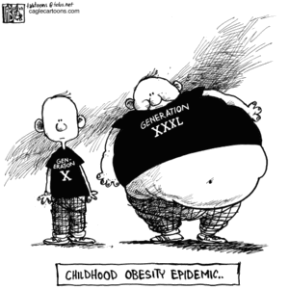
Obesity - Key Facts
In England alone, nearly a quarter of men and women are now obese. The trends for children are even more cause for concern, with 18 per cent of 2 to 15 year olds currently obese and a further 14 per cent overweight.
The Foresight report on obesity, published last year, indicated that on current trends nearly 60 per cent of the UK population will be obese by 2050 - that is almost two out of three in the population defined as severely overweight. If this trend continues, millions of adults and children will inevitably face deteriorating health and a lower quality of life and we face spiralling health and social care costs.
Obesity is one of the major public health issues in the developing world. It can lead to increased risk of heart disease, type 2 diabetes and some cancers.
Around 58% of type 2 diabetes, 21% of heart disease and between 8% and 42% of certain cancers (endometrial, breast, and colon) are attributable to excess body fat.
Obesity is responsible for 9,000 premature deaths each year in England, and reduces life expectancy by, on average, 9 years.
Obese people are more likely to suffer from social and psychological problems, such as depression, prejudice, discrimination, stigmatization and low self-esteem.
Obesity has serious economic costs. It has been estimated that the cost of obesity to the NHS is approximately £1billion per year, with an additional £2.3b - £2.6b per year to the economy as a whole. If the current trend is not halted, Wanless estimated that by 2010 the cost to the economy alone could be £3.6b per year.
The National Audit Office (NAO) has predicted that one million fewer obese people in this country could lead to around 15,000 fewer people with coronary heart disease, 34,000 fewer people developing type 2 diabetes, and 99,000 fewer people with high blood pressure.
In 2007, 1.23 million prescription items were dispensed for the treatment of obesity compared to 0.13 million items in 1999. Between 2006 and 2007, the number of items dispensed for the treatment of obesity increased by 16 per cent (from 1.06 million in 2006).

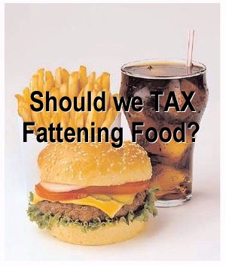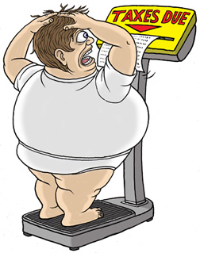
Fat tax
Researchers at Oxford University say that charging Value Added Tax (VAT) at 17.5 percent on foods deemed to be unhealthy would cut consumer demand and reduce the number of heart attacks and strokes.
The purchase tax is already levied on a small number of products such as potato crisps, ice cream, confectionery and chocolate biscuits, but most food is exempt.
The move could save an estimated 3,200 lives in Britain each year, according to the study in the Journal of Epidemiology and Community Health. "A well-designed and carefully-targeted fat tax could be a useful tool for reducing the burden of food-related disease," the study concluded.
The team from Oxford's Department of Public Health said higher taxes have already been imposed on cigarettes and alcohol to encourage healthy living.

Questions/Discussion Points
- The NHS is usually described as a Merit Good. What is a Merit Good?

- Why would obesity be seen as a negative externality?

- Give three social costs of obesity

- Should the government intervene to reduce obesity? Explain your answer.
- The government has formulated a strategy to reduce obesity levels you can find it here, http://nds.coi.gov.uk/content/detail.aspx?NewsAreaId=2&ReleaseID=347137
What are its main ideas? How likely do you think they are to be successful?

- Some analysts have recommended introducing a so called ‘Fat tax’ to reduce consumption of unhealthy fatty, sugary and salty foods.
- How does an indirect tax reduce consumption?
- What are the possible benefits of such a tax?
- What are the possible drawbacks of such a tax?
- What is your conclusion?

- Can you think of any other ways to reduce obesity?
Teachers notes
Questions
The questions are just a framework that could be used to look at the issues surrounding a negative externality and as such fit into unit 4.3.1b as well as providing an introduction to the wider topics found in unit 4.3.4b.
Obesity is a negative externality that has serious social costs with impacts in both the short and long run. There is much that can be discussed on the issue of ‘should the government intervene?’ to reduce obesity. After all, the government already does intervene via taxation and persuasion to reduce consumption of alcohol and tobacco and of course it legislates to prevent the consumption of so called ‘recreational’ drugs.
As with alcohol and tobacco there has been much discussion of a fat tax as a way of reducing obesity, so far the government has decided not to do this and has instead opted for persuasion and education.
The issue of a fat tax brings in all kinds of issues which could be discussed; such as the effectiveness of such a measure, how easy it would be to avoid it, how much tax to charge and on which foods to levy it. Then there is the revenue that would be raised and what to use it for, to fund other obesity reducing initiatives, or to raise funds for the government? Then there is the issue of it being a regressive tax, is this fair? What effect would this have on disposable income and other types of spending? How would it affect the industries that produce unhealthy foods and employment in those businesses? Does it matter? If you tax chocolate does it matter that it may have harmful effects on the livelihoods of cocoa producers in developing economies?
Some useful background information
Fat tax proposals
http://www.guardian.co.uk/society/2007/jul/12/health.politics
The fat tax; economic incentives to reduce obesity
http://www.ifs.org.uk/bns/bn49.pdf
Some useful but rather more provocative information!
'Fat tax' to hit McDonald's in Essex
http://www.telegraph.co.uk/foodanddrink/foodanddrinknews/6169880/Fat-tax-to-hit-McDonalds-in-Essex.html
“Shouldn’t we tax fatties?”
http://www.dailymail.co.uk/health/article-388001/Shouldnt-tax-fatties.html
Ryanair’s fat tax
http://www.timesonline.co.uk/tol/travel/news/article6146887.ece

