In the following passage you are given information about a dispute.
Write a reasoned case in which you divide your answer as follows:
(a) Assess the credibility of the evidence given by each participant / source. Make clear how far this is influenced by any relevant factors. e.g. what they could have seen, and any assumptions that need to be made. [12]
(b) Come to a reasoned judgement about who stole the money.
You should:
• Identify where there is corroboration and / or conflicting evidence.
• Outline the balance of evidence.
• Justify your judgement by discussing the weight and quality of the supporting evidence. [8]
Sponsorship money of £800 in £10 notes has disappeared from an administration office. This occurred in the teaching unit of Highfield Hospital during timetabled lectures. The money had been brought in that morning, and was due to be presented to the Hospital Chaplain (C) in respect of his launch of the appeal to refurbish the children’s ward. A dispute has now arisen as to who stole the money.

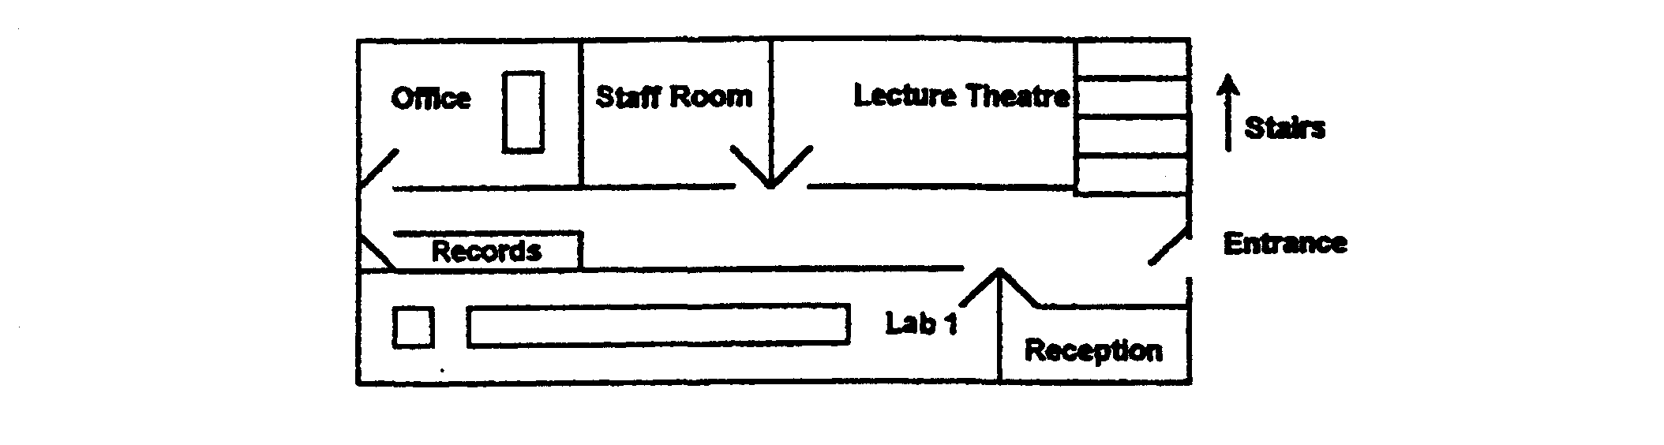

The administrator (A), a longstanding employee approaching retirement, claimed that she had momentarily left the money unattended on her office table. She said that she had been distracted from locking it up by ‘the persistent but unnecessary request’ of student nurse (N).
(N), however, insisted that she had not seen any money on the office table when she went into query her financial assistance award. In order to deal with the query, (A) and (N) had to leave the office to consult filed records in the room opposite. (N) added that she was certain that no one had entered the office whilst she stood in the doorway of the records room, waiting for the administrator to retrieve the information. (N) complained that (A) seemed ‘too quick to declare that the money had been stolen’ when they returned to the office to answer the phone which had been ringing continuously.
The Chaplain (C) remembered being aware of the phone ringing as he left the staff room. He had glanced up the corridor and seen Balfour (B), (N)’s cousin, coming out of the office. However, (B) claimed that she had been working in a busy practical session in Lab 1 at the time. Indeed, that she had completed and handed in a task sheet at the end of the session.
The recently appointed senior tutor (T) confirmed that he had received the sheet and that, apart from (N), he ‘had not noted any late arrivals to the session’. In addition, having consulted (B)’s previous year’s report, he felt able to state that she was a ‘high performing and dedicated nurse who was sensitive to the needs of others’.

