In the following passage you are given information about a dispute.
Write a reasoned case in which you divide your answer as follows:
(a) Assess the credibility of the evidence given by each participant / source. Make clear how far this is influenced by any relevant factors. e.g. what they could have seen, and any assumptions that need to be made. [12]
(b) Come to a reasoned judgement as to whether or not the first strike bomber was shot down.
You should:
• Identify where there is corroboration and / or conflicting evidence.
• Outline the balance of evidence.
• Justify your judgement by discussing the weight and quality of the supporting evidence. [8]

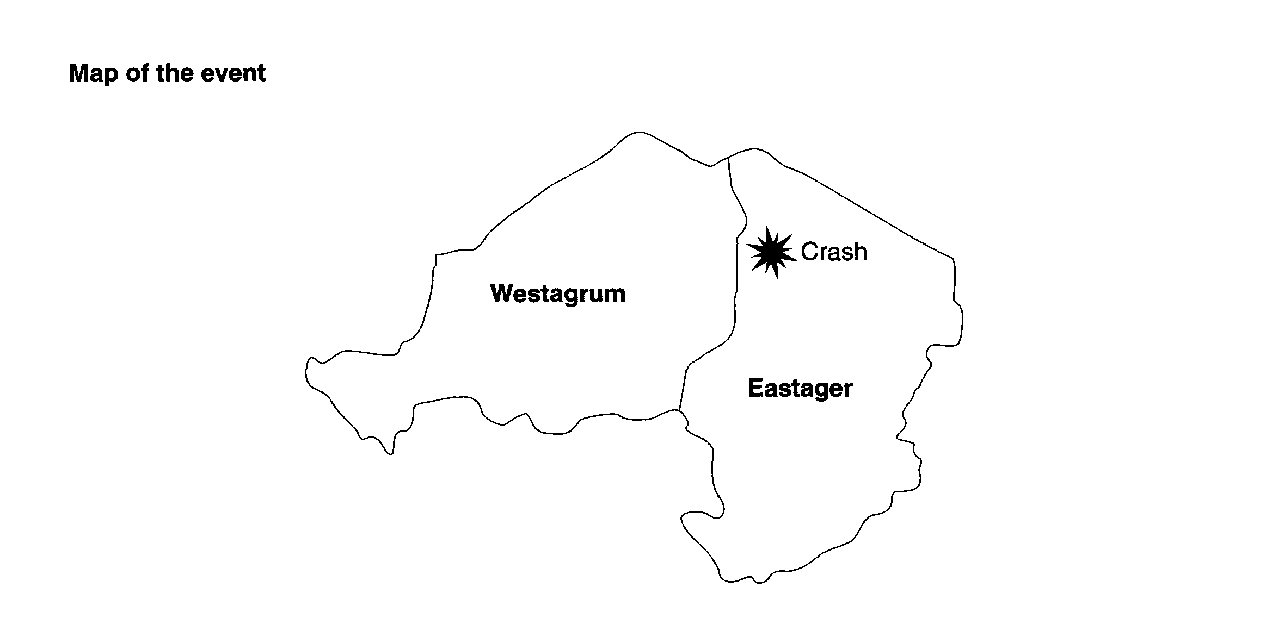

In an armed conflict between neighbouring countries, a first strike bomber from Westagrum crashed onto Eastager territory. This type of aircraft was invisible to radar. There is a dispute as to the cause of the crash.
Eastager national news immediately released subtitled film footage of anti-aircraft gunners (A) in action against the Westagrum bombardment. Their jubilant voices, scarcely audible above the noise of the artillery fire claimed, ‘We tracked their plane and shot it out of the skies. They can’t surprise us now. We’re ready for them’.
Hours later an International Red Cross worker (R) reported that the pilots had ejected seconds before the plane hit the ground. She had treated the sole survivor for shock and exhaustion when he had escaped over the border. She added, ‘They lost control after experiencing technical failure which caused the engine to stall. The plane had not been shot down’.
A video clip (V) was released some days later by the Eastager government to GNN, Global News Network. A close-up showed wreckage of the plane, identifiable by its distinctive shape, with bullet holes clearly visible in the wing. Debris of the plane was scattered along the scarred field leading to the main wreckage. An aerial shot showed the whole area cordoned off by the military, with an enclosure for international reporters who had been invited to film from a safe distance.
A press release from the Westagrum military Commander (M) stated that the plane had not been attacked. It had discharged its weapons and was returning home. He claimed, ‘As a developing country, Eastager does not have the advanced surveillance technology, let alone the appropriate weaponry to threaten this advanced aircraft.’ He added that although these planes were noted for their high speed manoeuvrability, the pilots had misjudged their position, pushed the agility of the plane beyond the safety limits and consequently failed to pull out of a dive. As the plane had turned, it had cart-wheeled, causing its wing to scythe through the ground.
Having recovered the aircraft’s ‘black box’, Eastager released excerpts from the cockpit voice recorder (C). They claimed that this settled the dispute beyond any reasonable doubt, since the pilots’ voices clearly admitted their defeat. Amongst recordings of the pilots losing control and making the decision to eject, they could be heard to say ‘They’ve got us now’.

Background Information
• Aircraft invisible to radar are used as first strike bombers to take out a nation’s surveillance and communications infrastructure, so that second strike bombers are less vulnerable.
• The International Red Cross is a charity which provides healthcare and aid in times of war, disaster and need.
• An Aircraft’s ‘black box’ records conversations in the cockpit, and information about how the aircraft’s systems are functioning. It is designed to be indestructible in the event of an impact. Its recordings are used to help determine the cause of a crash.

