In the following passage you are given information about a dispute.
Write a reasoned case in which you divide your answer as follows:
(a) Assess the credibility of the evidence given by each participant / source. Make clear how far this is influenced by any relevant factors. e.g. what they could have seen, and any assumptions that need to be made. [12]
(b) Come to a reasoned judgement about who was the cause of the accident.
You should:
• Identify where there is corroboration and/or conflicting evidence.
• Outline the balance of evidence.
• Justify your judgement by discussing the weight and quality of the supporting evidence. [8]
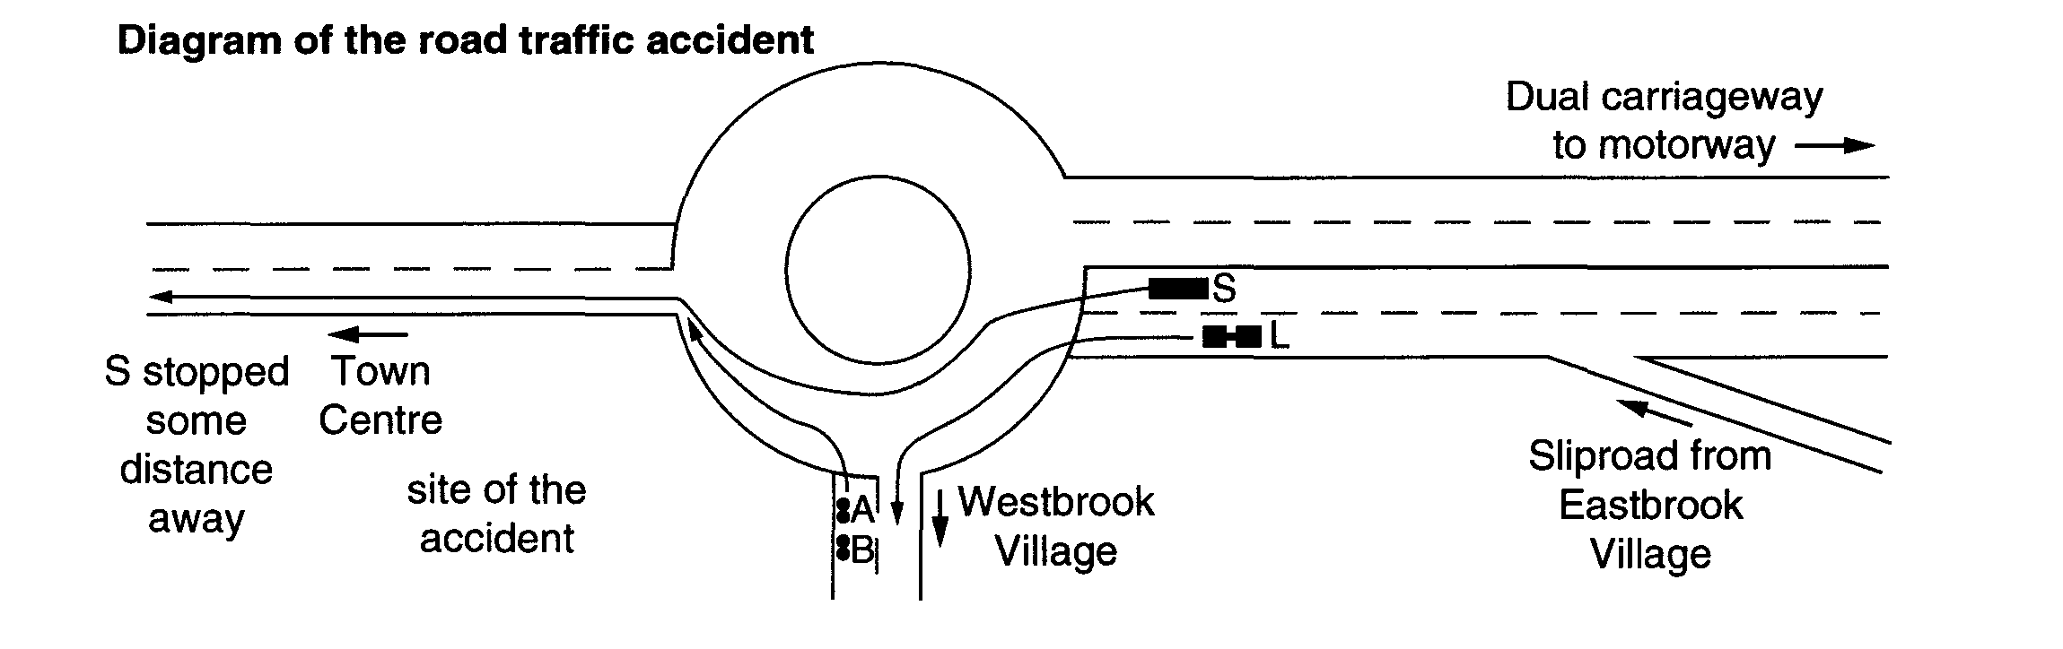
A traffic accident occurred at 8:45am involving moped users Adams (A), Bartlett (B) and sports car driver (S). There was one witness (L) who was driving a Land Rover towing a horse box. Area traffic police (P) attended the scene of the incident within minutes of it taking place. There is a dispute as to who caused the accident.

(A) claimed that she had stopped at the junction, and had pulled out towards the Town Centre turn off when the road to the right was clear. She had seen (B) follow her in her mirror. She pointed out that they had both recently passed the CBT (compulsory basic training) in motor cycle riding and were aware of the right of way of traffic from the dual carriageway.
(B) stated that (S) sped out of his junction and shot across the path of (A) into the Town Centre turn off. This caused (A) to brake suddenly, herself (B) to hit the back of (A) and both to overturn in the road.
(S) claimed that both (A) and (B) crawled out of their junction in front of him whilst he was on the roundabout. He stated that he always drove carefully as he was a sales representative and needed his licence for his job. He had been a passenger with a colleague when the latter was convicted of a drink driving accident and subsequently lost his licence. There was no way he would jeopardise his career by causing an accident. He claimed that he had driven safely as he had successfully avoided a collision. He had also returned to offer help as soon as he realised that the moped riders had lost their balance and had fallen off.
Witness (L) claimed that (5) overtook him at speed on the dual carriageway. He had clearly seen (A) pull out onto the roundabout before (S). He had then looked in the mirror to check the horse box before pulling out so he had not noticed (B). He supposed that she would be closely behind (A), as he knew that they always rode into work together from the neighbouring village.
(P) who recognised (S) as a passenger in a previous accident, recorded that there were no visible signs of damage to (S)’s car and no skid marks on the road to indicate an attempt to stop. Indeed (L) had reported to (P) that (S) had continued to speed on for some distance apparently oblivious of the accident, before he decided to stop and return to the scene, where (L) had already called for an ambulance.

