Co-ordination - exercises and discussion
Exercises and discussion E3.31

1 The diagram below represents part of the eye, showing the circular (sphincter) muscle of
the iris and a part of the retina. The brain is represented very simply.
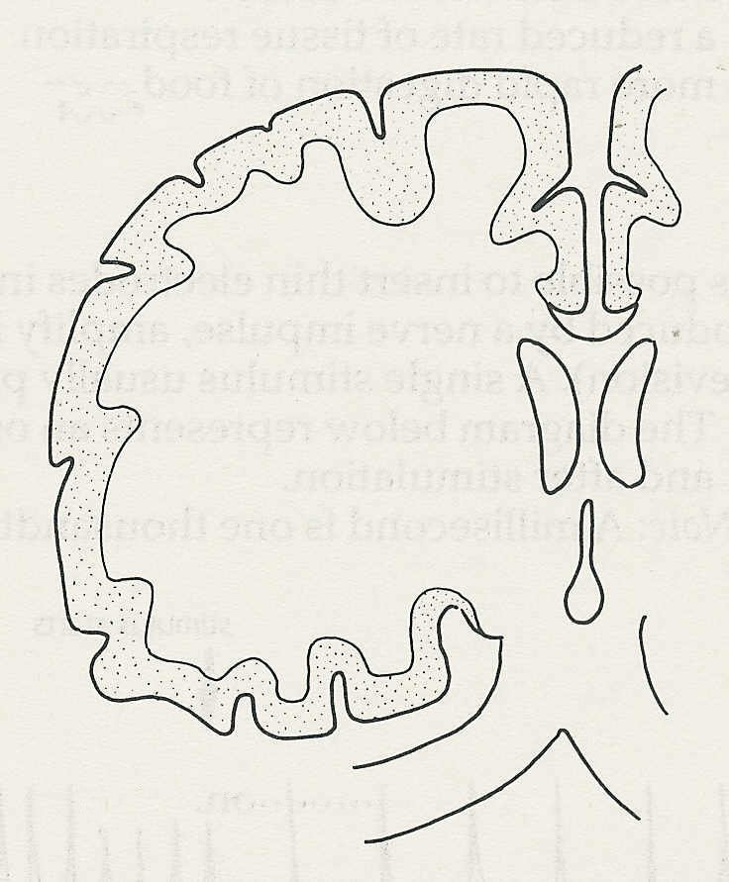

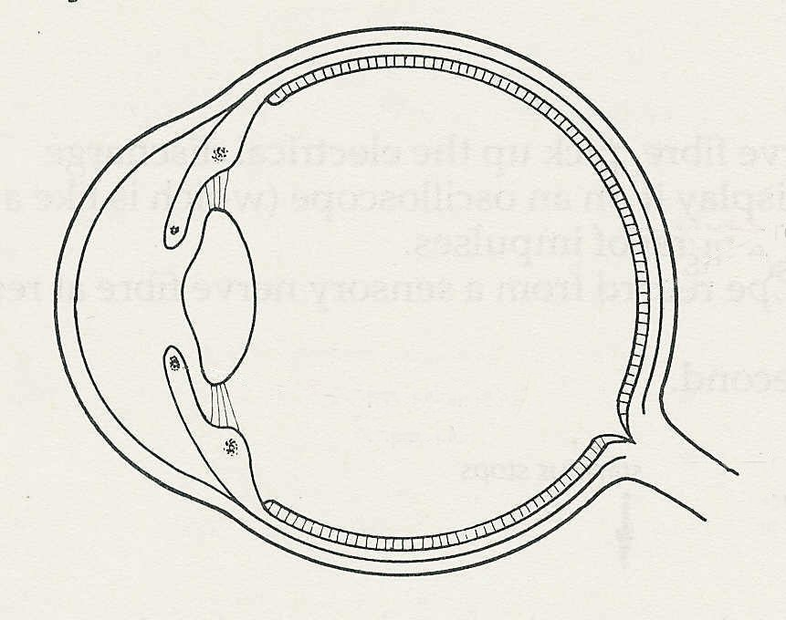
eye
brain
retinal cells

optic
nerve

iris sphincter
muscle
optic
nerve

Draw in the nervous connections that would produce a reflex decrease in size of the pupil
in response to a bright light. You need show only single nerve fibres. Synapses can be
represented very simply. The connections in the brain may be assumed to be similar to
those in the spinal cord. The drawing does not have to be anatomically accurate. (A)

2 To reduce some of the discomfort of childbirth an epidural injection is sometimes given. An anaesthetic is injected between two1umbar vertebrae into the epidural space between the spinal cord and the vertebral (neural) canal.
(a) Why, do you think, does this help to reduce pain during labour?
(b) What disadvantage might the anaesthetic have? (A)
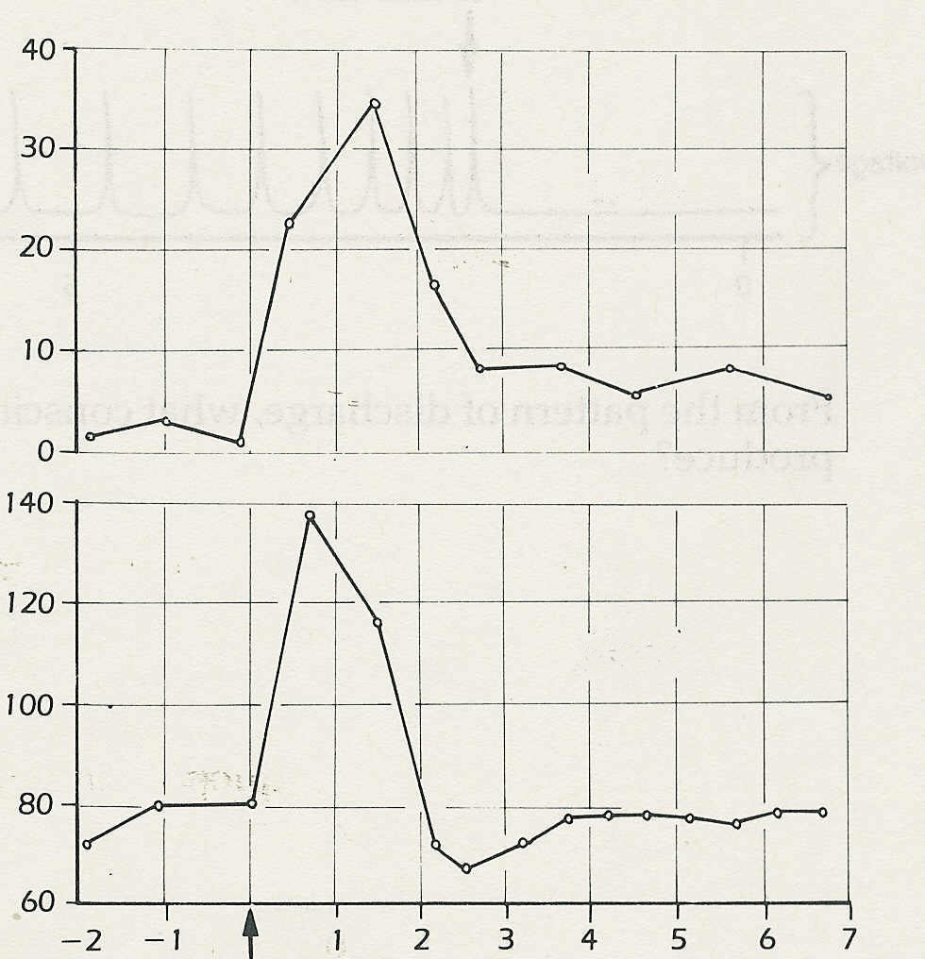
plasma insulin/ µg per cm³
50g glucose eaten
blood glucose/ mg per 100 cm³
hours
© Passmore and Robson
3 The graphs show the glucose and insulin
insulin
concentrations in the blood of a healthy man
over a period of 9 hours. After 2 hours the man
ate 50 grams of sugar.
(a) What is the approximate 'normal'
concentration of blood glucose
(i.e. immediately before and 4 hours
after eating the sugar)?
(b) What effect does eating sugar appear to
have on the production of insulin?
(c) After eating the sugar is there any
perceptible delay before the production
glucose
of insulin starts to increase.
(d) When the blood glucose is at its
maximum, what is happening to the
insulin concentration?
(e) How long does It take for the blood
glucose concentration to return to its
'normal' level?
(f) Between 2 and 4 hours after eating the
sugar, the blood glucose concentration
is lower than normal. From the graph,
suggest a reason for this fall in concentration. (I)
Co-ordination - exercises and discussion (continued)
Exercises and discussion E3.32

4 Giving a pituitary growth hormone to rats was found to increase their growth rate. Which of the following is the least likely explanation?
The growth hormone brings about
(a) increased intake of food
(b) more efficient use of food
(c) a reduced rate of tissue respiration
(d) more rapid digestion of food. (A/H)

5 It is possible to insert thin electrodes into a nerve fibre, pick up the electrical discharge
produced by a nerve impulse, amplify it and display it on an oscilloscope (which is like a
television). A single stimulus usually produces a burst of impulses.
(a) The diagram below represents an oscilloscope record from a sensory nerve fibre at rest
and after stimulation.
NOTE: A millisecond is one thousandth of a second. (I)

stimulus starts
stimulus stops
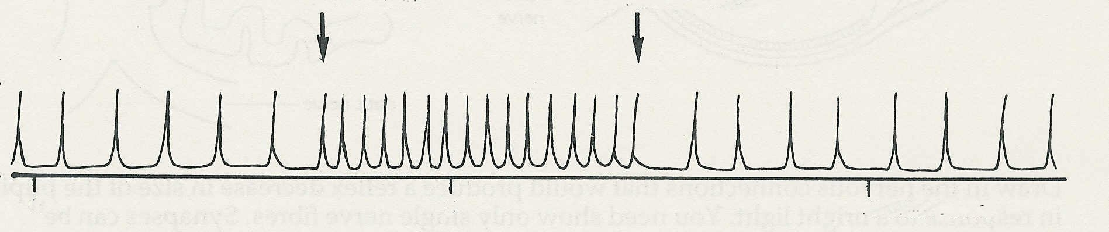

voltage

0
5
10
milliseconds

How did the stimulus affect (i) the strength (voltage) and (ii) the frequency of the impulses?
(iii) How would the brain be made aware of when the stimulus started and stopped?

(b) The diagram below is part of an oscilloscope record of the electrical discharge from a
nerve fibre coming from a touch receptor. The touch stimulus was maintained for 2
seconds.

stimulus starts
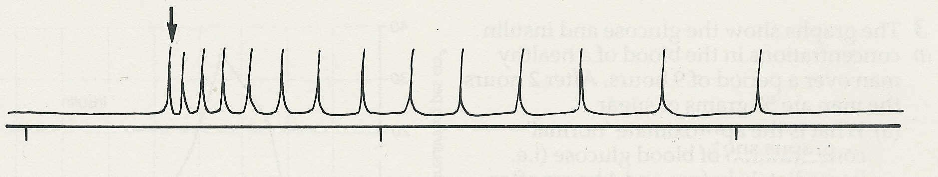
voltage

0
5
10
milliseconds

From the pattern of discharge, what conscious sensation do you think this stimulus would
produce?

