Experiment 9. The effect of one-sided lighting on shoots

You are provided with two seedlings with straight shoots.

(a) Place the seedlings in turn alongside a ruler and use a spirit marker to put lines or dots at
2 mm intervals on the hypocotyls. (Fig. 1). Count the number of marks on each shoot and record this in your book.

(b) Use the spirit marker to label two test-tubes A and B and add your initials.

(c) Fill both tubes with water. Wrap a strip of cotton wool round the base of the hypocotyl of each seedling and insert them in the mouths of the test-tubes with the root systems fully immersed in water (Fig. 2).

(d) Place tube A vertically in a container on the clinostat and tube B in the rack provided
(Fig. 3).

(e) Arrange 60 W bench lamps 35-40 cm from both groups of seedlings and adjust their height
so that the bulbs are level with a point 2-3 cm below the rim of the test-tubes (Fig. 2).

(f) Place sheets of cardboard round the experiments to screen them from direct light from windows, skylights or other sources and leave the plants for 1-3 days (Fig. 3).

READ ALL INSTRUCTION (g) before collecting your seedlings.

(g) After 1-3 days, remove the screens and before taking your own seedlings examine the whole group to see (i) whether the shoots have continued to grow vertically, (ii) whether they have
altered their direction of growth but not in a consistent way or (iii) whether they have changed
their direction of growth in a recognizable pattern.
If only some of the seedlings have changed their direction of growth note (i) how many and
(ii) whether this direction is related to the side from which they received illumination.

(h) Take your own seedlings from the test-tubes and study the spacing of marks on the stem. . Make a simple outline drawing of shoot B (the stationary seedling) indicating the direction
from which the light was coming.

(i) Answer the discussion questions as far as possible while the seedlings are still available for study
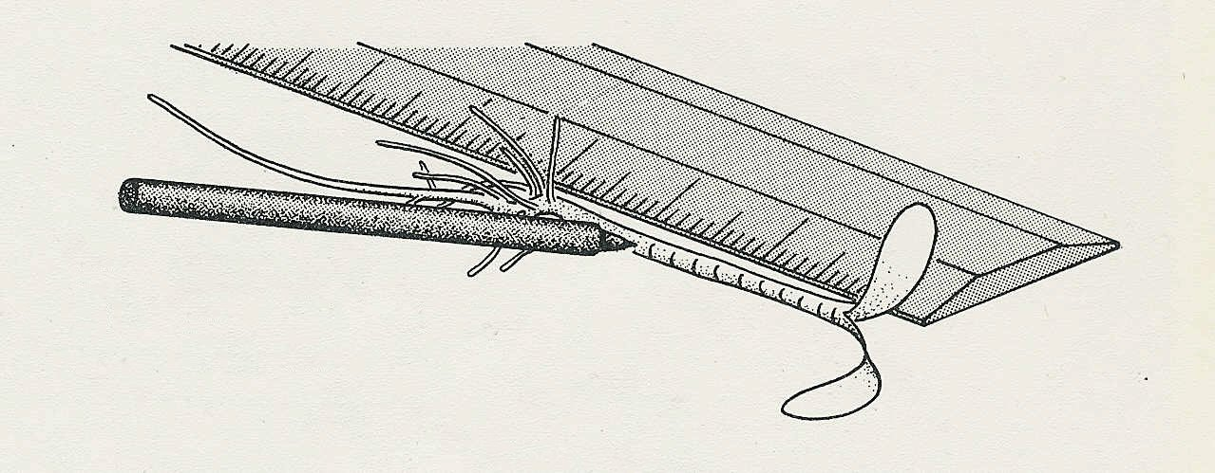

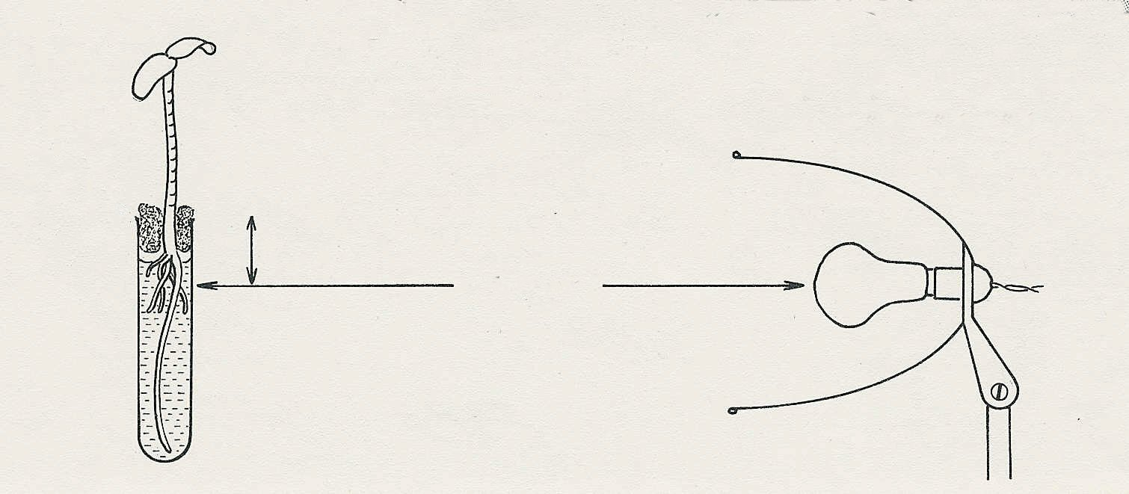
Fig. 1 Mark the hypocotyls at 2mm intervals
cotton wool plug
2-3 cm
35-40 cm
Fig. 2

